Supporting Information
Two-photon responsive porphyrinic metal-organic framework involving Fenton-like reaction for enhanced photodynamic and sonodynamic therapy
Wenyao Duan,^{1†} Bo Li,^{1†} Wen Zhang,^{2†} Jiaqi Li,¹ Xin Yao,² Yupeng Tian,² Jun Zheng,^{1*} Dandan Li^{1,2*}
¹ Institutes of Physics Science and Information Technology, Key Laboratory of Structure and Functional Regulation of Hybrid Materials, Ministry of Education, Anhui University, Hefei 230601, P. R. China
² Department of Chemistry, Key Laboratory of Functional Inorganic Material Chemistry of Anhui Province, Anhui University, Hefei 230039, P. R. China
† Wenyao Duan, Bo Li and Wen Zhang contributed equally to this work
* Corresponding author: J. Zheng (jzheng@ahu.edu.cn); D. Li (chemlidd@163.com)

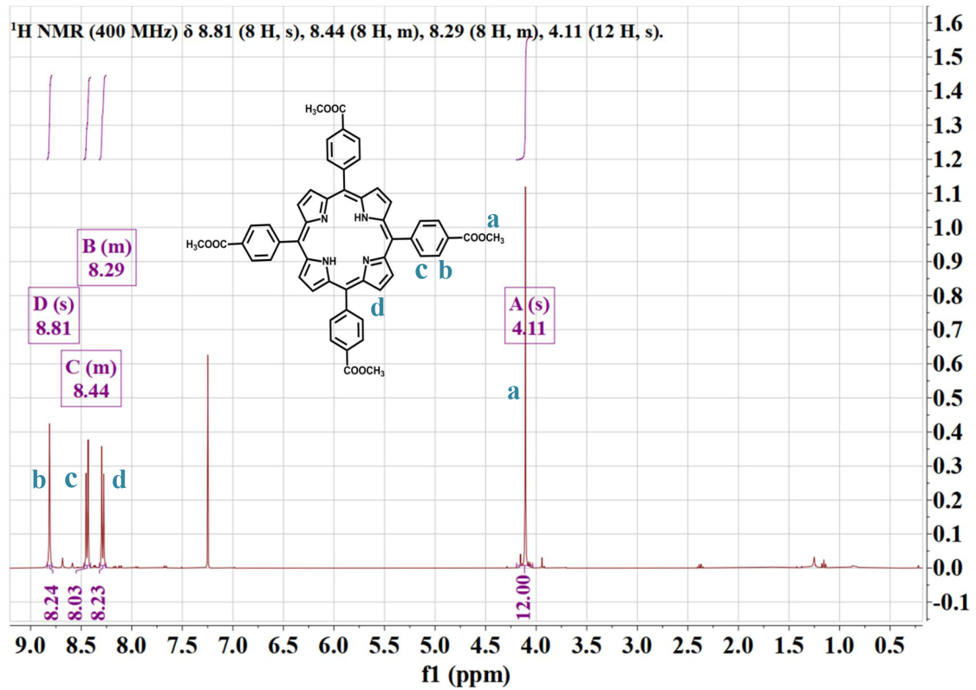
Fig. S1 ¹H NMR spectrum of TCPP-OME (CDCl₃).
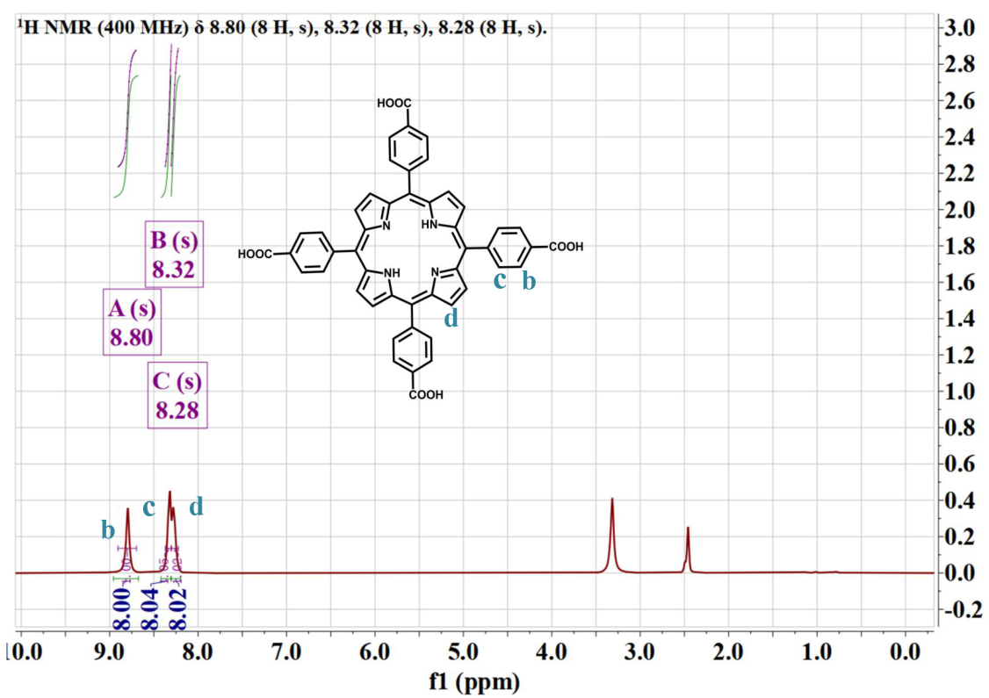
Fig. S2 ¹H NMR spectrum of TCPP (DMSO-d₆).

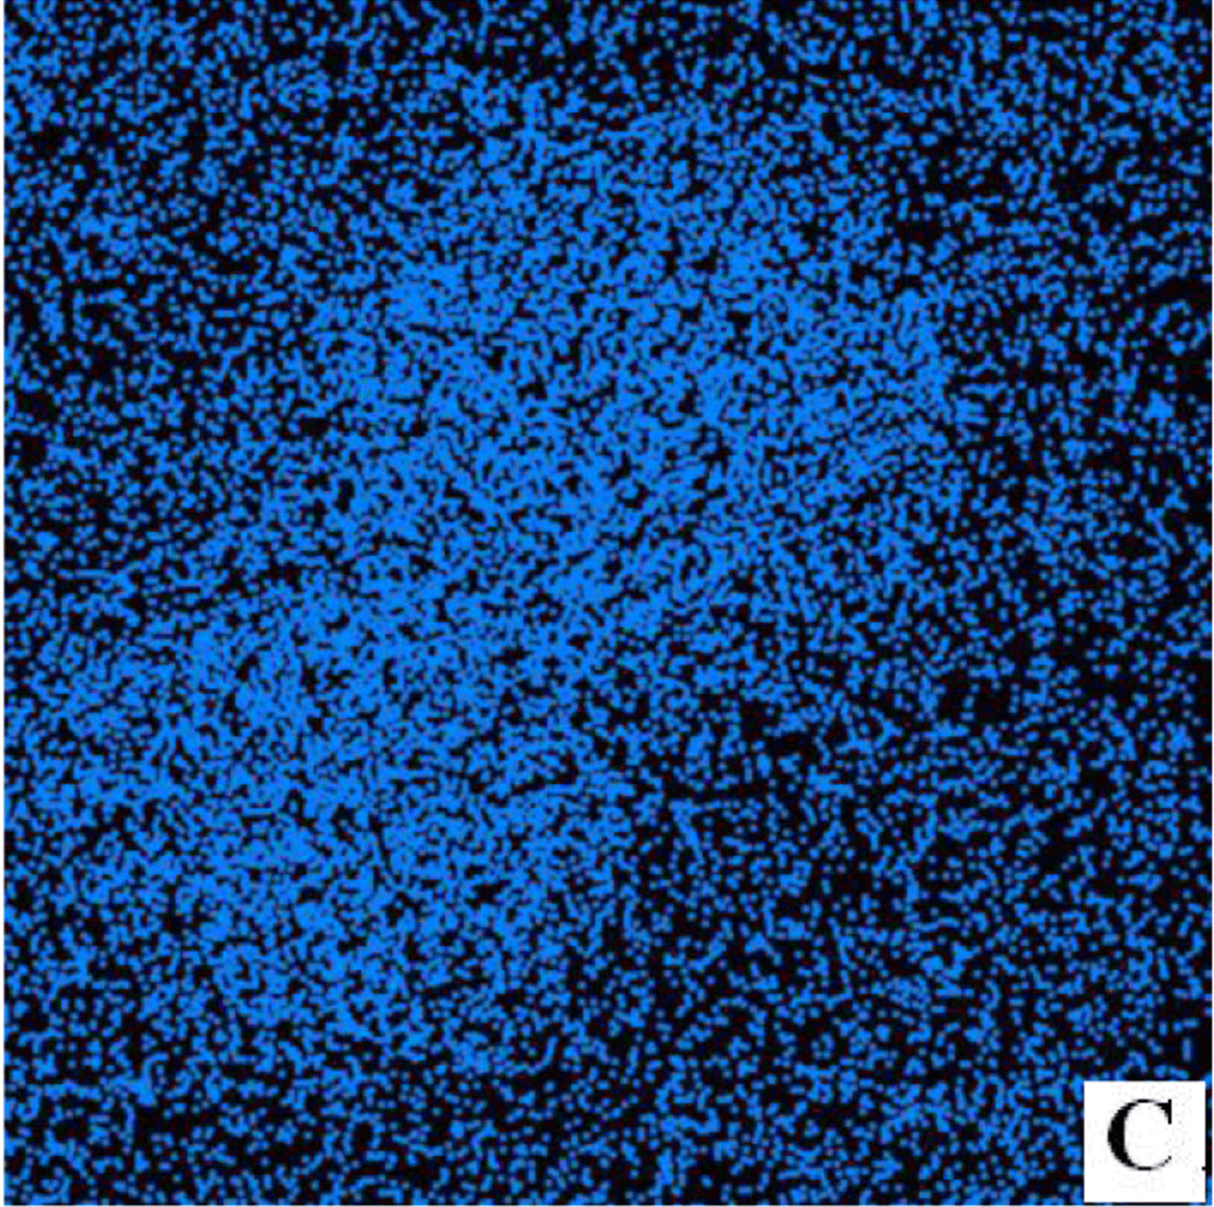
Fig. S3 TEM elemental mappings of C of Pd@MOF-525.
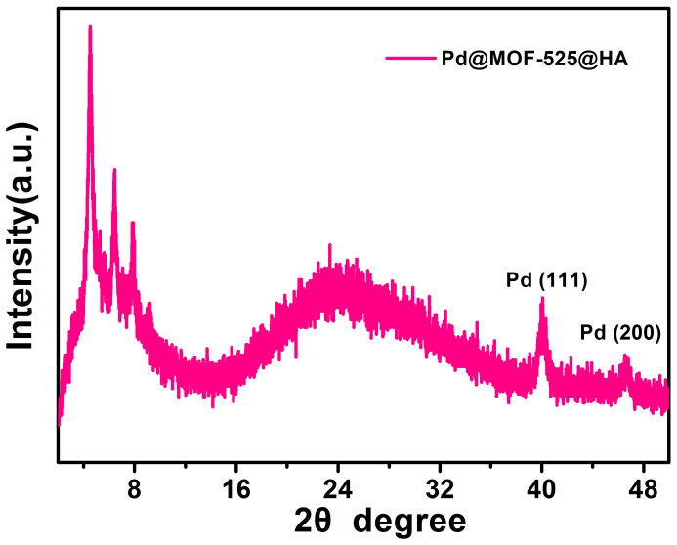
Fig. S4 PXRD patterns of Pd@MOF-525@HA nanoparticles.
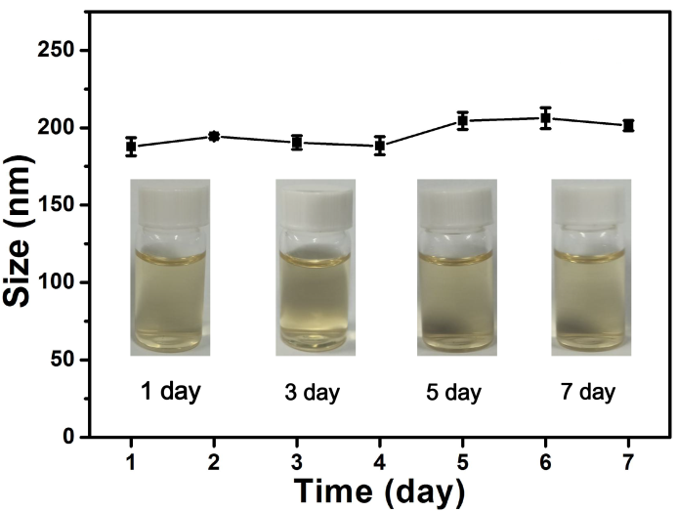
Fig. S5 Hydrodynamic size distribution of Pd@MOF-525@HA for 7 days in serum-containing DMEM.
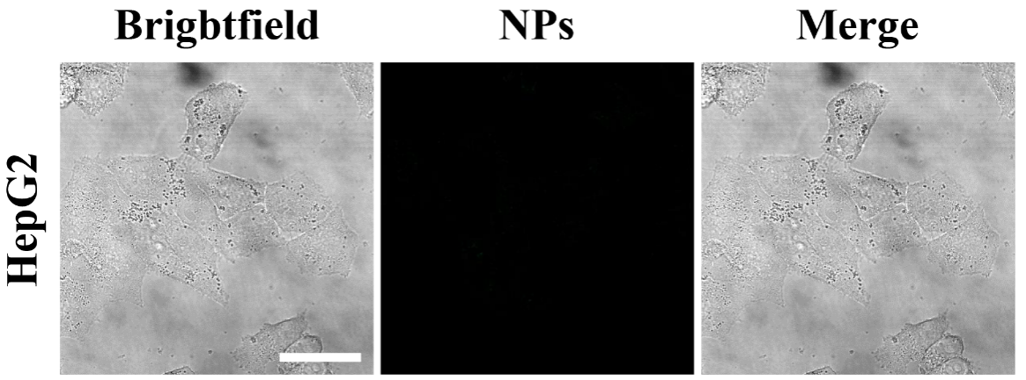
Fig. S6 CLSM images of HepG2 cells incubated with Pd@MOF-525@HA (HepG2 cells treated with free HA in advance, scale bar: 25 μm).
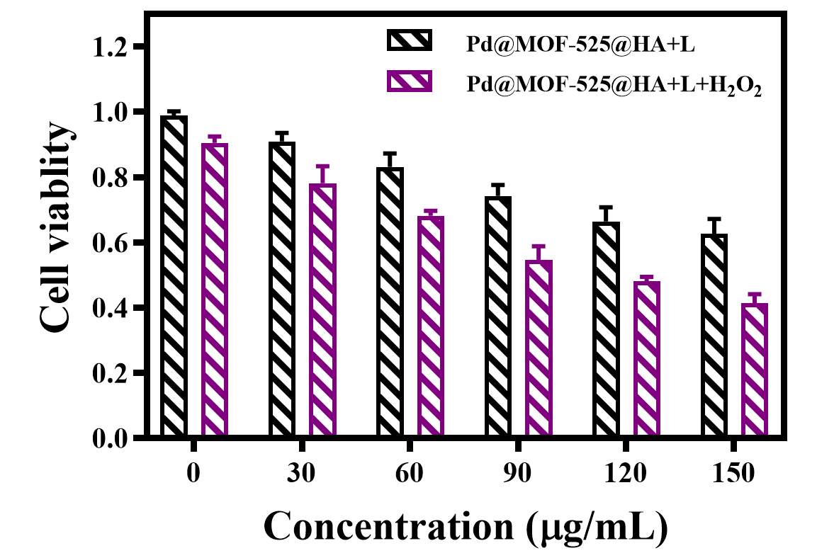
Fig. S7 Cell viability of HepG2 cells incubated with Pd@MOF-525@HA under laser irradiation (800 nm, 1 W cm⁻²; H₂O₂: 100 μM; Pd@MOF-525@HA:100 μg/mL).
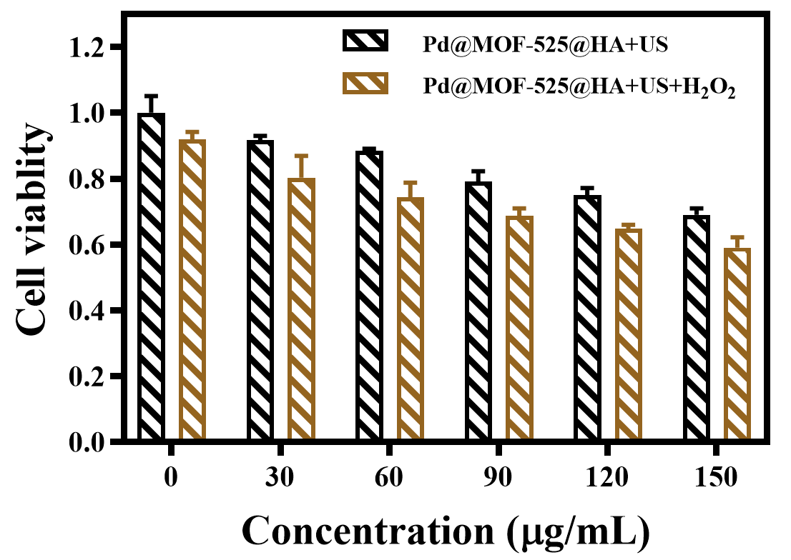
Fig. S8 Cell viability of HepG2 cells incubated with Pd@MOF-525@HA under ultrasonic irradiation (US: 1.2 W cm⁻²; H₂O₂: 100 μM; Pd@MOF-525@HA:100 μg/mL).
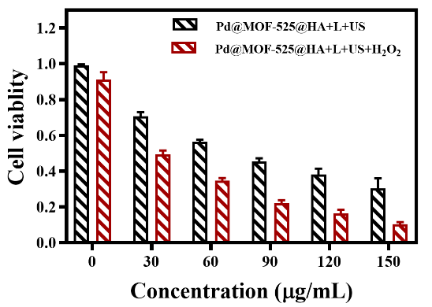
Fig. S9 Cell viability of HepG2 cells incubated with Pd@MOF-525@HA under light and ultrasonic irradiation (Laser: 800 nm, 1 W cm⁻²; US: 1.2 W cm⁻²; H₂O₂: 100 μM; Pd@MOF-525@HA:100 μg mL⁻¹).
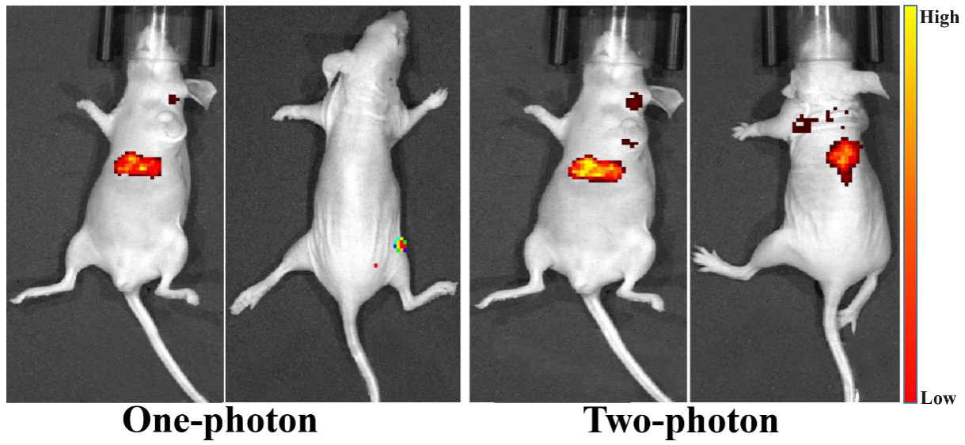
Fig. S10 One/Two-photon fluorescence images after tail intravenous injection of Pd@MOF-525@HA (100 μg mL⁻¹).

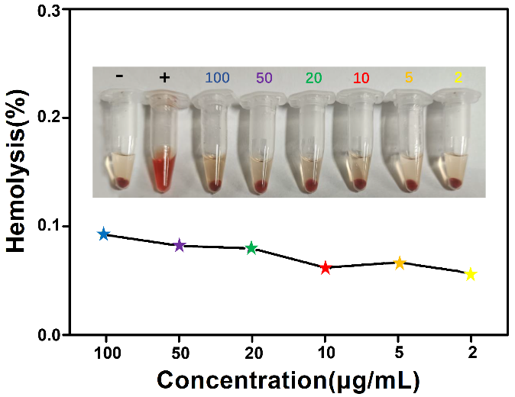
Fig. S11 The images and hemolysis rates of red blood cells treated with different concentrations of Pd@MOF-525@HA.
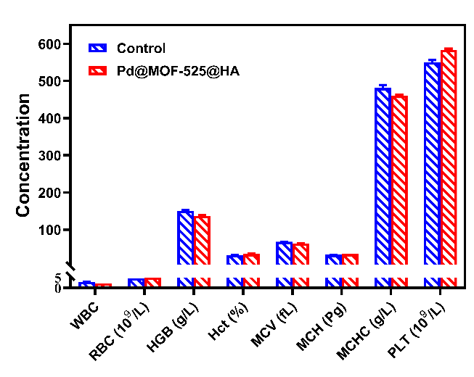
Fig. S12 Blood biochemical and hematological analysis of the mice injected with Pd@MOF-525@HA after 14 days.
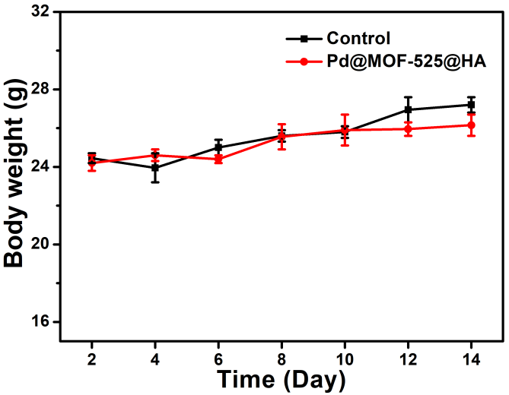
Fig. S13 Curves of body weight of mice after different treatments.

