Supplemental Information
Dual-functional alginate and collagen–based injectable hydrogel for the treatment of cancer and its metastasis

Juyoung Hwang^{1,2,3}, Eun-Koung An^{2,3}, Wei Zhang¹, Hyo Jeong Kim⁴, Youngho Eom⁴, and Jun-O Jin^{1, 2,3,}*

¹ Shanghai Public Health Clinical Center & Institutes of Biomedical Sciences, Shanghai Medical College, Fudan University, Shanghai 201508, China
² Department of Medical Biotechnology, Yeungnam University, Gyeongsan 38541, Republic of Korea
³ Research Institute of Cell Culture, Yeungnam University, Gyeongsan 38541, Republic of Korea
⁴ Department of Polymer Engineering, Pukyong National University, Busan 48513, Republic of Korea

*Corresponding author. E-mail: jinjo@yu.ac.kr

Figure S1. Thermographic images of CT-26 tumor-bearing mice intratumorally injected with PBS, poly I:C, Gel, pGel, TRG, and pTRG and then exposed to an 808-nm laser at a power density of 1.5 W/cm² for 5 min (n = 6).

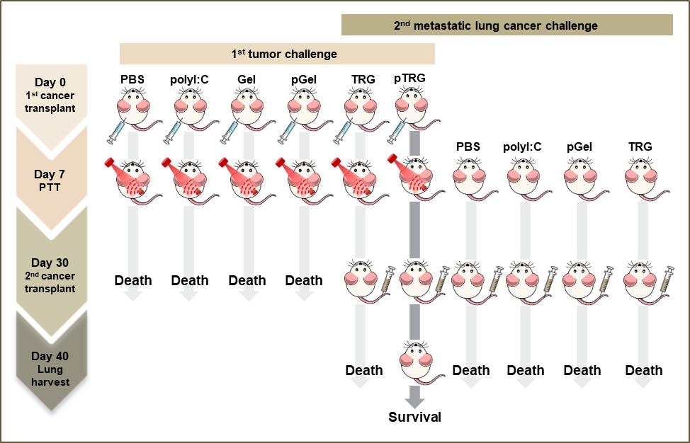
Figure S2. Schematic illustration of the treatment strategy and the first and second tumor challenge models

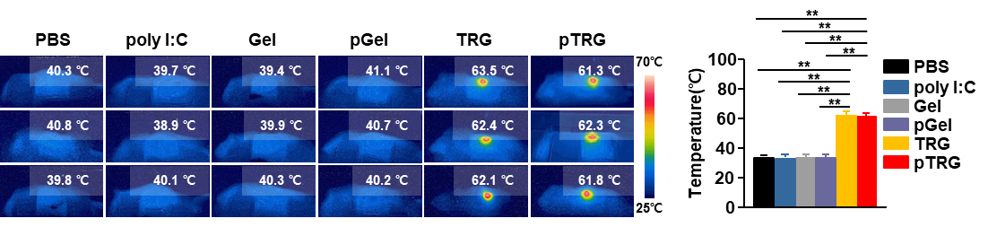
Figure S3. Thermal images of 4T1 tumor-bearing mice intratumorally treated with PBS, poly I:C, Gel, TRG, and pTRG (left panel) and the average temperature after 808-nm laser irradiation (right panel, n = 6, **p < 0.01)

Figure S4. Cumulative release of the stimulator of interferon genes ligand (STING L), anti-PD-1 antibody (α-PD-1), and the anti-PD-L1 antibody (α-PD-L1) from TRGs after 808-nm laser irradiation (1.5 W/cm², 5 min).

Figure S5. Thermal images of CT-26 tumor-bearing mice irradiated with 808-nm laser (1.5 W/cm², 5 min) after an i.t. injection of TRGs incorporated with poly I:C, stimulator of interferon genes ligand (STING L), anti-PD-1 antibody (α-PD-1), or anti-PD-L1 antibody (α-PD-L1).

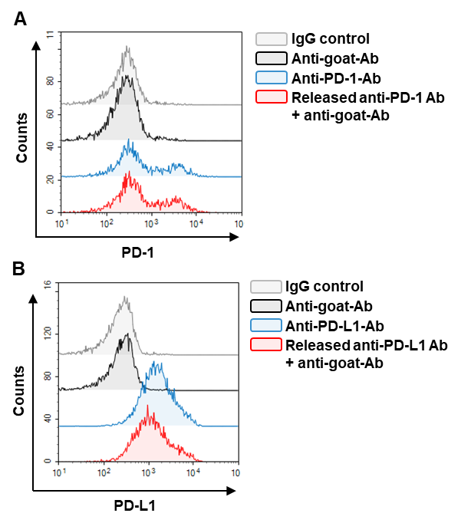
Figure S6. Measurement of antibody activity after NIR irradiation in TRG. Anti-PD-1 and anti-PD-L1 antibodies were harvested from TRGs after NIR irradiation (1.5 W/cm², 5 min). (A) Isolated CD3⁺ T cells were incubated with the released (A) anti-PD-1 antibodies and (B) anti-PD-L1 antibodies for 15 min, followed by secondary antibody (anti-goat-APC) staining for the evaluation of the functional activity of the released antibodies.

Figure S7. Treatment with immune-stimulatory molecules failed to inhibit tumor growth. The CT-26 cells were injected into BALB/C mice as shown in Figure 7A. Indicated immune-stimulatory molecules containing TRGs were injected i.t. 7 days after tumor injection. (A) The representative tumor masses are shown 24 days after tumor injection. (B) CT-26 mouse tumor growth curves (n = 6).

