Supplementary Information

For

Traditional Chinese Medicine Active Ingredients-based Selenium Nanoparticles Regulate Antioxidant Selenoproteins for Spinal Cord Injury Treatment

Siyuan Rao^{1,2#}, Yongpeng Lin^{1,2#}, Rui Lin², Jinggong Liu², Hongshen Wang², Weixiong Hu², Bolai Chen^{1,2*}, Tianfeng Chen^{3*}

Table S1. Sequences of the qPCR primers used in this study
Genes Forward primer (5ʹ→3’) Reverse primer (5ʹ→3’)
GPX2 TGTCAATGGGCAGAATCAGCATCC AGGGAGAATGGGTCGTCATAAGGG
GPX4 ATAAGAACGGCTGCGTGGTGAAG TAGAGATAGCACGGCAGGTCCTTC
TRXR1 CACGGATGAGGAGCAGACCAATG CATACAGCCTCTGAGCCAGCAATC
TRXR2 GGGAGGGCAGCAGAACTTTGATC TAGTCAGCCACAGCCACCTTCC
SelK CAGGTGTTAGACAGCCGGAATCAG CCCCGTAGCCTCTTCTTTTCTTCAC
SelT CCGCTGCTCAAGTTTCAGATTTGTG GTCTGGATACCGCTGGCTAATAACC

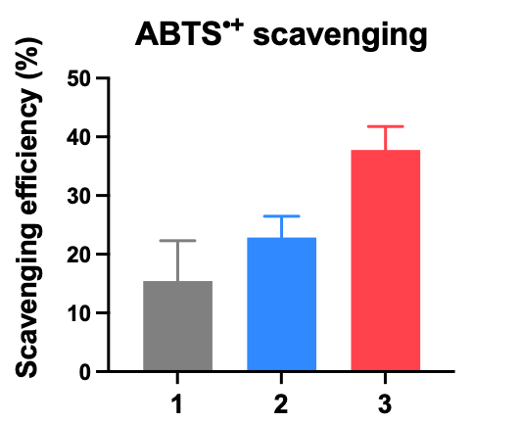
Figure S1. ROS scavenging efficiency of (1) APS, (2) TSIIA and (3) TSIIA@SeNPs-APS by ABTS method.

