Additional file 1

Biomimetic doxorubicin/ginsenoside co-loading nanosystem for chemoimmunotherapy of acute myeloid leukemia

Mo Chenª, Yingyu Qiaoª, Jie Caoª, La Taª, Tianyuan Ci^{b,}*, Xue Ke^{a,}*
ªDepartment of Pharmaceutics, China Pharmaceutical University, Nanjing, Jiangsu province, 210009, China
^{b}Department of Pharmaceutical Sciences, Shanghai University of Traditional Chinese Medicine, Shanghai, 201203, China

Corresponding author:
Corresponding authors: Xue Ke*
Mailing address: China Pharmaceutical University, Xuanwumen Campus, No.24, Tongjiaxiang, Gulou District, Nanjing, 210009, China
E-mail: kexue1973@vip.sina.com
Corresponding authors: Tianyuan Ci*
Mailing address: Shanghai University of Traditional Chinese Medicine, Shanghai, 201203, China
Tel: +86-21-51322197
E-mail: citianyuan_cpu@163.com

This word file includes:
Fig. S1. Size distribution and PDI changes of DR@PLip
Fig. S2. Statistical analysis of cellular uptake of DR@Lip and DR@PLip.
Fig. S3. In vitro drug release of free DOX and DR@PLip.
Fig. S4. In vitro Rg3 release from DR@PLip.
Fig. S5. Cytotoxicity of R@Lip in C1498 cell line.
Fig. S6. Plasma concentration-time curves of DR@Lip and DR@PLip.
Fig. S7. Statistical analysis of T_{1/2} and AUC_{0-t} of DOX in rats after i.v. with DR@Lip and DR@PLip.
Fig. S8. The proportions of T_{EM} cells (CD3⁺, CD8⁺, CD44⁺, CD62L⁻) in spleen.
Fig. S9. H&E staining of the major organs collected from the saline group and DR@PLip+aPDL1 group.
Table S1. Pharmacokinetic parameters of DOX in rats after i.v. with DR@Lip and DR@PLip.

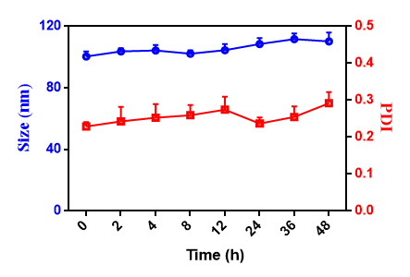
Fig. S1. Size distribution and PDI changes of DR@PLip in 48 h at DMEM medium + 10% FBS (n = 3).

Fig. S2. Statistical analysis of cellular uptake of DR@Lip and DR@PLip. P values were calculated by Student's t test, ***p < 0.001.

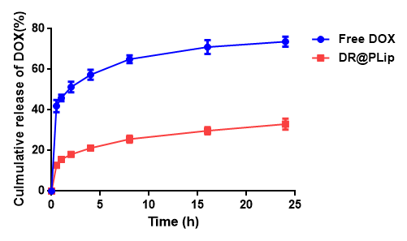
Fig. S3. In vitro drug release of free DOX and DR@PLip. Results are expressed as mean ± SD (n = 3).

Fig. S4. In vitro Rg3 release from DR@PLip. Results are expressed as mean ± SD (n = 3).

Fig. S5. Cytotoxicity of R@Lip in C1498 cell line (n = 3).

Fig. S6. Plasma concentration-time curves of DR@Lip and DR@PLip after intravenous injection in rats (n = 3).

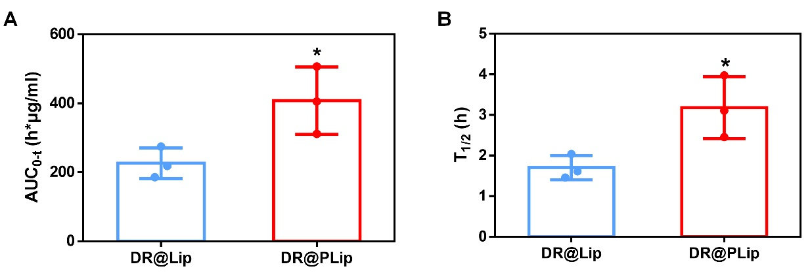
Fig. S7. Statistical analysis of (A) T_{1/2} and (B) AUC_{0-t} of DOX in rats after i.v. with DR@Lip and DR@PLip. P values were calculated by Student's t test, *p < 0.05.

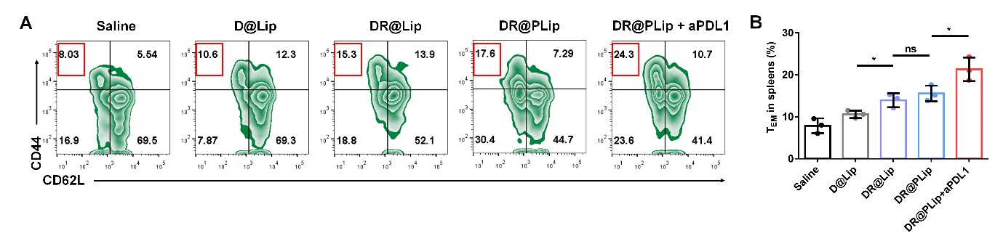
Fig. S8. (A) The proportion of T_{EM} cells (CD3⁺, CD8⁺, CD44⁺, CD62L⁻) in spleen (n = 3). (B) Statistical analysis of (A). P values were calculated by Student's t test, *p < 0.05, ns means no significant difference.

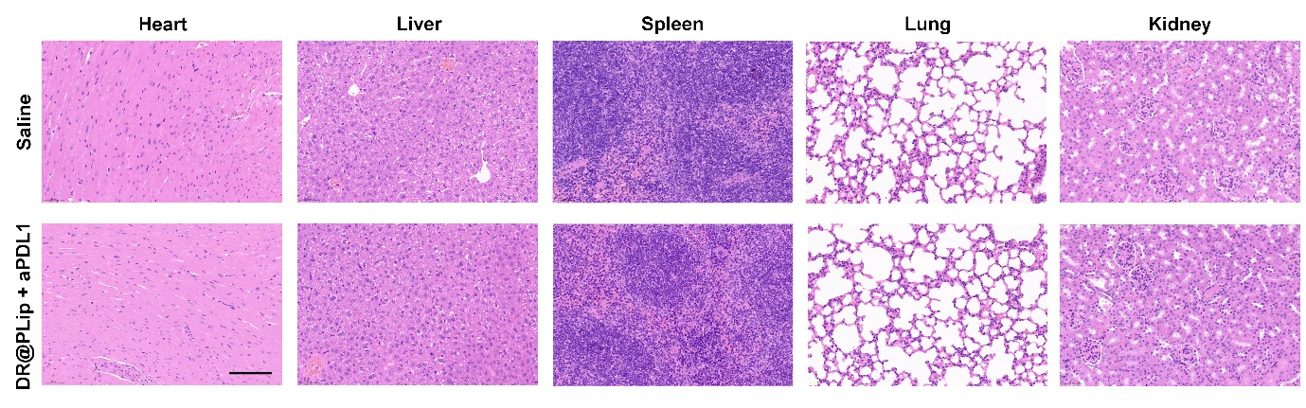
Fig. S9. H&E staining of the major organs collected from the saline group and DR@PLip+aPDL1 group (scale bar, 100 μm).

Table S1 Pharmacokinetic parameters of DOX in rats after i.v. with DR@Lip and DR@PLip at the dose of 5 mg kg⁻¹ DOX.
Parameter | DR@Lip | DR@PLip
C_{max} (μg/ml) | 94.8 ± 3.65 | 95.74 ± 3.16
T_{1/2} (h) | 1.70 ± 0.30 | 3.18 ± 0.76
AUC_{0-t} (h*μg/ml) | 226.02 ± 44.78 | 407.42 ± 97.78
CL (L (h kg⁻¹)⁻¹) | 4.54 ± 0.87 | 2.55 ± 0.062

