PLA-lignin nanofibers as antioxidant biomaterials for cartilage regeneration and osteoarthritis treatment

Ruiming Liang ^{a#} , Xingchen Yang ^{a#} , Pek Yin Michelle Yew ^{b,c#}, Sigit Sugiarto ^{b}, Qiang Zhu ^{b}, Jinmin Zhao ^{a,d}, Xian Jun Loh ^{b}, Li Zheng ^{a,d*}, Dan Kai ^{b,e*}

ª Guangxi Engineering Center in Biomedical Materials for Tissue and Organ Regeneration & Collaborative Innovation Center of Regenerative Medicine and Medical Biological Resources Development and Application, Life Sciences Institute, Guangxi Medical University, Nanning, 530021, China
^{b} Institute of Materials Research and Engineering (IMRE), A*STAR, 2 Fusionopolis Way, #08-03 Innovis, 138634, Singapore
^{c} Department of Biomedical Engineering, Faculty of Engineering, National University of Singapore, 117583, Singapore
^{d} Department of Orthopaedics Trauma and Hand Surgery, Guangxi Key Laboratory of Regenerative Medicine, The First Affiliated Hospital of Guangxi Medical University, Guangxi Medical University, Nanning, 530021, China
^{e} Institute of Sustainability for Chemicals, Energy and Environment (ISCE2), A*STAR, 2 Fusionopolis Way, Innovis, #08-03, Singapore 138634

E-mail: zhengli224@163.com; kaid@imre.a-star.edu.sg

Totally 10 pages with 2 tables and 7 figures

Table S1 Table characterization of lignin-g-PLA copolymers
Sample | Feed Ratio |  |  | Mn ^{i} | Mw ^{i} | PDI | Yield ^{ii}
Sample | Lignin : Lactide |  |  | [ kDa ] | [ kDa ] | PDI | [%]
PL5 | 5 | : | 95 | 75.6 | 100.2 | 1.33 | 92
PL10 | 10 | : | 90 | 61.5 | 87.2 | 1.42 | 80
PL20 | 20 | : | 80 | 49.0 | 57.2 | 1.17 | 72
PL30 | 30 | : | 70 | 38.7 | 47.7 | 1.23 | 76
PL40 | 40 | : | 60 | 28.5 | 35.9 | 1.26 | 69
PL50 | 50 | : | 50 | 15.4 | 21.2 | 1.38 | 65
^{i} Determined by GPC. ^{ii} Isolated yield.

Table S2 TGA characterisation table of PLLA and PLLA/PLA-lignin nanofibers
Sample | T₉₅ (°C) ª | T_{max} (°C) ^{b} | Residue at 400°C | Residue at 500°C
PLLA | 311 | 366 | 2.5% | 1.9%
PLLA/PL10 | 310 | 360 | 7.1% | 4.5%
PLLA/PL20 | 302 | 365 | 8.5% | 6.6%
PLLA/PL30 | 292 | 356 | 8.4% | 6.1%
PLLA/PL40 | 290 | 354 | 12.9% | 9.8%
PLLA/PL50 | 281 | 351 | 15.2% | 11.5%
ª Temperature at 5 wt% loss. ^{b} Maximum degradation temperature.

Figure S1 ¹H NMR (CDCl₃) of the synthesized alkylated lignin
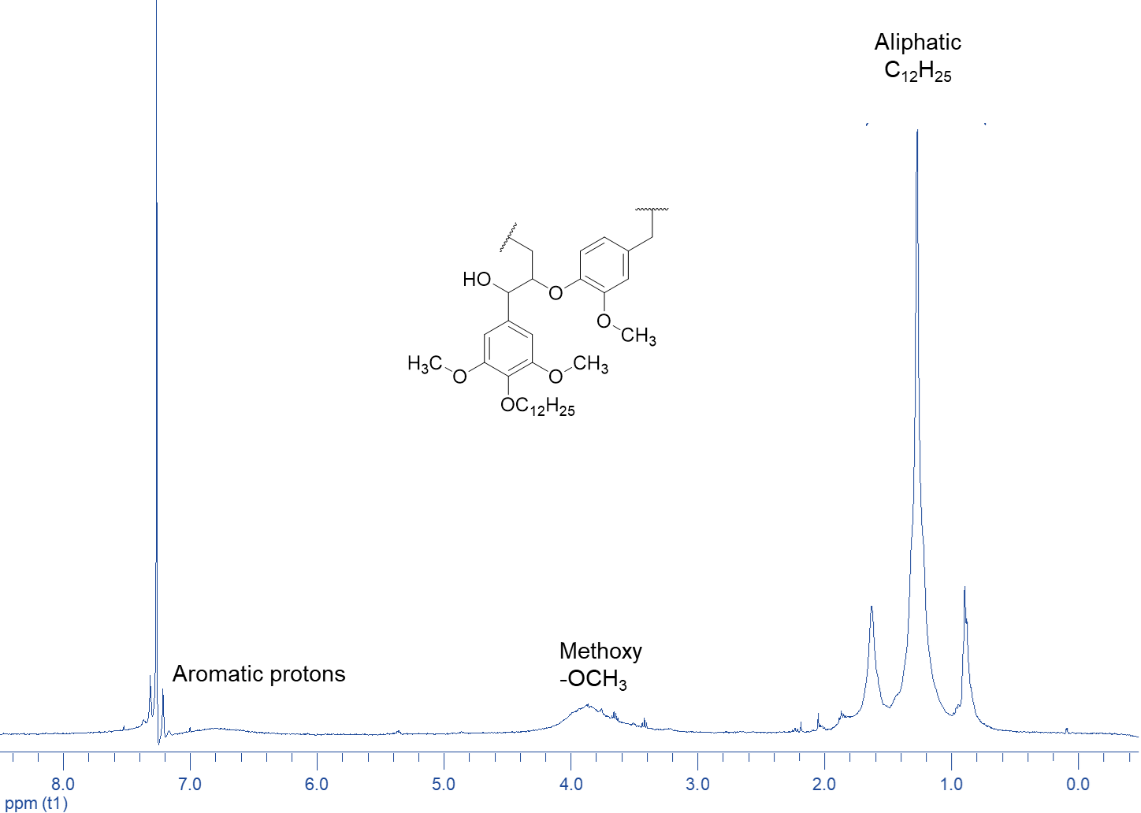

Figure S2 ¹H NMR (CDCl₃) of the alkylated lignin-g-PLA
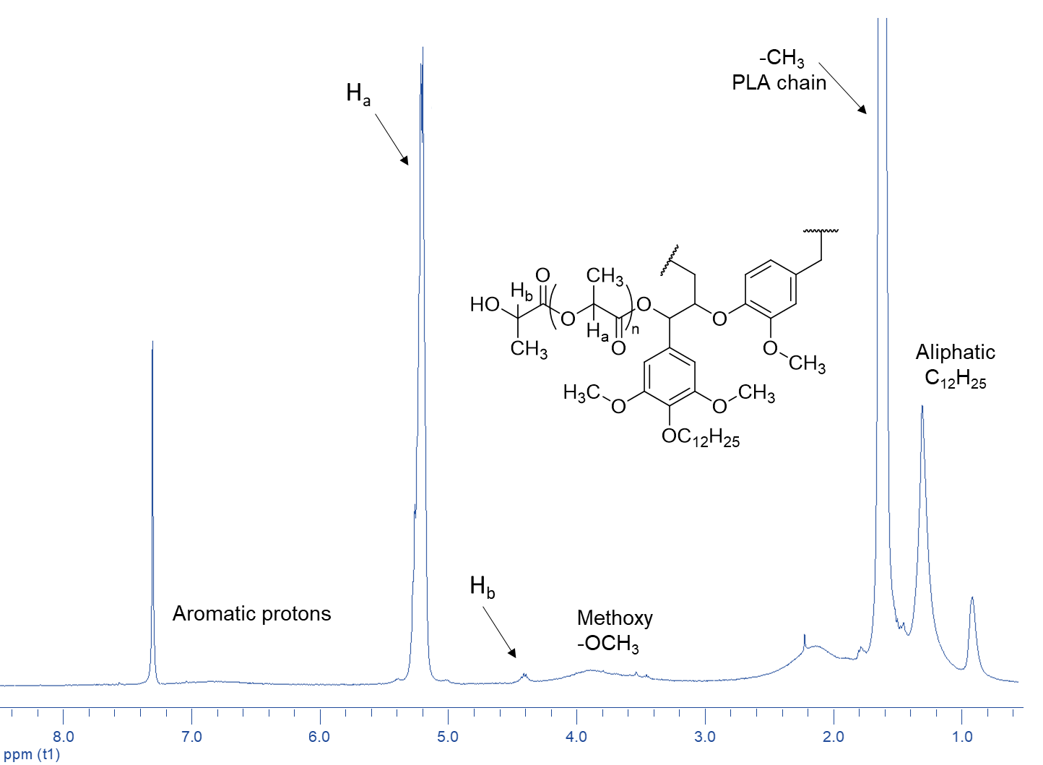
Figure S3 FTIR spectra of lignin and PLA-lignin copolymers.
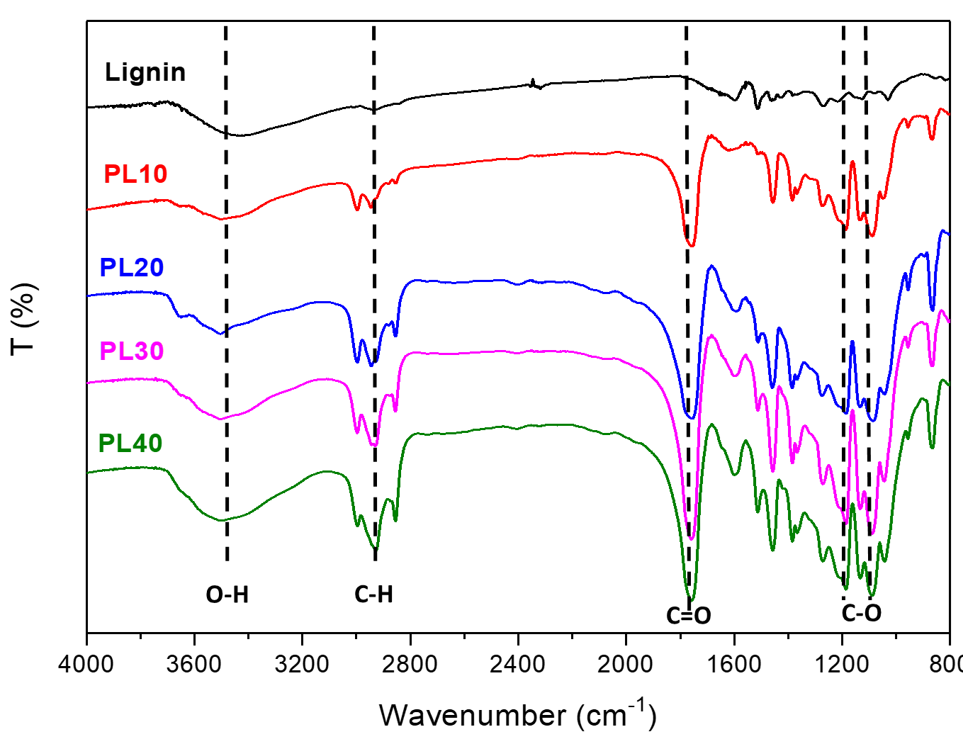

Figure S4 Images showing the water contact angles of PLLA and PLLA/PLA-lignin nanofibers
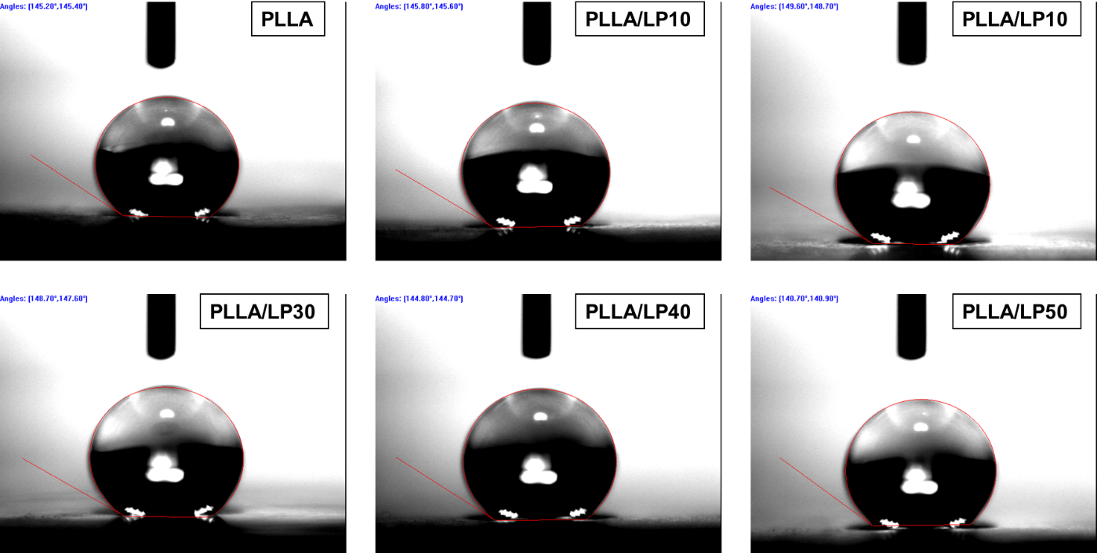

Figure S5 Typical stress-strain curves of the PLLA/PLA-lignin nanofibers by tensile test.

Figure S6 DSC curves of PLA-lignin copolymers

Figure S7 DSC curves of PLLA/lignin-PLA nanofibers
