Supporting Information
Biocompatible exosome-modified fibrin gel accelerates the recovery of spinal cord injury by VGF-mediated oligodendrogenesis

Xiaolie He†, Li Yang†, Kun Dong, Feng Zhang, Yuchen Liu, Bei Ma, Youwei Chen, Jian Hai, Rongrong Zhu*, and Liming Cheng*

Key Laboratory of Spine and Spinal Cord Injury Repair and Regeneration of Ministry of Education, Orthopaedics Department of Tongji Hospital, School of Medicine, School of Life Sciences and Technology, Tongji University, 200065, Shanghai, P. R. China

*Correspondence: rrzhu@tongji.edu.cn, limingcheng@tongji.edu.cn.
†These authors contributed equally to this work

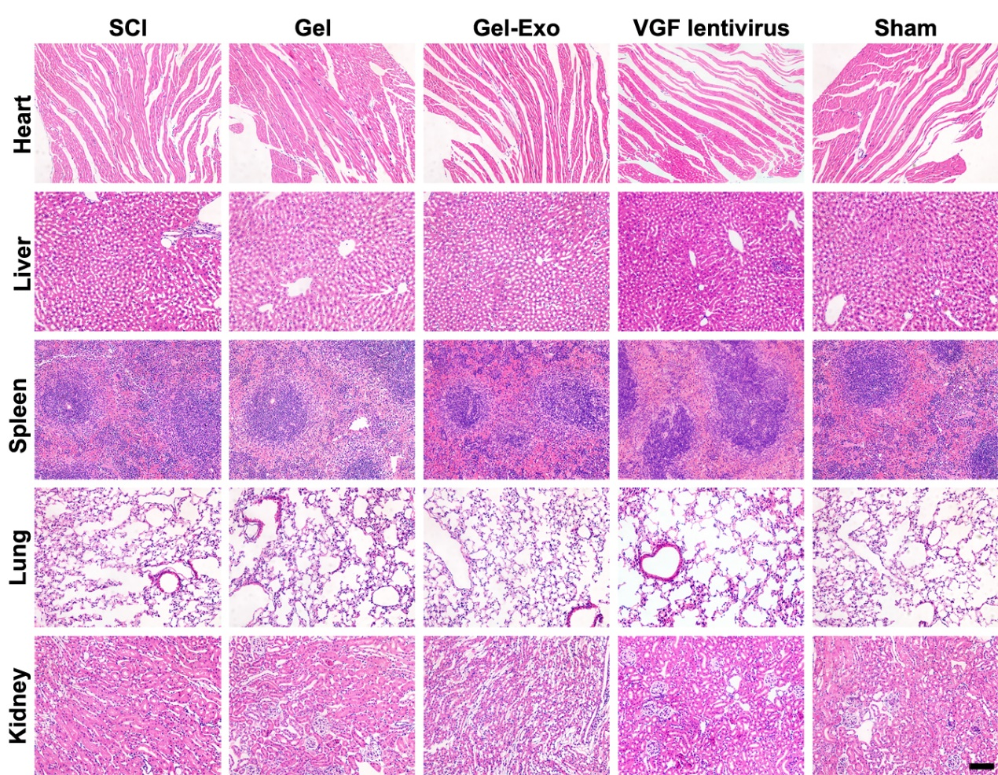
Fig. S1 HE staining of the heart, liver, spleen, lung, and kidney in all groups.

Table S1 Antibody information
Antibody name | Company | Catalog #
CD11B/C PE | Thermo Fisher Scientific | 12-0110-80
CD44 PE | Thermo Fisher Scientific | 12-0444-80
CD29 FITC | Thermo Fisher Scientific | 11-0291-80
CD45 FITC | Thermo Fisher Scientific | 11-0461-80
CD63 | System Biosciences | EXOAB-CD63A-1
CD9 | System Biosciences | EXOAB-CD9A-1
β-ACTIN | Proteintech | 66009-1-
NEUN | Sigma-Aldrich | ABN90
TUJ1 | Abcam | ab78078
VGF | Bioss | bs-11795R
MBP | Millipore | MAB386
OLIG2 | Abcam | ab1091186

Table S2 the specific surface area and pore volume
Species | Gene | Forward Primer | Reverse Primer
Mouse | Gapdh | AGGTCGGTGTGAACGGATTTG | TGTAGACCATGTAGTTGAGGTCA
Mouse | Dcx | CATTTTGACGAACGAGACAAAGC | TGGAAGTCCATTCATCCGTGA
Mouse | NeuN | GGGTATGGGTAGGATTGGGG | GTGGAAGGTTTCACTACAACAGA
Mouse | Tuj1 | TAGACCCCAGCGGCAACTAT | GTTCCAGGTTCCAAGTCCACC
Mouse | Vgf | AAGGATGACGGCGTACCAGA | TGCCTGCAACAGTACCGAG
Mouse | Mbp | GGCGGTGACAGACTCCAAG | GAAGCTCGTCGGACTCTGAG
Mouse | Olig2 | TCCCCAGAACCCGATGATCTT | CGTGGACGAGGACACAGTC
Mouse | Sox10 | ACACCTTGGGACACGGTTTTC | TAGGTCTTGTTCCTCGGCCAT
Rat | Gapdh | AGTGCCAGCCTCGTCTCATA | TGAACTTGCCGTGGGTAGAG
Rat | Vgf | CAGCCCTCGACCATCTTTCA | CGCAATCCTCGTTCTGGGTA

