Additional file
Title
Sequential Acid/Reduction Response of Triblock Copolymeric Nanomicelles to Release Camptothecin and Toll-Like Receptor 7/8 Agonist for Orchestrated Chemoimmunotherapy
Authors:
Xiaoyan Ge 1#, Yanyun Hao 1#, Hui Li 1, Huajun Zhao 2, Yang Liu 1, Yutong Liu 1, Xia Li 1, Hongfei Chen 1, Jing Zou 1, Shiying Zhang 1, Lingling Huang 1, Gang Shan 3, Zhiyue Zhang 1*
Affiliations:
1Department of Pharmaceutics, Key Laboratory of Chemical Biology (Ministry of Education), School of Pharmaceutical Sciences, Cheeloo College of Medicine, Shandong University, 44 Wenhuaxi Road, Jinan, Shandong Province 250012, P. R. China.
2Institute of Immunopharmaceutical Sciences, School of Pharmaceutical Sciences, Cheeloo College of Medicine, Shandong University, Jinan, Shandong Province 250012, P. R. China.
3Department of Medicinal Chemistry, School of Pharmaceutical Sciences, Cheeloo College of Medicine, Shandong University, Jinan, Shandong 250012, P. R. China.
#These authors contributed equally to this work.
*Corresponding authors:
Prof. Dr. Zhiyue Zhang, E-mail: zhiyue.zhang@sdu.edu.cn

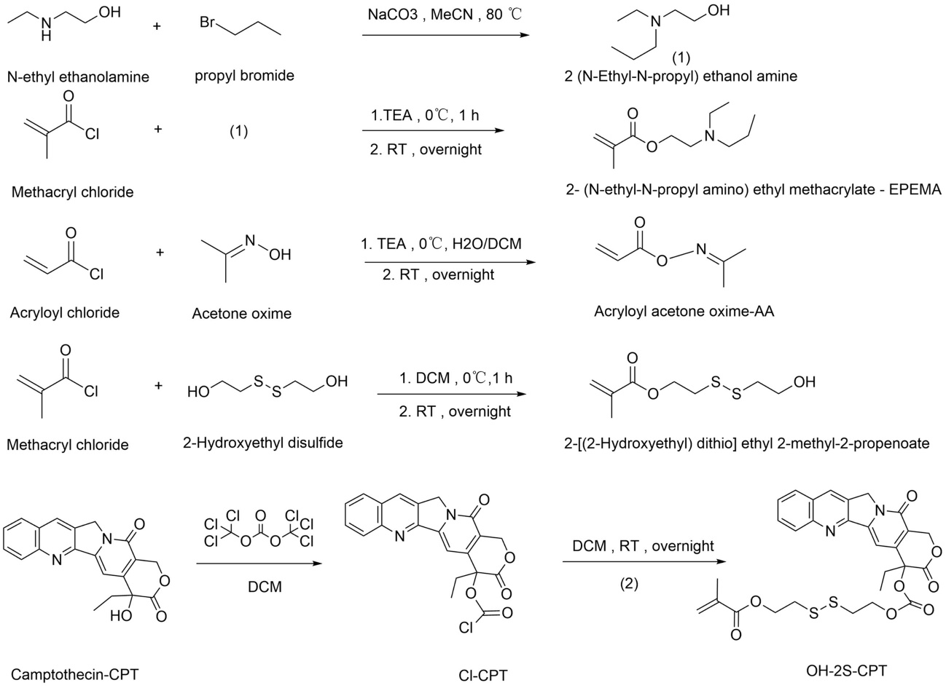
Fig S1. The synthetic route of EPEMA, AA, OH-2S-CPT.

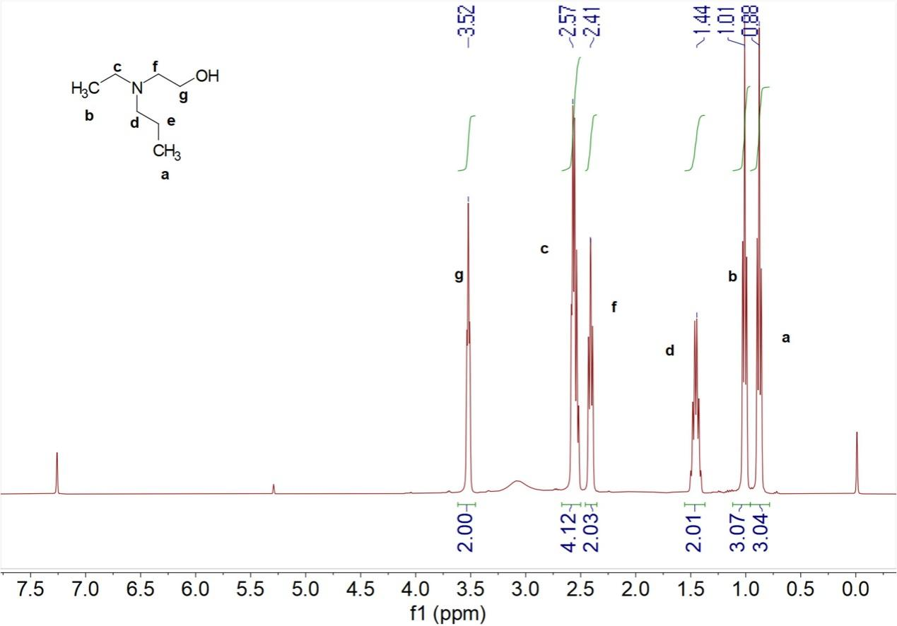
Fig S2. ¹H-NMR spectrum of 2-(N-Ethyl-N-propyl) ethanol amine.
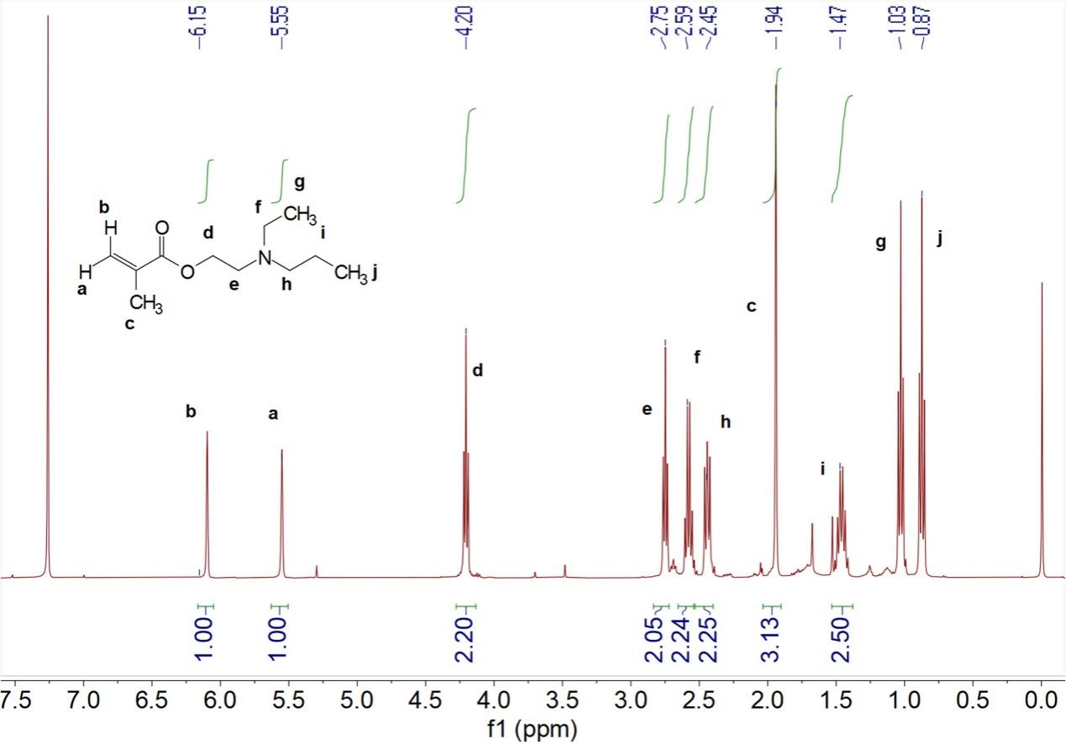
Fig S3. ¹H-NMR spectrum of EPEMA.
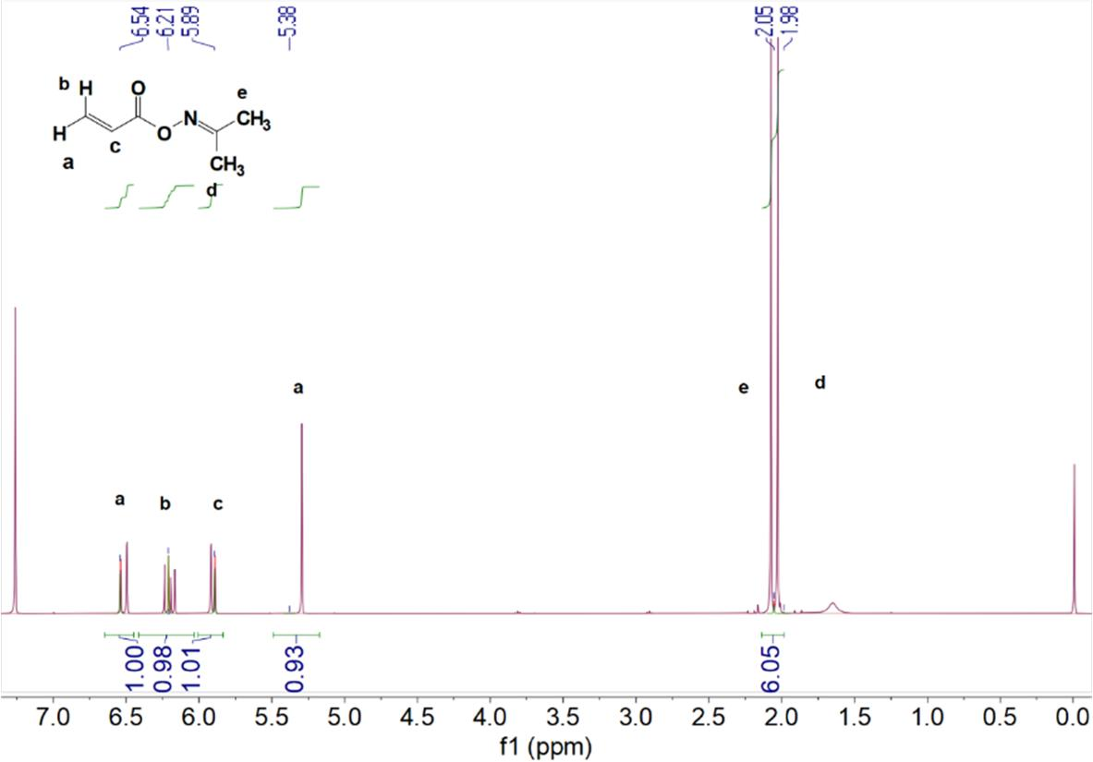
Fig S4. ¹H-NMR spectrum of AA.
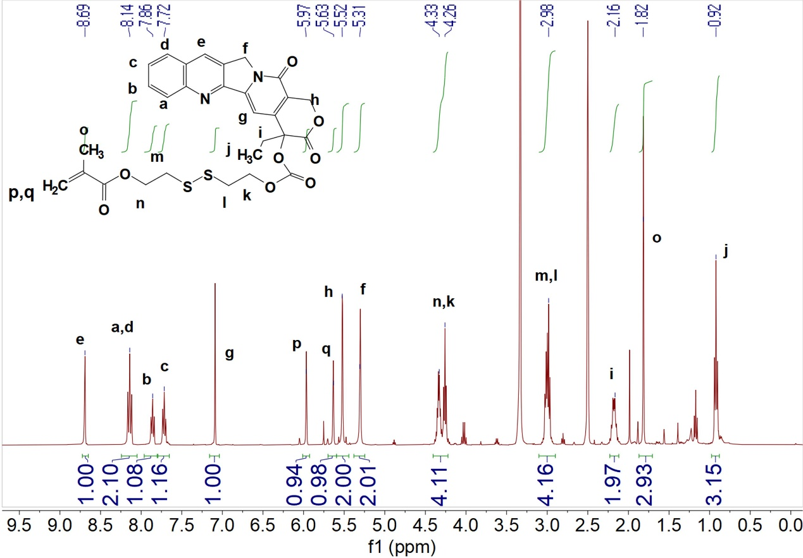
Fig S5. ¹H-NMR spectrum of OH-2S-CPT.
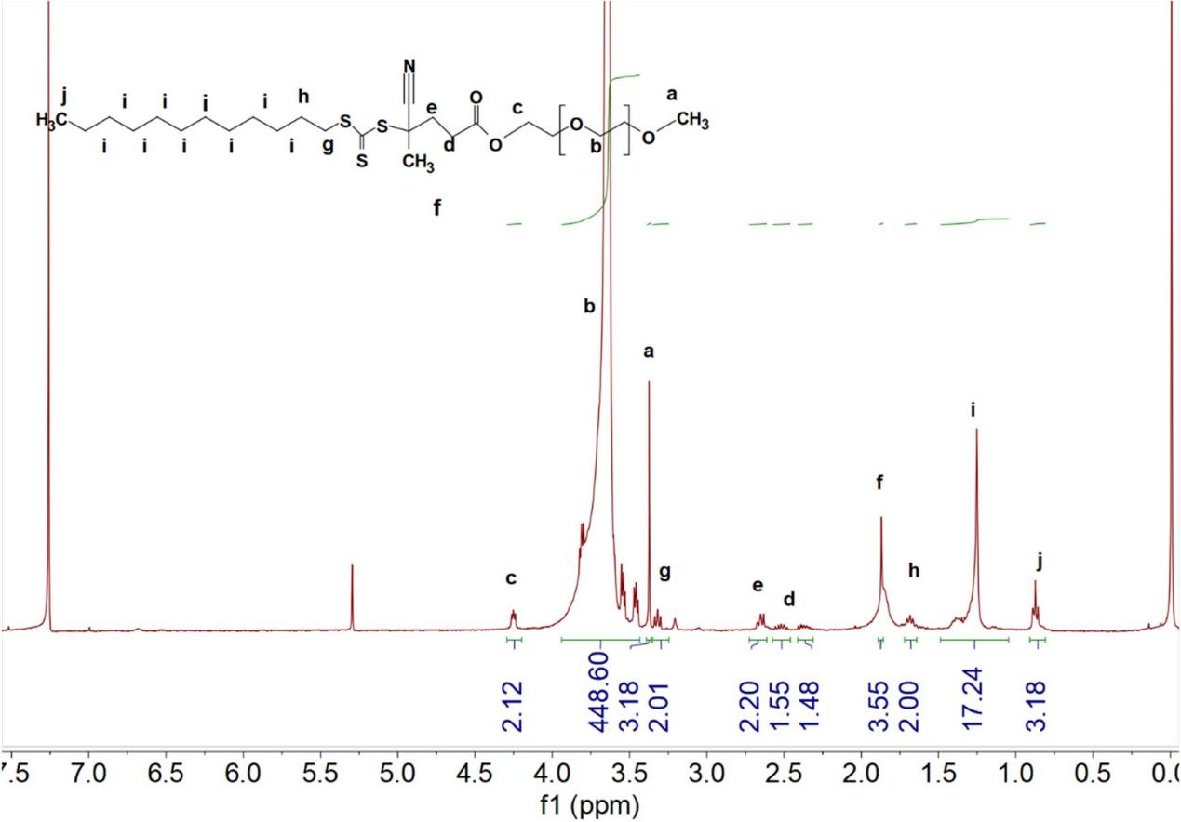
Fig S6. ¹H-NMR spectrum of PEG-DCT.
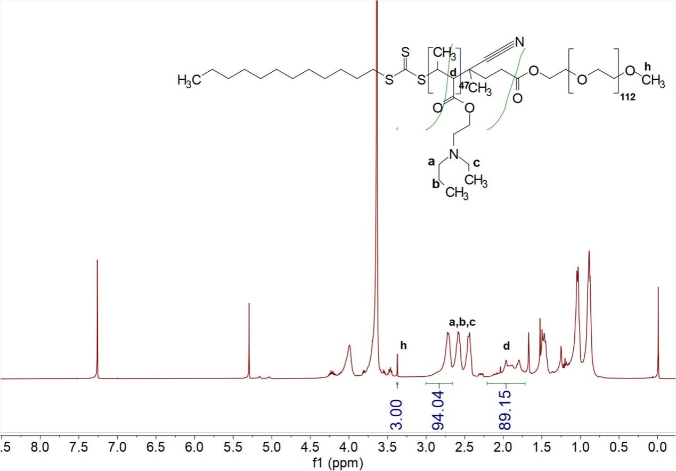
Fig S7. ¹H-NMR spectrum of PEG-PEPEMA.
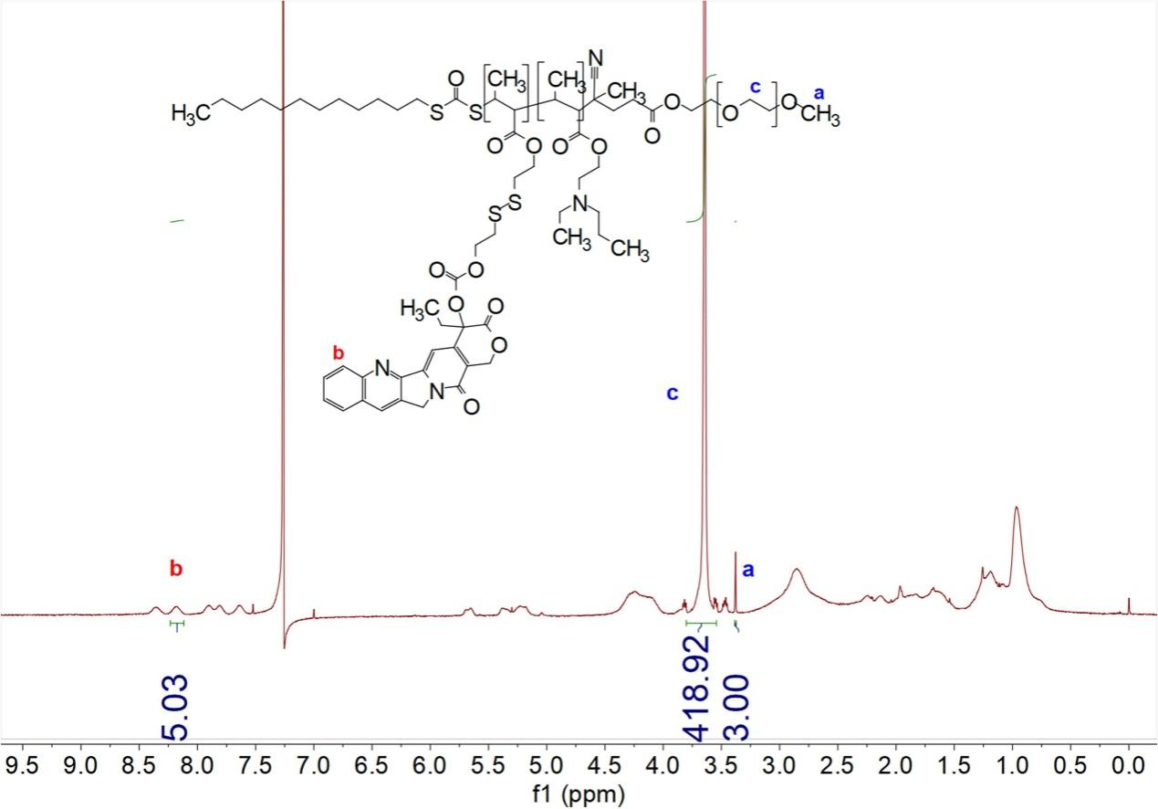
Fig S8. ¹H-NMR spectrum of PEG-PEPEMA-PCPT.
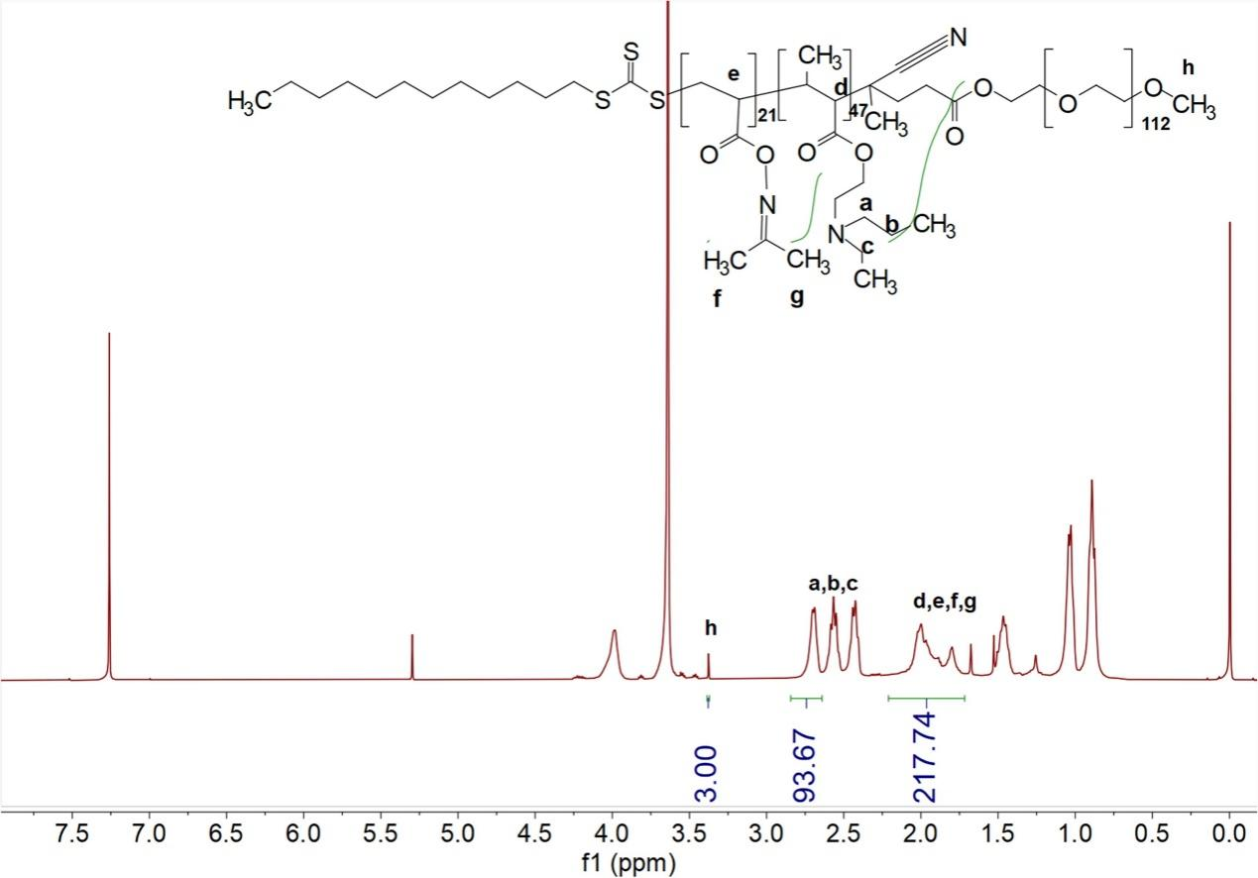
Fig S9. ¹H-NMR spectrum of PEG-PEPEMA-PAA.
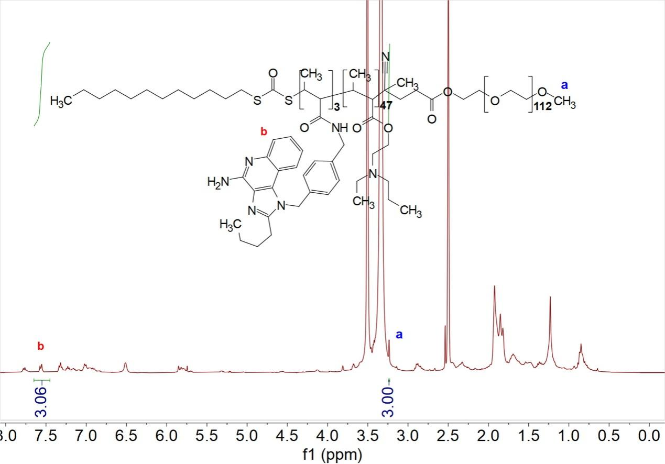
Fig S10. ¹H-NMR spectrum of PEG-PEPEMA-PIMDQ.
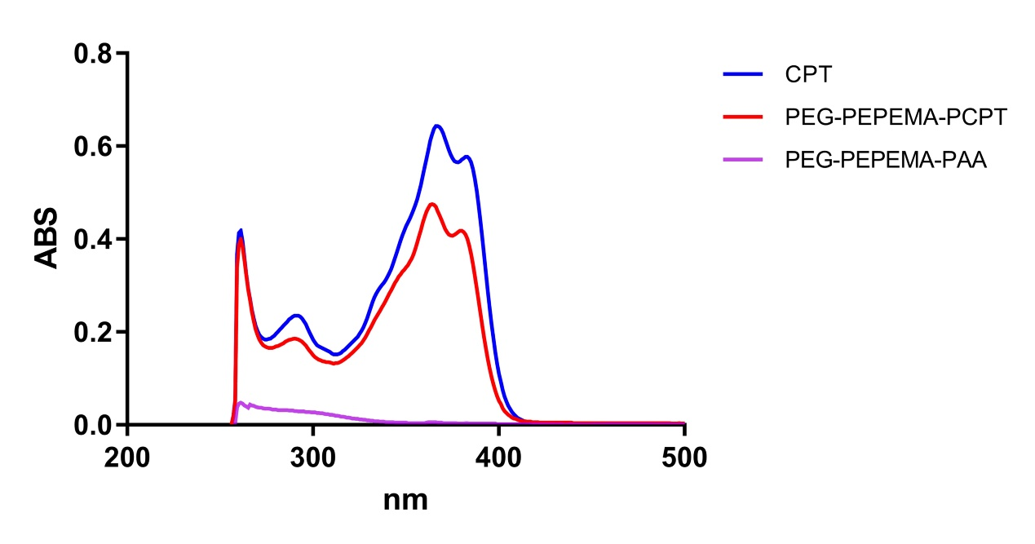
Fig S11. UV-vis spectrum of PEG-PEPEMA-PCPT.

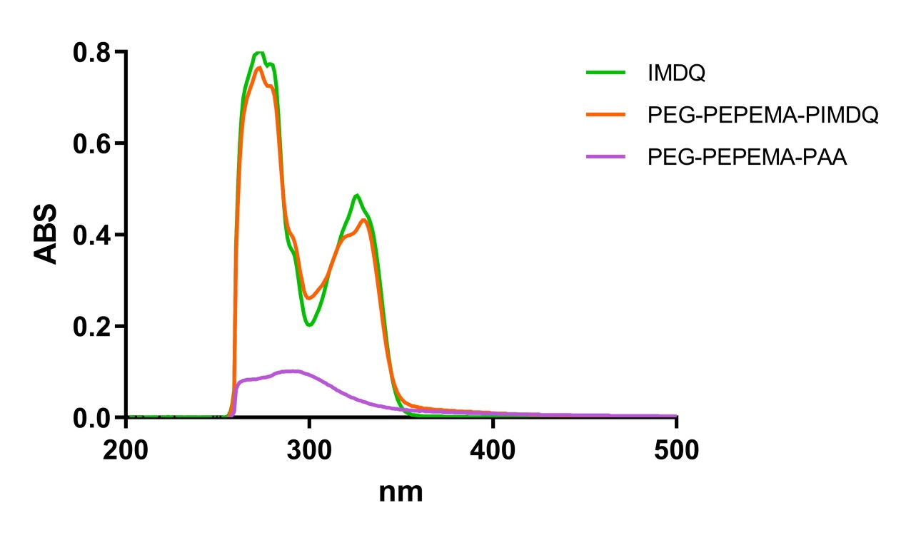
Fig S12. UV-vis spectrum of PEG-PEPEMA-PIMDQ.
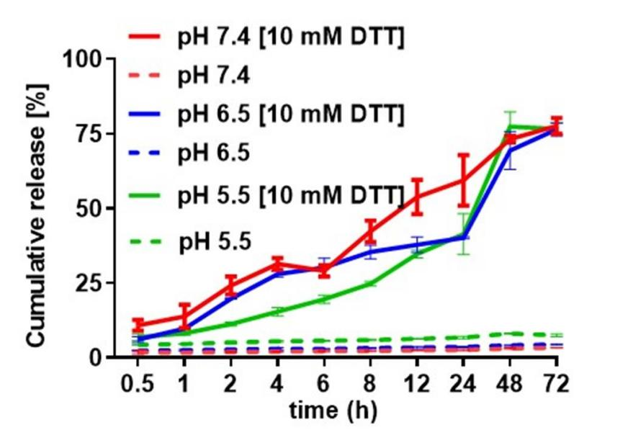
Fig S13. DTT-triggered CPT release from Nano^{PCPT} in vitro, at the release medium with different pH values.

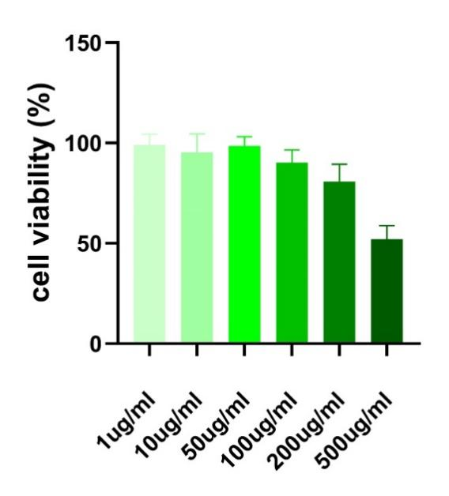
Fig S14. CT26 cytotoxicity of PEG-PEPEMA-PAA polymer detected by CCK-8.
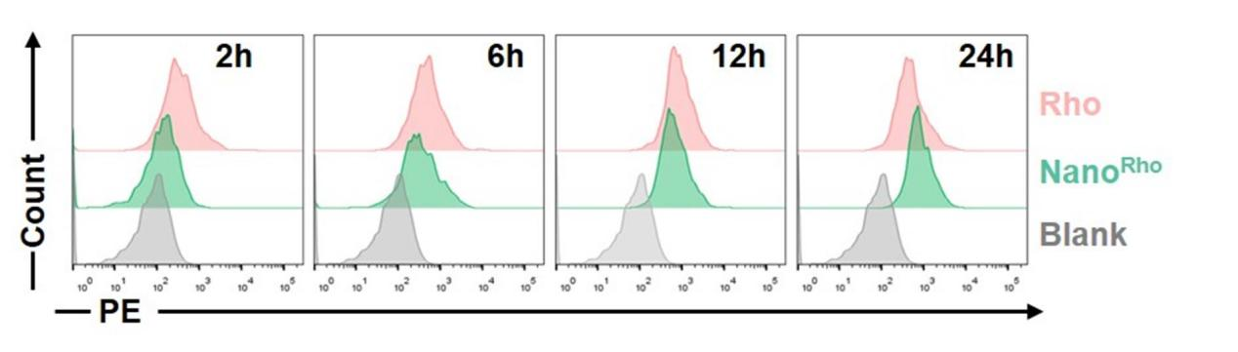
Fig S15. In vitro uptake of nanomicelles by BMDCs at different times (n=3).
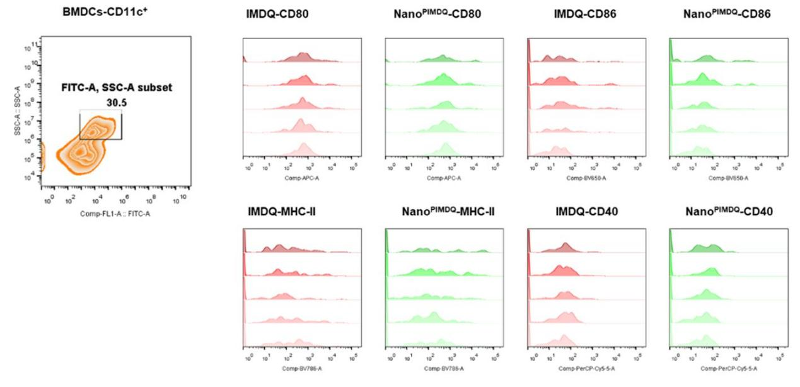
Fig S16. The flow cytometric images of in vitro BMDCs maturation.
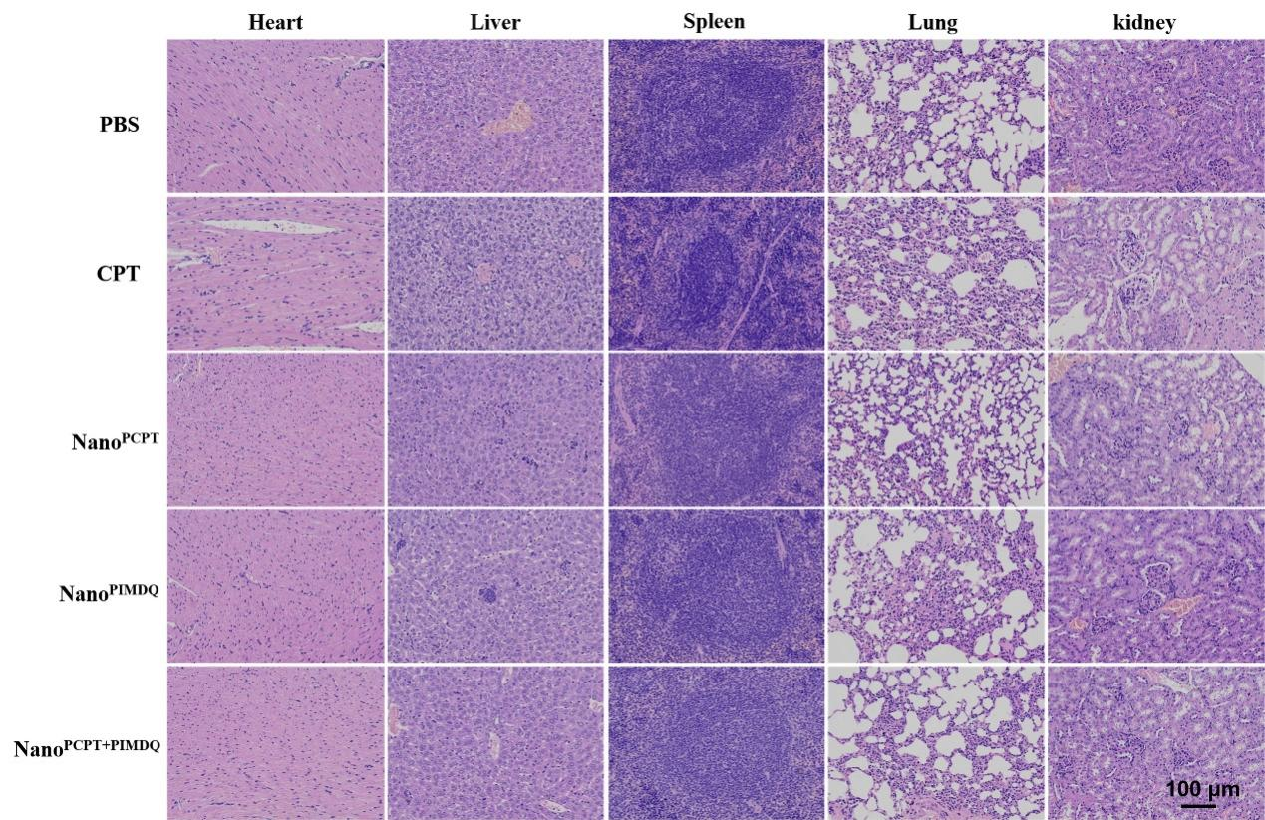
Fig S17. H&E (200×, bar 100μm) staining of major organs slides after the final treatment in different preparation groups.
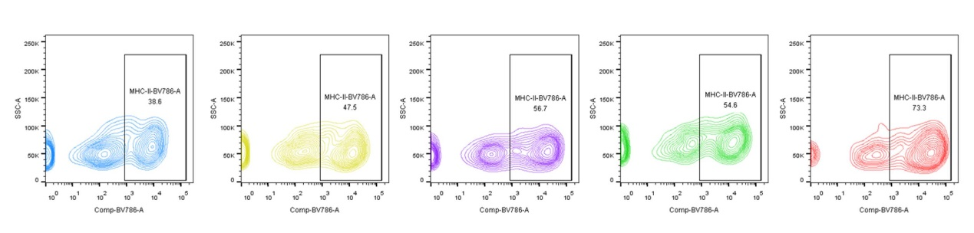
Fig S18. Representative flow cytometric analysis images of CD11c⁺ MHC-II⁺ in spleens.

