Supporting Information

Hemin-incorporating DNA Nanozyme Enabling Catalytic Oxygenation and GSH Depletion for Enhanced Photodynamic Therapy and Synergistic Tumor Ferroptosis

Xiaoxiong Xiao^{2, 3, 4}, Min Chen⁶, Yuchen Zhang⁷, Liang Li⁵, Ying Peng⁵, Junyu Li¹*, Wenhu Zhou^{3, 5}*

¹. Department of Radiation oncology, Jiangxi Cancer hospital, Nanchang, Jiangxi Province, China
². Department of Thoracic Surgery, Xiangya Hospital, Central South University, Changsha, Hunan, China
³. Xiangya Lung Cancer Center, Xiangya Hospital, Central South University, Changsha, Hunan, China
⁴. National Clinical Research Center for Geriatric Disorders, Changsha, China
⁵. Xiangya School of Pharmaceutical Sciences, Central South University, Changsha, Hunan, China
⁶. Department of Thoracic Surgery, The Second People's Hospital of Huaihua City, Huaihua, China
⁷. Department of Pharmacy, Yichun People's hospital, Yichun, Jiangxi Province, China
[⁺] These authors contributed equally to this work.
E-mail: zhouwenhuyaoji@163.com
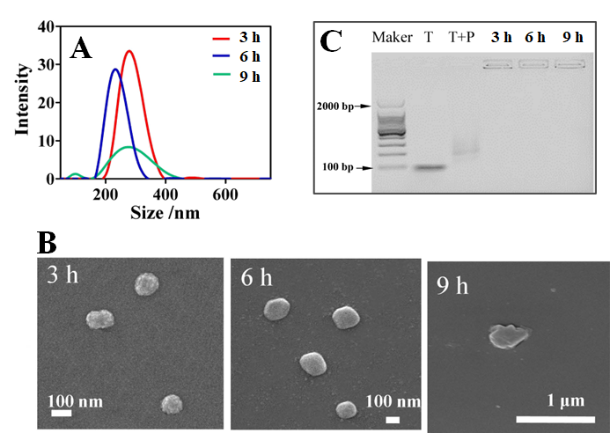
Figure S1. Dynamic monitoring the DF formation via RCA by (A) hydrodynamic size, (B) TEM micro-images, and (C) gel electrophoresis.
Figure S2. Dynamic monitoring the particle size of CH/DF in PBS buffer and FBS-containing medium over 24 h.

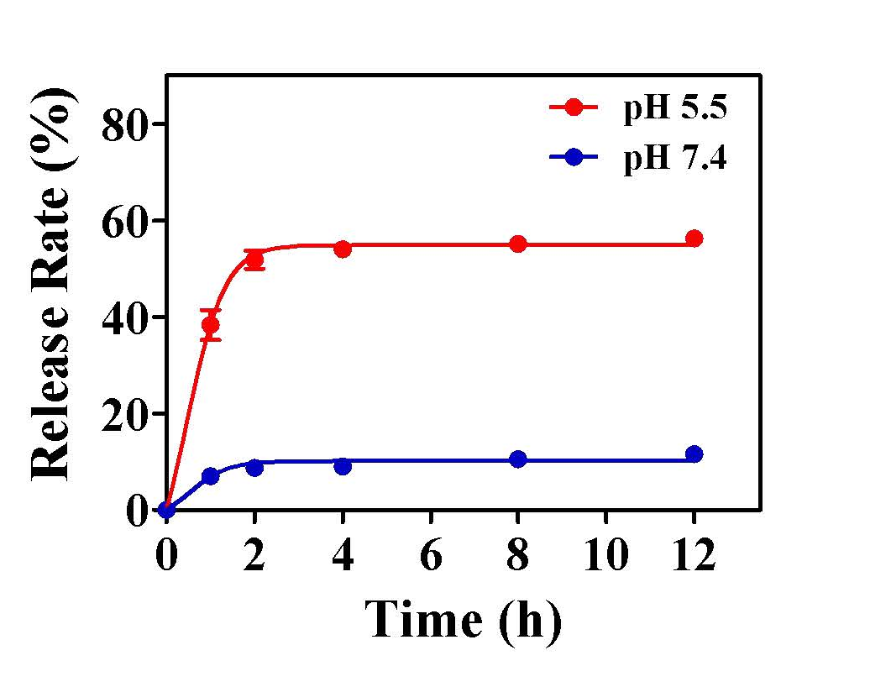
Figure S3. Kinetics of drug release in different buffer conditions.

Figure S4. Multiple turn-over test of the nanozyme. The reaction was performed for 80 s, and then the nanoparticles were collected by centrifugation. Next, the nanoparticles were re-dispersed for next round of reaction.

Figure S5. ¹O₂ generation upon laser irradiation for CH/DF and CH/G4 without addition of H₂O₂.

Figure S6. ¹O₂ generation upon laser irradiation for CH/DF and CH/G4 in solution.

Figure S7. Dynamic monitoring the body weight of the mice during treatments.

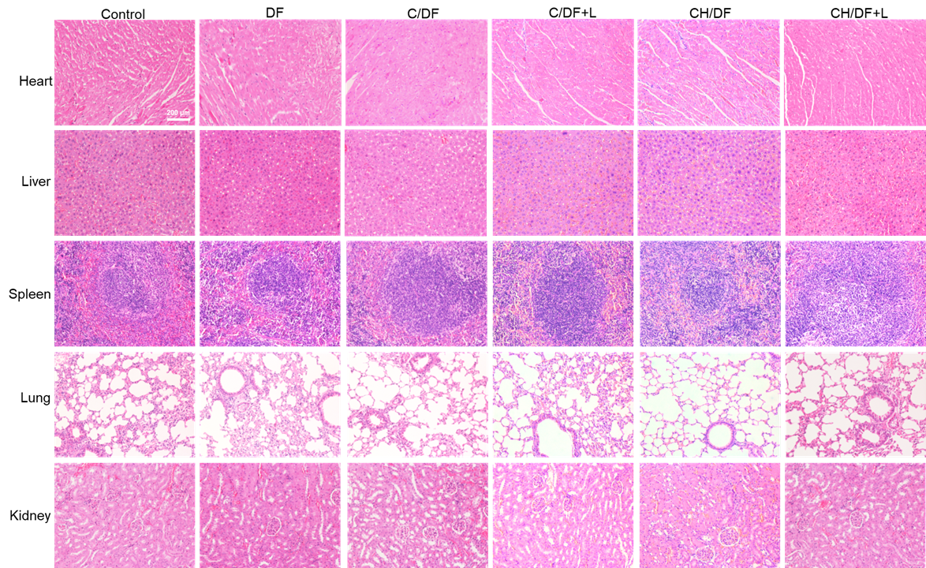
Figure S8. H&E staining the major organs after various treatments.

