Supporting Information
Dual-targeting nanozyme for tumor activatable photo-chemodynamic theranostics
Chaoyi Chen^{1, 2}, Yuwen Chen², Lulu Zhang¹, Xuanhao Wang², Qingshuang Tang¹, Yan Luo², Yuan Wang¹, Cheng Ma^{2,3}* and Xiaolong Liang¹*
¹ Department of Ultrasound, Peking University Third Hospital, Beijing 100191, China
Add: 49 North Garden Rd., Haidian District Beijing, P.R. China
² Department of Electronic Engineering, Beijing National Research Center for Information Science and Technology, Tsinghua University, Beijing 100084, China
³ Institute for Precision Healthcare, Tsinghua University, Beijing 100084, China
*Corresponding authors
Xiaolong Liang (xiaolong_liang@bjmu.edu.cn)
Cheng Ma (cheng_ma@tsinghua.edu.cn)

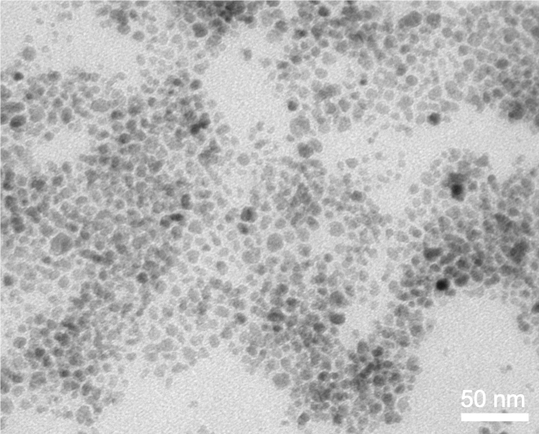
Fig. S1 TEM image of Fe₃O₄ NPs.

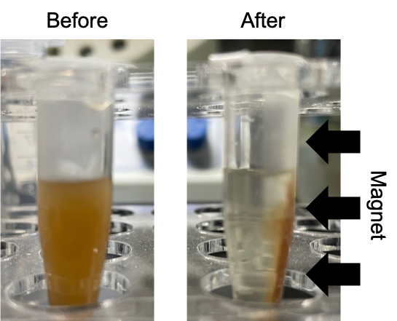
Fig. S2 Photographs depict FTRNPs before and after magnetic field attraction.

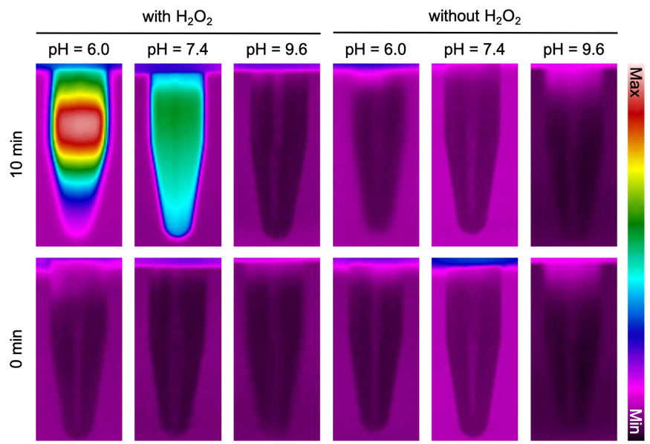
Fig. S3 In vitro IR thermal images of FTRNPs (0.5 mg/mL, Fe₃O₄) with different treatment (H₂O₂, 80 μM, 60 min, pH 6.0-9.6) under NIR laser irradiation (808 nm, 1 W/cm², 10 min).

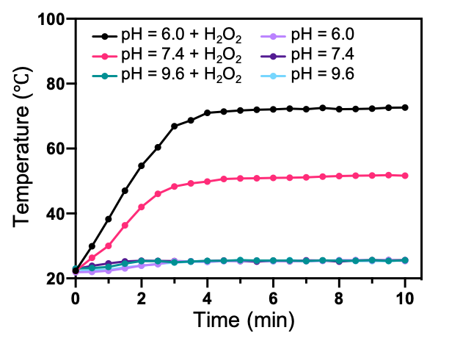
Fig. S4 Real-time temperature monitoring of FTRNPs solution (0.5 mg/mL, Fe₃O₄) with different treatments (H₂O₂, 80 μM, 60 min, pH 6.0-9.6) under NIR laser irradiation (808 nm, 1 W/cm²).
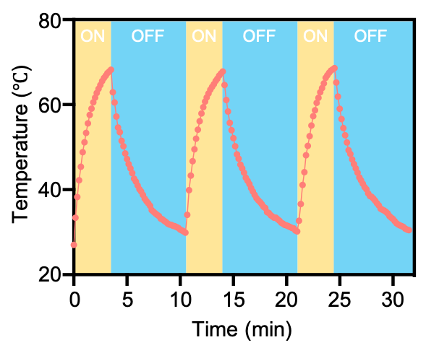
Fig. S5 Photostability study of FTRNPs after H₂O₂ (80 μM) response in pH 6.0 PBS buffer by reversible photothermal heating (808 nm, 1 W/cm²) and natural cooling cycles.

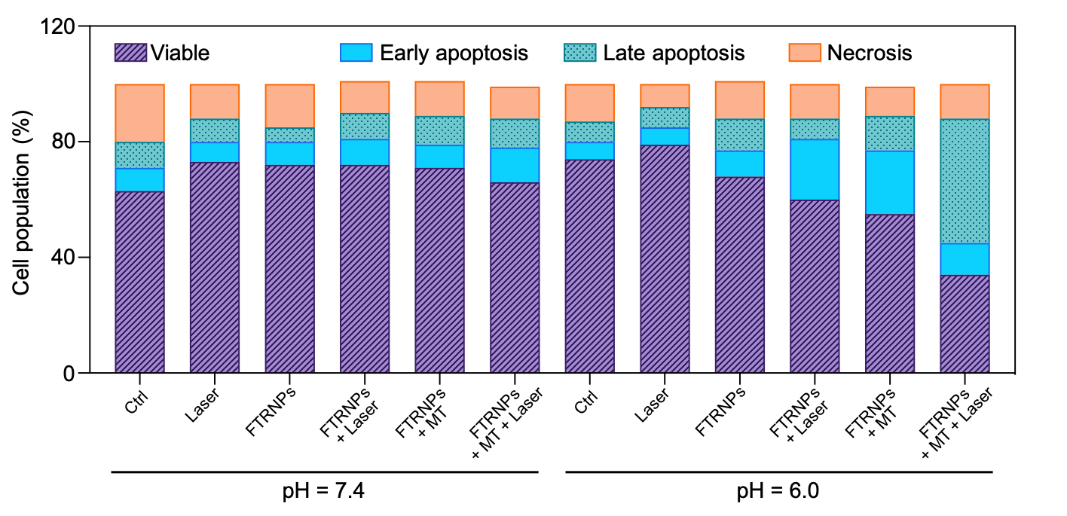
Fig. S6 Quantitative analysis of flow cytometric apoptosis/necrosis analysis based on Annexin V-APC/PI staining assay of 4T1 cells with different treatments (PBS/FTRNPs (100 μg/mL, Fe₃O₄), mild acidic conditions/neutral conditions, with/without irradiation (808 nm, 1 W/cm², 5 min), with/without magnetic targeting).

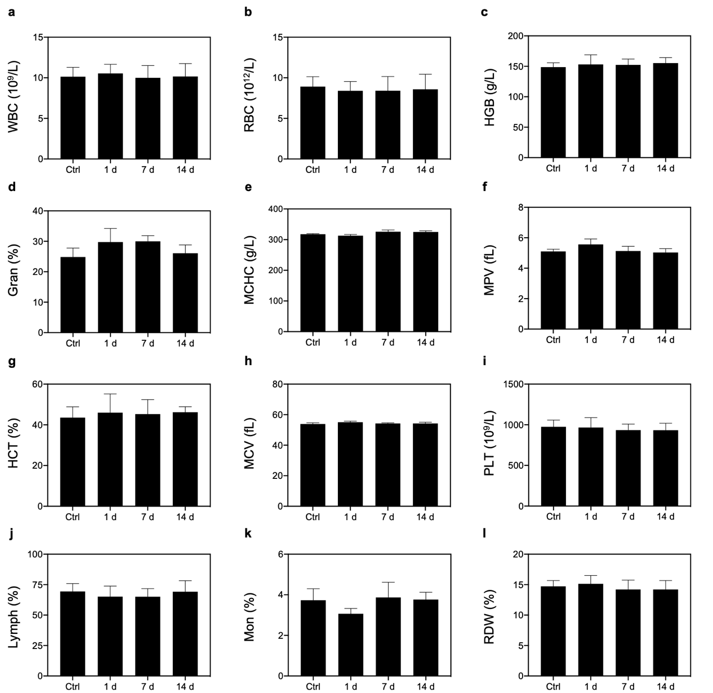
Fig. S7 Complete blood panel and blood biochemistry analysis of mice i. v. injected with FTRNPs (10 mg/kg, Fe₃O₄). (a) White blood cell (WBC) counts. (b) Red blood cell (RBC) counts. (c) Hemoglobin (HGB). (d) Granulocyte percentage (Gran). (e) Mean corpuscular hemoglobin concentration (MCHC). (f) Mean platelet volume (MPV). (g) Hematocrit (HCT). (h) Mean corpuscular volume (MCV). (i) Platelets (PLT). (j) Lymphocyte percentage (Lymph). (k) Monocyte percentage (Mon). (l) Red blood cell distribution width (RDW).

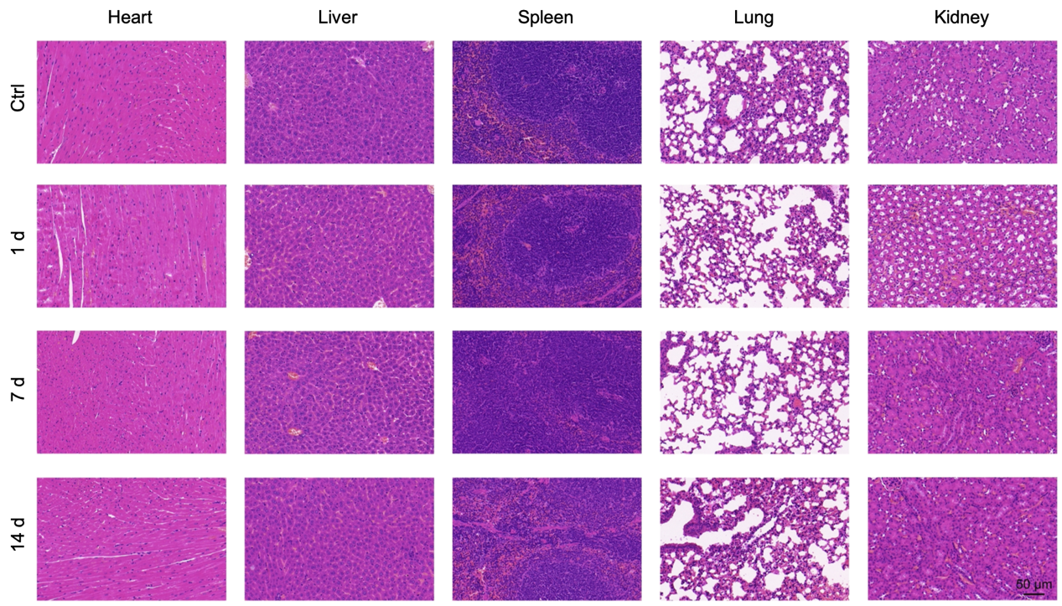
Fig. S8 H&E-stained tissue sections of major organs including heart, liver, spleen, lung and kidney of mice receiving intravenous injection of FTRNPs (10 mg/kg, Fe₃O₄).

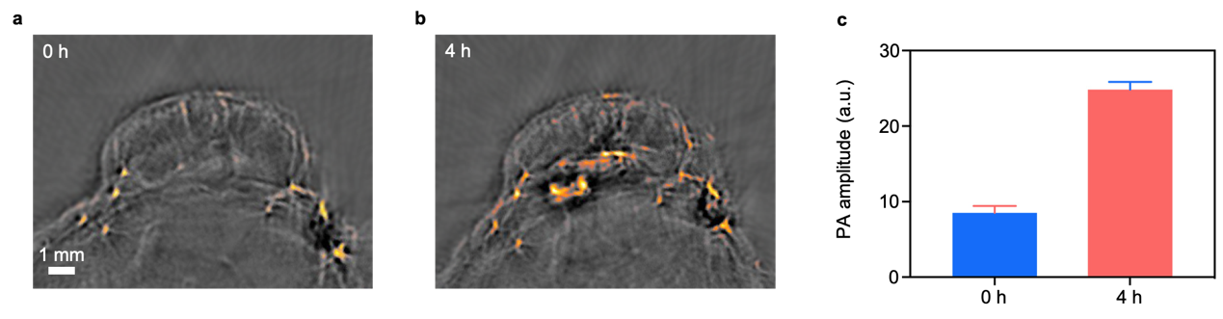
Fig. S9 In vivo PACT images of tumor site by intratumorally treated with FTNPs (10 mg/kg, Fe₃O₄) at (a) 0 h without FTNPs injection and (b) 4 h post-injection. (c) Quantitative analysis of (a) and (b).

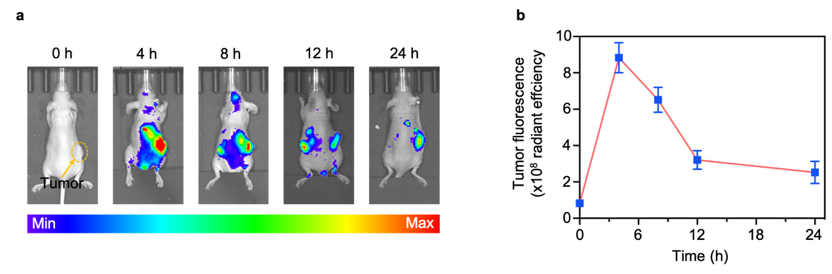
Fig. S10 In vivo FL imaging (a) and quantified results (b) of mice after systemic administration of Cy5.5-labeled-FTNPs (10 mg/kg, Fe₃O₄).

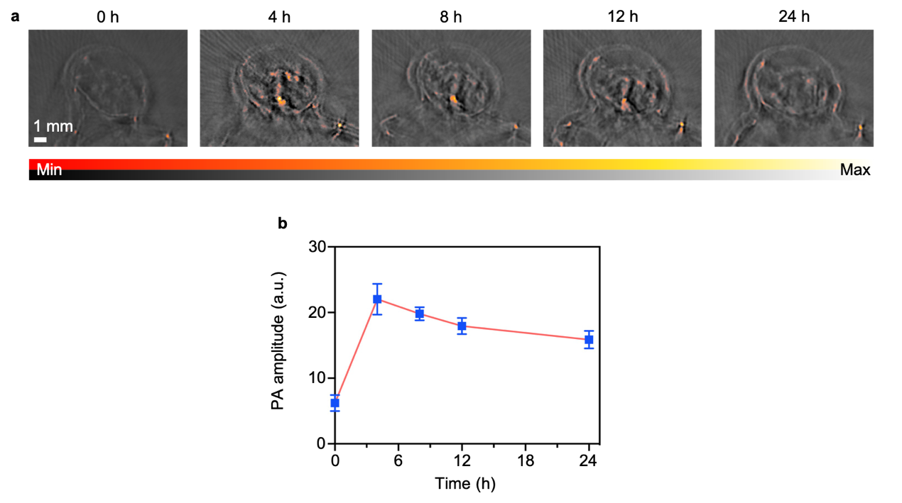
Fig. S11 In vivo PACT imaging (a) and quantified results (b) of mice after systemic administration of FTNPs (10 mg/kg, Fe₃O₄).

Fig. S12 The temperature of the tumor site and the temperature around the normal tissue after irradiation (808 nm, 2 W/cm², 10 min).

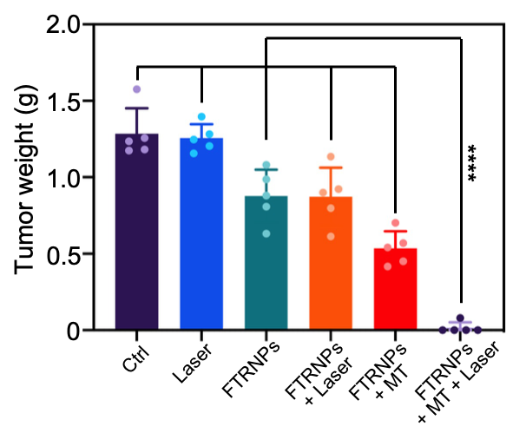
Fig. S13 Tumor weights of mice after different treatments (PBS/FTRNPs (10 mg/kg, Fe₃O₄), with/without irradiation (808 nm, 2 W/cm², 10 min), with/without magnetic targeting).

