Additional file
L-Arginine-containing mesoporous silica nanoparticles embedded in dental adhesive for targeting cariogenic dental biofilm
¹Marta López Ruiz, ¹Victoria Fuentes Fuentes, ¹Isabel Giráldez de Luis, ¹Laura Ceballos García*, ²Carmen María Ferrer Luque, ³Paloma Fernández García, ³Samuel Martínez-Erro, ³Francisco Navas López, ³Victoria Morales Pérez, ³Raúl Sanz Martín, ³Rafael A. García-Muñoz*
¹Faculty of Health Sciences, IDIBO Research Group, Rey Juan Carlos University, Madrid, Spain
²Department of Stomatology, School of Dentistry, University of Granada, Campus de Cartuja, Colegio Máximo s/n, E-18071, Granada, Spain
³Department of Chemical and Environmental Technology, Rey Juan Carlos University, C/ Tulipán s/n, 28933, Móstoles, Madrid, Spain
*E-mail: rafael.garcia@urjc.es
laura.ceballos@urjc.es

DSDA N-oleoyl-arginine (N-oleoyl-arginine)
¹H NMR (CDCl₃): δ 5.32 (m, 2H (H₁₂, H₁₃)); 4.11 (m, 1H (H₄)); 3.17 (m, 2H (H₁)); 2.20 (m, 2H (H₅)); 2.00 (m, 4H (H₁₁, H₁₄)); 1.74 (m, 2H (H₂₀)); 1.56 (m, 4H (H₆, H₁₀)); 1.24 (s, 20H (H₂, H₃ H₇, H₈, H₉, H₁₅ ,H₁₆, H₁₇ ,H₁₈, H₁₉)); 0.87 (t, 3H, J = 7.2 Hz (H₂₁)). ¹³C RMN (CDCl₃): δ 180.5 (C_{f}), 178.1 (C_{g}), 174.3 (C_{g}), 157.8 (C_{a}), 130.2 (C_{o}), 129.8 (C_{p}), 54.4 (C_{e}), 41.0 (C_{b}), 36.8 (C_{h}), 32.1 (C_{v}), 30.1, 30.0, 29.8, 29.6 (C_{d}, C_{j}, C_{k}, C_{l}, C_{m}, C_{n}, C_{q}, C_{r}, C_{s}, C_{t,} C_{u}), 27.5 (C_{c}), 26.2 (C_{i}), 22.9 (C_{w}), 14.3 (C_{x}). UHPLC/MS [M+H]⁺ = 439.4.

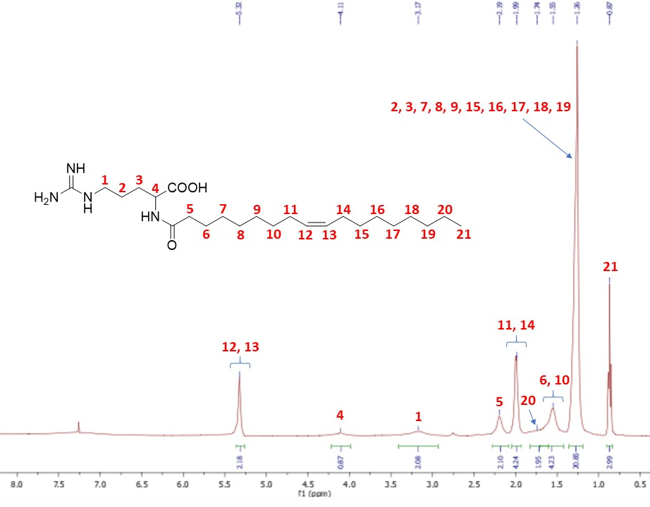
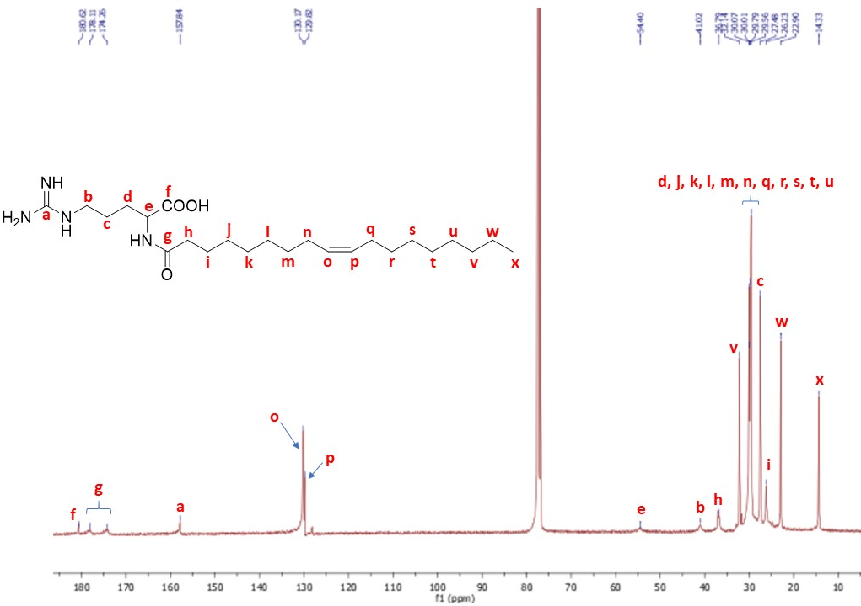
Figure S1. ¹H NMR and ¹³C NMR spectra of the DSDA N-oleoyl-arginine in CDCl_{3.}

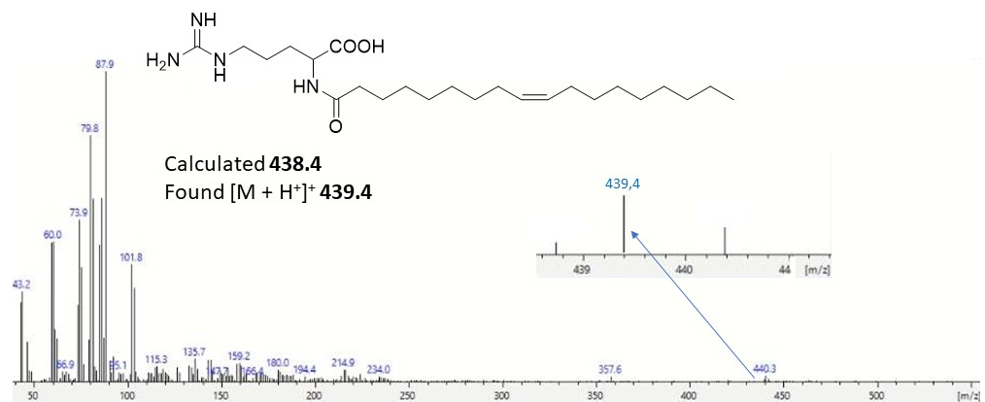
Figure S2. ESI-Mass spectrum of the DSDA N-oleoyl-arginine.

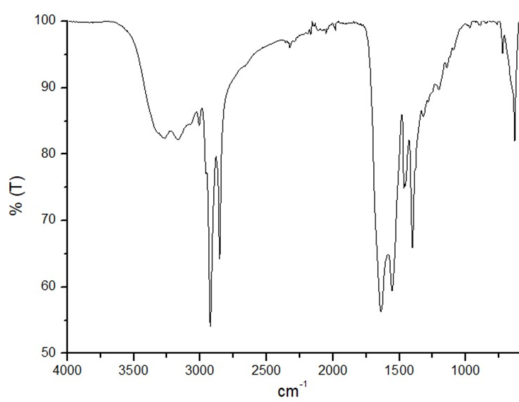
Figure S3. FTIR spectrum of the DSDA N-oleoyl-arginine.

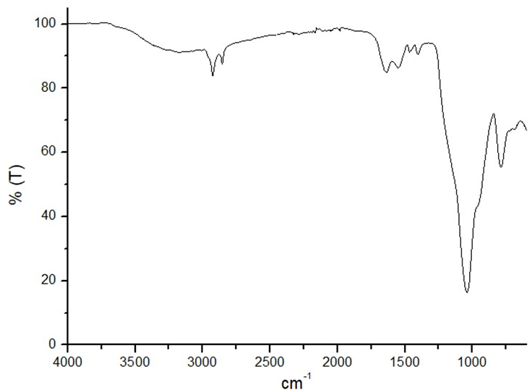
Figure S4. FTIR spectrum of the Arg@MSNs.

