Additional file 1
Intestinal epithelium penetration of liraglutide via cholic acid pre-complexation and zein/rhamnolipids nanocomposite delivery
Xiaoyan Bao,¹‡ Kang Qian,²‡ Mengjiao Xu,¹‡ Yi Chen,³ Hao Wang,¹ Ting Pan,¹ Zhengyi Wang,¹ Ping Yao⁴* and Li Lin¹*
ª School of Pharmaceutical Sciences, Wenzhou Medical University, Wenzhou 325035, China
^{b} Key Laboratory of Smart Drug Delivery, Ministry of Education, School of Pharmacy, Fudan University, Shanghai 201203, China
^{c} State Key Laboratory of Functions and Applications of Medicinal Plants, Guizhou Medical University, Guiyang 550014, China
^{d} State Key Laboratory of Molecular Engineering of Polymers, Collaborative Innovation Center of Polymers and Polymer Composite Materials, Department of Macromolecular Science, Fudan University, Shanghai 200438, China.

‡ These authors contribute equally
* Correspondence authors
E-mail address: linliwz@163.com (Li Lin); Tel: +86 135 8759 8702
E-mail address: yaoping@fudan.edu.cn (Ping Yao); Tel: +86 137 6163 8566

Supporting Figures
Fig. S1 (A-H) The images and affinity values from second to ninth rank of the docking conformations between cholic acid and liraglutide.

Fig. S2 The Z-Average hydrodynamic diameter change of NPs after 21-day storage at 2 ~ 8 °C, **P < 0.01 compared with the particle size in 0 d (n = 3).
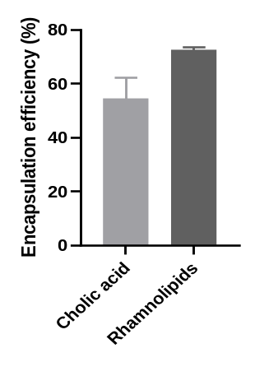
Fig. S3 Encapsulation of cholic acid and rhamnolipids in LIRA/CA@Zein/RLs (n = 3).

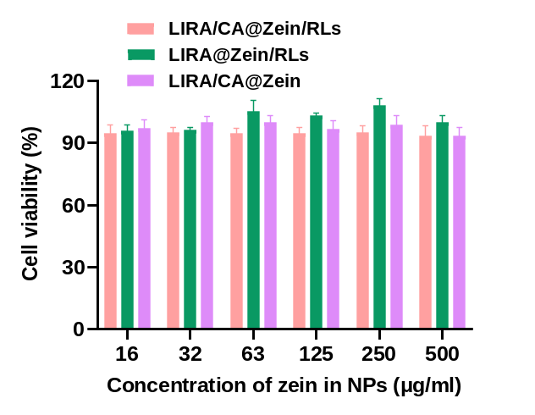
Fig. S4 Caco-2 cell viabilities after 48 h incubations with LIRA/CA@Zein/RLs, LIRA @Zein/RLs and LIRA/CA@Zein at the zein concentrations of 16−500 μg/mL (n = 6).

Fig. S5 The impact of CA on the Caco-2 cell uptake. Mean fluorescence intensity of FITC-LIRA in LIRA/CA@Zein/RLs, LIRA@Zein/RLs and mixture of LIRA@Zein/RLs and CA solution groups determined by flow cytometry. ** P < 0.01, compared with the LIRA/CA@Zein/RLs group; # P < 0.05, compared with LIRA @Zein/RLs group (n = 3).

