Endothelial cell-derived exosomes boost and maintain repair-related phenotypes of Schwann cells via miR199-5p to promote nerve regeneration
Jinsheng Huang¹, Geyi Zhang¹, Senrui Li¹, Jiangnan Li¹, Wengang Wang¹, Jiajia Xue⁴, Yuanyi Wang^{3,*} Mengyuan Fang^{2,*}, Nan Zhou^{1,*}
¹Department of Orthopedics, The First Affiliated Hospital of Zhengzhou University, Zhengzhou, China
²Department of Ophthalmology, The First Affiliated Hospital of Zhengzhou University, Zhengzhou, China
³Department of Spinal Surgery, The First Hospital of Jilin University, Changchun, China
⁴State Key Laboratory of Organic-Inorganic Composites, Beijing Laboratory of Biomedical Materials, Beijing University of Chemical Technology, Beijing, China
*Correspondence:
Nan Zhou, fcczhoun@zzu.edu.cn
Address: Department of Orthopedics, The First Affiliated Hospital of Zhengzhou University, No. 1 Jianshe East Road, Zhengzhou 450052, Henan, China. Tel: +8615514371219
Mengyuan Fang, fccfangmy@zzu.edu.cn
Address: Department of Ophthalmology, The First Affiliated Hospital of Zhengzhou University, No. 1 Jianshe East Road, Zhengzhou 450052, Henan, China.
Yuanyi Wang, wangyuanyi@jlu.edu.cn
Address: Department of Spine Surgery, the First Hospital of Jilin University, Jilin Engineering Research Center For Spine And Spinal Cord Injury, 1 Xinmin St. Changchun 130021, China.

Short title: EC-derived exosomes promote nerve regeneration

Figure

Fig. S1 The effect of EC-EXO on cell phenotypes of SCs.
A The proliferation of SCs treated with EC-EXO of different concentration (1, 10, 50 and 100 μg/mL) for 24 and 48 h was detected by CCK8 assay. The data are expressed as mean ± SD (n=3). B Cell growth curve was detected by CCK-8 assay in 50 μg/mL EXO-treated and control groups. The data are expressed as mean ± SD (n=3). C SC apoptotic levels determined by flow cytometry assay. The data are expressed as mean ± SD (n=3). D Statistical results of cell apoptotic. The data are expressed as mean ± SD (n=3). E The protein levels of proliferation-related protein (PCNA) and apoptosis-related protein (BAX and Bcl2) were analyzed by WB following incubation of SCs to EC-EXO for 24 h. F Quantification of PCNA, BAX and Bcl2 levels in EXO-treated and control groups. The data are expressed as mean ± SD (n=3). G The mRNA levels of immune factors (LIF, Gal-3 and MCP-1) were detected by RT-qPCR of SCs in each group. The mRNA levels are expressed as fold change of the control. The data are expressed as mean ± SD (n=3). ns = not significant, *p < 0.05, **p<0.01, ***p <0.001.

Fig. S2 Comparison of the effects of EC-EXO and SC-EXO on the proliferation and migration phenotypes of SCs.
A Representative transmission electron microscopy (TEM) images of SC-EXO. Scale bar, 100 nm. B Protein immunoblots of exosomes, including the typical markers (TSG101, CD9 and CD81) and GAPDH. C Particle size distribution of SC-EXO measured by nanoparticle tracking analysis (NTA), inset showing representative exosome images captured from the NTA video frames. D Representative EdU staining images in different groups. Scale bar, 50 μm. E Statistical evaluation of percentage of EdU-positive SCs. The data are expressed as mean ± SD (n=3). F Representative images of vertical migration of SCs in different groups for 24 h. Scale bar, 100 μm. G The number of migrated SCs was counted and analyzed. The data are expressed as mean ± SD (n=3). H Representative images of the colony formation in indicated groups. Scale bar, 500 μm. I Statistical results of the colony formation in each group. The data are expressed as mean ± SD (n=3). *p < 0.05, **p<0.01, ***p <0.001.

Fig. S3 PI3K inhibitor (PI3Ki) could depress the proliferative and migratory phenotype of SCs induced by EC-EXO.
A Western blotting of PI3K, p-PI3K, AKT, p-AKT and PTEN in control, EXO and EXO+PI3Ki groups. B Quantification of PI3K, p-PI3K, AKT, p-AKT and PTEN protein levels in each group. Data are expressed as mean ± SD (n=3). C Representative EdU staining images in different groups. Scale bar, 50 μm. D Statistical evaluation of percentage of EdU-positive SCs. The data are expressed as mean ± SD (n=3). E Representative images of vertical migration of SCs in different groups for 24 h. Scale bar, 100 μm. F The number of migrated SCs was counted and analyzed. The data are expressed as mean ± SD (n=3). G Representative images of the colony formation in indicated groups. Scale bar, 500 μm. H Statistical results of the colony formation in each group. The data are expressed as mean ± SD (n=3). ns = not significant, *p < 0.05, **p<0.01, ***p <0.001, ****p<0.0001.

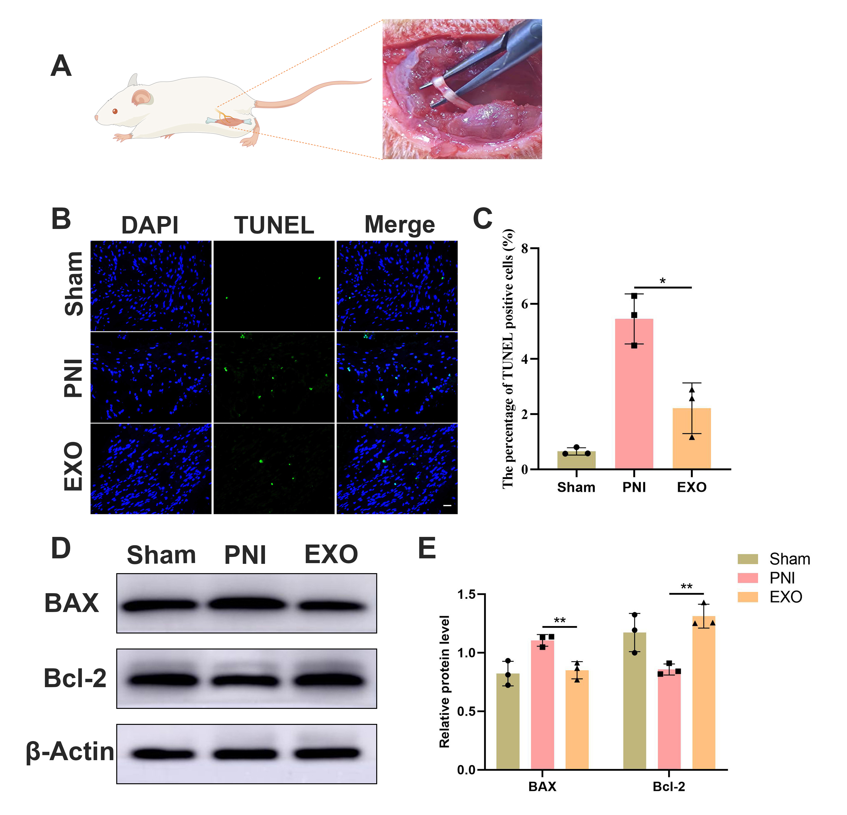

Fig. S4 EC-EXO improved the anti-apoptotic ability of injured nerve tissue. To study the effect of EC-EXO in vivo, 50 μg/mL EC-EXO (20 μL) were injected locally under the epineurium of injured sciatic nerve. A The left picture is a schematic illustration of a sciatic nerve crush model on rats. The right picture illustrated the injured sciatic nerve during the surgery. B, C TUNEL-positive (green) cells were detected in sciatic nerves by TUNEL staining and the statistical results. The data are expressed as mean ± SD (n=3). Scale bar, 20 μm. D The protein levels of BAX and Bcl2 of sciatic nerves in each group were analyzed by WB. E Quantification of BAX and Bcl2 levels in each group. The data are expressed as mean ± SD (n=3). *p < 0.05, **p<0.01.

Table

Table S1 The primer sequences of the genes related.
Primer name | Primer sequence
GAPDH-F | GACATGCCGCCTGGAGAAAC
GAPDH-R | AGCCCAGGATGCCCTTTAGT
Gal-3-F | GGAGGAGCACTAACCAGGAAA
Gal-3-R | CCGGATAGGCACTAGGAGGA
LIF-F | CGCCCAACATGACGGATTTC
LIF-R | TTGTTGCACAGACGGCAAAG
MCP-1-F | TAGCATCCACGTGCTGTCTC
MCP-1-R | CAGCCGACTCATTGGGATCA
GDF15-F | CTGCTGTTCCTGCTGCTCT
GDF15-R | ACCCCAATCGCACCTCT
CCN1-F | GCATTCCTCTGTGTCCCCAA
CCN1-R | TCCGTGCCAAAGACAGGAAG
JunD-F | GAAAGTCCTCAGCCACGTCA
JunD-R | CGTAGGACTGGGGGTACAGA
TXNIP-F | GACCTTGGACTACTTGCGCT
TXNIP-R | GGCAGACACTGGTGCCATTA
KLF10-F | GACCGTCCCAGCATTCTGTT
KLF10-R | TGTGTGACGGATGACACTGG

