Additional file
Ultrasmall and Highly Biocompatible Carbon Dots Derived from Natural Plant with Amelioration Against Acute Kidney Injury
Xiaoke Wang^{1#}, Tong Wu^{2#}, Yingxin Yang³, Long Zhou³, Shuxian Wang³, Jiaxing Liu⁴, Yafang Zhao³, Meiling Zhang⁵, Yan Zhao³, Huihua Qu^{3,6*}, Hui Kong^{3*}, Yue Zhang^{7*}
¹ Encephalopathy Hospital, The First Affiliated Hospital of Henan University of Chinese Medicine, Zhengzhou 450000, China.
² School of Chinese Materia Medica, Beijing University of Chinese Medicine, Beijing 100029, China.
³ School of Traditional Chinese Medicine, Beijing University of Chinese Medicine, Beijing 100029, China.
⁴ Third Affiliated Hospital, Beijing University of Chinese Medicine, Beijing 100029, China.
⁵ Key Laboratory of Chinese Internal Medicine of the Ministry of Education, Dongzhimen Hospital Affiliated to Beijing University of Chinese Medicine, Beijing 100020, China.
⁶ Center of Scientific Experiment, Beijing University of Chinese Medicine, Beijing 100029, China.
⁷ School of Life Science, Beijing University of Chinese Medicine, Beijing 100029, China.
# These authors contributed equally.
*Corresponding authors. Tel +86 10 64286705; Fax +86 16 4286821
- mail addresses:
quhuihuadr@163.com (Huihua Qu); doris7629@126.com (Hui Kong); 201801024@bucm.edu.cn (Yue Zhang);

Table S1. Compared with plant-derived CDs for optical properties and applications.
No. | Name of Plant precursors | Synthetic methods | Optical properties |  |  | Application | Ref.
No. | Name of Plant precursors | Synthetic methods | EM/EX* | QY | Luminescence | Application | Ref.
1 | Artemisiae argyi folium | One-step pyrolysis  (350 ºC for 1 h) | EM: 410 nm  EX: 322 nm | 0.19% | Blue light | Anti-frostbite effect | [1]
2 | Paeonia radix alba | One-step pyrolysis  (350 ºC for 1 h) | EM: 411 nm  EX: 320 nm | 5.34% | No description | Hepatoprotective Effect | [2]
3 | Atractylodes macrocephalae rhizoma | One-step pyrolysis  (350 ºC for 1 h) | No done | No done | Blue-green light | Anti-gastric ulcers effect | [3]
4 | Juncus medulla | One-step pyrolysis  (350 ºC for 1 h) | EM: 447 nm  EX: 336 nm | No done | No description | Hemostasis/Hepatoprotec-tion | [4]
5 | Zingiberis rhizoma | One-step pyrolysis  (350 ºC for 1 h) | EM: 470 nm EX: 357 nm | 5.20% | No description | Analgesia | [5]
6 | Phellodendri chinensis cortex | One-step pyrolysis  (400 ºC for 1 h) | EM: 445 nm EX: 330 nm | 5.63% | No description | Treatment of psoriasis /immunoregulation | [6]
7 | Phellodendri chinensis cortex | One-step pyrolysis  (350 ºC for 1 h) | No done | No done | No description | Treatment of Dein-agkistrodon acutus venom-induced acute kidney injury | [7]
8 | Phellodendri chinensis cortex | One-step pyrolysis  (350 ºC for 1 h) | EM: 438 nm EX: 363 nm | 9.62% | Blue light | Hemostasis | [8]
9 | Lonicerae japonicae flos | One-step pyrolysis  (350 ºC for 1 h) | EM: 464 nm EX: 384 nm | 0.50% | No description | Anti-inflammatory effect/ alleviating fever | [9]
10 | Schizonepetae spica | One-step pyrolysis  (350 ºC for 1 h) | EM: 454 nm EX: 355 nm | 2.26% | No description | Hemostasis | [10]
11 | Typhae pollen | One-step pyrolysis  (350 ºC for 1 h) | EM: 442 nm  EX: 352 nm | No done | Blue light | Hemostasis | [11]
12 | Aurantii fructus immaturus | One-step pyrolysis  (350 ºC for 1 h) | EM: 469 nm  EX: 380 nm | 7.20% | Blue light | Anti-gouty effect | [12]
13 | Armeniacae Semen Amarum | One-step pyrolysis  (300 ºC for 1 h) | EM: 436 nm EX: 353 nm | 3.17% | No description | Treatment of acute lung injury | [13]
14 | Jujubae frucrus | Hydrothermal  (200 ºC for 6 h) | EM: 440 nm  EX: 360 nm | No done | Blue light | Treatment of cancer-related anemia | [14]
15 | Persicae semen /Carthami flos | Hydrothermal  (240 ºC for 16 h) | EM: 434.6 nm EX: 361.6 nm | 3.84% | Blue light | Traumatic brain injury | [15]
16 | Carica papaya leaves | Sand bath  (180 ºC for 24 h) | EX: 440 nm  EM: 530 nm | No done | Blue light | Antioxidant and anti-inflammatory activities | [16]
17 | Typhae pollen | One-step pyrolysis  (400 ºC for 1 h) | EM: 457 nm  EX: 359 nm | 8.47% | Blue light | Treatment of rhabdomyolysis-induced acute kidney injury | This work

Fig. S1 The HRTEM image of PT-CDs in 400 ℃.

Fig. S2 The appearance of PTC in different temperature (250 ℃, 300 ℃, 350 ℃ and 400 ℃).

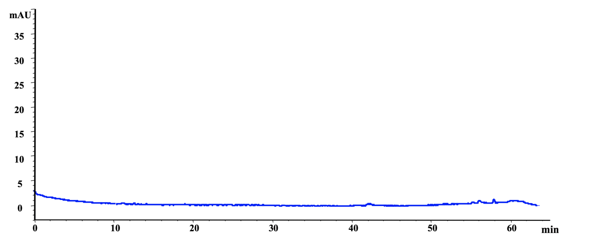
Fig. S3 The image of HPLC assay on PT-CDs.

Reference:
1. Kong H, Zhao Y, Zhu Y, Xiong W, Luo J, Cheng J, Zhang Y, Zhang M, Qu H, Zhao Y: Carbon dots from Artemisiae Argyi Folium Carbonisata: strengthening the anti-frostbite ability. Artif Cells Nanomed Biotechnol 2021, 49:11-19.
2. Zhao Y, Zhang Y, Kong H, Zhang M, Cheng J, Wu J, Qu H, Zhao Y: Carbon Dots from Paeoniae Radix Alba Carbonisata: Hepatoprotective Effect. Int J Nanomedicine 2020, 15:9049-9059.
3. Lu F, Ma Y, Huang H, Zhang Y, Kong H, Zhao Y, Qu H, Wang Q, Liu Y, Kang Z: Edible and highly biocompatible nanodots from natural plants for the treatment of stress gastric ulcers. Nanoscale 2021, 13:6809-6818.
4. Cheng JJ, Zhang ML, Sun ZW, Lu F, Xiong W, Luo J, Kong H, Wang QG, Qu HH, Zhao Y: Hemostatic and hepatoprotective bioactivity of Junci Medulla Carbonisata-derived Carbon Dots. Nanomedicine 2019, 14:431-446.
5. Zhang ML, Cheng JJ, Zhang Y, Kong H, Wang SN, Luo J, Qu HH, Zhao Y: Green synthesis of Zingiberis rhizoma-based carbon dots attenuates chemical and thermal stimulus pain in mice. Nanomedicine 2020, 15:851-869.
6. Zhang M, Cheng J, Hu J, Luo J, Zhang Y, Lu F, Kong H, Qu H, Zhao Y: Green Phellodendri Chinensis Cortex-based carbon dots for ameliorating imiquimod-induced psoriasis-like inflammation in mice. J Nanobiotechnology 2021, 19:105.
7. Zhang ML, Cheng JJ, Sun ZW, Kong H, Zhang Y, Wang SN, Wang XK, Zhao Y, Qu HH: Protective Effects of Carbon Dots Derived from Phellodendri Chinensis Cortex Carbonisata against Deinagkistrodon acutus Venom-Induced Acute Kidney Injury. Nanoscale Research Letters 2019, 14:13.
8. Liu XM, Wang YZ, Yan X, Zhang ML, Zhang Y, Cheng JJ, Lu F, Qu HH, Wang QG, Zhao Y: Novel Phellodendri Cortex (Huang Bo)-derived carbon dots and their hemostatic effect. Nanomedicine 2018, 13:391-405.
9. Wu JS, Zhang ML, Cheng JJ, Zhang Y, Luo J, Liu YH, Kong H, Qu HH, Zhao Y: Effect of Lonicerae japonicae Flos Carbonisata-Derived Carbon Dots on Rat Models of Fever and Hypothermia Induced by Lipopolysaccharide. International Journal of Nanomedicine 2020, 15:4139-4149.
10. Sun ZW, Lu F, Cheng JJ, Zhang ML, Zhang Y, Xiong W, Zhao Y, Qu HH: Haemostatic bioactivity of novel Schizonepetae Spica Carbonisata-derived carbon dots via platelet counts elevation. Artificial Cells Nanomedicine and Biotechnology 2018, 46:S308-S317.
11. Yan X, Zhao Y, Luo J, Xiong W, Liu XM, Cheng JJ, Wang YZ, Zhang ML, Qu HH: Hemostatic bioactivity of novel Pollen Typhae Carbonisata-derived carbon quantum dots. Journal of Nanobiotechnology 2017, 15:8.
12. Wang SN, Zhang Y, Kong H, Zhang ML, Cheng JJ, Wang XK, Lu F, Qu HH, Zhao Y: Antihyperuricemic and anti-gouty arthritis activities of Aurantii fructus immaturus carbonisata-derived carbon dots. Nanomedicine 2019, 14:2925-2939.
13. Zhao Y, Zhang Y, Kong H, Cheng G, Qu H, Zhao Y: Protective Effects of Carbon Dots Derived from Armeniacae Semen Amarum Carbonisata Against Acute Lung Injury Induced by Lipopolysaccharides in Rats. Int J Nanomedicine 2022, 17:1-14.
14. Xu Y, Wang B, Zhang M, Zhang J, Li Y, Jia P, Zhang H, Duan L, Li Y, Li Y, et al: Carbon Dots as a Potential Therapeutic Agent for the Treatment of Cancer-Related Anemia. Adv Mater 2022, 34:e2200905.
15. Luo WK, Zhang LL, Li XX, Zheng J, Chen Q, Yang ZY, Cheng MH, Chen Y, Wu Y, Zhang W, et al: Green functional carbon dots derived from herbal medicine ameliorate blood-brain barrier permeability following traumatic brain injury. Nano Research 2022, 15:9274-9285.
16. Gudimella KK, Gedda G, Kumar PS, Babu BK, Yamajala B, Rao BV, Singh PP, Kumar D, Sharma A: Novel synthesis of fluorescent carbon dots from bio-based Carica Papaya Leaves: Optical and structural properties with antioxidant and anti-inflammatory activities. Environ Res 2022, 204:111854.

