Additional file for
In vivo toxicity evaluation of glycol chitosan nanoparticles in healthy mice: Repeated high-dose of glycol chitosan nanoparticles potentially induce cardiotoxicity
Hyeyoun Chang^{1,#}, Ji Young Yhee^{1,#}, Sangmin Jeon¹, Man Kyu Shim¹, Hong Yeol Yoon¹, Sangmin Lee^{2,*} and Kwangmeyung Kim^{1,3,*}

¹ Medicinal Materials Research Center, Biomedical Research Division, Korea Institute of Science and Technology, Seoul, 02792, Republic of Korea.
²Department of Pharmacy, College of Pharmacy, Kyung Hee University, Seoul 02447, Republic of Korea.
³College of Pharmacy, Graduate School of Pharmaceutical Sciences, Ewha Womans University, Seoul 03760, Republic of Korea.

#These authors contributed equally to this work.
*Correspondence and requests for materials should be addressed to K. Kim (kimkm@ewha.ac.kr) and S. Lee (leesm@khu.ac.kr).

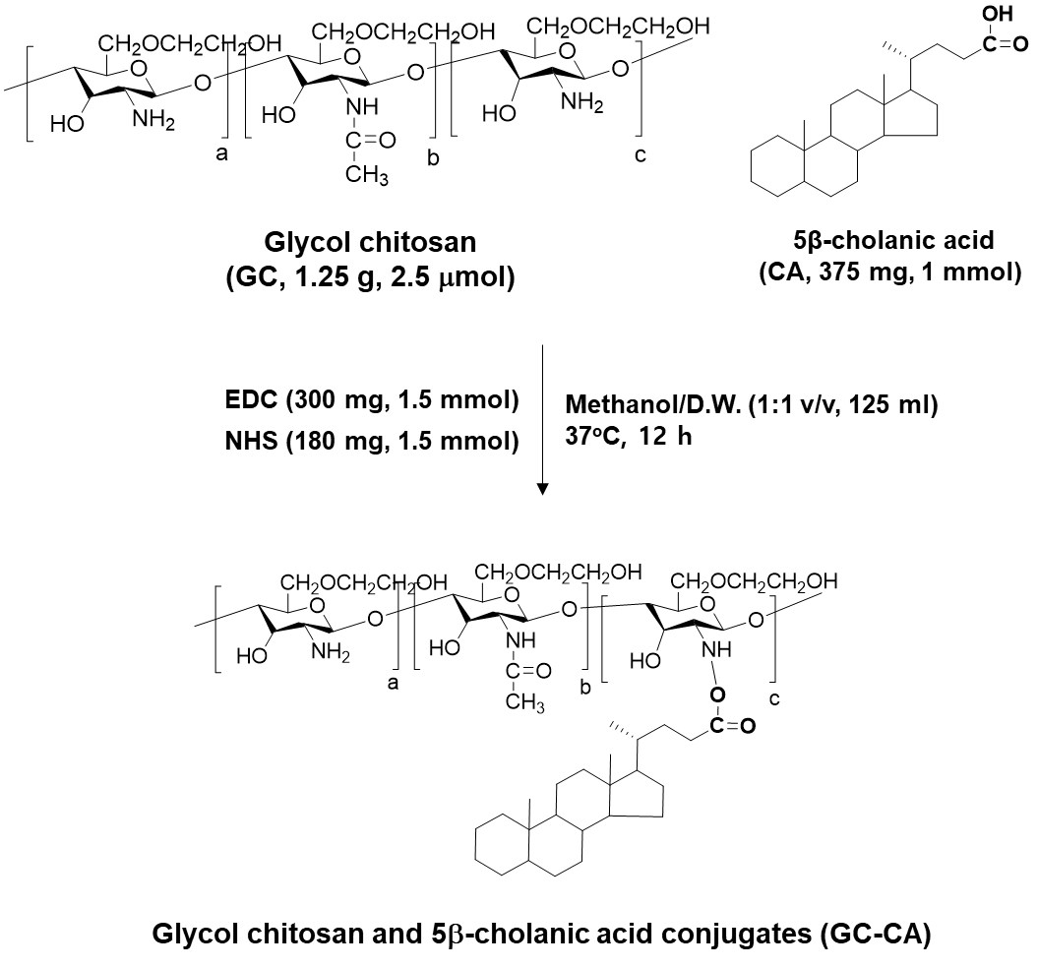
Figure S1. Synthetic route to prepare the glycol chitosan and 5β-cholanic acid conjugates.
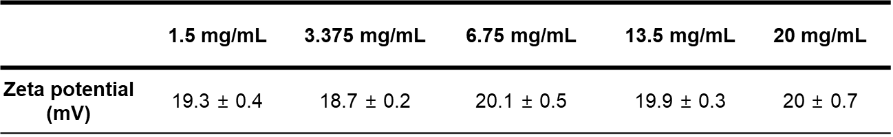
Figure S2. Zeta potential (mV) of CNPs in the clinically relevant highly concentrated aqueous condition (1.5, 3.375, 6.75, 13.5 or 20 mg/1 ml).

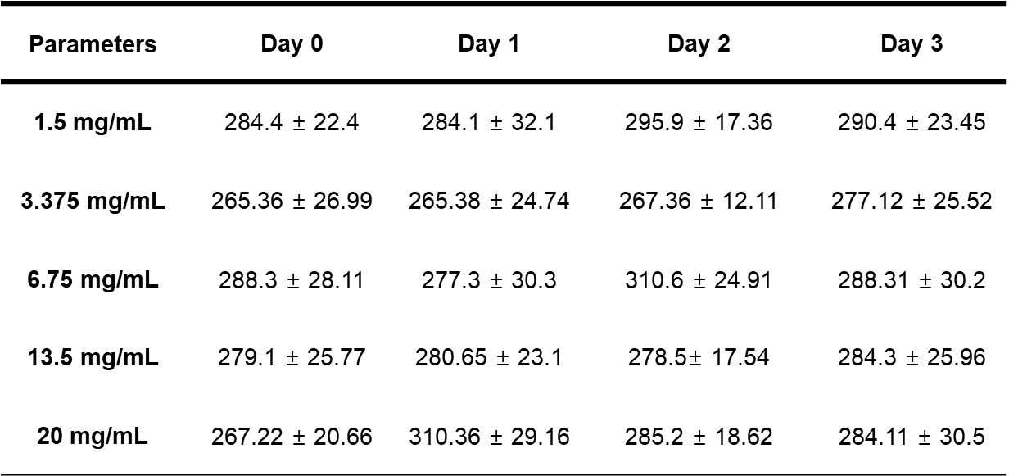
Figure S3. Detail information of average size of different concentrations of CNPs in the mouse serum (n=5).

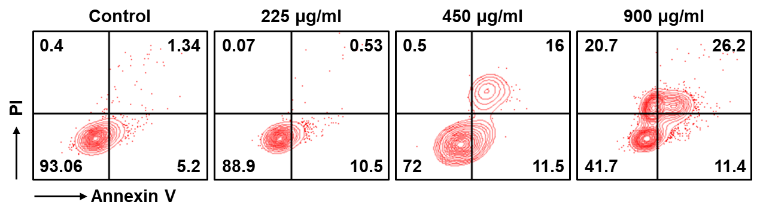
Figure S4. Flow cytometric results showing H9C2 cells stained with Annexin V/PI after treatment with CNPs for 24 h.

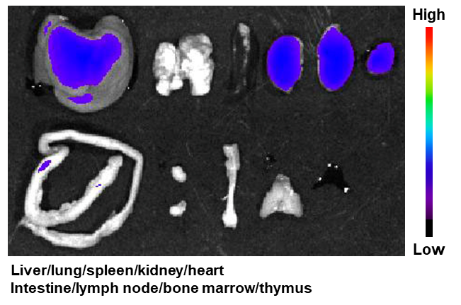
Figure S5. Fluorescence image of major organs from mice treated with 90 mg/kg of CNPs for 7 days. Fluorescence intensities were normalized with the results of Figure 3B and 3C.

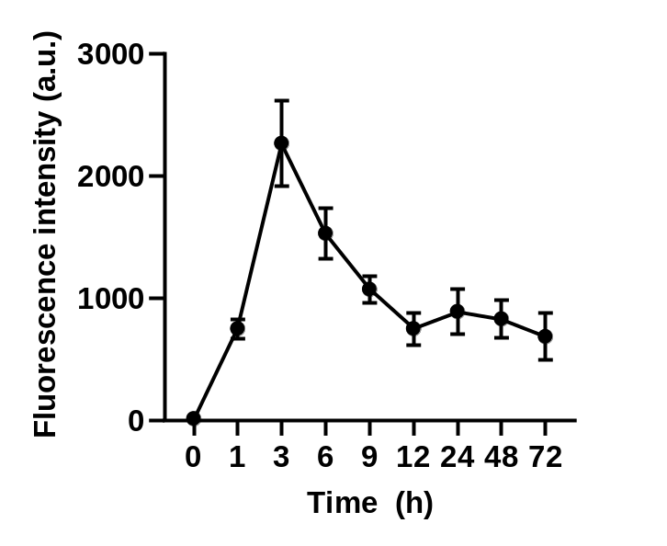
Figure S6. Excretion profile of Cy5.5-CNPs after 90 mg/kg treatment. The urines were collected from the mice at the indicated time points, followed by analysis of Cy5.5 fluorescence intensity using HPLC.

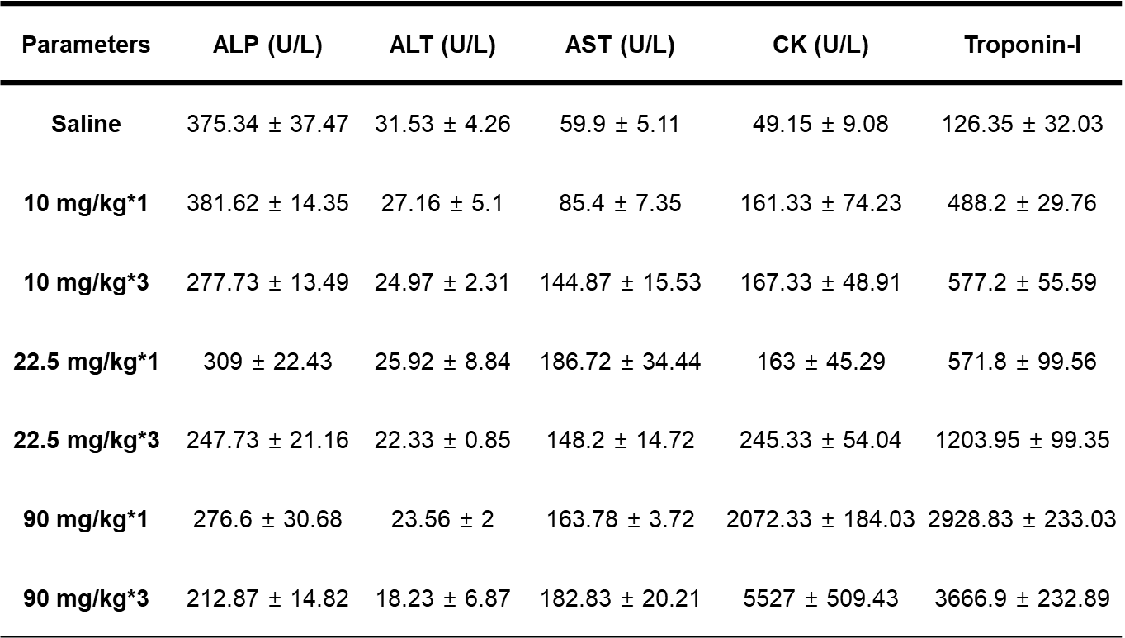
Figure S7. Detail information of hematological parameters on day 7 after single- or multi-dose of 10, 22.5 or 90 mg/kg CNPs (n=5).
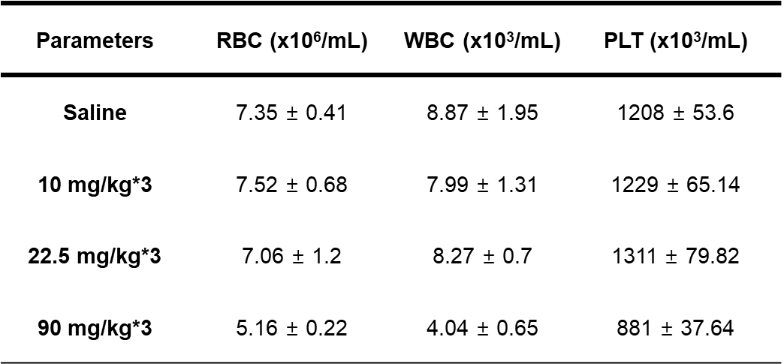
Figure S8. Detail information of complete cell count results on day 7 after single- or multi-dose of 10, 22.5 or 90 mg/kg CNPs (n=5).

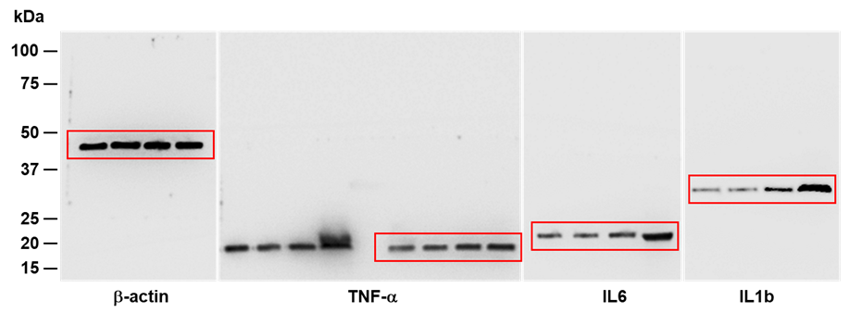
Figure S9. Uncropped images of western blot results in Figure 5E.

