Cu-doped TiO₂ nanoparticles improve local antitumor immune activation and optimize dendritic cell vaccine strategies.

Evelien Hesemans,^{1†} Neshat Saffarzadeh,^{1†} Christy Maksoudian,¹ Mukaddes Izci,¹ Tianjiao Chu,¹ Carla Rios Luci,¹ Yuqing Wang,^{2,3} Hendrik Naatz,^{2,3} Sebastian Thieme,⁴ Cornelia Richter,⁴ Bella B. Manshian,^{5,6} Suman Pokhrel,^{2,3} Lutz Mädler,^{2,3} Stefaan J. Soenen^{1,6,7*}.

Affiliations
¹NanoHealth and Optical Imaging Group, Department of Imaging and Pathology, KULeuven, Belgium.
²Leibniz Institute for Materials Engineering IWT, Badgasteiner Straße 3, D-28359 Bremen, Germany
³Faculty of Production Engineering, University of Bremen, Badgasteiner Straße 1, D-28359 Bremen, Germany
⁴UniversitatsKlinikum Dresden, Germany.
⁵Translational Cell and Tissue Research Unit, Department of Imaging and Pathology, KULeuven, Belgium
⁶Leuven Cancer Institute, KULeuven, Belgium
⁷KU Leuven Institute of Physics-based Modeling for In Silico Health, KULeuven, Belgium
†These authors contributed equally to this work
*Corresponding author email: s.soenen@kuleuven.be

Supporting information
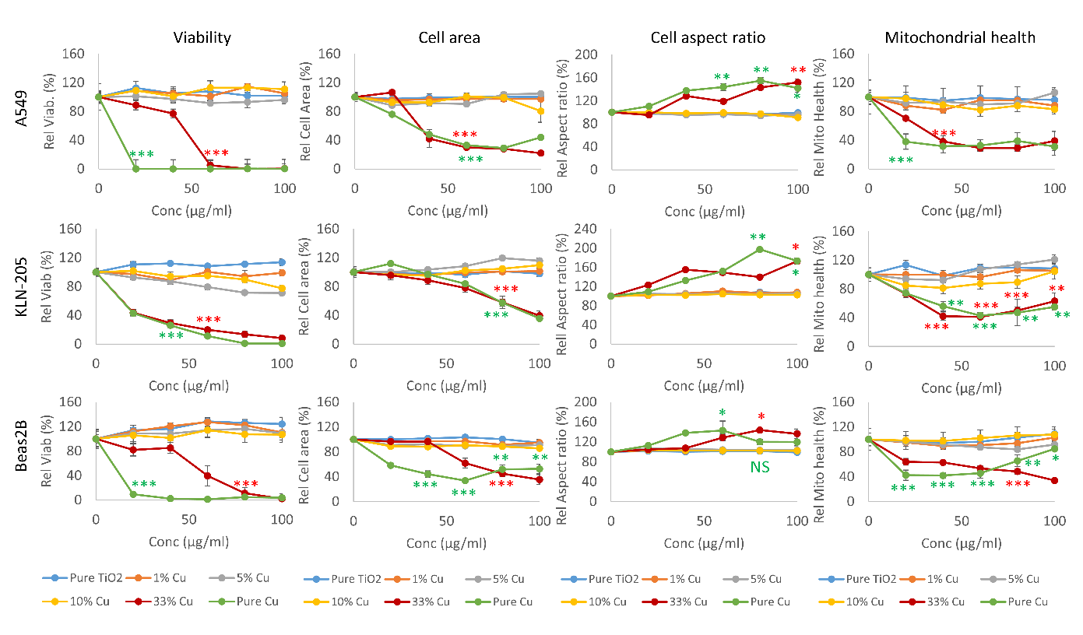
Figure S1. Histograms displaying the relative effect of the different nanoformulations on cell viability (left column), cell area (2nd column), cell aspect ratio (3rd column) and mitochondrial health (right column) for A549 cells (top row), KLN-205 cells (middle row) and Beas-2B cells (bottom row). All data are presented as mean + SEM and are expressed relative to untreated control cells (= 100%). The degree of significance is indicated where appropriate. In case only one condition is indicated, then the level of significance is maintained for any subsequent time point unless otherwise indicated. (NS: not significant; p < 0.05: *, p < 0.01: **; p < 0.001: ***) based on ANOVA testing using GraphPad Prism 9 (n = 4).

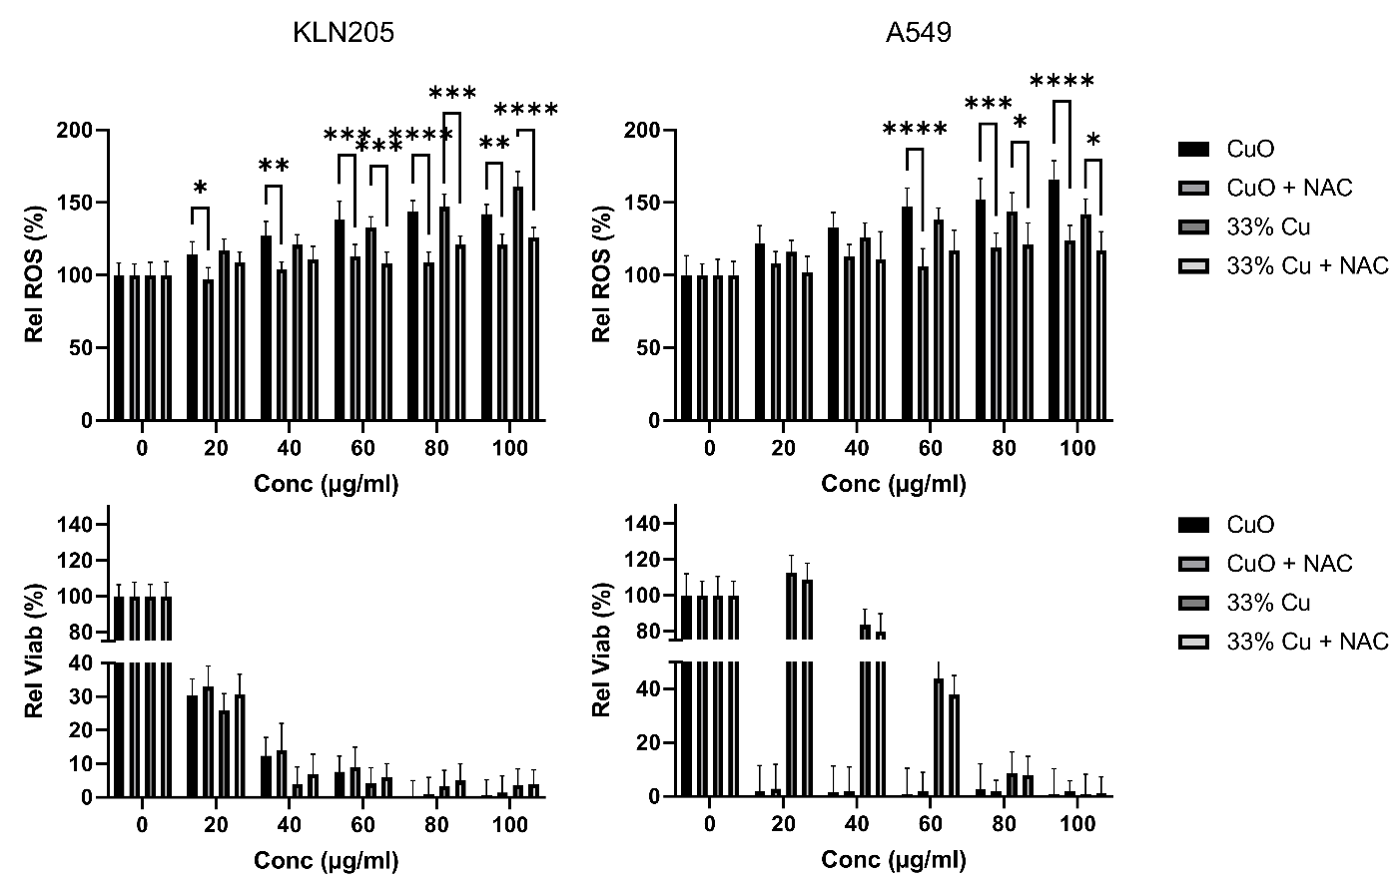
Figure S2. Histograms displaying the relative ROS (top row) and relative viability (bottom row) of KLN-205 (left column) and A549 (right column) exposed to pure CuO or 33% Cu-doped TiO₂ in the presence or absence of the ROS-scavenger NAC. All data are presented as mean + SEM and are expressed relative to untreated control cells (= 100%). The degree of significance is indicated where appropriate; (p < 0.05: *, p < 0.01: **; p < 0.001: ***; p < 0.0001) based on ANOVA testing using GraphPad Prism 9 (n = 4).

