Additional file information for

Cascade amplification of tumor starvation and chemodynamic therapy via Fe-MOF based functional nanosystem
Xinmin Zheng¹, Xiang Li¹, Siyu Meng², Guolin Shi¹, Hui Li¹, Huiping Du², Liangliang Dai^{2*} and Hui Yang^{1*}
¹ School of Life Sciences, Northwestern Polytechnical University, Xi’an 710072, China
² Institute of Medical Research, Northwestern Polytechnical University, Xi’an 710072, China
*Corresponding author: liangliangdai@nwpu.edu.cn (L.L. Dai)
*Corresponding author: kittyyh@nwpu.edu.cn ( H. Yang)

Lift of Contents

Fig. S1 Surface Zeta potential of FNP and HFNP S4
Fig. S2 XRD of FNP and HFNP S5
Fig. S3 H-NMR of FNP and HFNP S6
Fig. S4 FTIR of FNP and HFNP S7
Fig. S5 Linear relationships between the UV-vis absorbance and the concentration of GOX S8
Fig. S6 Efflux time of pure PFC and HFNP@GOX@PFC nanoparticles S9
Fig. S7 Linear relationships between the GC intensity and the concentration of PFC S10
Fig. S8 TEM images of FNP and HFNP after treatment with H₂O₂ S11
Fig. S9 DLS curves of FNP and HFNP after treatment with H₂O₂ S12
Fig. S10 pH values and generated H₂O₂ concentrations at various time points arisen from GOX and HFNP@GOX@PFC catalyzed disintegration reaction of glucose S13
Fig. S11 Biostability of HFNP@GOX@PFC in gluconic acid with or without H₂O₂ S14
Fig. S12 Intracellular ROS ﬂuorescence intensity of 4T1 cells S15
Fig. S13 Corresponding quantitative MFI analysis of CD47 S16
Fig. S14 Bcl-2, BAX, CytC and Casp3 relative mRNA expressions S17
Fig. S15 Gate strategy S18
Fig. S16 Wound healing rate of 4T1 cells S19
Fig. S17 Migration rate of 4T1 cells S20
Fig. S18 Invasion rate of 4T1 cells S21
Fig. S19 Body weight of tumor-bearing mice S22
Fig. S20 The quantitative IFC intensity analysis of CD47 S23
Fig. S21 The quantitative IFC intensity analysis of CD86 S24
Fig. S22 Biomedical blood index of tumor-bearing BALB/c mice S25
Fig. S23 H&E staining for major tissues S26
Table S1. Primer sequences S27

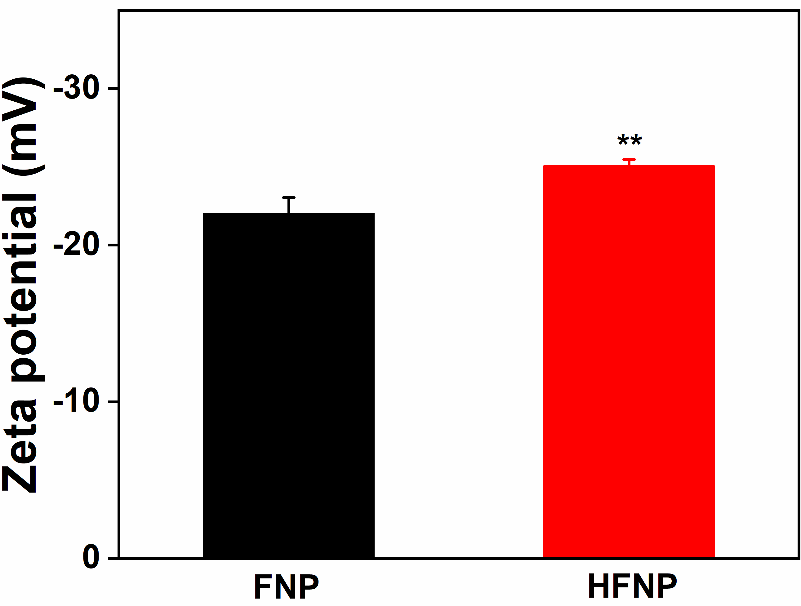

Fig. S1 Surface Zeta potential of FNP and HFNP measured using DLS. Error bars present as mean ± SD (n = 6).

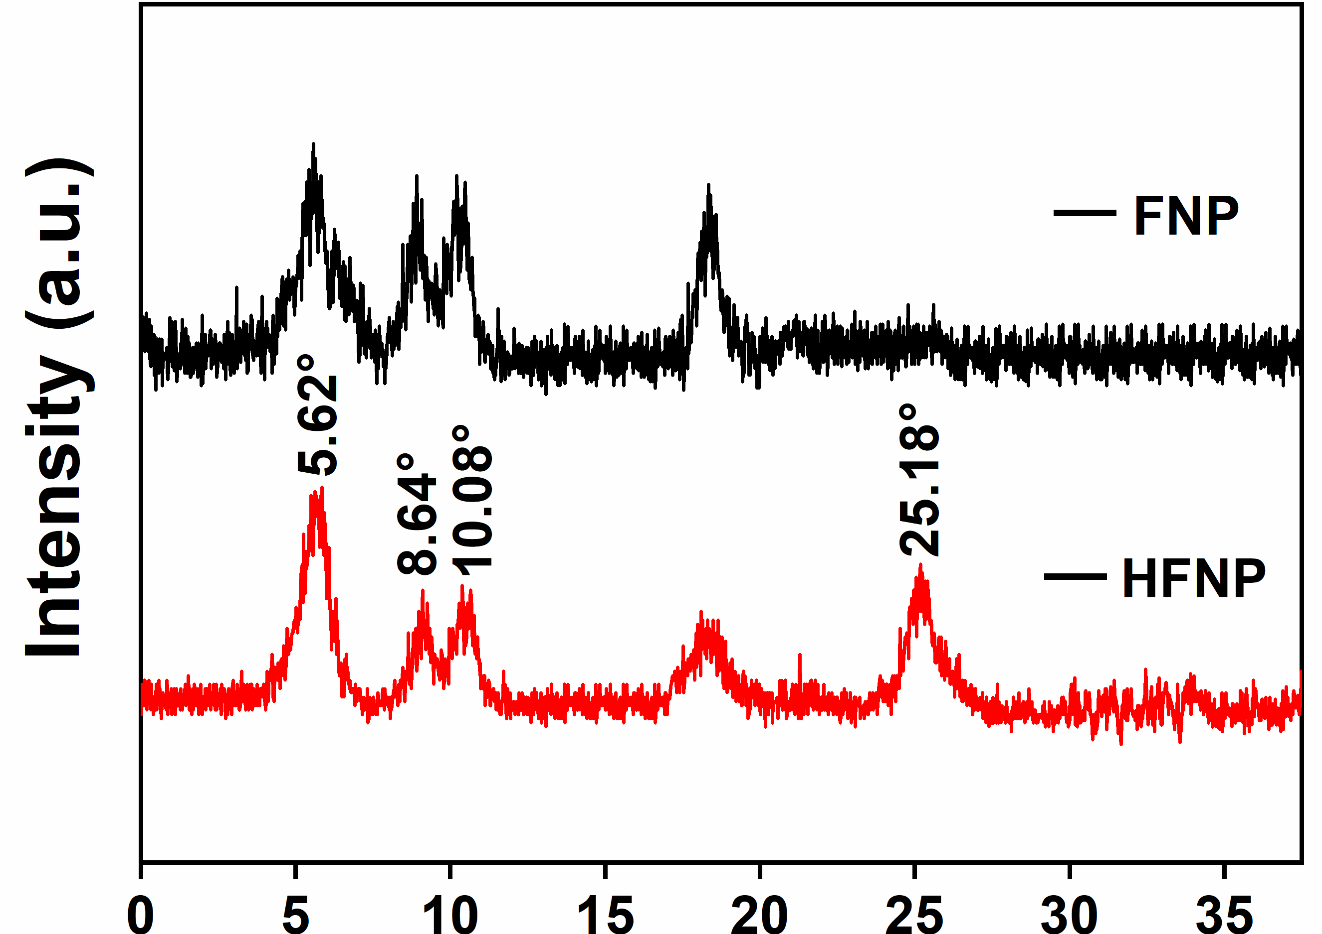

Fig. S2 XRD of FNP and HFNP.

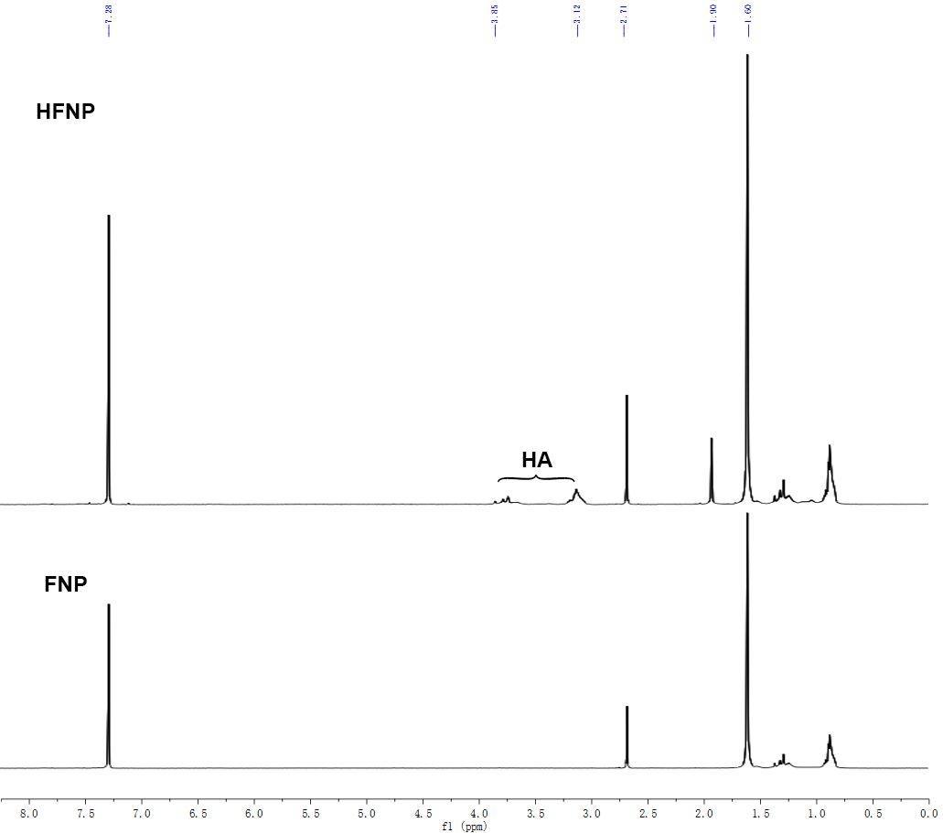

Fig. S3 H-NMR of FNP and HFNP.

Fig. S4 FTIR of FNP and HFNP.

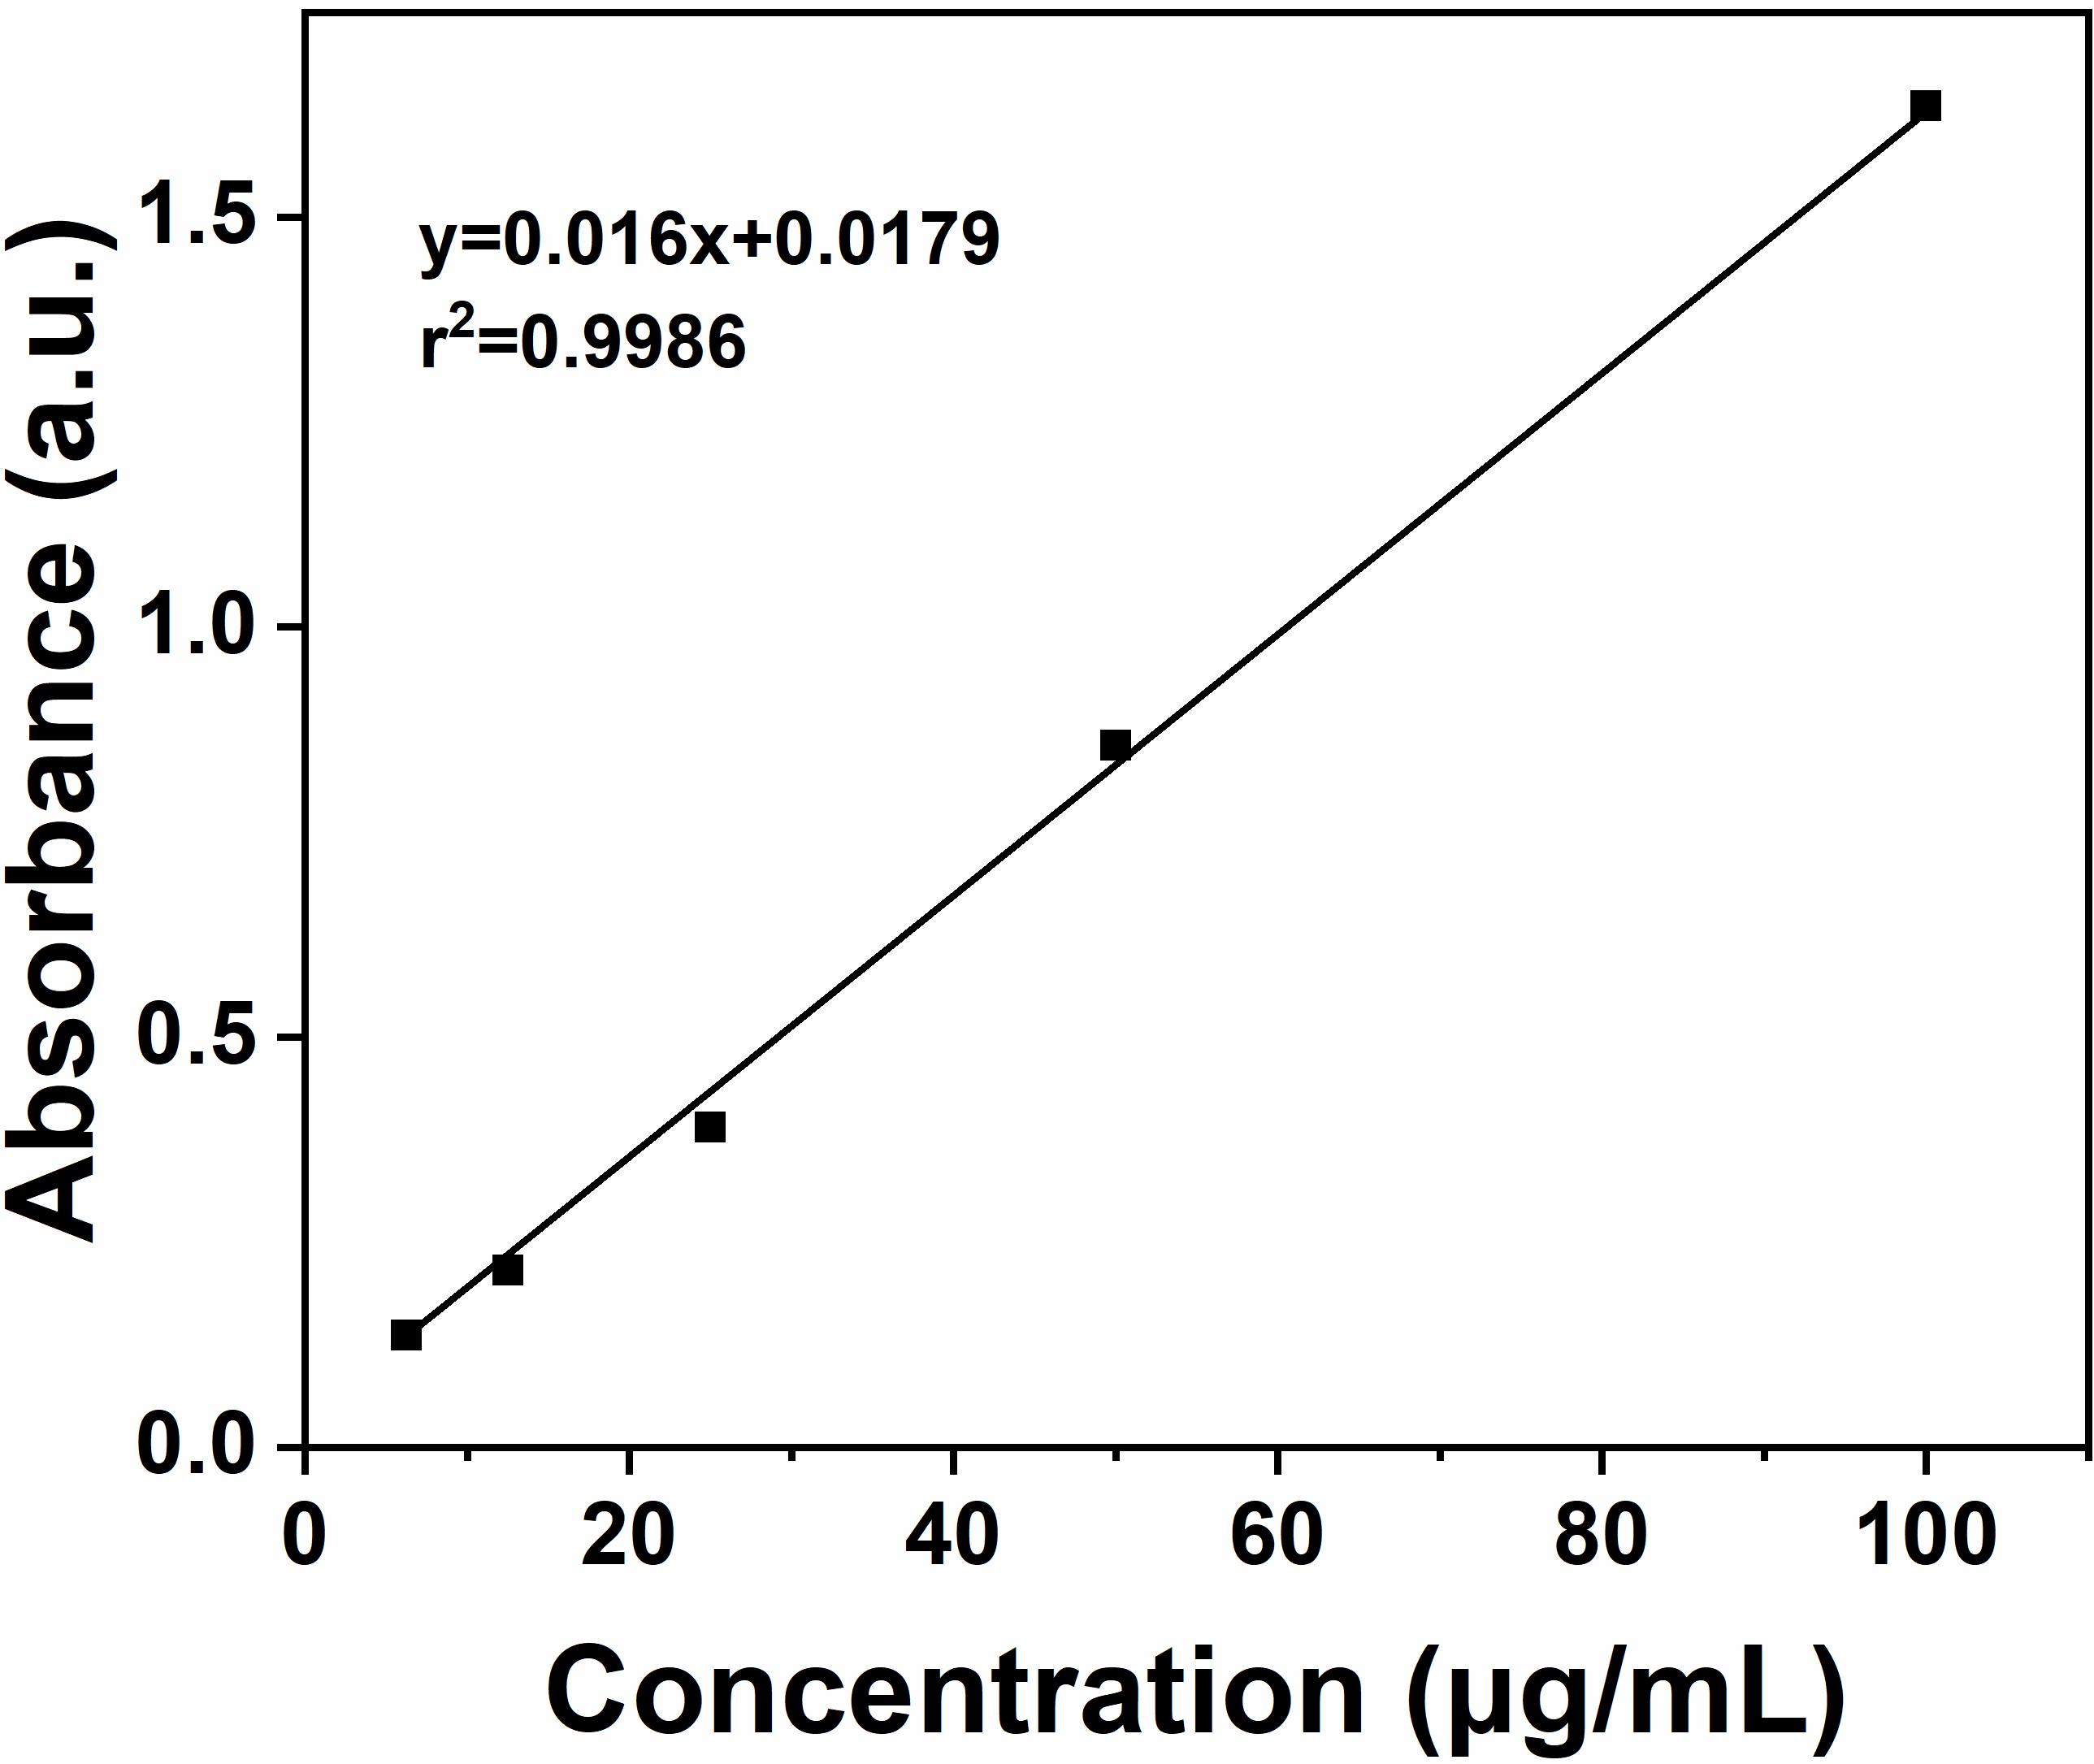

Fig. S5 Linear relationships between the UV-vis absorbance and the concentration of GOX.

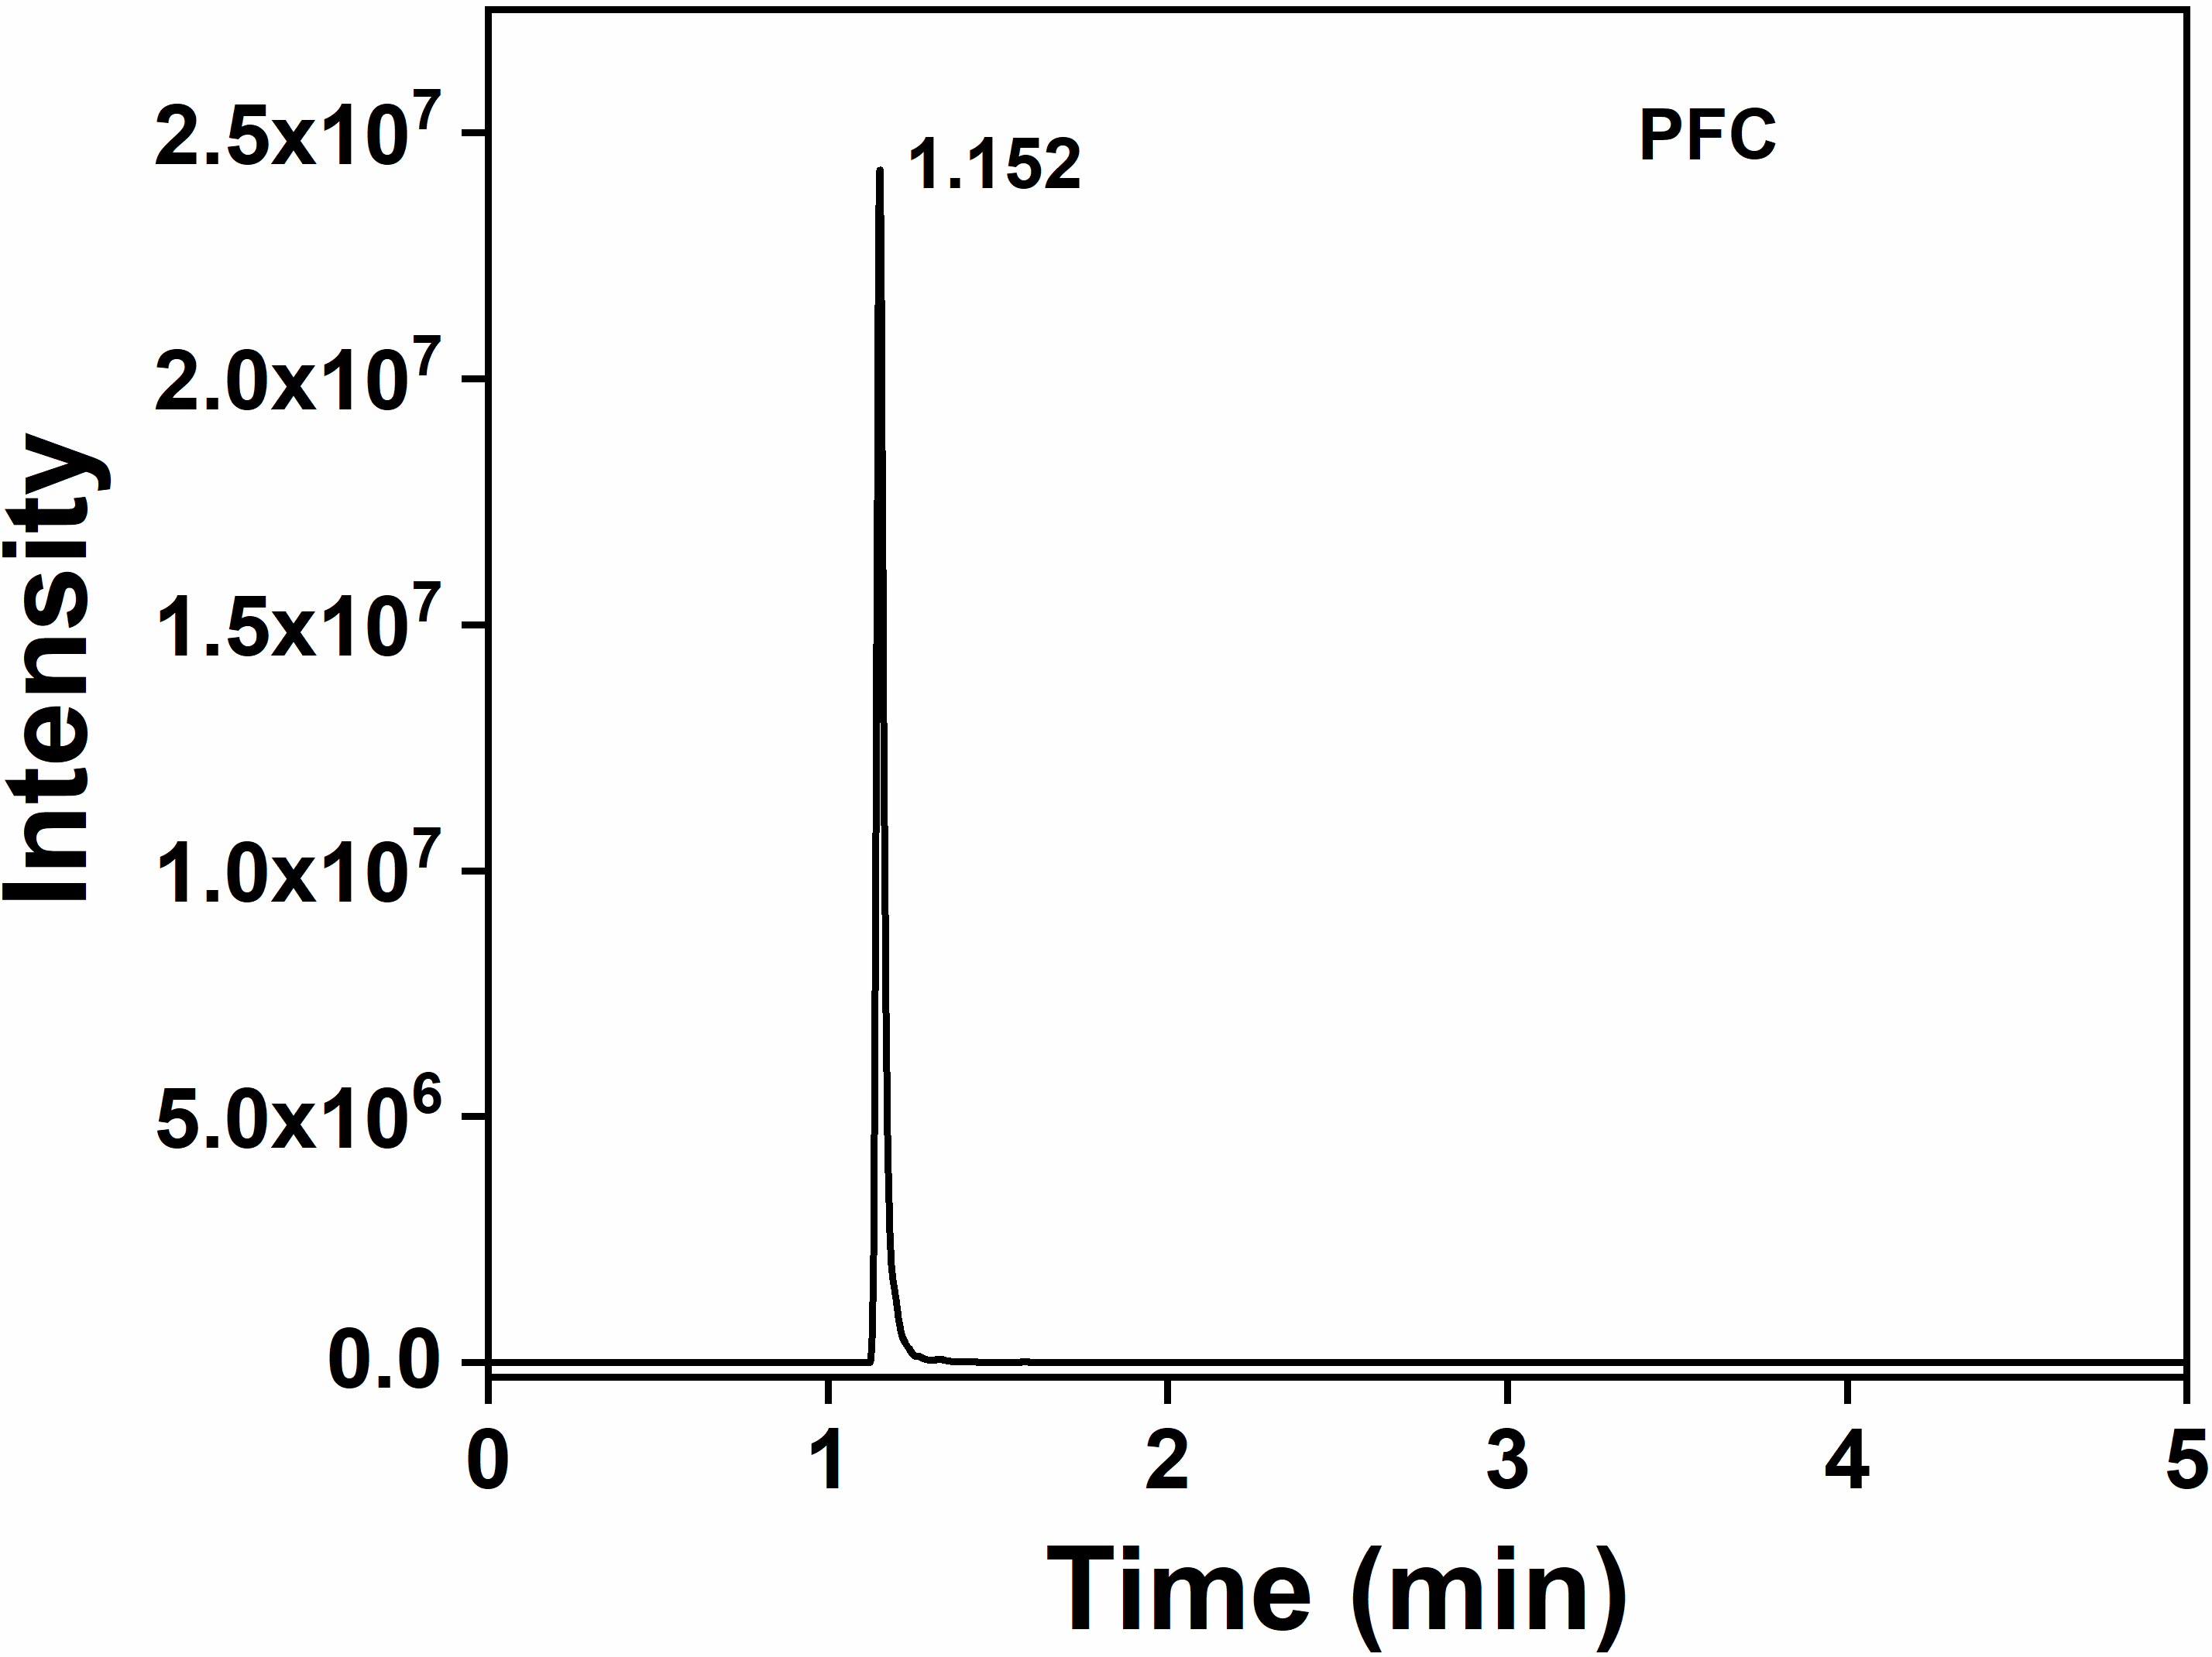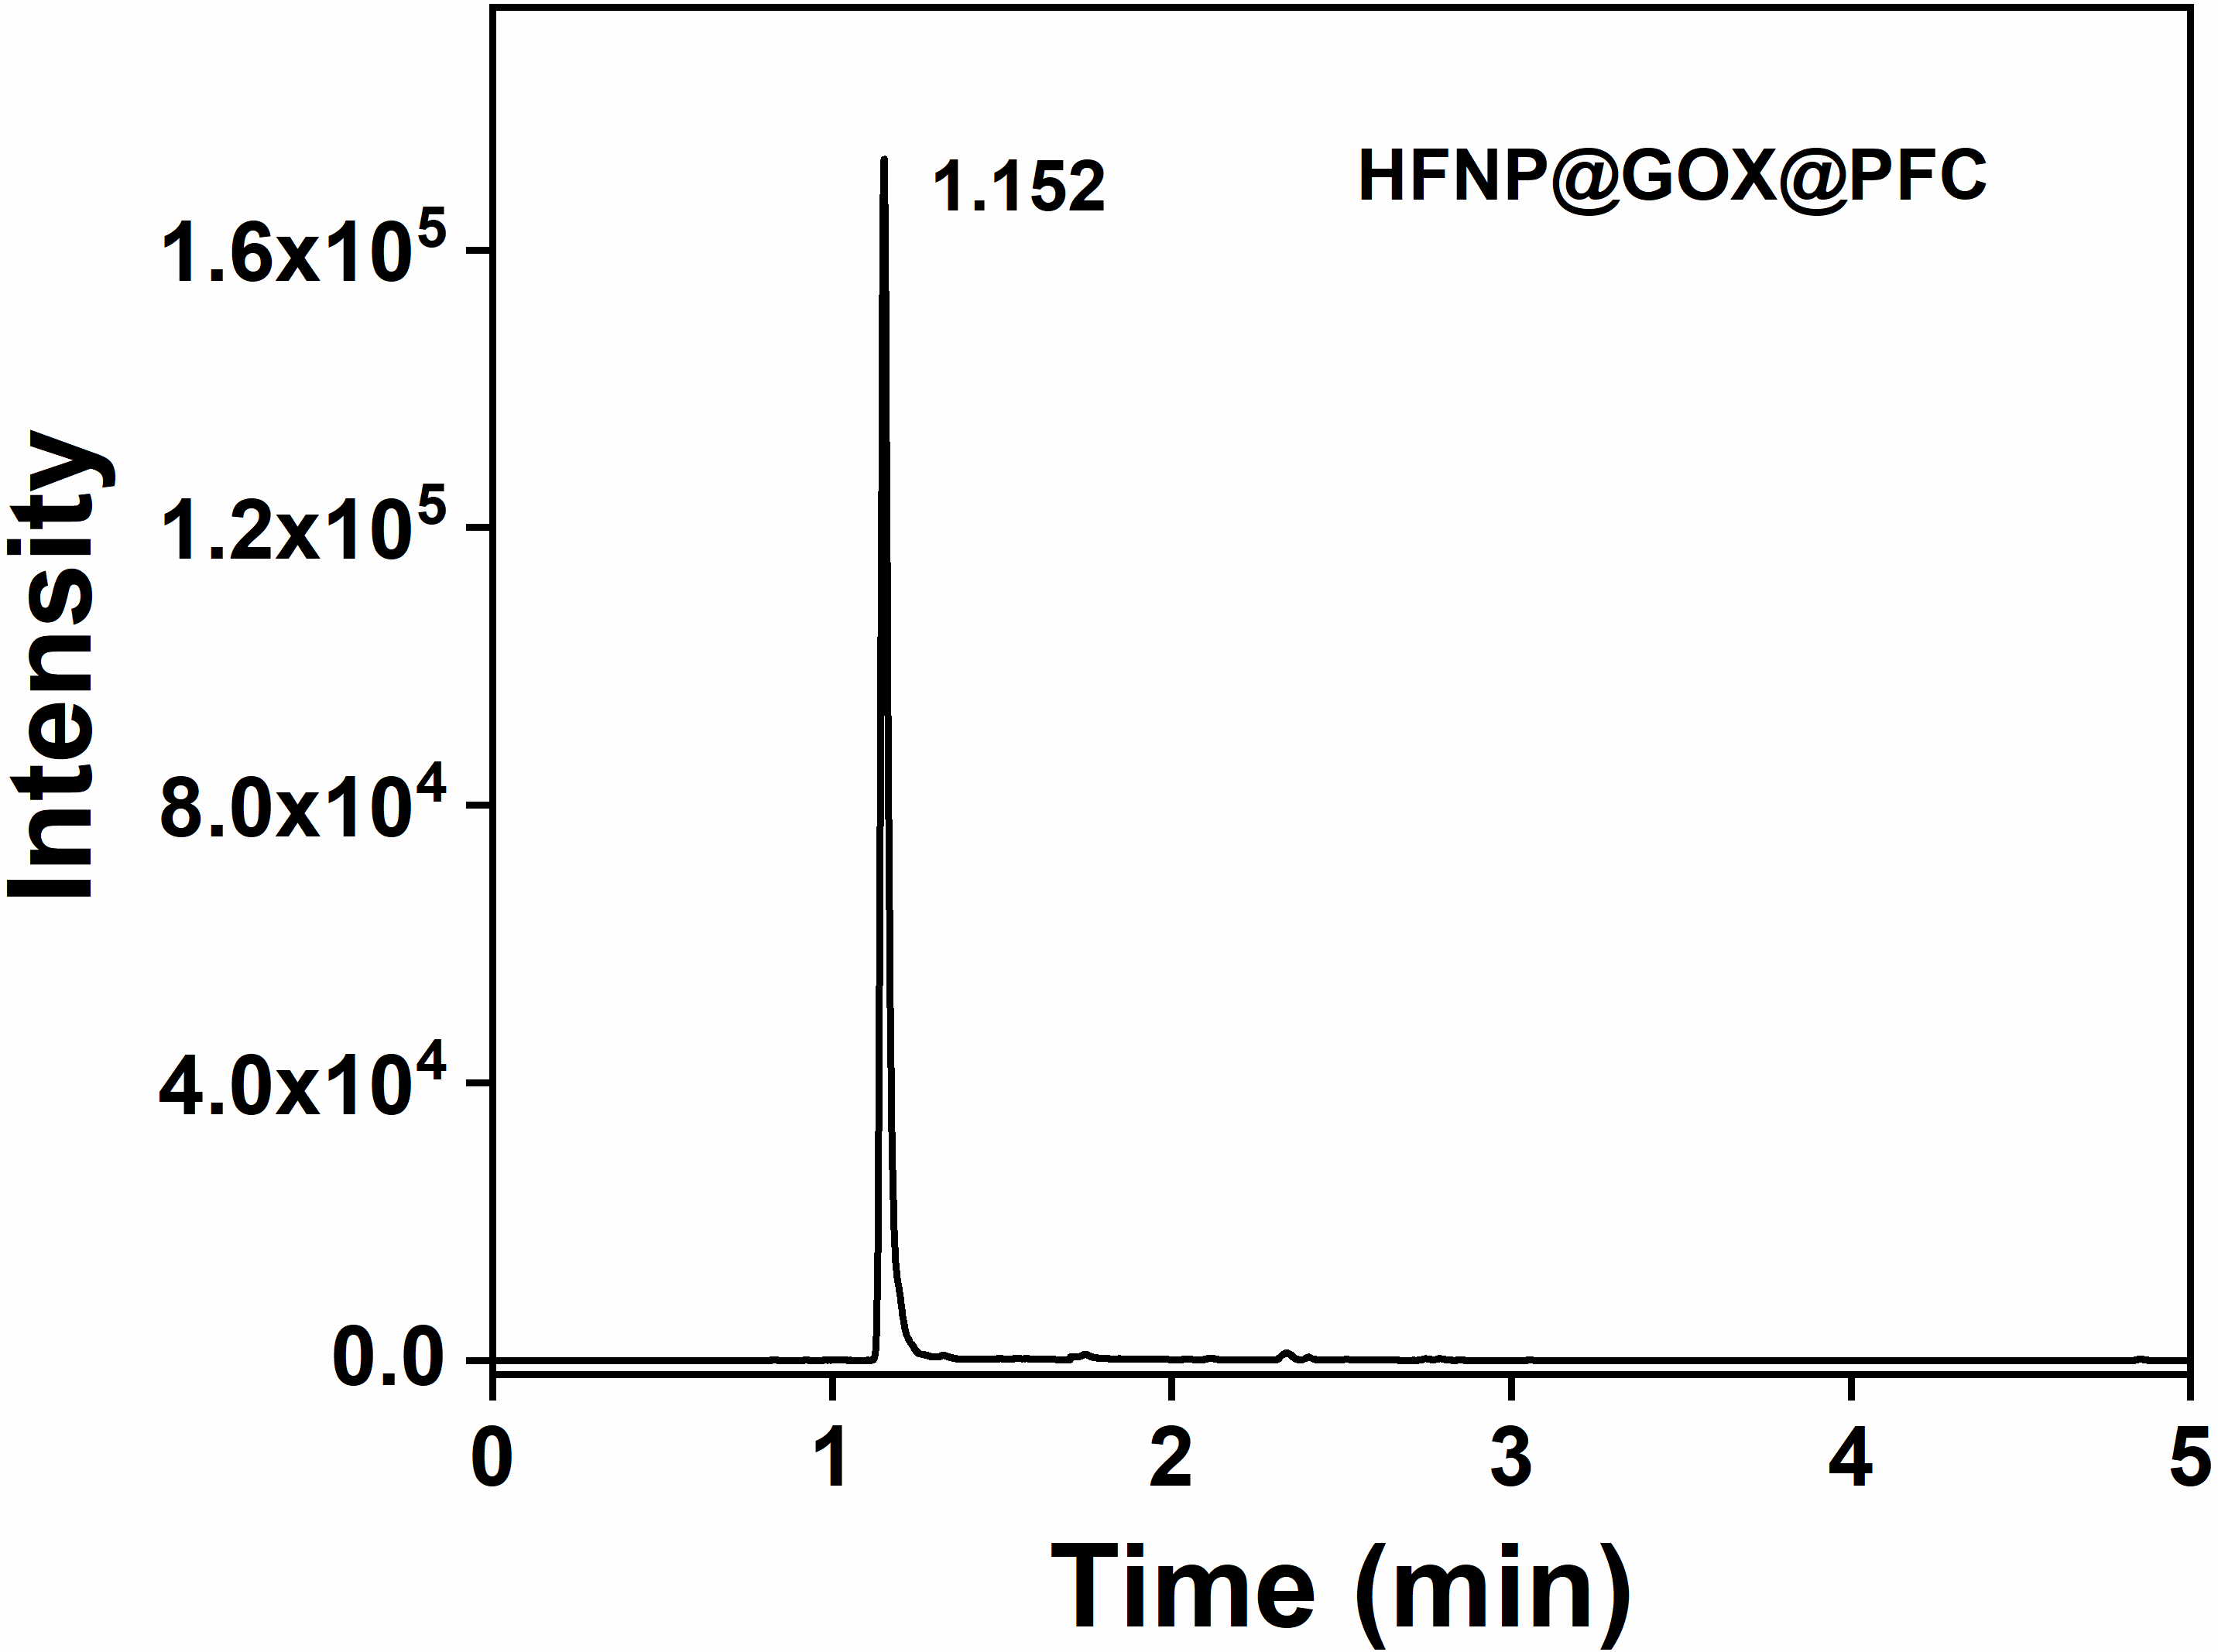
(b)
(a)

Fig. S6 Efflux time of (a) pure PFC and (b) HFNP@GOX@PFC nanoparticles measured by GC. The samples were extracted by acetonitrile and pentafluorobutane before GC-MS measurement following a literature protocol.

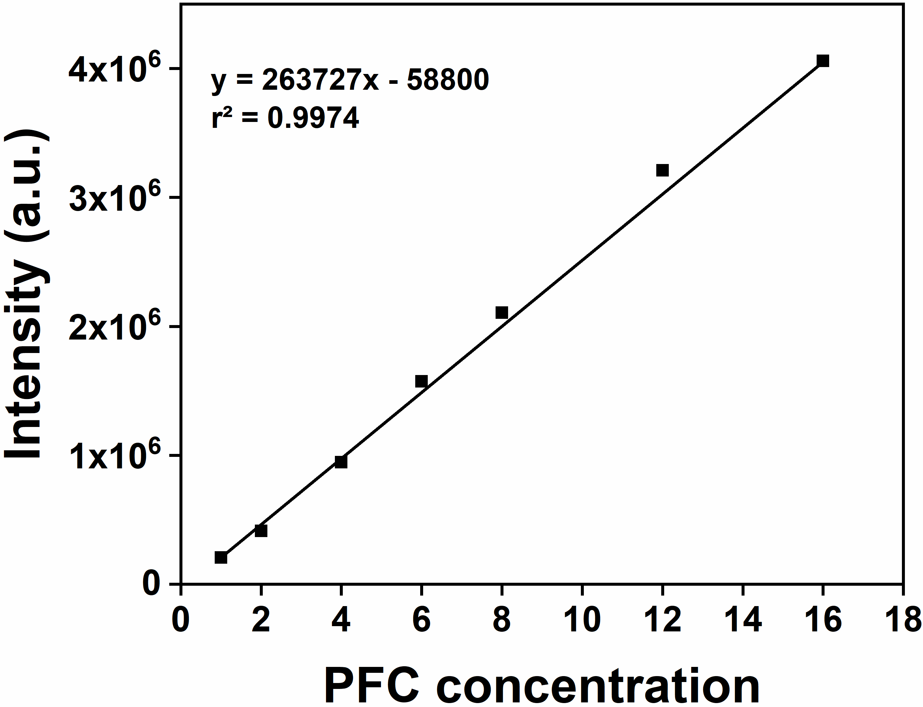

Fig. S7 Linear relationships between the GC intensity and the concentration of PFC.

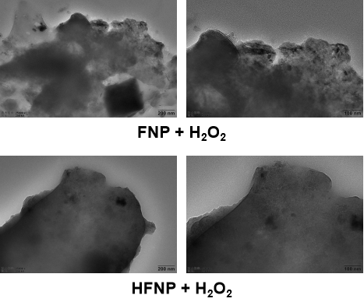
Fig. S8 TEM images of FNP and HFNP after treatment with H₂O₂. Scale bar: 200 nm for left figures and 100 nm for right figures.

Fig. S9 DLS curves of FNP and HFNP after treatment with H₂O₂.

(b)
(a)
Fig. S10 pH values and generated H₂O₂ concentrations at various time points arisen from (a) GOX and (b) HFNP@GOX@PFC catalyzed disintegration reaction of glucose. Error bars present as mean ± SD (n = 3).

Fig. S11 Biostability of HFNP@GOX@PFC in gluconic acid with or without H₂O₂. Error bars present as mean ± SD (n = 3).

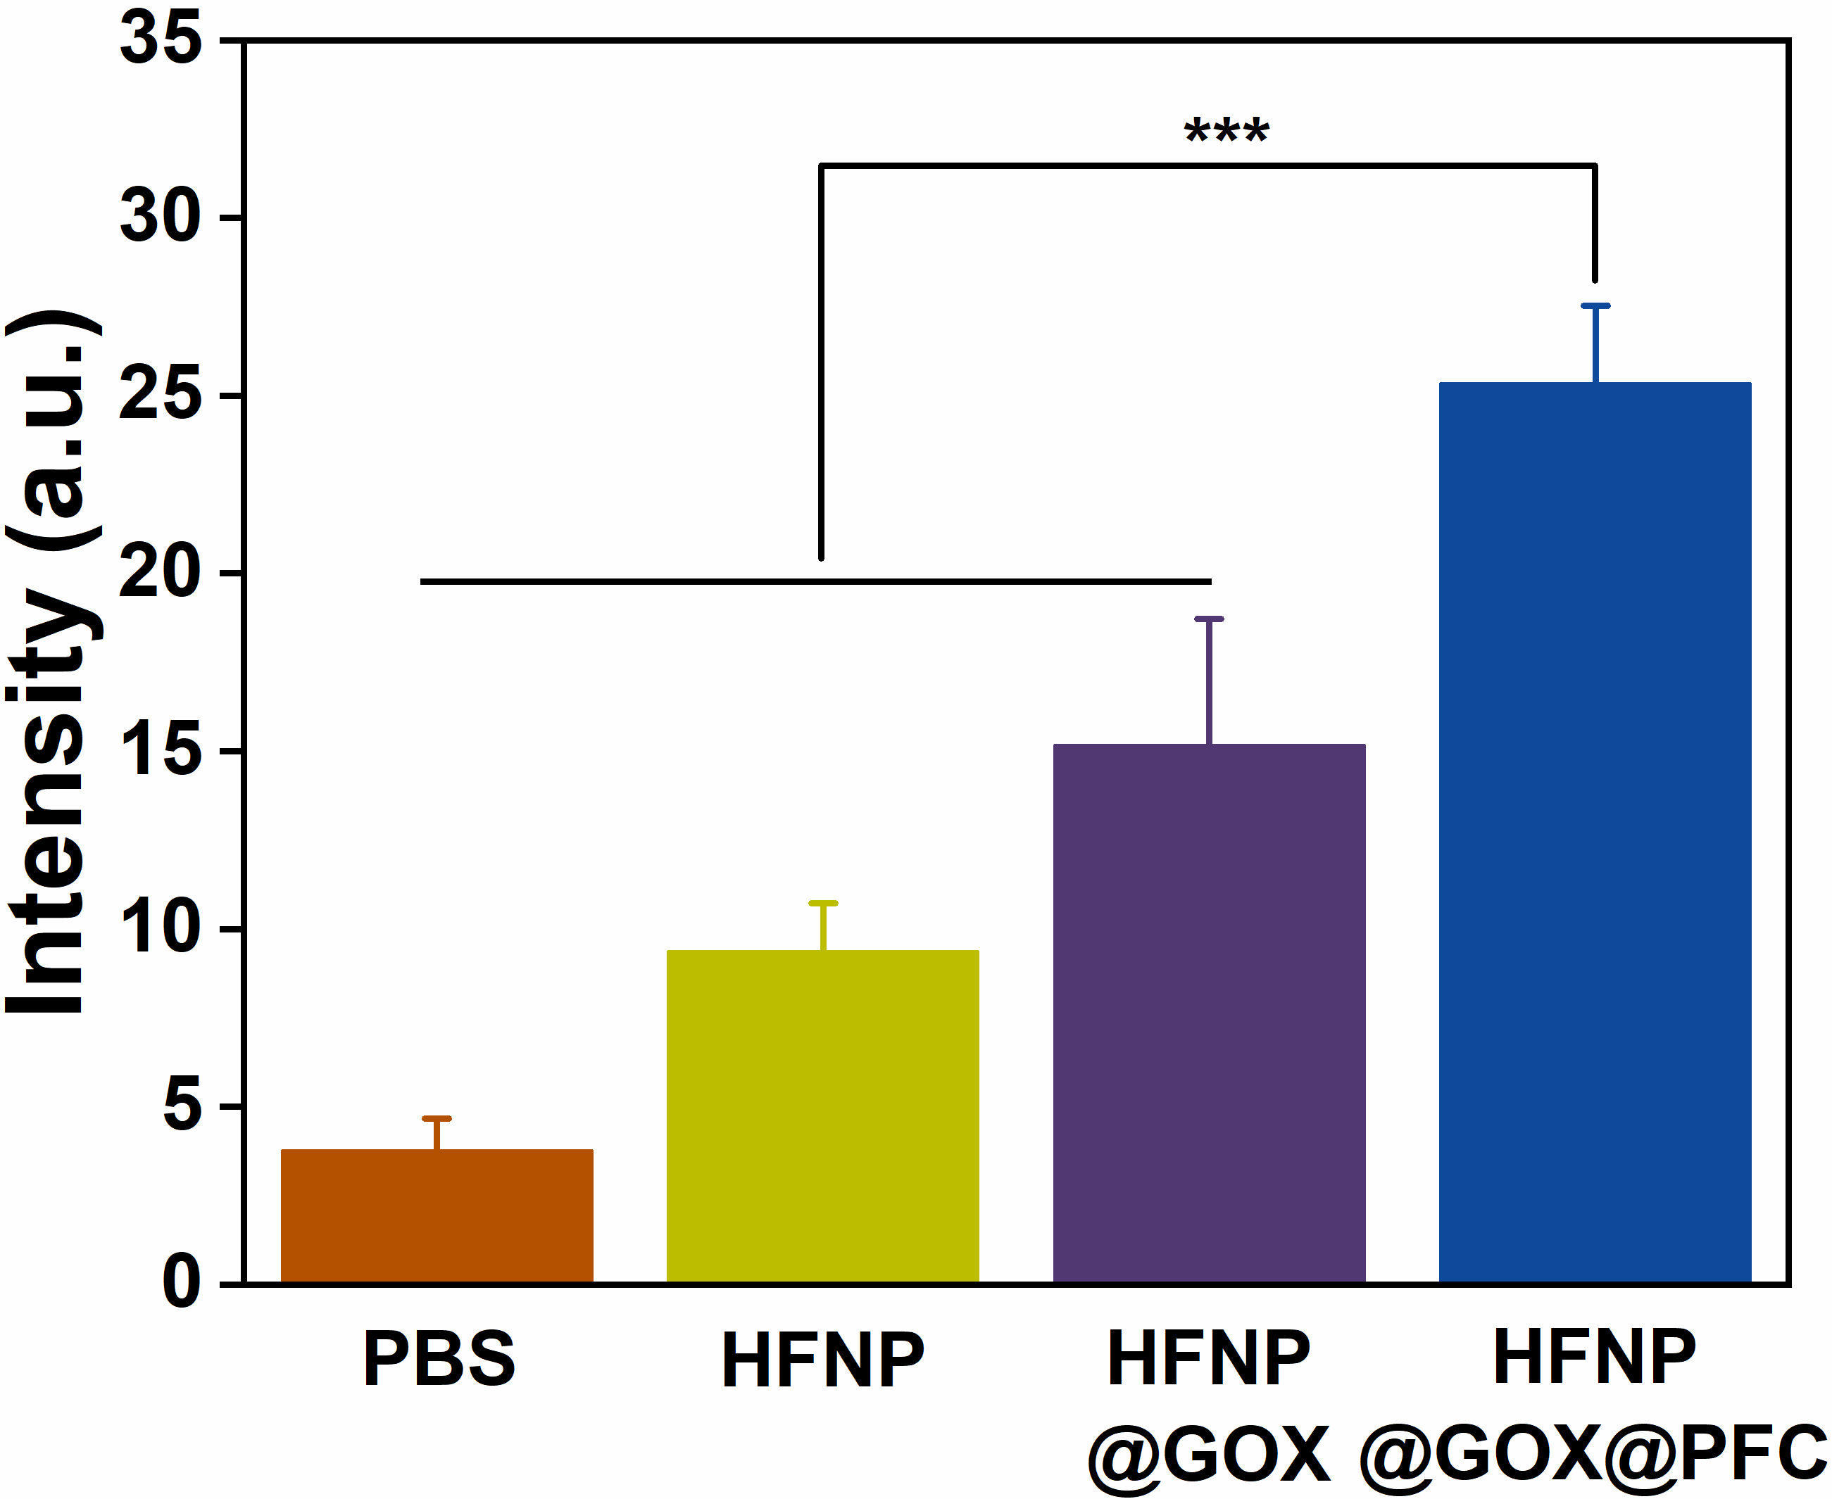

Fig. S12 Intracellular ROS ﬂuorescence intensity of 4T1 cells. Error bars present as mean ± SD (n = 6).

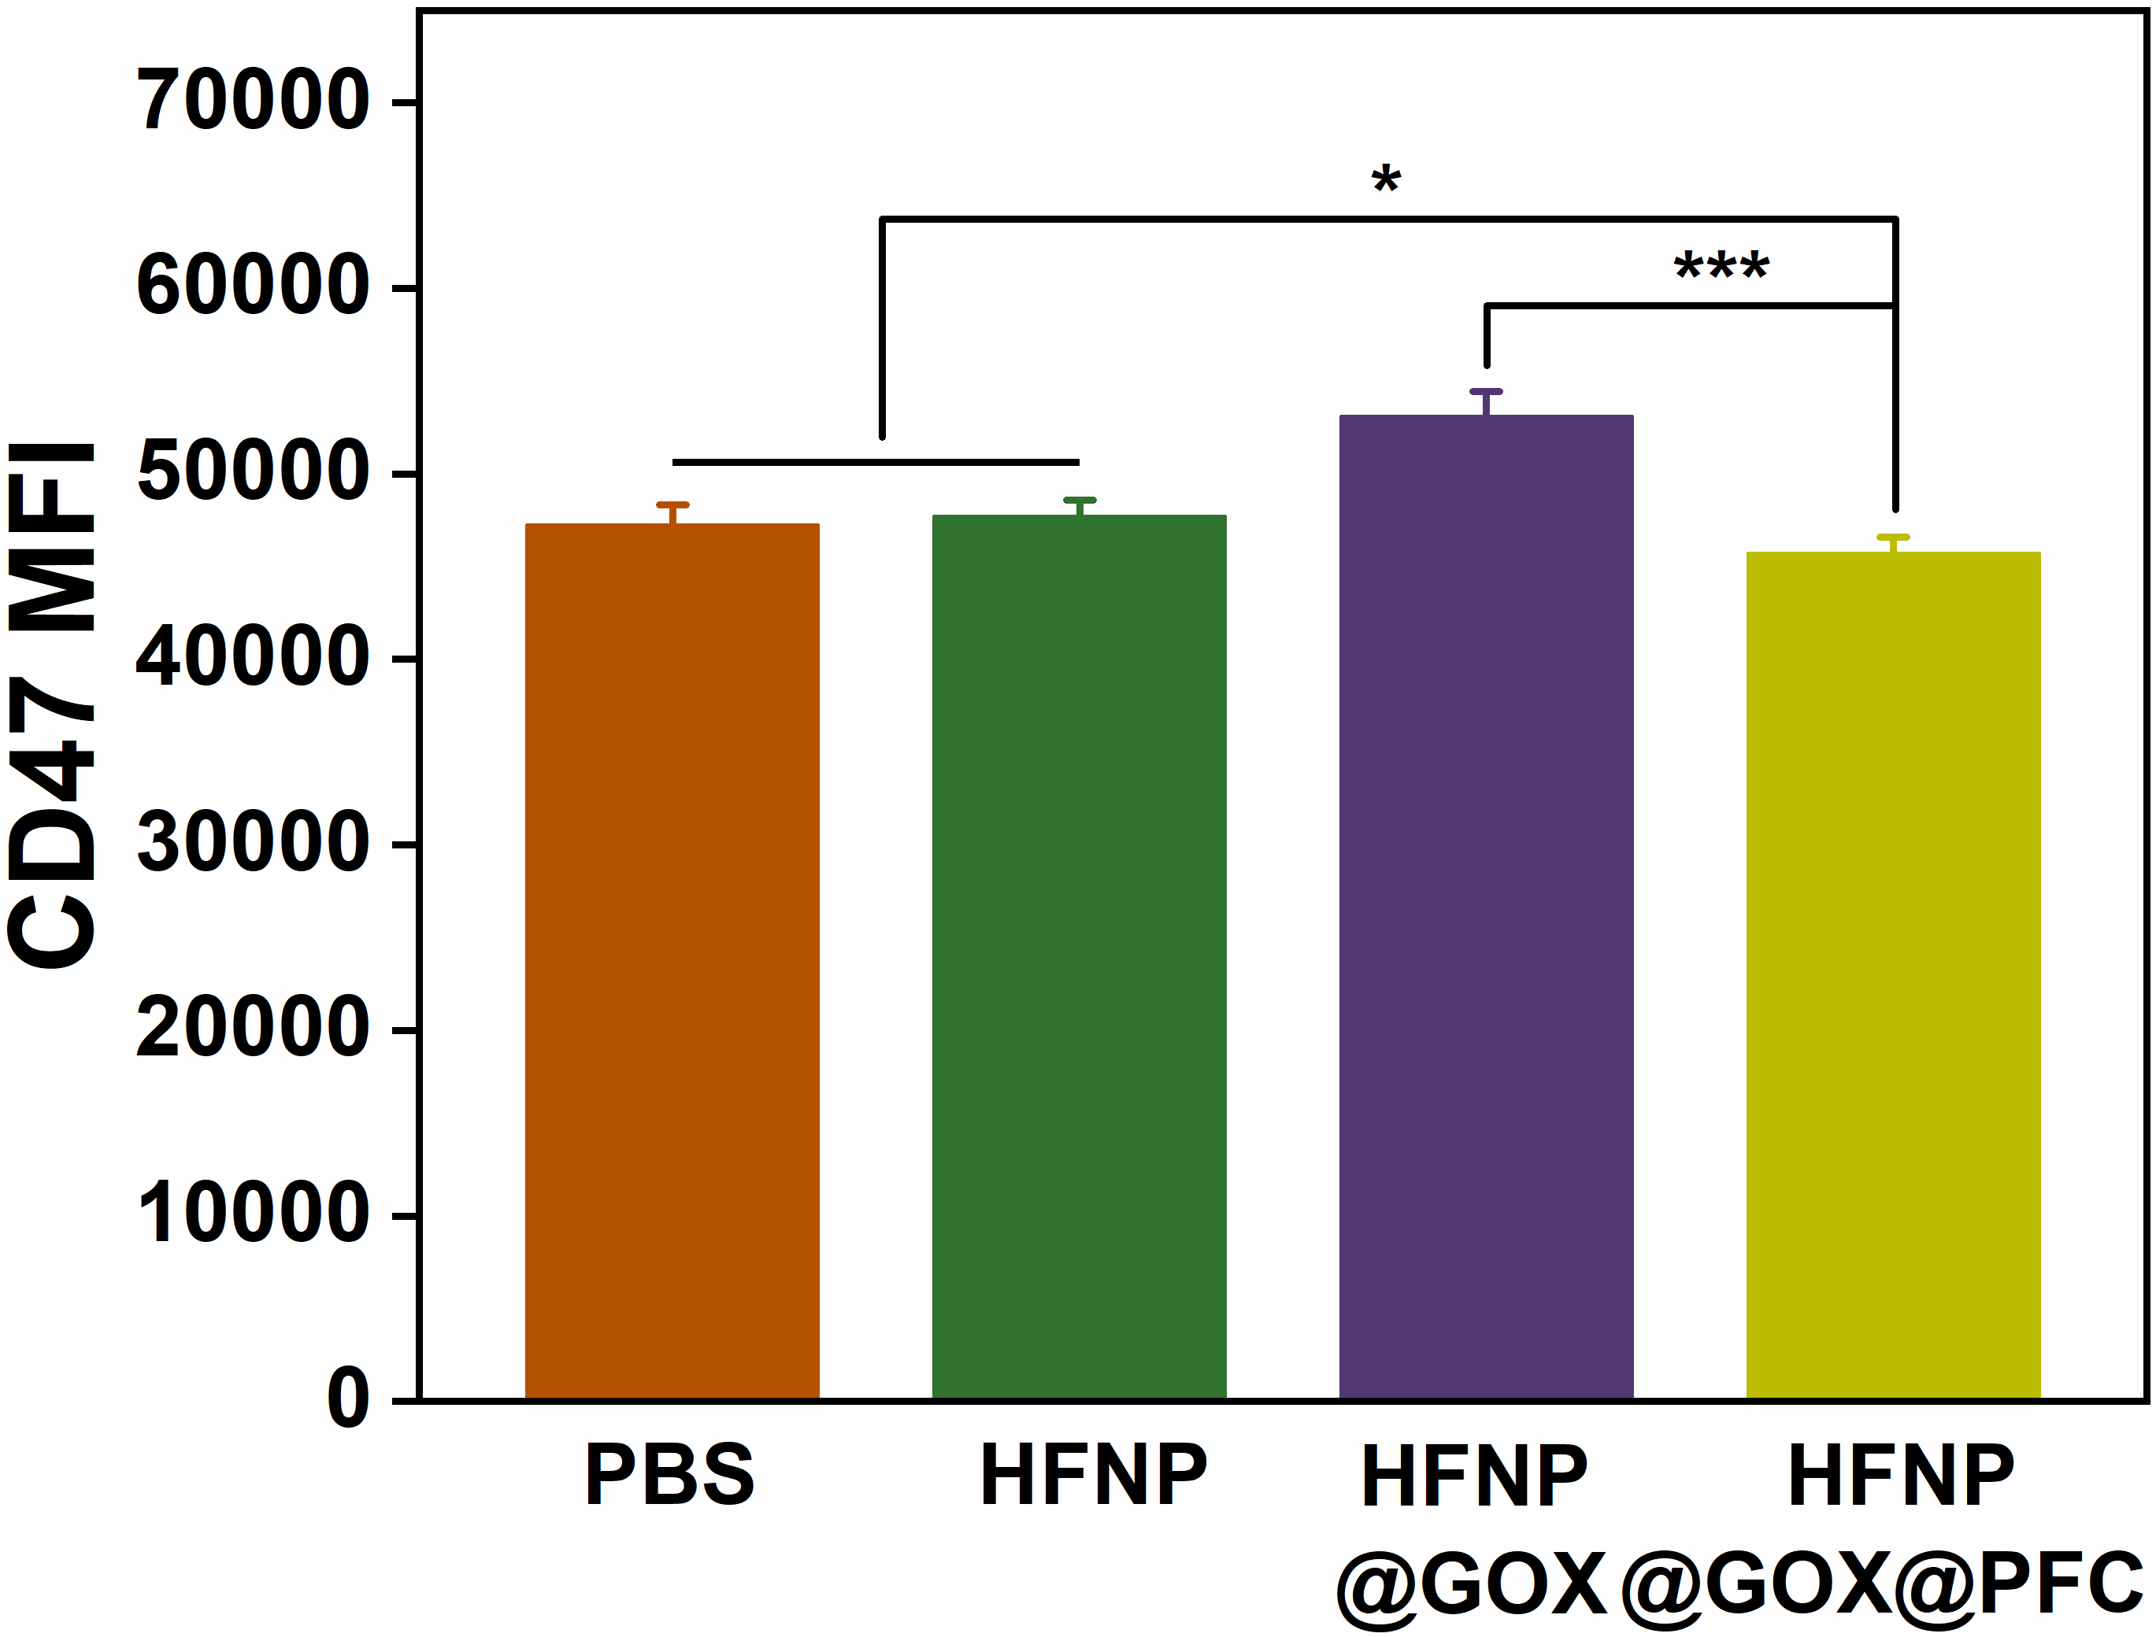

Fig. S13 Corresponding quantitative MFI analysis of CD47 expression in 4T1 cells after treatment with PBS, HFNP, HFNP@GOX & HFNP@GOX@PFC for 24 h based on Fig. 4D. Error bars present as mean ± SD (n = 6).

Fig. S14 (a) Bcl-2, (b) BAX, (c) CytC and (d) Casp3 relative mRNA expressions analysis of 4T1 cells treated with PBS, HFNP & HFNP@GOX@PFC. Error bars present as mean ± SD (n = 6).

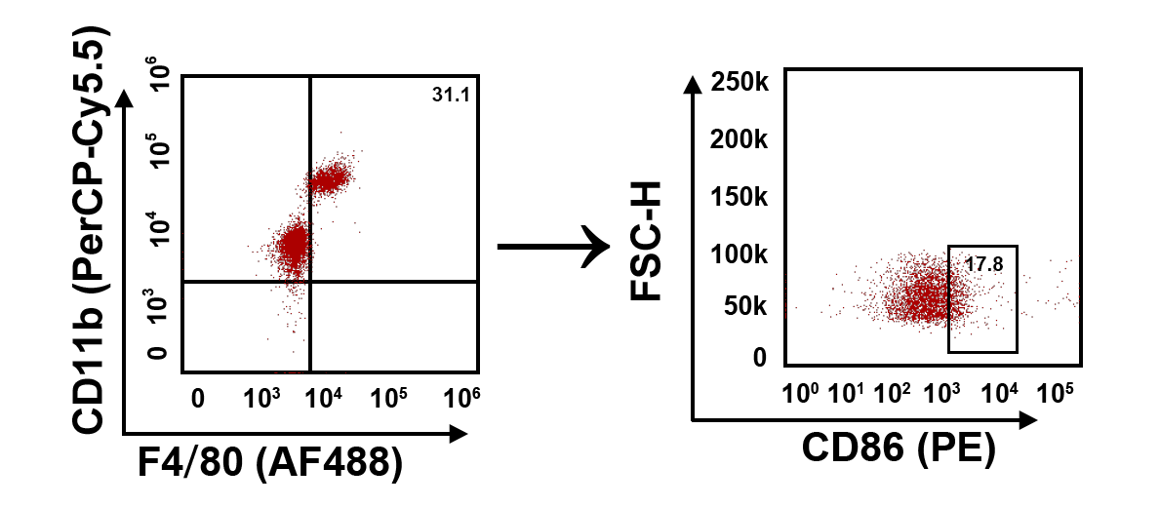

Fig. S15 Gate strategy for assessing TAMs polarization by following the indicated treatments.

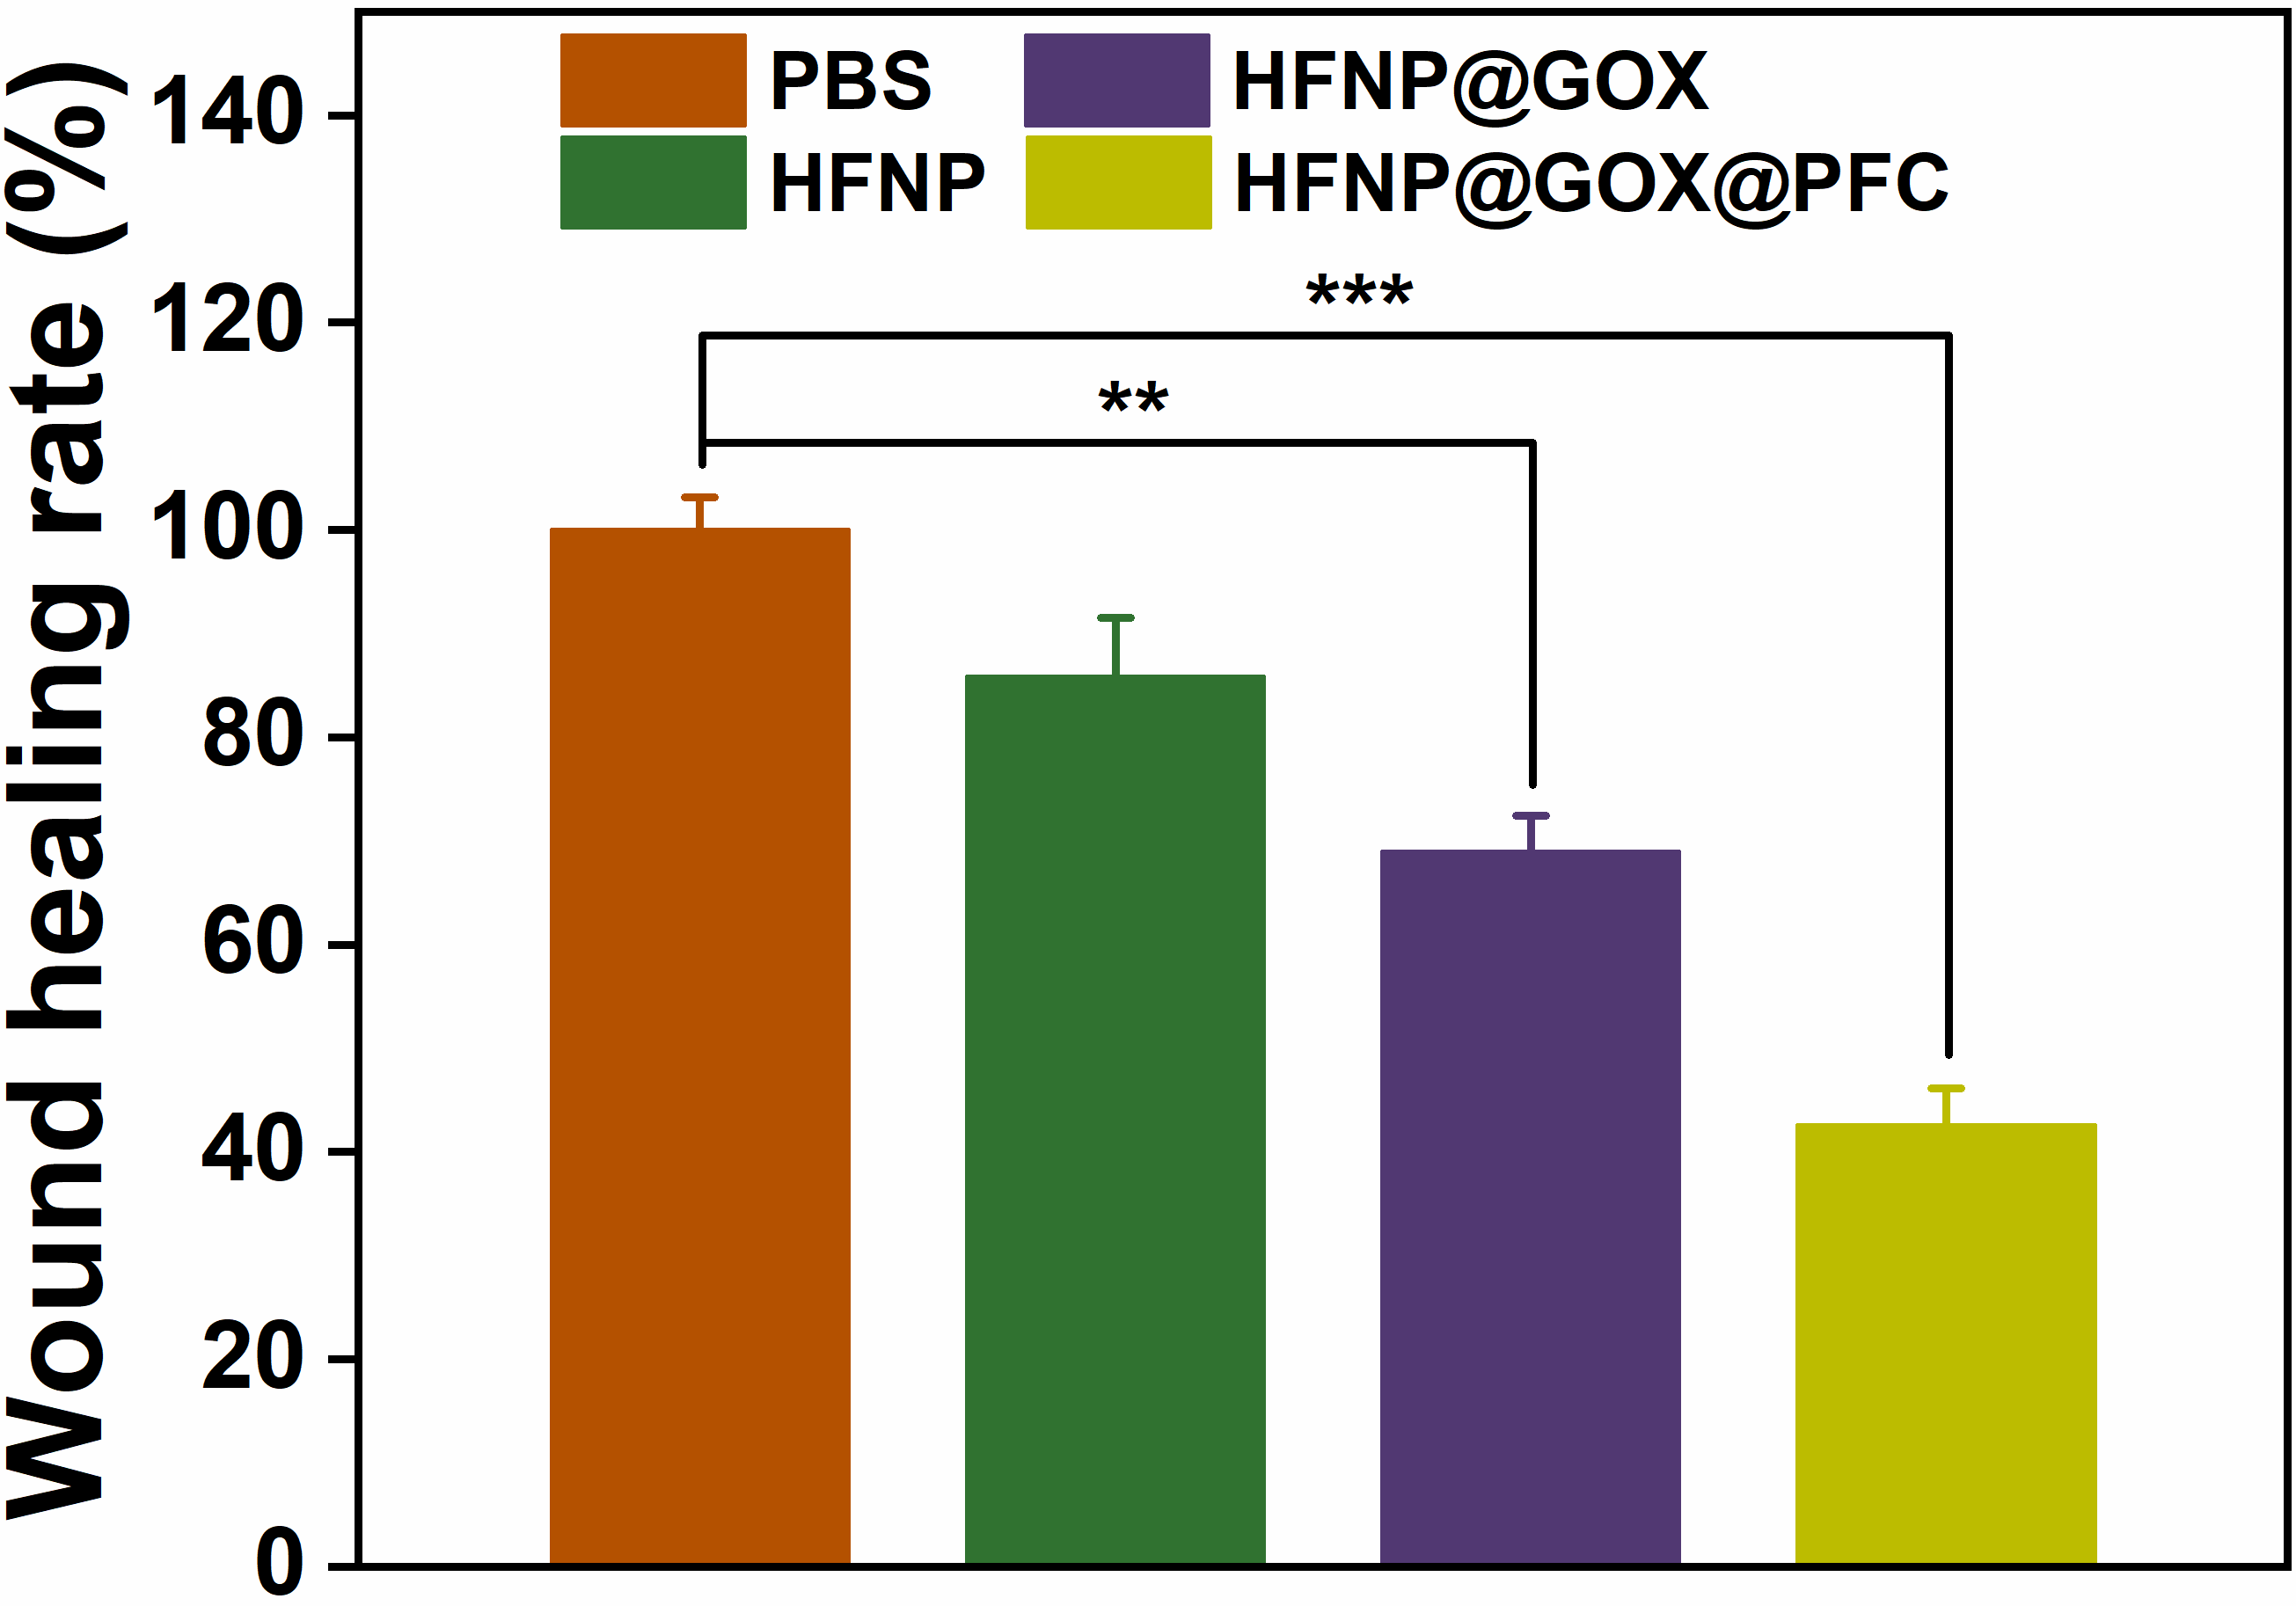

Fig. S16 Wound healing rate of 4T1 cells after various treatments. Error bars present as mean ± SD (n = 6).

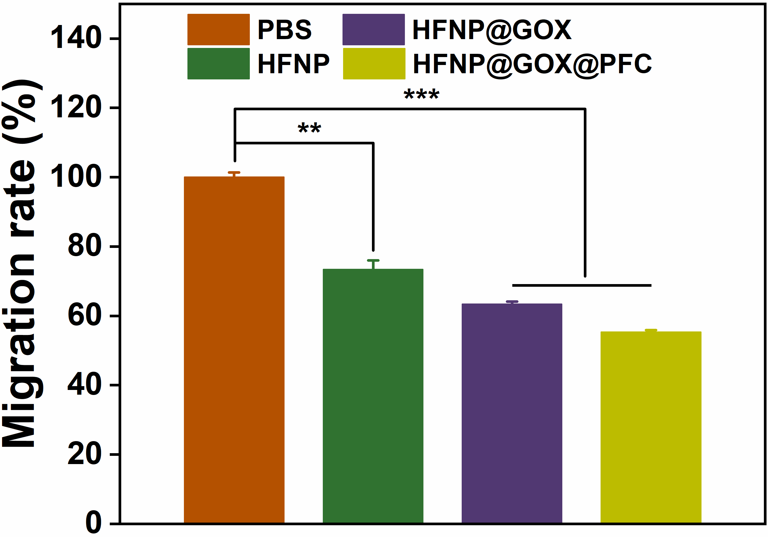

Fig. S17 Migration rate of 4T1 cells after various treatments. Error bars present as mean ± SD (n = 6).

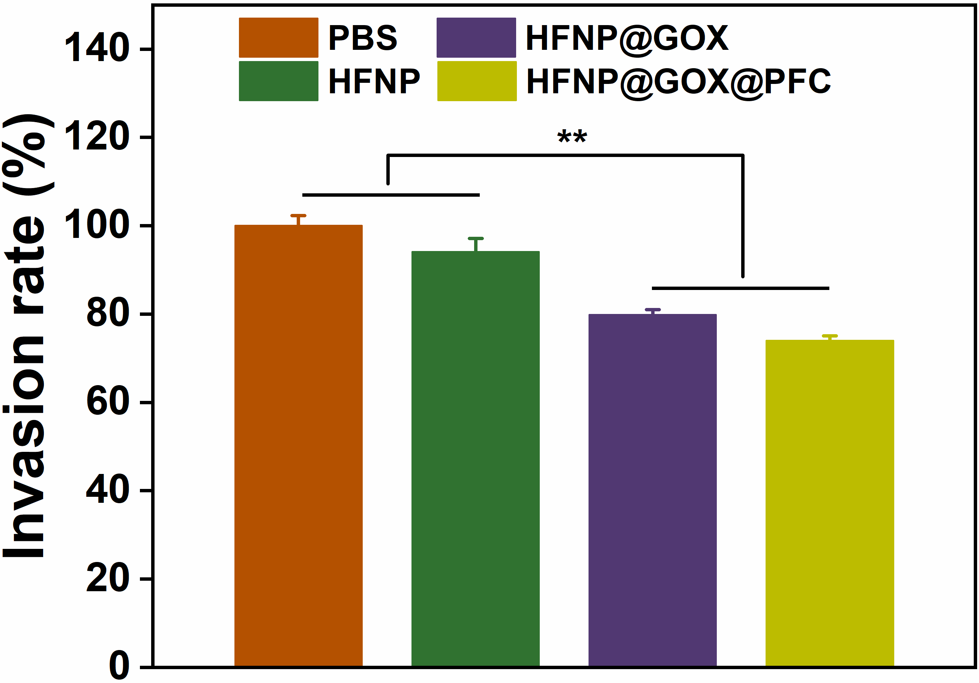

Fig. S18 Invasion rate of 4T1 cells after various treatments. Error bars present as mean ± SD (n = 6).

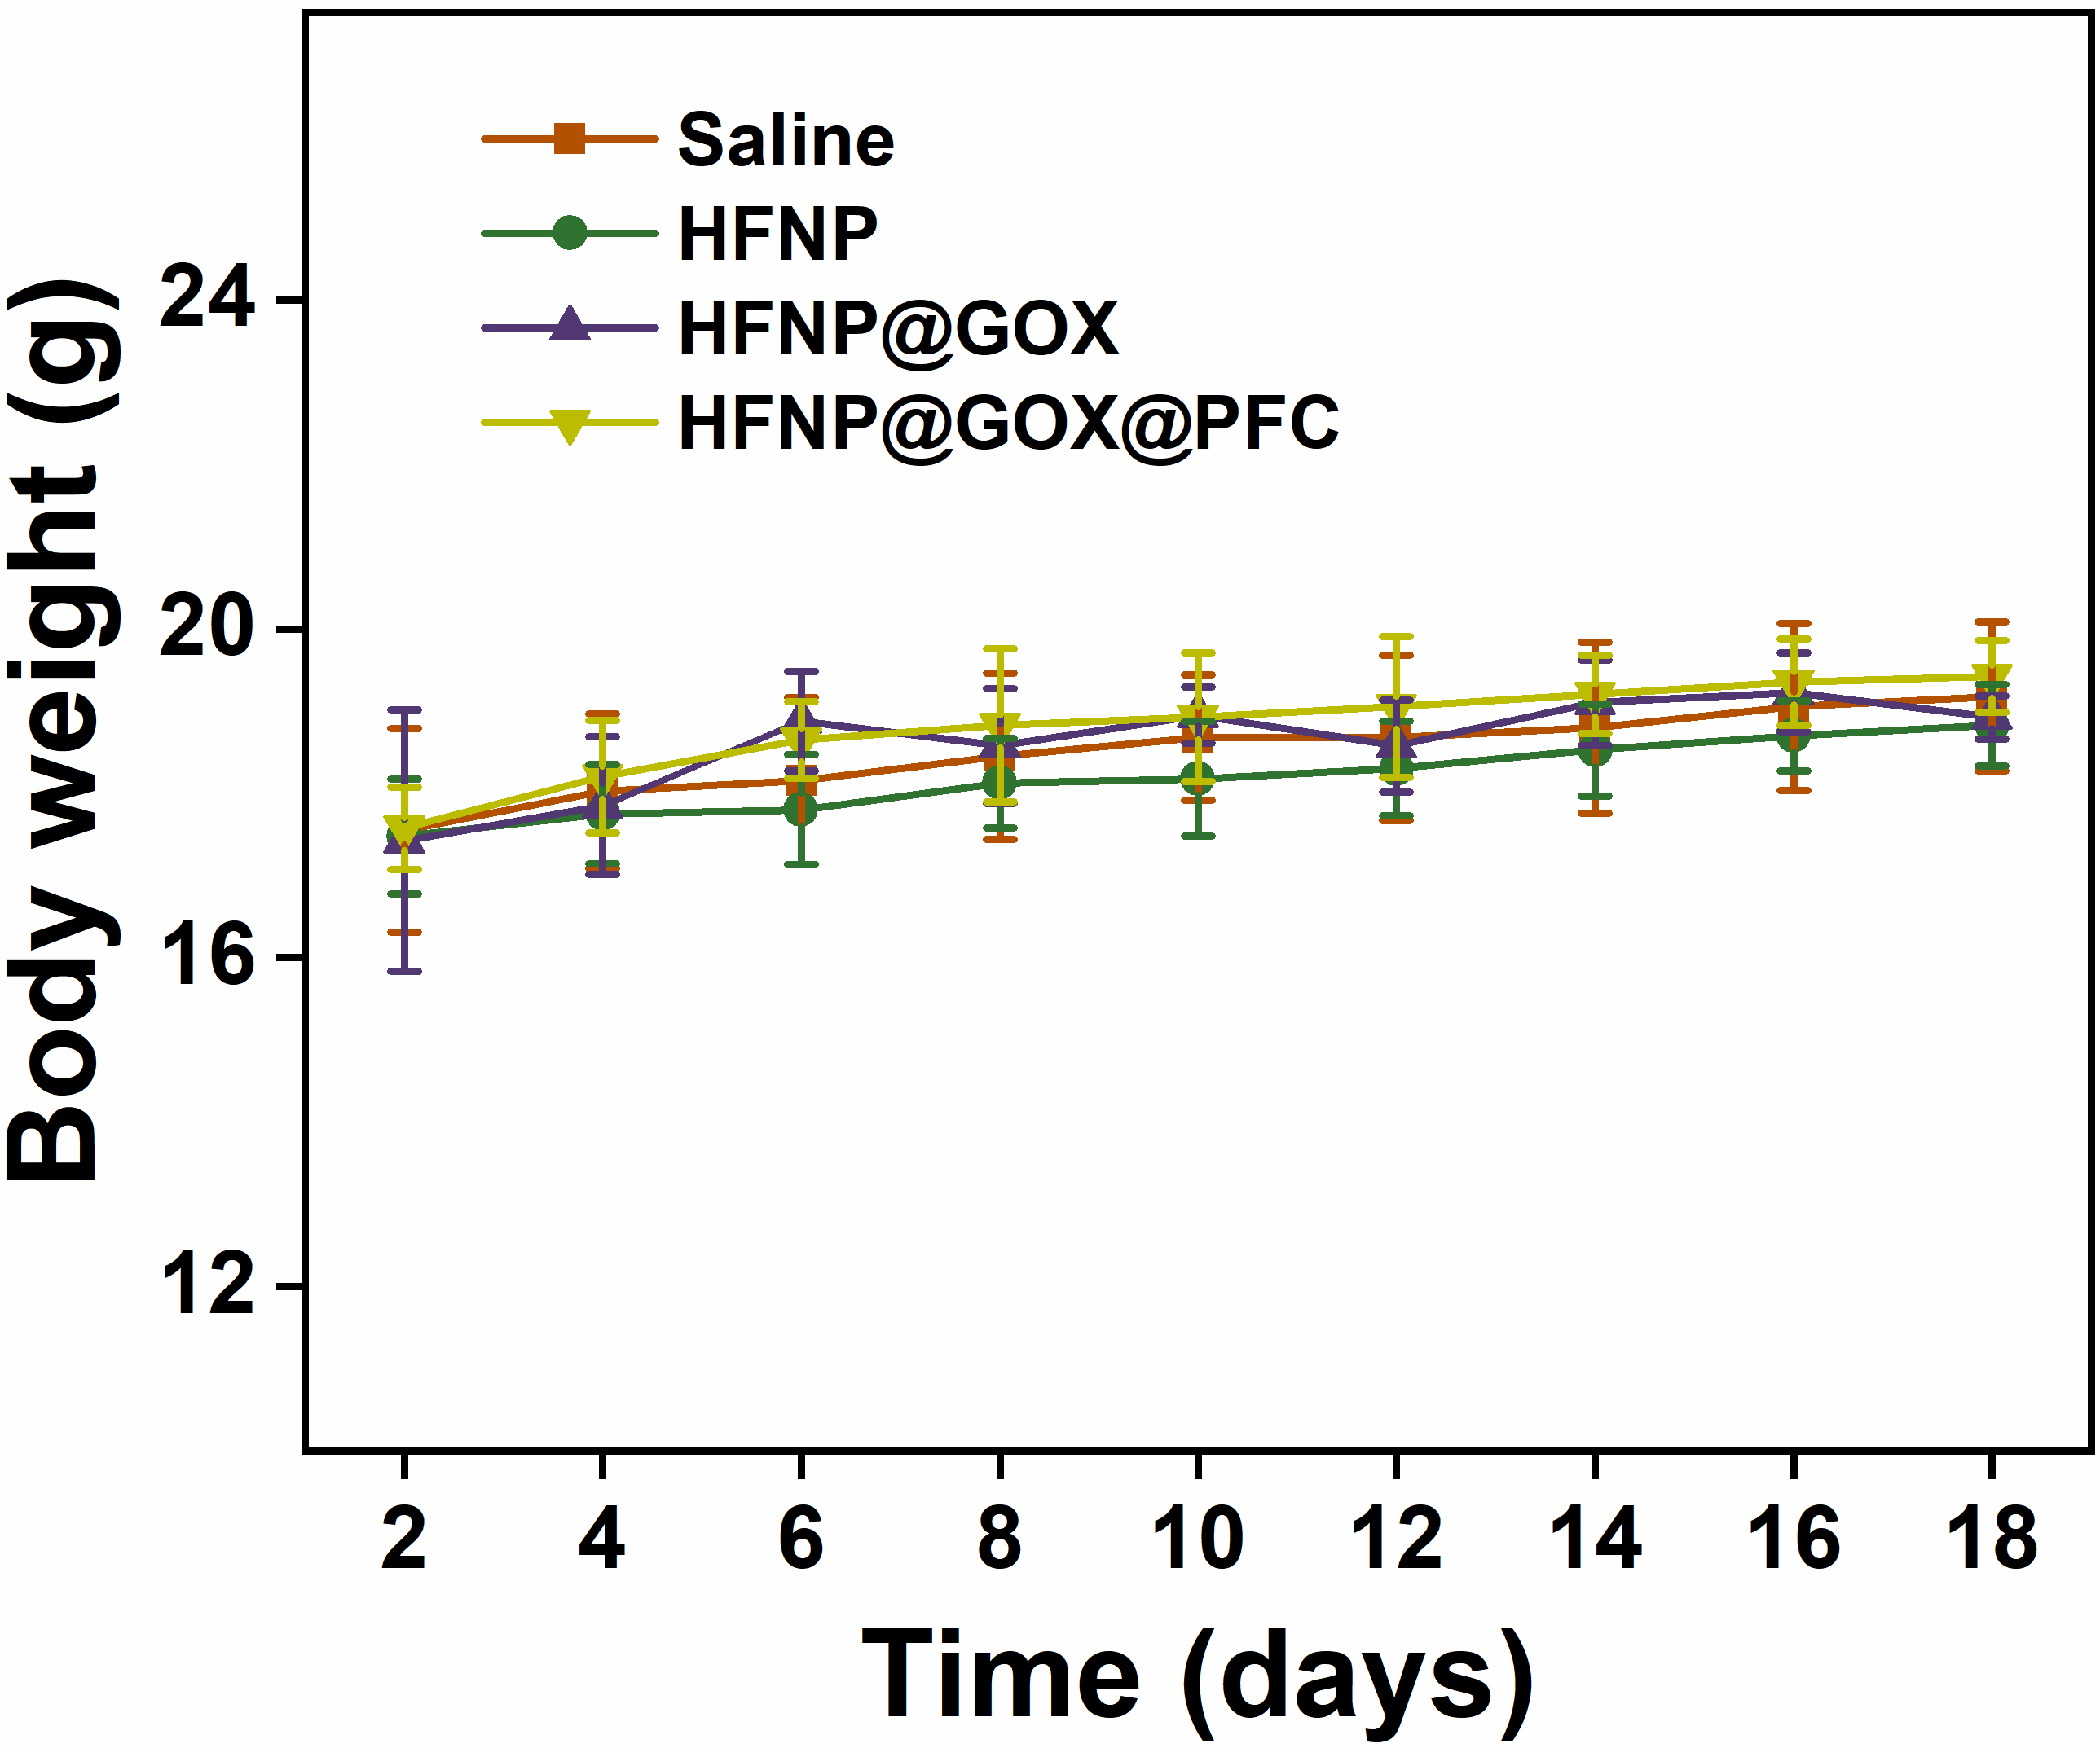

Fig. S19 Body weight of tumor-bearing mice after various treatments for 18 days. Error bars present as mean ± SD (n = 6).

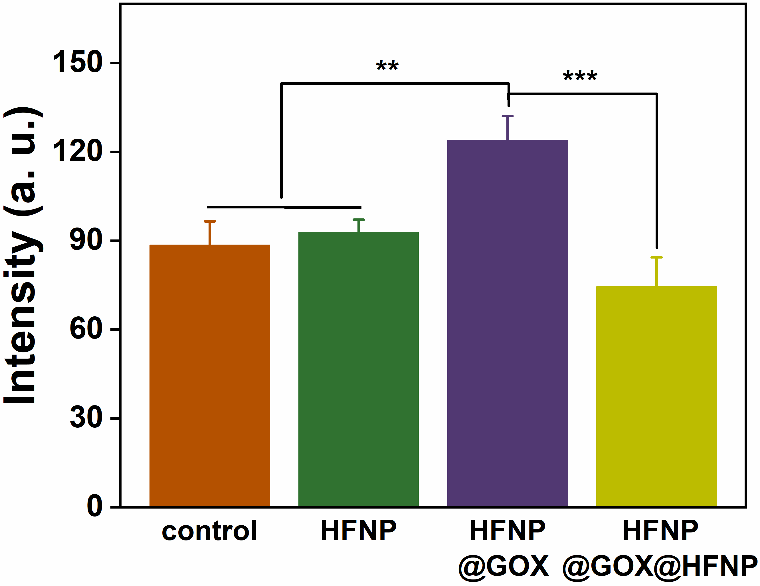

Fig. S20 The quantitative IFC intensity analysis of CD47 based on Fig. 6D. Error bars present as mean ± SD (n = 6).

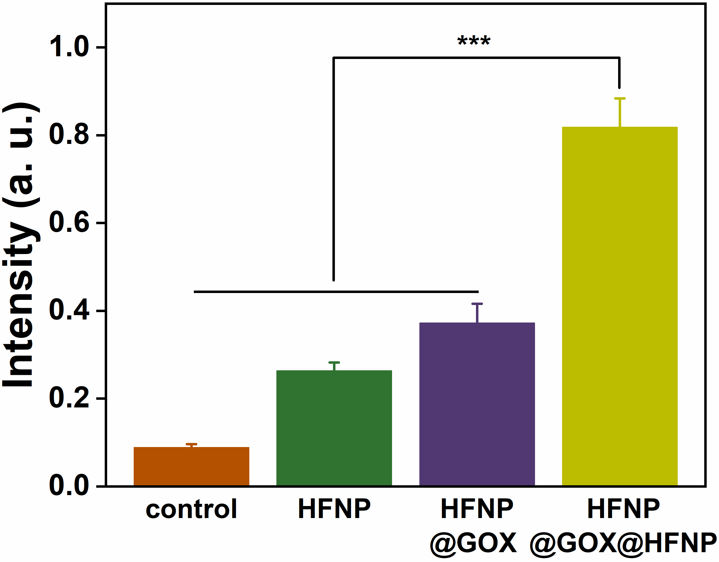

Fig. S21 The quantitative IFC intensity analysis of CD86 based on Fig. 6D. Error bars present as mean ± SD (n = 6).

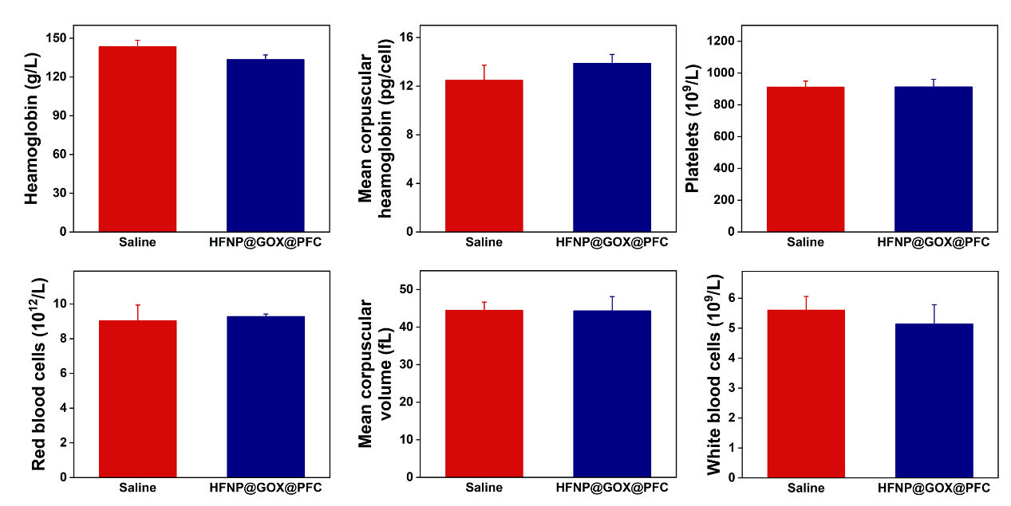

Fig. S22 Biomedical blood index of tumor-bearing BALB/c mice after treatment with saline and HFNP@GOX@PFC for 18 days. Error bars present as mean ± SD (n = 4).

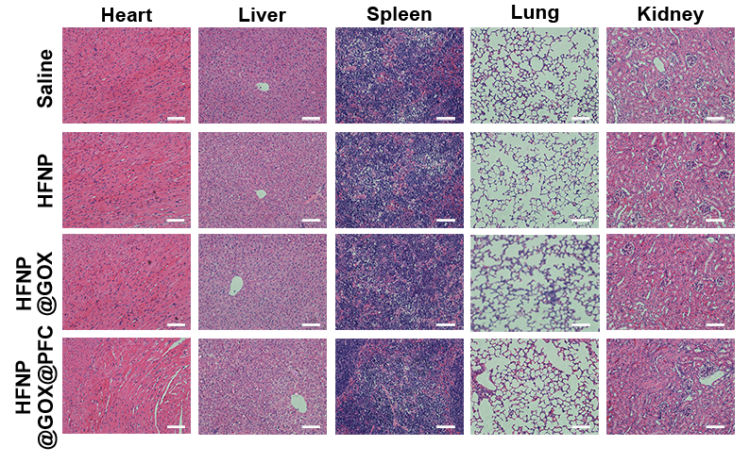

Fig. S23 H&E staining for major tissues (heart, spleen, liver and kidney). Scale bar: 100 μm.

Table S1. Primer sequences.
Gene | Forward Primer (5’→3’) | Reverse Primer (5’→3’)
BCL-2 | ATCGCCCTGTGGATGACTGA | CAGAGACAGCCAGGAGAAATCA
BAX | TGCTAGCAAACTGGTGCTCA | GGTCCCGAAGTAGGAGAGGA
Casp3 | CATCTGCATCCGTCCTGA | CTCTCGGCTGTGGTGGGTGAA
CytC | CACCGACACCGGTACATAGG | TCTCCCCAGGTGATGCCTTT
β-actin | GGTGTGATGGTGGGAATGGG | ACGGTTGGCCTTAGGGTTCAG

