Supporting Information
Kinetically and Thermodynamically Controlled One-pot Growth of Gold Nanoshells with NIR-II Absorption for Multimodal Imaging-Guided Photothermal Therapy

Ming Chen¹*, Xiao-Tong Chen², Lian-Ying Zhang², Wei Meng², Yong-Jian Chen², Ying-Shan Zhang², Zhi-Cong Chen², Hui-Min Wang², Chun-Mei Luo¹, Xiu-Dong Shi², Wen-Hua Zhang³, Mao-Sheng Wang¹ and Jin-Xiang Chen ²*

Figure S1 The TEM images of UGs with the ratio of formic acid to formaldehyde being 0.06% at 0 °C (a) and 50 °C (b), show that UGs form more quickly at a high temperature. nanoparticles with the ratio of formic acid to formaldehyde being 0.06% at 0 °C (a) and 50 °C (b), respectively.
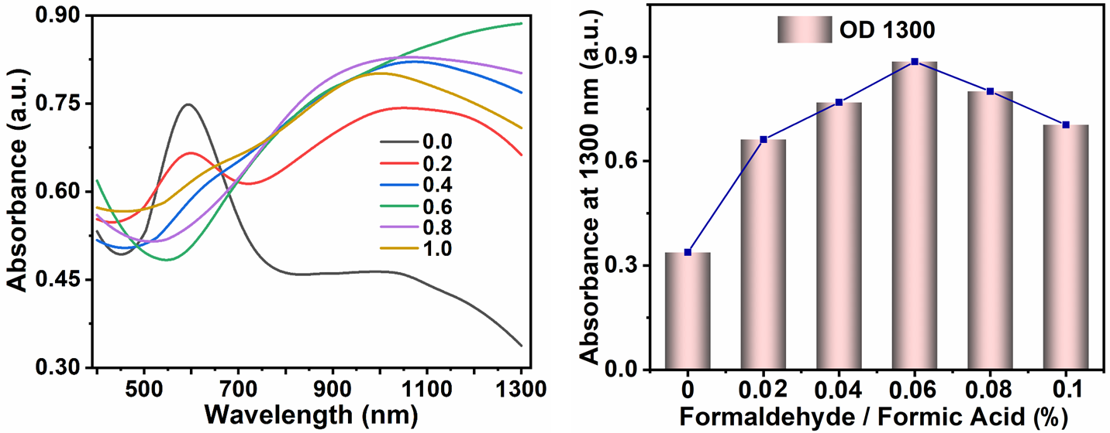
Figure S2 The corresponding UV-Vis absorbance spectra of UGs aqueous solution in 200 μL reductant (formic acid/formaldehyde (v/v)% = 0%, 0.02%, 0.04%, 0.06%, 0.08%, 0.1%).
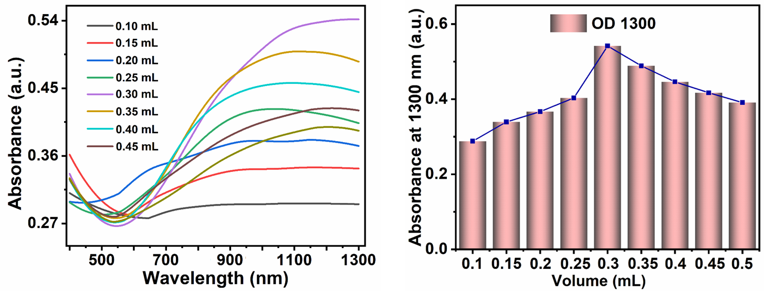
Figure S3 The corresponding UV-Vis absorbance spectra of UGs aqueous solution with different volumes (0.10, 0.15, 0.20 0.25, 0.30, 0.35, 0.40, 0.45, and 0.50 mL) of HAuCl₄ (10 mg mL⁻¹).
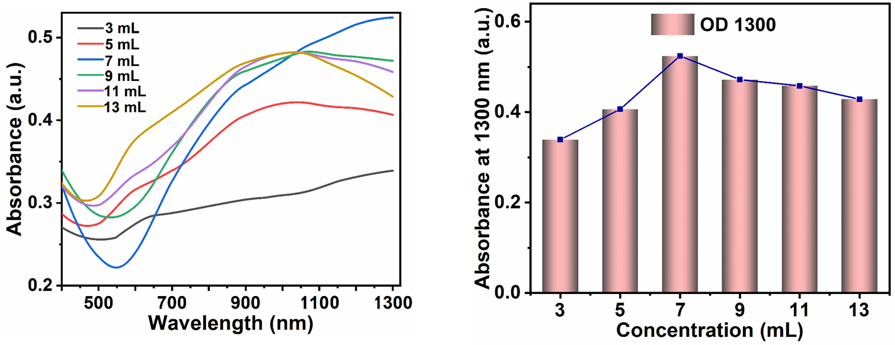
Figure S4 The corresponding UV-Vis absorbance spectra of UGs aqueous solution at the different volumes (3, 5, 7, 9, 11, and 13 mL) of 3 mg mL⁻¹ K₂CO₃.

Figure S5 The corresponding UV-Vis absorbance spectra of UGs aqueous solution at different volume (0, 0.025, 0.05, 0.1, 0.3, 0.5, and 1.0 mL) of 1.0 mg mL⁻¹ PVP.

Figure S6 (a) The aqueous solution color change during the UGs formation process. (b) The SEM images, and (c) the UV-Vis for the formation process of UGs at different reaction times (0, 5, 10, 15, 20, 30 min).

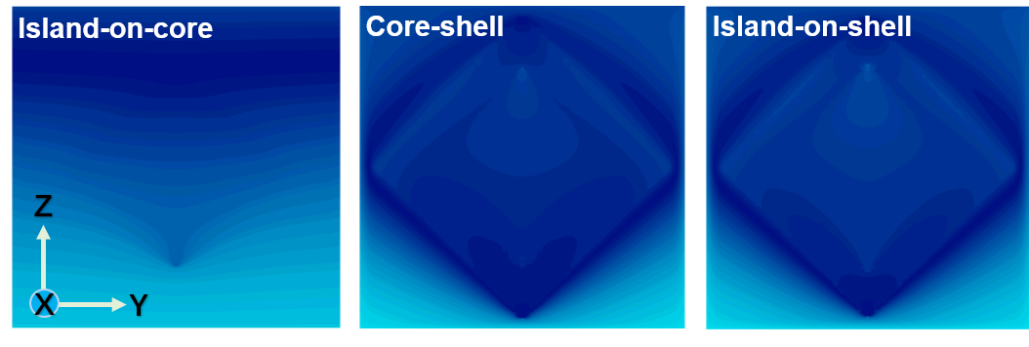
Figure S7 Electric field distributions of the island-on-core, core-shell, and island-on-shell nanostructures with an incidence of 1064 nm laser at the x-direction.
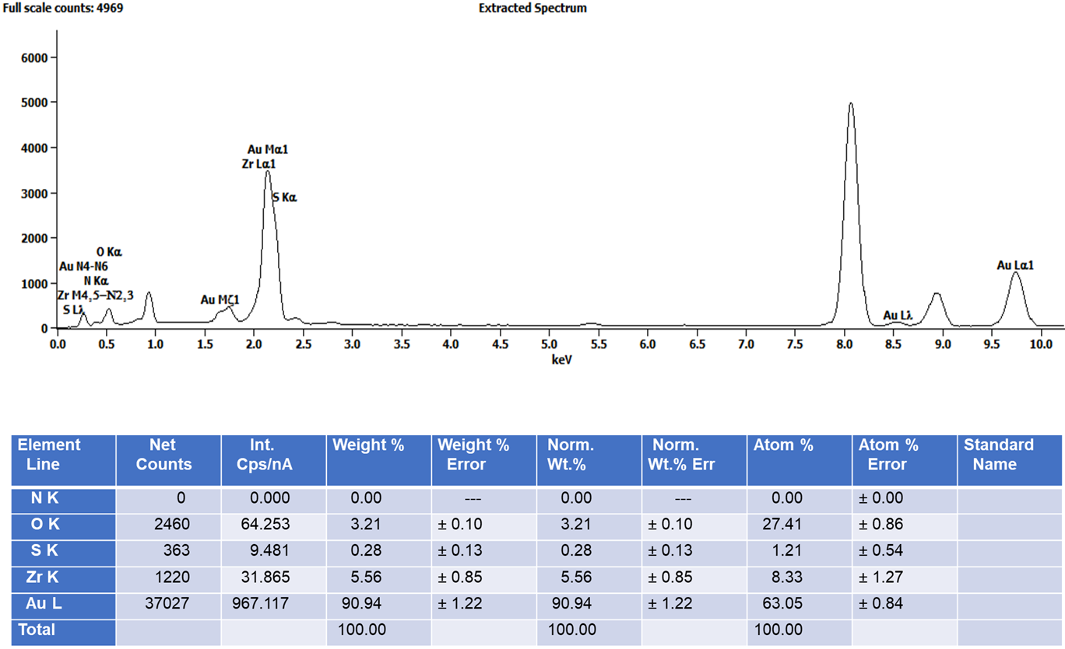Figure S8 The EDS spectrum of UGs and analysis results for UGs.
Figure S9 The photothermal stability test of UGs with four heating/cooling cycles under 1064 nm laser irradiation (200 μg mL⁻¹, 1.0 W cm⁻²).
Figure S10 The fluorescence images of 4T1 cells upon living (green) and dead (red) staining after various treatments. A laser irradiation (1064 nm) power at 1.5 W cm⁻² for 3 min was employed. Scale bar: 100 μm.
Figure S11 The hemolysis analysis of UGs@PEG.
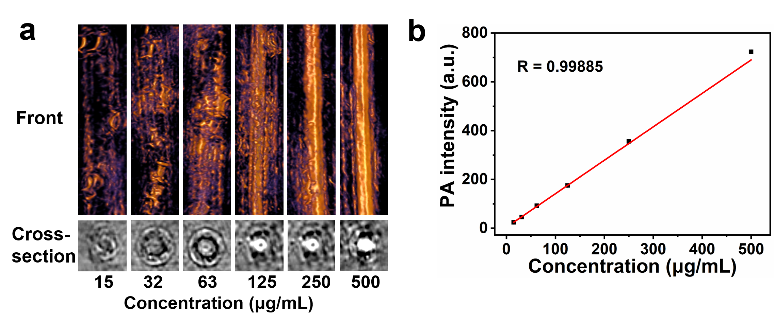
Figure S12 (a) The photoacoustic imaging (PAI) of deionized water and UGs@PEG aqueous suspensions with different concentrations (15, 32, 63, 125, 250, and 500 μg mL⁻¹) in the front and cross-section of photoacoustic tubes under 1064 nm lasers. (b) The photoacoustic signals of deionized water and UGs@PEG aqueous suspensions (15, 32, 63, 125, 250, and 500 μg mL⁻¹) under 1064 nm lasers.

Figure S13. The Au uptake content in the organs and tumor distribution were evaluated by ICP-MS analysis. After being injected with UGs@PEG (n = 4, dose = 20 mg/kg, mouse body weight) intravenously, tissues were harvested and broken up from mice bearing tumors at 24 h postinjection.

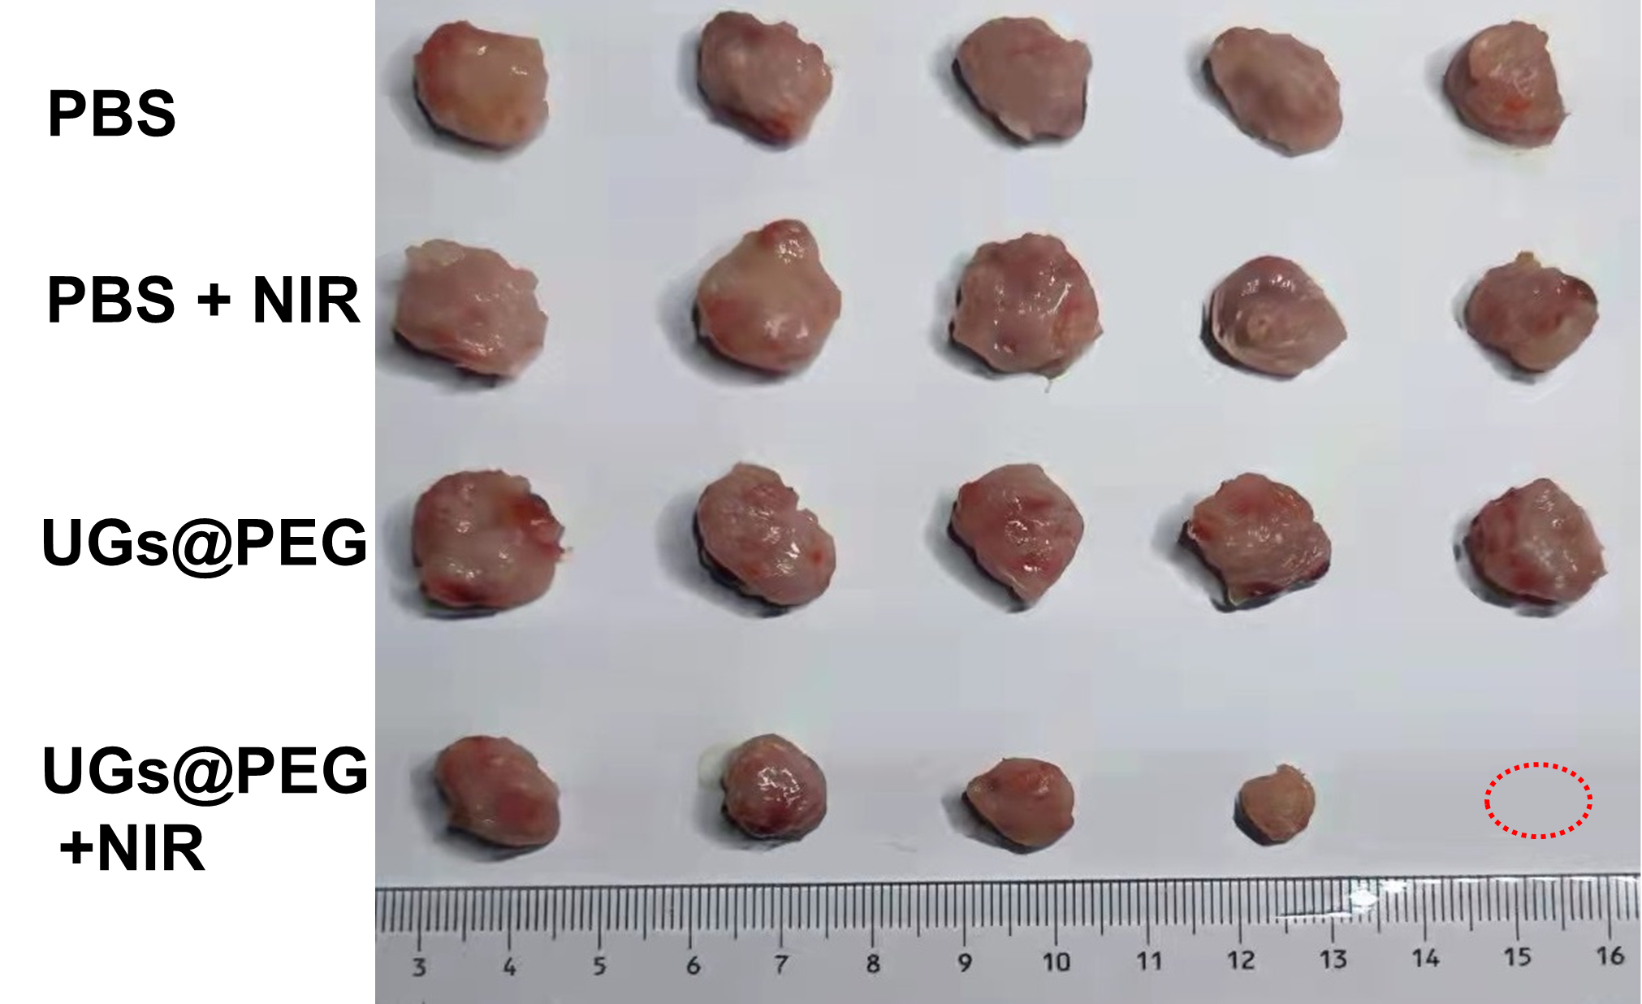
Figure S14 The tumors recorded after the therapeutic process show their varying sizes and thus different therapeutic efficacies.
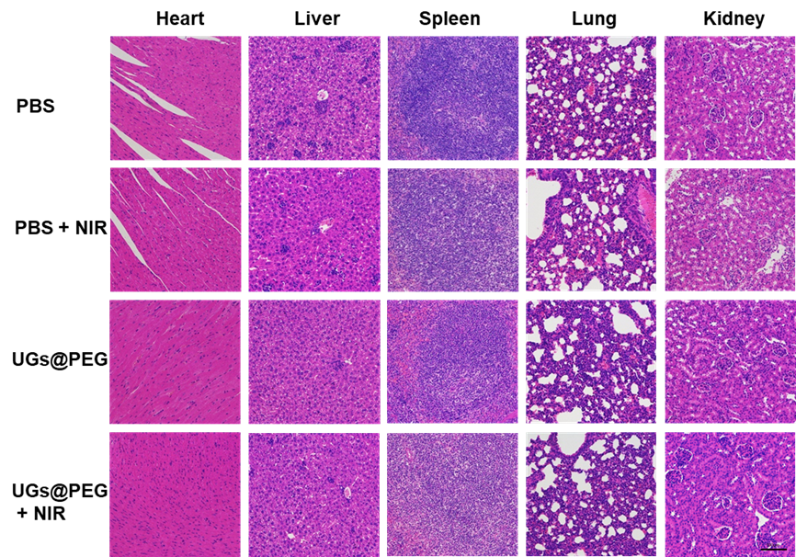
Figure S15 Hematoxylin and eosin (HE) staining of main organs from all experimental groups: PBS, PBS + NIR, UGs@PEG, and UGs@PEG + NIR. Scale bar: 100 μm.

Table S1. UV-Vis absorption peak and photothermal conversion efficiencies of reported gold nanoshells.
Materials | Description | Photothermal conversion efficiencies, η | UV-Vis absorption peak | Reference
Silica@Au nanoshells | Core (silica) coated with  a metallic layer (gold) | 8.25% | 800 nm | [S1]
mSiO₂@Au nanoshells | A hollow gold nanoshells | 21.00% | 600-800 nm | [S2]
GNShells | Hollow spherical GNShells | 21.77% | 600-800 nm | [S3]
PGNSs | Porous gold  nanoshells | 22.43% | 600-800 nm | [S4]
Pt-MOF@GNSs | Pt-decorated MOF@gold shells | 38.55% | 800 nm | [S5]
Gold nanoshells | A hollow gold nanoshells | 45.00% | 832 nm | [S6]
AuNPs-BA-Lips | Gold-nanobranched coated betulinic acid liposomes | 55.70% | 520 nm | [S7]
Pt@Au-TP-Lips | Platinum/gold bimetallic-nanoshell-coated triptolide | 56.50% | 650 nm | [S8]
PUA | Pt@UiO-66-NH₂@Au_{shell} nanoparticles | 58.65% | 800-810 nm | [S9]
SPIO-HGNS | Iron oxide-enclosed hollow gold nanoshell | 60.00% | 945 nm | [S10]
UGs@PEG | Diffusion growth mechanism of gold nanoshells | 74.03% | Beyond 1300 nm | this work

Supplementary References

[1] F.Y. Cheng, C.T. Chen, C.S. Yeh, Comparative Efficiencies of Photothermal Destruction of Malignant Cells Using Antibody-Coated Silica@Au Nanoshells, Hollow Au/Ag Nanospheres and Au Nanorods. Nanotechnology 20 (2009) 425104.
[2] M. Emamzadeh, G. Pasparakis, Polymer Coated Gold Nanoshells for Combinational Photochemotherapy of Pancreatic Cancer with Gemcitabine. Sci. Rep. 11 (2021) 1−15.
[3] Q. You, Q. Sun, M. Yu, J.P. Wang, S.Y. Wang, L. Liu, Y. Cheng, Y.D Wang, Y.L. Song, F.P. Tan, N. Li, BSA–Bioinspired Gadolinium Hybrid-Functionalized Hollow Gold Nanoshells for NIRF/PA/CT/MR Quadmodal Diagnostic Imaging-Guided Photothermal/Photodynamic Cancer Therapy. ACS Appl. Mater. Interfaces 9 (2017) 40017−40030.
[4] P.C. Xu, R. Wang, W.Q. Yang, Y.Y. Liu, D.S. He, Z.X. Ye, D.Q. Chen, Y. Ding, J.S. Tu, Y. Shen, A DM1-doped Porous Gold Nanoshell System for NIR Accelerated Redox-Responsive Release and Triple Modal Imaging Guided Photothermal Synergistic Chemotherapy. J. Nanobiotechnology 19 (2021) 1−19.
[5] Q. You, K.Y. Zhang, J.Y. Liu, C.L. Liu, H.Y. Wang, M.T. Wang, S.Y. Ye, H.Q. Gao, L.T. Lv, C. Wang, L. Zhu, Y.L. Yang, Persistent Regulation of Tumor Hypoxia Microenvironment via a Bioinspired Pt-Based Oxygen Nanogenerator for Multimodal Imaging-Guided Synergistic Phototherapy. Adv. Sci. 7 (2020) 1903341.
[6] Y.N. Guan, Z. Xue, J.L. Liang, Z.Z. Huang, W.S. Yang, One-pot Synthesis of Size-Tunable Hollow Gold Nanoshells via APTES-in-Water Suspension. Colloids Surf. A Physicochem. Eng. Asp. 502 (2016) 6−12.
[7] Y.P. Liu, X.W. Zhang, L.Y. Luo, L. Li, R.Y. Zhu, A.S. Li, Y.C. He, W.W. Cao, K. Niu, H. Liu, J.Y. Yang, D.W. Gao, Gold-Nanobranched-Shell Based Drug Vehicles with Ultrahigh Photothermal Efficiency for Chemo-Photothermal Therapy. Nanomedicine 18 (2019) 303−314.
[8] L.Y. Luo, H.Y. He, C.H. Li, Y.Q. He, Z.N. Hao, S. Wang, Q.Q. Zhao, Z.W. Liu, D.W. Gao, Near-Infrared Responsive Bimetallic Nanovesicles for Enhanced Synergistic Chemophotothermal Therapy. ACS Biomater. Sci. Eng. 5 (2019) 1321−1331.
[9] C. Liu, L.J. Luo, L.Y. Zeng, J. Xing, Y.Z, Xia, S. Sun, L.Y. Zhang, Z. Yu, J.L. Yao, Z.S. Yu, O.U. Akakuru, M. Saeed, A.G. Wu, Porous Gold Nanoshells on Functional NH₂-MOFs: Facile Synthesis and Designable Platforms for Cancer Multiple Therapy. Small 14 (2018) 1801851.
[10] M.Z. Yuan, X.H. Feng, T.H. Yan, J.F. Chen, X.Z. Ma, P. Cunha, S.F. Lan, Y. Li, H.C. Zhou, Y. Wang, Superparamagnetic iron oxide-enclosed hollow gold nanostructure with tunable surface plasmon resonances to promote near-infrared photothermal conversion. Adv. Compos. Mater. (2022) 1−12.

