Additional Materials
Tannic Acid-Functionalized 3D Porous Nanofiber Sponge for Antibiotic-Free Wound Healing with Enhanced Hemostasis, Antibacterial, and Antioxidant Properties
Zihang Huang¹, Donghui Wang², Steffan Møller Sønderskov³, Dan Xia^{1*}, Xiaotong Wu¹, Chunyong Liang^{1, 2*}, Mingdong Dong^{3*}
¹ Tianjin Key Laboratory of Materials Laminating Fabrication and Interface Control Technology, School of Materials Science and Engineering, Hebei University of Technology, Tianjin 300130, China
² Center for Health Science and Engineering, School of Health Sciences and Biomedical Engineering, Hebei University of Technology, Tianjin 300130, China
³ Interdisciplinary Nanoscience Center (iNANO), Aarhus University, Aarhus C, DK-8000, Denmark
* Correspondence: xiad@hebut.edu.cn (D.X.); liangchunyong@hebut.edu.cn (C.L.); dong@inano.au.dk (M.D.)

Additional file 1: Additional Figures

Fig. S1 Macroscopic morphology of 3D nanofiber sponge. (a) Comparison of 3D nanofiber sponge and 2D nanofiber membrane; The photographs of 3D sponges with different (b) heights and (c) morphologies prepared via different molds.
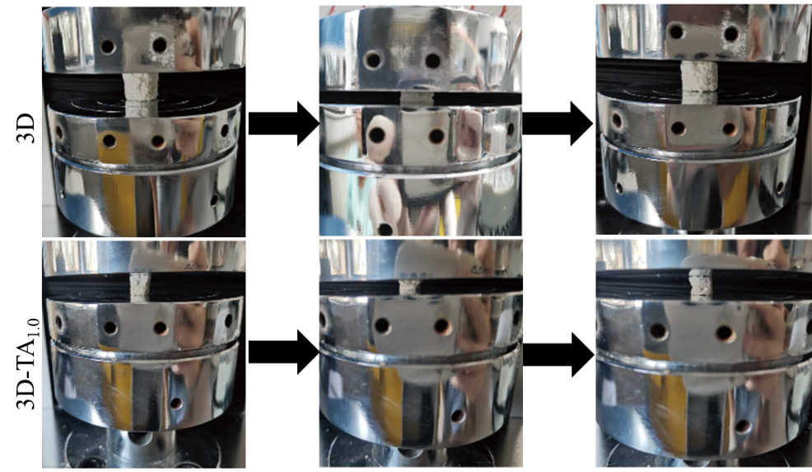
Fig. S2 Compression/resiliecne process. The compression/resiliecne process of 3D and 3D-TA_{1.0} nanofiber sponges.
Fig. S3 Cell Live-dead staining. Live-dead staining florescent images of L929 co-cultured with different sample extracts for 3 days.

