Additional file Information

Biomimetic hypoxia-triggered RNAi nanomedicine for synergistically mediating chemo/radiotherapy of glioblastoma

Zhen Wang^{a‡}, Xianglong Tang^{b,c‡*}, Mengjie Zhao^{b,c‡}, Yong Xiao^{a‡}, Yiding Zhangª, Yuyang Liuª, Chunfa Qianª, Yan-dong Xie ª, Yong Liuª, Yuanjie Zouª, Kun Yangª* and Hongyi Liu^{a,b,c}*

ª Department of Neurosurgery, the Affiliated Brain Hospital with Nanjing Medical University, Fourth Clinical College of Nanjing Medical University, Nanjing 210029, China
^{b} Department of Neuro-Psychiatric Institute, the Affiliated Brain Hospital with Nanjing Medical University, Nanjing 210029, China
^{c} Institute of Neuro-science, Nanjing Medical University, Nanjing 210029, China

* Correspondence should be addressed to H.Y. Liu (njnkyylhy@163.com) or K.Y. (yk_nj@hotmail.com) or X.L.Tang (xltang0326@163.com)

(1)
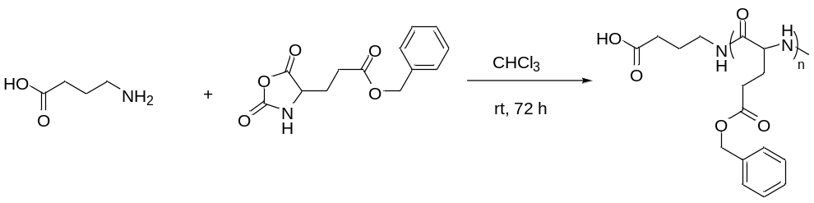
(2)
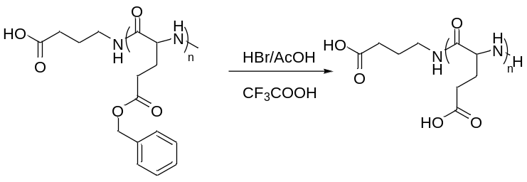
(3)
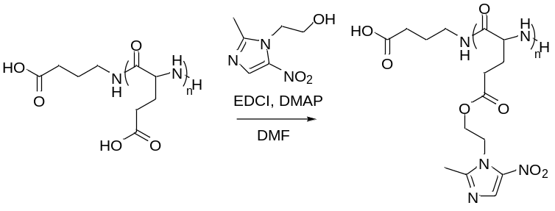
(4)
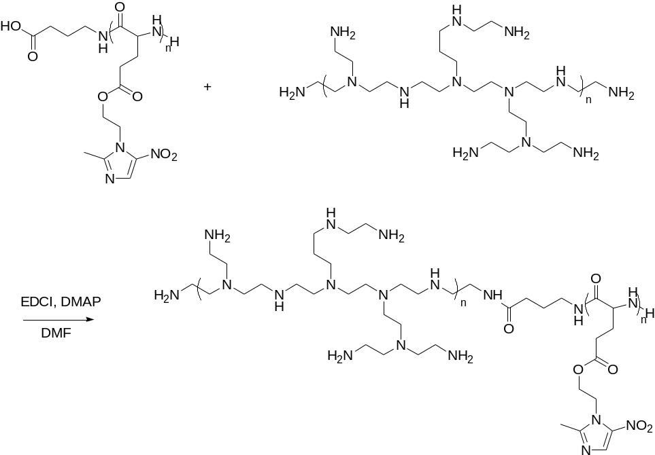
Figure S1. Synthetic routes of poly(MIs)-PEI block copolymers by ROP reaction and condensation reaction.
Figure S2. ¹H NMR spectra of poly(MIs)-PEI block copolymers by D₂O exchange of active hydrogen (D₂O/DMSO-d6, 400 MHz).

Figure S3. FT-IR spectra of poly(MIs)-PEI block copolymers.

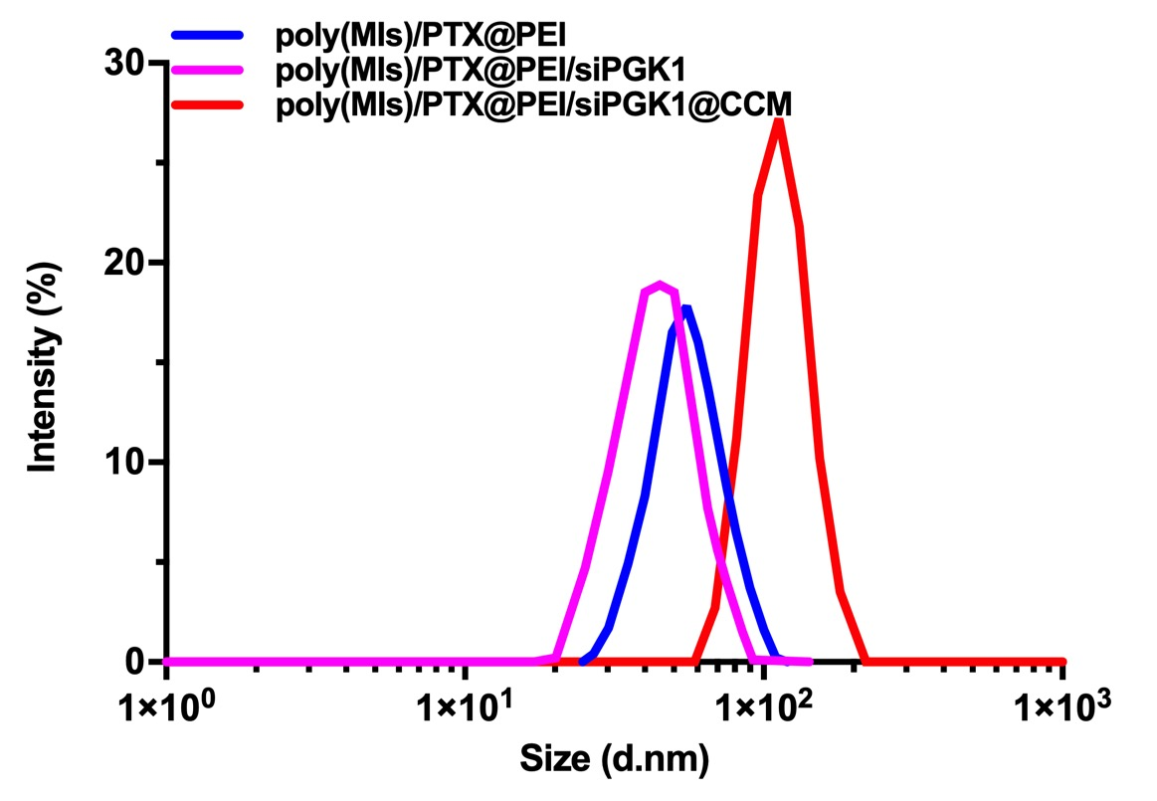
Figure S4. Size distribution of poly(MIs)/PTX@PEI, poly(MIs)/PTX@PEI/siPGK1 and poly(MIs)/PTX@PEI/siPGK1@CCM in PBS.
Figure S5. (A) Size distribution of poly(MIs)/PTX@PEI/siPGK1@CCM under normoxic and hypoxic conditions. (B) UV-Vis absorption spectra of poly(MIs) under normoxia and hypoxia.
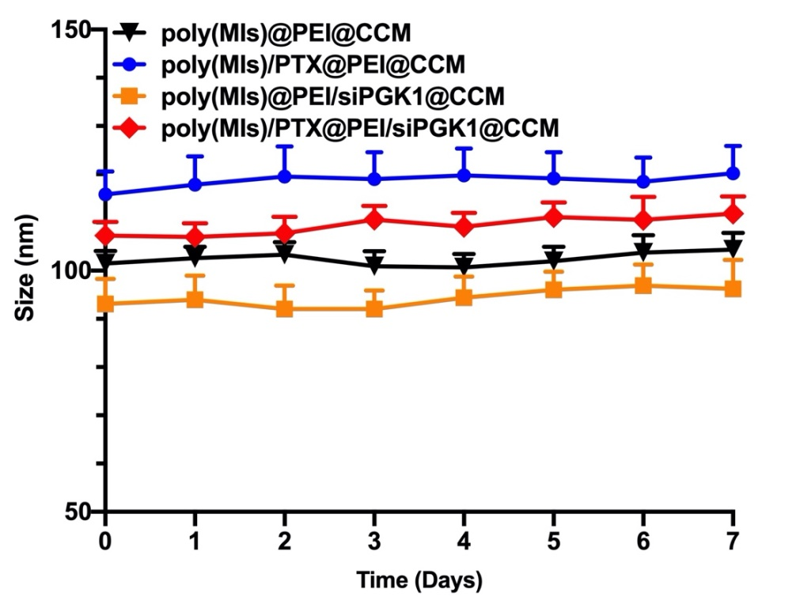
Figure S6. The stability of poly(MIs)@PEI@CCM, poly(MIs)/PTX@PEI@CCM, poly(MIs)@PEI/siPGK1@CCM and poly(MIs)/PTX@PEI/siPGK1@CCM NPs were investigated in DMEM containing 10% FBS over seven days. Data are shown as mean ± SD (n=3).
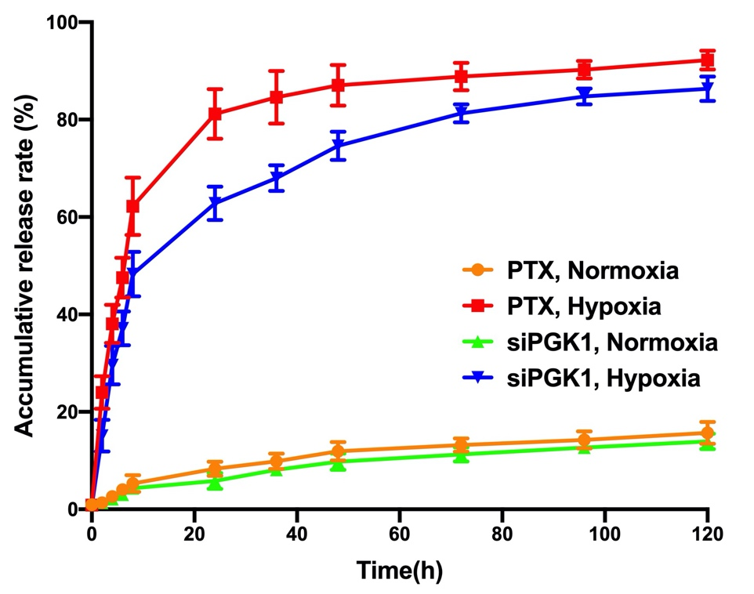
Figure S7. Sequential release of siPGK1 and PTX from poly(MIs)/PTX@PEI/ siPGK1@CCM. Data are shown as mean ± SD (n=3).
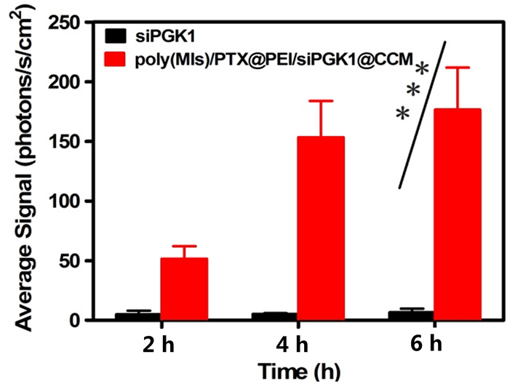
Figure S8. Quantitative analysis of cumulative transport of poly(MIs)/PTX@PEI/ siPGK1@CCM at different time points across the bEnd.3 monolayer. Data are shown as mean ± SD (n=3).
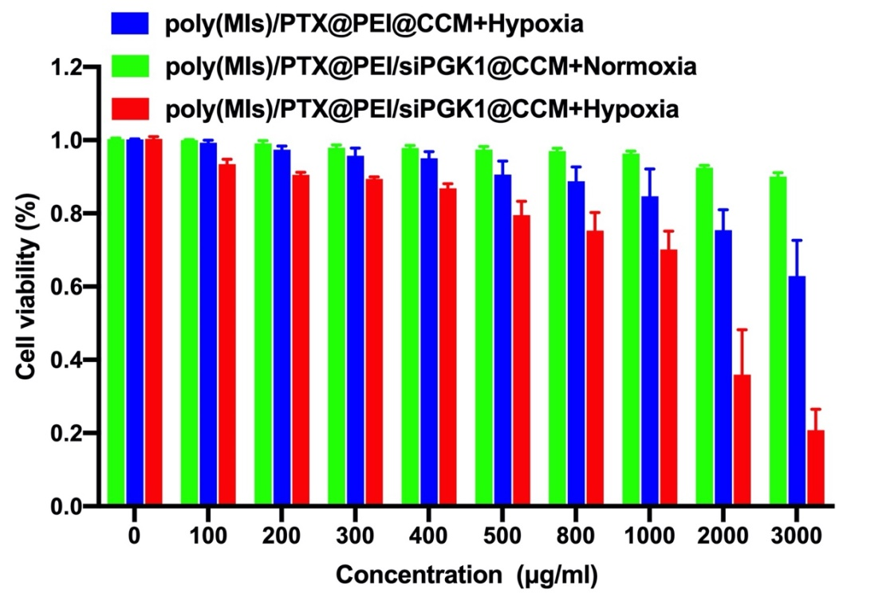
Figure S9. Cell viability of poly(MIs)/PTX@PEI/siPGK1@CCM with various concentration in normoxia and hypoxia, respectively. Data are shown as mean ± SD (n=3).

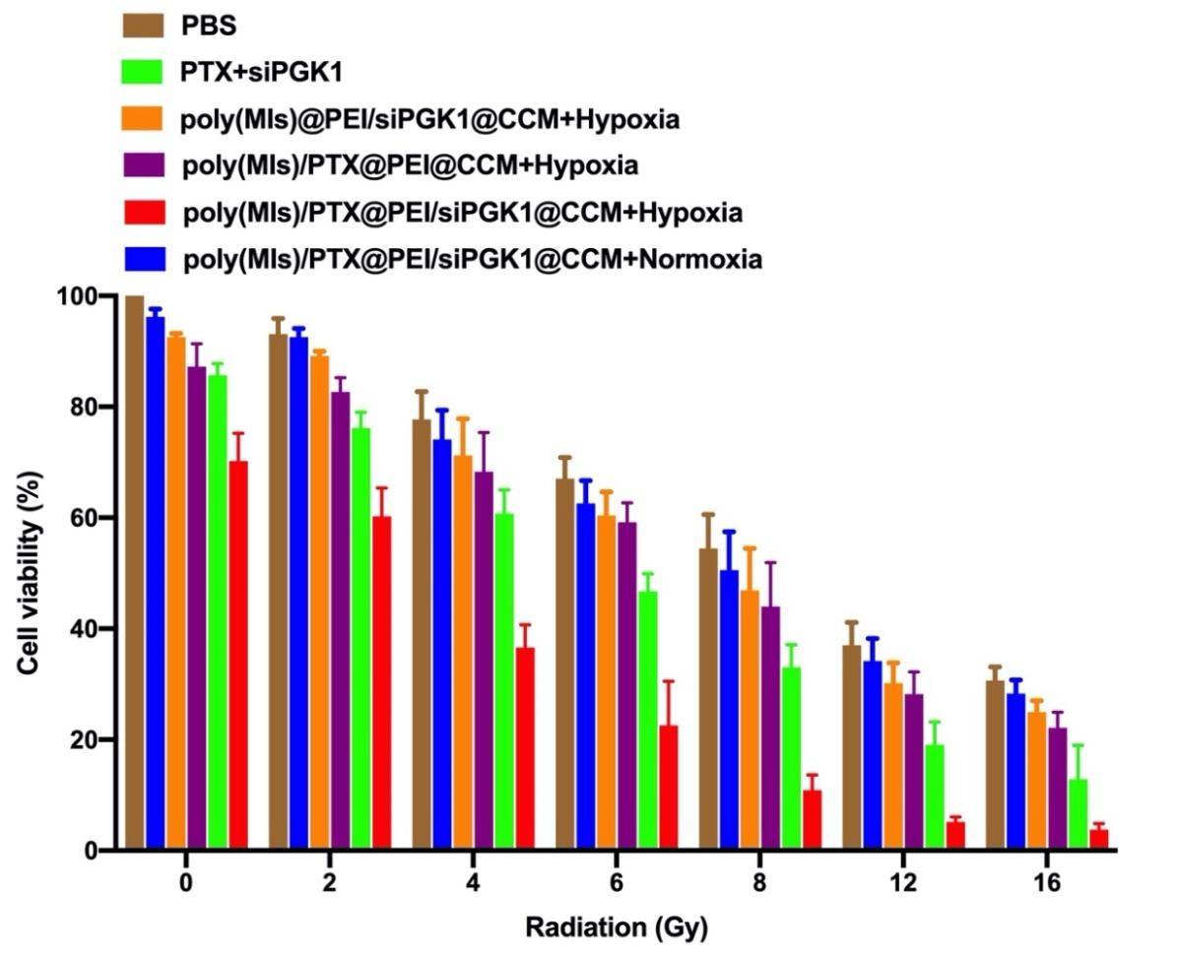
Figure S10. Cell viability of poly(MIs)/PTX@PEI/siPGK1@CCM with different radiation dose. Data are shown as mean ± SD (n=3).
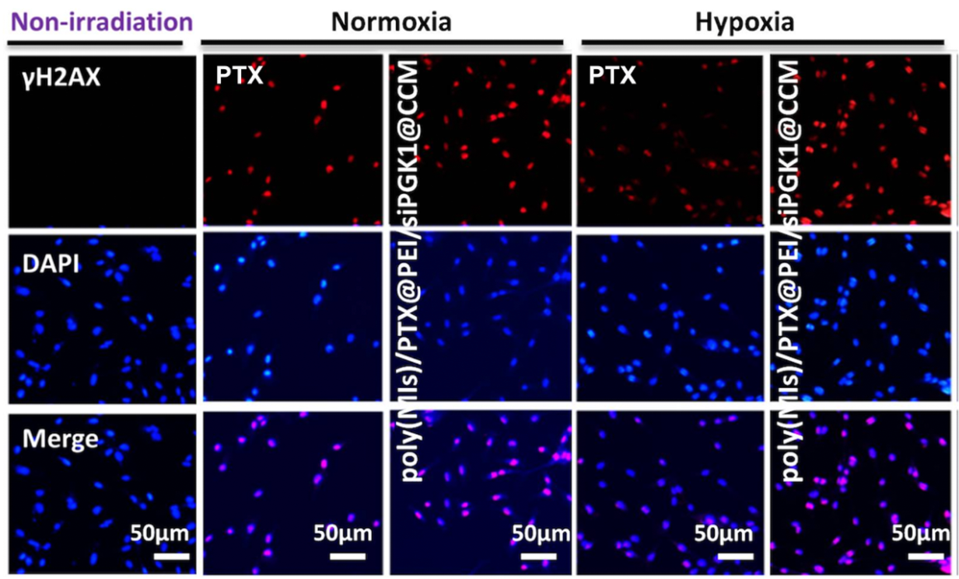
Figure S11. Immunocytochemical analysis of γ-H2AX expressed by U87 cells. Cells were stained with an anti-γ-H2AX antibody (red) and DAPI (blue) 24 h after RT
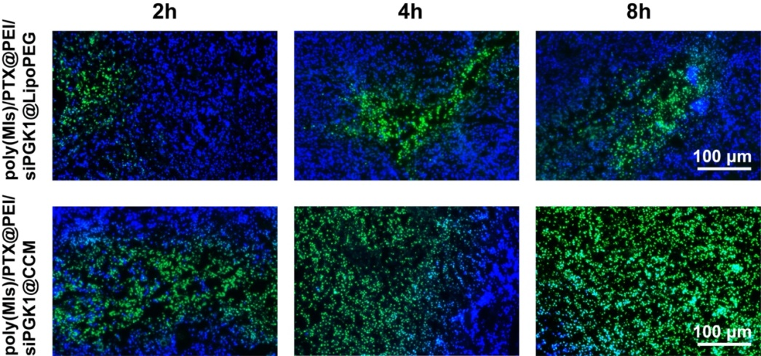
Figure S12. Fluorescence images of frozen sections of tumor tissue (at a siPGK1 concentration of 2.3 mg kg⁻¹) at different times after injection of poly(MIs)/PTX@PEI/siPGK1@LipoPEG and poly(MIs)/PTX@PEI/siPGK1@CCM. FAM-siPGK1 (green), and cell nuclei (blue). (Scale bar: 100 μm)
Figure S13. Representative tissue sections of mice stained with hematoxylin and eosin (H&E) after 30 days of different treatments.
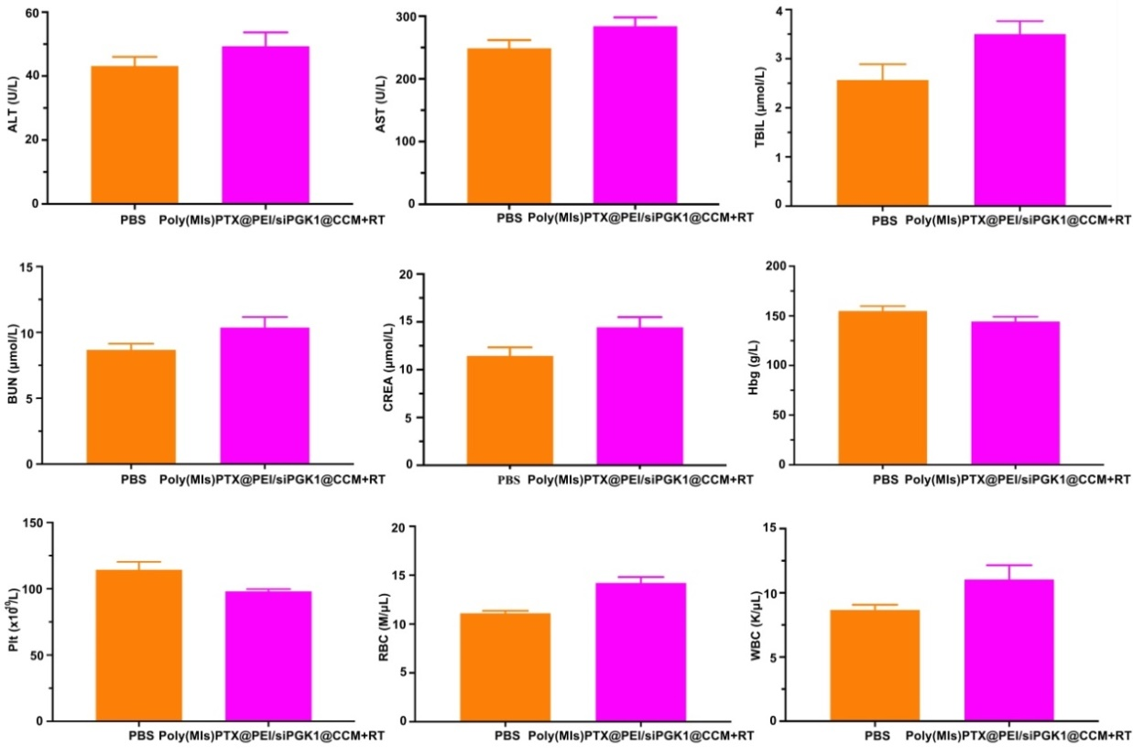
Figure S14. Results analysis of liver and kidney functions by blood biochemistry after treatment with poly(MIs)/PTX@PEI/siPGK1@CCM.

