Supporting Information

Biodegradable FePS₃ nanoplatform for efficient treatment of osteosarcoma by combination of gene and NIR-II photothermal therapy

Tingting Luo^{1†}, Mingyang Jiang^{2†}, Ziqiang Cheng^{3†}, Yuntao Lin¹, Yuling Chen¹, Zhenyu Zhang², Jian Zhou¹, Wenhua Zhou², Xue-Feng Yu², Shuchun Li^{1*}, Shengyong Geng^{2*}, and Hongyu Yang^{1*}

¹ Guangdong Provincial High-level Clinical Key Specialty, Guangdong Province Engineering Research Center of Oral Disease Diagnosis and Treatment, The Institute of Stomatology, Peking University Shenzhen Hospital, Shenzhen Peking University-The Hong Kong University of Science and Technology Medical Center, Guangdong province, China
² Materials and Interfaces Center, Shenzhen Institutes of Advanced Technology, Chinese Academy of Sciences, Shenzhen 518055, China
³ Department of Applied Physics, School of Science, East China Jiaotong University, Nanchang 330013, China

* Corresponding authors:
Shengyong Geng, Email: sy.geng@siat.ac.cn
Shuchun Li, Email: lisc56@163.com
Hongyu Yang, Email: hyyang192@hotmail.com

† These authors contributed equally to this work.
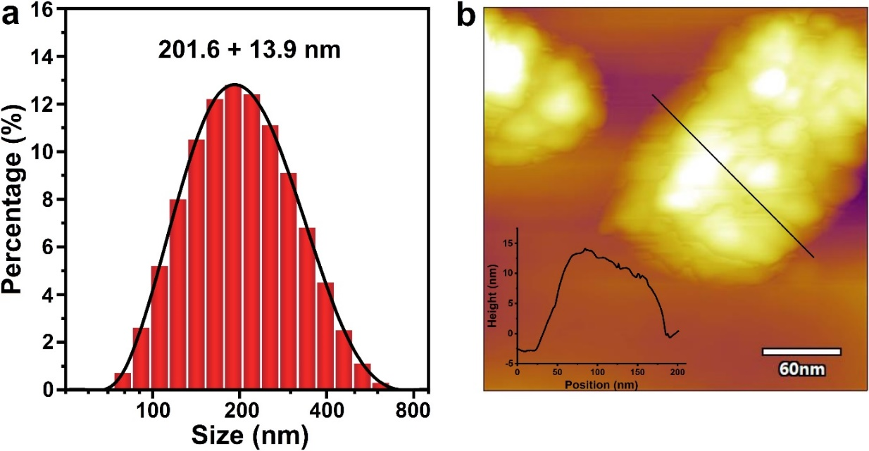
Fig. S1 (a) Size distribution analyzed by DLS. (b) AFM image of FePS NSs.

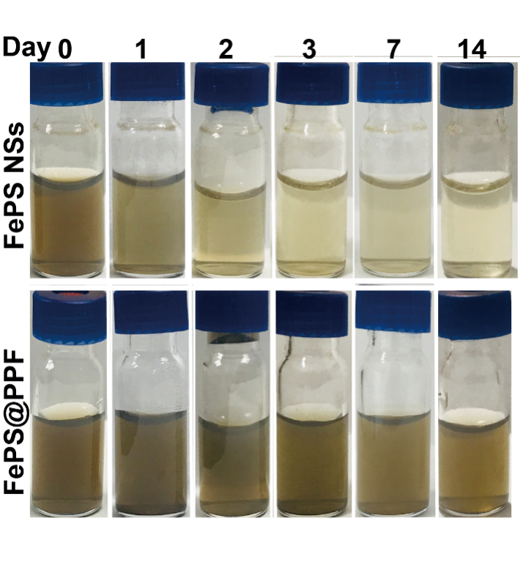
Fig. S2 Digital images of FePS NSs and FePS@PPF dispersed in water with different periods of time.

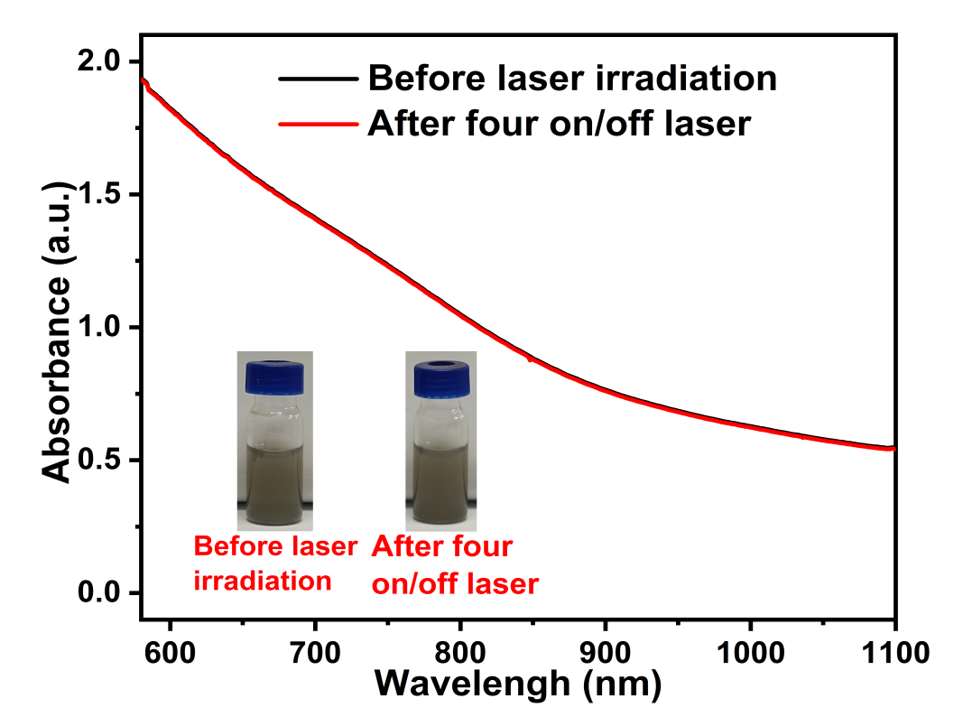
Fig. S3 The UV-Vis-NIR absorbance and digital images of FePS@PPF before/after four laser on/off cycles.

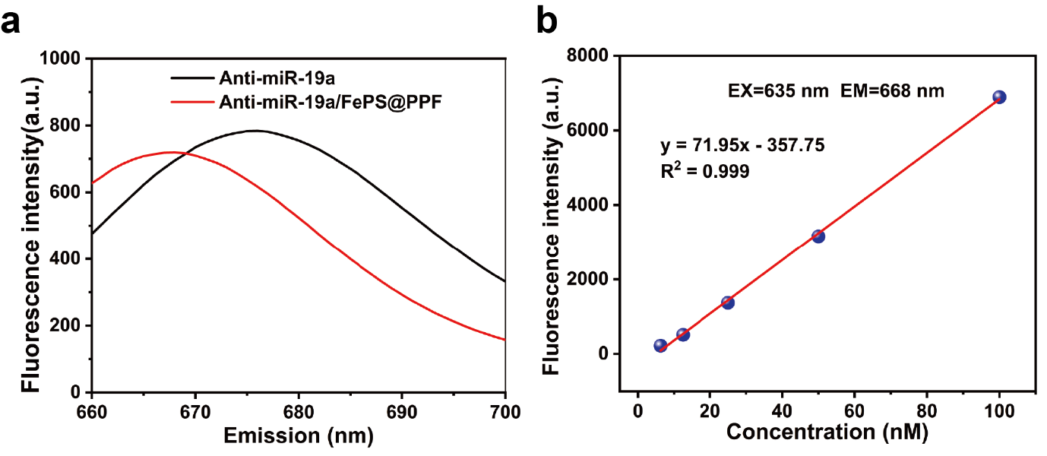
Fig. S4 The fluorescence detection of Cy5.5-labeled anti-miR-19a. (a) Emission (EM) spectrum of Cy5.5-labeled anti-miR-19a and Cy5.5-labeled anti-miR-19a/FePS@PPF at 635 nm of excitation. (b) The fluorescence intensity of Cy5.5-labeled anti-miR-19a at different concentration (EX = 635 nm, EM = 668 nm).

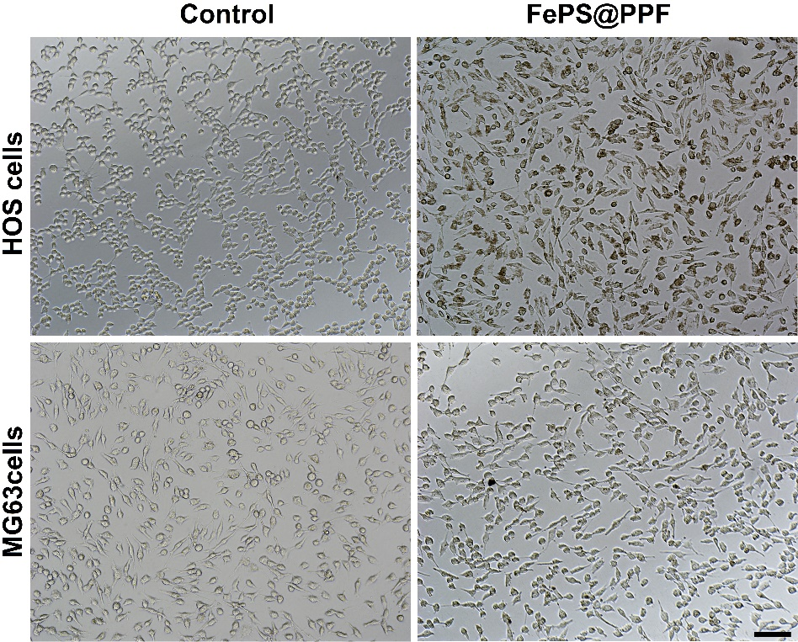
Fig. S5 Bright-field images of HOS cells and MG63 cells with or without treatment of FePS@PPF. Scale bar is 100 µm.

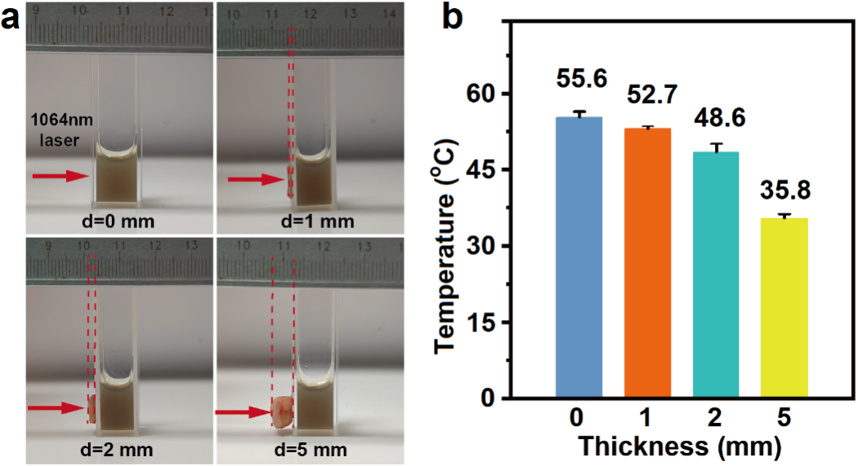
Fig. S6 (a) Digital images of different tumor thicknesses (0, 1, 2, and 5 mm). (b) Temperature of FePS@PPF after the irradiation of 1064 nm laser (1.0 W/cm²) for 10 min.

