Supporting Information

Facile and eco-friendly fabrication of biocompatible hydrogel containing CuS@Ser NPs with mechanical flexibility and photothermal antibacterial activity to promote infected wound healing

Ye Guo, Bingqing Xie, Min Jiang, Lingling Yuan, Xueyu Jiang, Silei Li, Rui Cai, , Junliang Chen, Xia Jiang, Yun He*, Gang Tao*

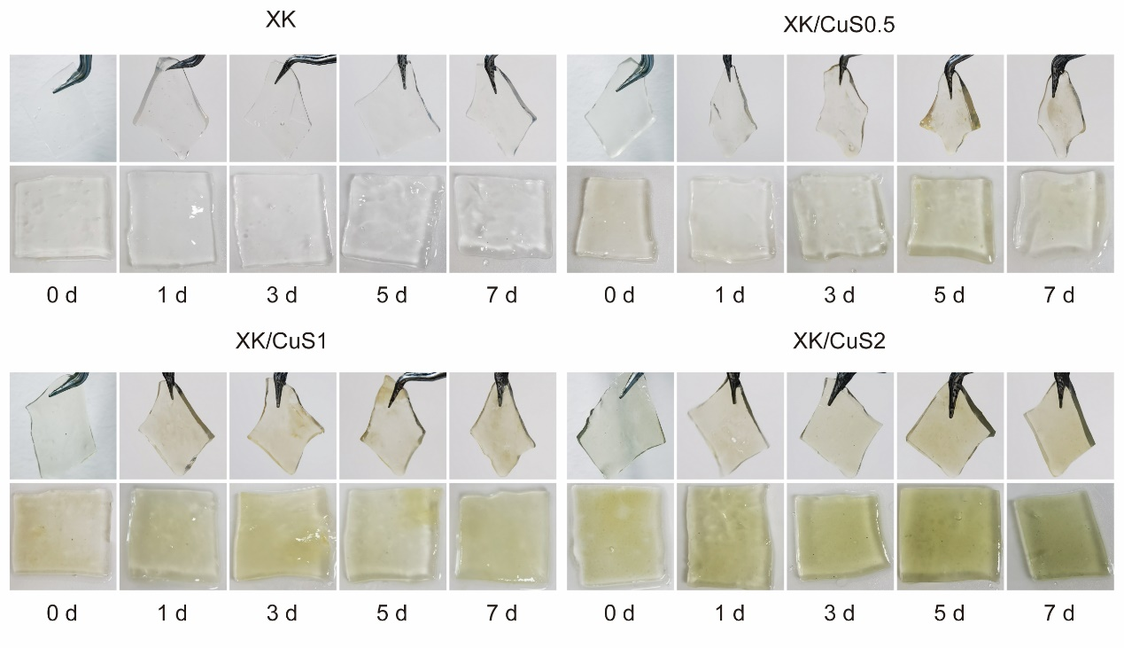
Fig. S1. Photograph of XK, XK/CuS0.5, XK/CuS1, and XK/CuS2 hydrogel after soaking in PBS for 0, 1, 3, 5, and 7 days, respectively.
Fig. S2. Weight change of XK, XK/CuS0.5, XK/CuS1, and XK/CuS2 hydrogel after soaking in PBS for 0, 1, 3, 5, and 7 days, respectively.

