Supplementary Materials
Conversion of senescent cartilage into a pro-chondrogenic microenvironment with antibody-functionalized copper sulfate nanoparticles for efficient osteoarthritis therapy

Xianming Wang^{a,b,c#}, Yu Cai^{d#}, Cuixi Wu^{e#}, Jiamin Liang^{f}, Kangning Tang^{c}, Zefeng Lin^{c}, Lingling Chen^{c}, Yao Lu^{e*}, Qing Wang^{a,b*}

ªDepartment of Orthopedic Surgery, The Second Affiliated Hospital, Guangzhou Medical University, Guangzhou, Guangdong, China.
^{b}The First School of Clinical Medicine, Southern Medical University, Guangzhou, Guangdong, China
^{c}Department of Orthopedics, General Hospital of Southern Theater Command of PLA, Guangzhou, Guangdong, China
^{d}Precision Medicine in Oncology (PrMiO), Department of Pathology, Erasmus MC Cancer Institute, Erasmus MC, Rotterdam, The Netherlands
^{e}Department of Joint and Orthopedics, Orthopedic Center, Zhujiang Hospital, Southern Medical University, Guangzhou, Guangdong, China
^{f}Department of Endocrinology, Zhujiang Hospital, Southern Medical University, Guangzhou, Guangdong, China

# These authors contributed equally to this work.
* Corresponding author: E-mail: oayul@smu.edu.cn (Y. Lu); wq748911@163.com (Q. Wang).

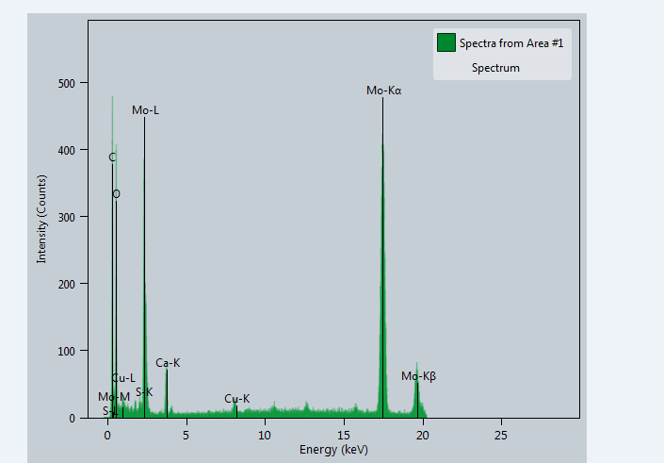
Figure S1. EDS spectra of CuS NPs. Noted that the presence of Mo is due to the use of molybdenum TEM grid.

Figure S2. Zeta potential of NPs.
Figure S3. Hydrated particle size of NPs.

Figure S4. Immunofluorescence staining of p16^{ink4a} in senescent cells.

Figure S5. SA-ꞵ-GAL staining of senescent cells.

Figure S6. Targeting effect of B2M-CuS toward senescent cells in the presence of free B2M antibody.

Figure S7. Targeting effect of NPs toward normal chondrocytes.

Figure S8. Hemolysis study of NPs. (a) Hemolytic rate of CuS and B2M-CuS NPs. (b) General image of blood with different treatments.

Figure S9. Intracellular ROS and mitochondrial ROS levels in normal chondrocytes.

Figure S10. Representative flow cytometry images of 7-AAD staining.

Figure S11. Representative flow cytometry analysis of apoptosis in senescent chondrocytes following treatment.

Figure S12. H&E staining of the main organs of mice after different treatments.

Figure S13. Cu²⁺ content in the main organs of mice 24 h after intra-articular injection of B2M-CuS NPs.

Table S1. Primers used for qRT-PCR
Genes | Sequence (5’-3’)
GAPDH | Forward: GAGGTATCCTGACCCTGAAGTA
GAPDH | Reverse: CACACGCAGCTCATTGTAGA
Caspase 3 | Forward: AGTGGGACTGATGAGGAGAT
Caspase 3 | Reverse: GAGACATCTCCTTCCCGTTTAC
Caspase 9 | Forward: GGCTTCATTTGGTTGGTTGG
Caspase 9 | Reverse: GGCCAGAACTTGGGAATAAGA
Bax | Forward: GTGGTTGCCCTCTTCTACTTT
Bax | Reverse: CAGCCCATGATGGTTCTGAT
Bcl-2 | Forward: GAGCAGGTGCCTACAAGAAA
Bcl-2 | Reverse: CTTTGTCCTCTGACTGGGTATG
Aggrecan | Forward: ATTTCCACACGCTACACCCTG
Aggrecan | Reverse: TGGATGGGGTATCTGACTGTC
Col-2 | Forward：AGATGGTCCCAAAGGTGTTC
Col-2 | Reverse: CATCTCCAGGTTCTCCTTTCTC

