Injectable Photocrosslinking Spherical Hydrogel-Encapsulated Targeting Peptide-Modified Engineered Exosomes for Osteoarthritis Therapy
Junlai Wan ^{a†}, Zhiyi He ^{a†}, Renpeng Peng ^{a†}, Xiaopei Wu ^{b}, Ziqing Zhu ª, Jiarui Cui ^{c}, Xiaoxia Hao ^{d}, Anmin Chen ^{a*}, Jiaming Zhang ^{a*}, Peng Cheng ^{a*}
ª Department of Orthopedics, Tongji Hospital, Tongji Medical College, Huazhong University of Science and Technology, Wuhan 430030, China
^{b} State Key Laboratory of Advanced Technology for Materials Synthesis and Processing, Wuhan University of Technology, Wuhan 430070, China
^{c} Longhua Hospital, Shanghai University of Traditional Chinese Medicine, Shanghai 200032, China.
^{d} Department of Rehabilitation, Tongji Hospital, Tongji Medical College, Huazhong University of Science and Technology, Wuhan 430030, China
† These authors contributed equally to this work.
* Correspondence should be addressed to Prof. Anmin Chen, Dr. Peng Cheng, and Dr. Jiaming Zhang.
E-mail: chengpeng2015@tjh.tjmu.edu.cn (P. Cheng); anminchen@hust.edu.cn (A. Chen); jiaming_zhangtjmc@icloud.com (J. Zhang: 0000-0001-8520-566X)
Fax: +86-027-83662640 Tel: +1-8868259760
Postal address: 1095#, Jie-Fang Avenue, Qiaokou District, Wuhan, Hubei 430030, China

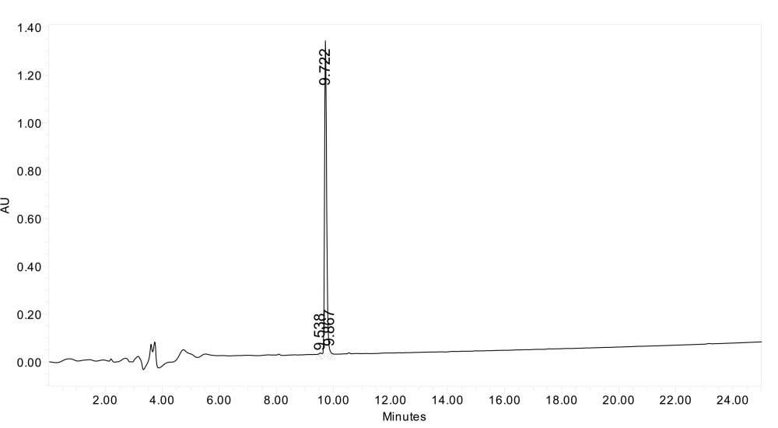
Figure S1. The detailed composition of targeting peptide sequence. The targeting peptide sequence is WYRGRL with 849.98 molecular weight. HPLC analysis showed the peptide purity is 99.07%. The specific parameters: HPLC Column Kromasil 100-5C18 (4.6 mm * 150 mm, 5 micron); Detection wavelength: 220 nm; Gradient 10-70% A in 25 min; Mobile phase buffer A: 0.1% TFA + 100% CH₃CN; Buffer B: 0.1%TFA + 100%H₂O.

Table S1. Determination of encapsulation efficiency of LRRK2-IN-1 in Exo
LRRK2-IN-1 (μg/mL) | Exo  (μg/mL) (W_{a}) | Concentration  (μg/mL) (W_{b}) | Encapsulation Efficiency (%) | Mean ± SD  (%)
400.00 | 400.00 | 210.78 | 52.70 | 49.95 ± 2.58
400.00 | 400.00 | 198.26 | 49.57 | 49.95 ± 2.58
400.00 | 400.00 | 190.32 | 47.58 | 49.95 ± 2.58
Exo, exosome; SD, standard deviation. Drug encapsulation efficiency =W_{b}/W_{a}×100%. W_{a} is the mass of the drug loaded, and W_{b} is the initial system mass of the drug.

Table S2. Determination of LRRK2-IN-1 loading capacity of Exo
Exo/LRRK2-IN-1  (μg/mL) (W₀) | Concentration  (μg/mL) (W₁) | Loading rate  (%) | Mean ± SD  (%)
610.78 | 210.78 | 34.51 | 33.30 ± 1.14
598.26 | 198.26 | 33.14 | 33.30 ± 1.14
590.32 | 190.32 | 32.24 | 33.30 ± 1.14
Exo, exosome; SD, standard deviation. Drug loading rate=W₁/W₀×100%. W₁ is the mass of the drug loaded, and W₀ is the total mass of the drug-loaded exosomes.

Table S3. Determination of encapsulation efficiency of exosomes into GelMA
Exo  (μg/mL) (W_{a}) | GelMA  (g) | Protein Concentration (μg/mL) (W_{b}) | Encapsulation Efficiency (%) | Mean ± SD  (%)
300 | 1.00 | 147.22 | 49.07 | 50.22 ± 1.08
300 | 1.00 | 151.14 | 50.38 | 50.22 ± 1.08
300 | 1.00 | 153.65 | 51.22 | 50.22 ± 1.08
GelMA, Gelatin-Methacryloyl; Exo, exosome; SD, standard deviation. Exosome encapsulation efficiency =W_{b}/W_{a}×100%. W_{a} is the mass of the exosome loaded, and W_{b} is the initial system mass of the exosome.

Table S4. Determination of loading capacity of exosomes into GelMA
GelMA/Exo  (μg/mL) (W₀) | Protein Concentration  (μg/mL) (W₁) | Loading rate  (%) | Mean ± SD  (%)
1147.22 | 147.22 | 12.83 | 13.09 ± 0.24
1151.14 | 151.14 | 13.12 | 13.09 ± 0.24
1153.65 | 153.65 | 13.32 | 13.09 ± 0.24
GelMA, Gelatin-Methacryloyl; Exo, exosome; SD, standard deviation. Exosome loading rate=W₁/W₀×100%. W₁ is the mass of the exosome loaded, and W₀ is the total mass of the exosome-loaded GelMA.

