Targeted co-delivery of curcumin and erlotinib by MoS₂ nanosheets for the

combination of synergetic chemotherapy and photothermal therapy

of lung cancer

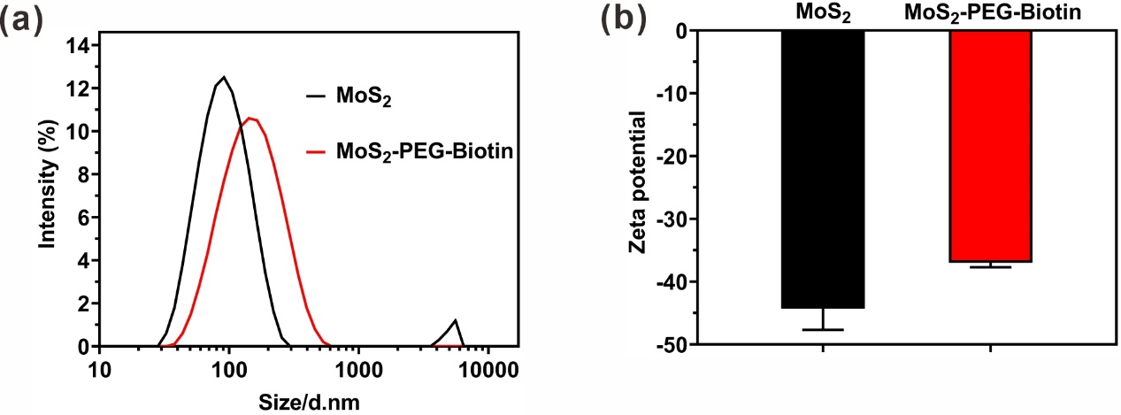
Fig. S1. Hydrodynamic sizes (a) and Zeta potentials (b) of MoS₂ and MoS₂-PEG-Biotin as determined by DLS.

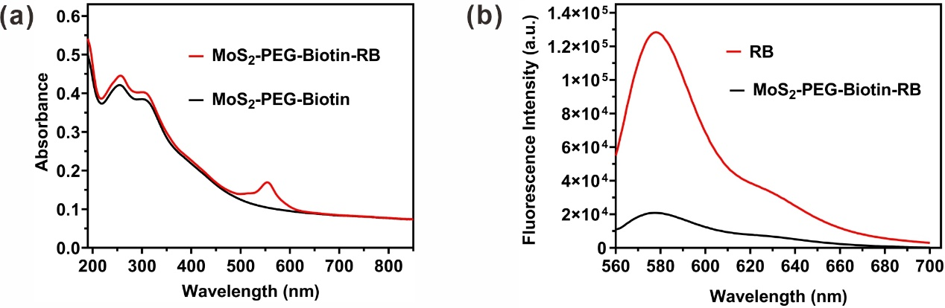
Fig. S2. (a) UV-vis-NIR spectra of MoS₂-PEG-Biotin before and after RB loading. (b) Fluorescence spectra of free RB and MoS₂-PEG-Biotin-RB at the same RB concentration (5 μg/mL, λex = 550 nm). The fluorescence of MoS₂-PEG-Biotin-RB was weaker than that of free RB at the same RB concentration, due to the partial fluorescence quenching caused by fluorescence resonance energy transfer.

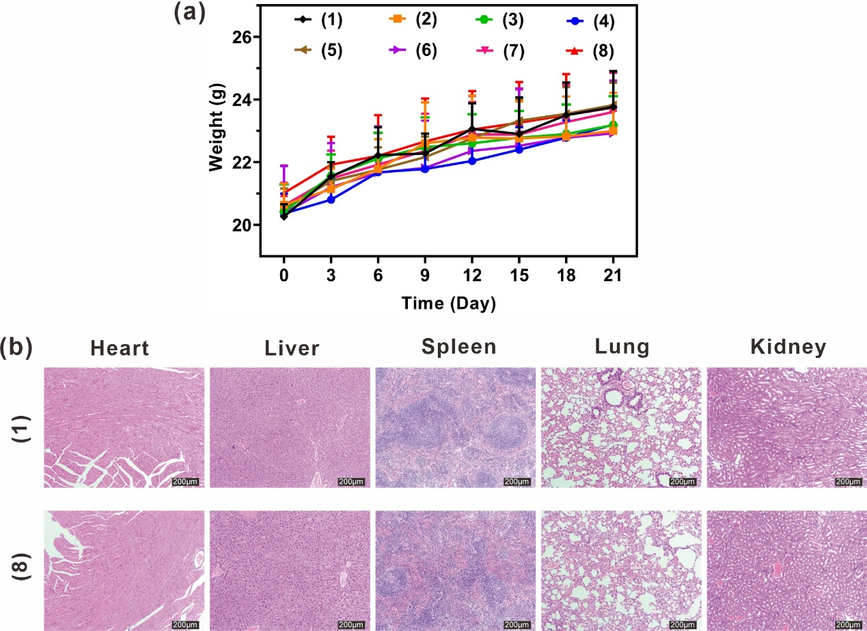

Fig. S3. Mice were divided into eight groups as follows: (1) PBS as a control, (2) MoS₂-PEG-Biotin, (3) Cur, (4) Er, (5) Cur + Er, (6) MoS₂-PEG-Biotin + NIR, (7) MoS₂-PEG-Biotin-Cur/Er, and (8) MoS₂-PEG-Biotin-Cur/Er + NIR. (a) Body weights of mice in each group as a function of time. (b) H&E images of major organs collected from mice after 21days of intravenous administration of PBS and MoS₂-PEG-Biotin-Cur/Er nanosheets.

