Additional Tables
Table S1. Primers for RT-qPCR
Gene | Forward (5’-3’) | Reverse (5’-3’)
Gapdh | GACATGCCGCCTGGAGAAAC | AGCCCAGGATGCCCTTTAGT
Tnf-a | ACTGAACTTCGGGGTGATCG | GCTTGGTGGTTTGCTACGAC
Il-1b | TTGAGTCTGCACAGTTCCCC | GTCCTGGGGAAGGCATTAGG
Il-6 | GAAAATCTGCTCTGGTCTTCTGGAG | CACTAGGTTTGCCGAGTAGACCTC
Col2a1 | GCCAGGATGCCCGAAAATTAG | GGCTGCAAAGTTTCCTCCAC
Acan | ATGCCTTCCGAGCTACAGAG | GCAGGGAGTGTCCATCAGAC
Krt19 | TCTCAGACCTGCGTCCCTTA | CGGAGGATGAGGACACGATG

Table S2. Primary antibodies used in this study
Antibody | Vendor | Catalog number
Vinculin | Abcam | ab129002
TNF alpha | Abcam | ab6671
Collagen II | Abcam | ab188570
Aggrecan | Proteintech | 13880-1-AP
ADAMTS5 | Abcam | ab41037
MMP3 | Abcam | ab52915
NRF2 | Proteintech | 16396-1-AP
Catalase | Affinity | DF7545
SOD2 | Proteintech | 24127-1-AP
Heme Oxygenase 1 | ZENBIO | R24541
P53 | Affinity | AF0879
P21 | Proteintech | 10355-1-AP
P16 | Abcam | ab51243
Beta Actin | Proteintech | 81115-1-RR

Additional Figures:
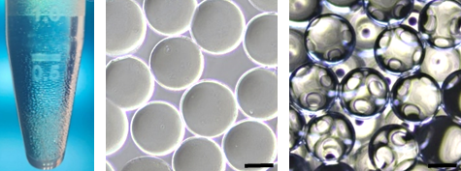
Figure S1. Pictures of GHHM microspheres in EP tubes, in PBS and in mineral oil, respectively, scale bar = 100μm.
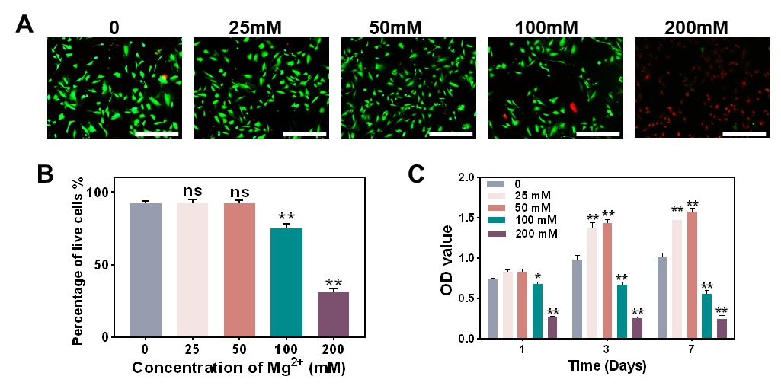
Figure S2. Selection of Mg²⁺ concentration. A) Live/Dead staining of cells after treatment with different concentrations of Mg²⁺ for 7 days, scale bar = 400 μm. B) Percentage of live cells in different concentrations of Mg²⁺ (compared with the control group). C) CCK-8 assay of different concentrations of Mg²⁺ (compared with the control group).
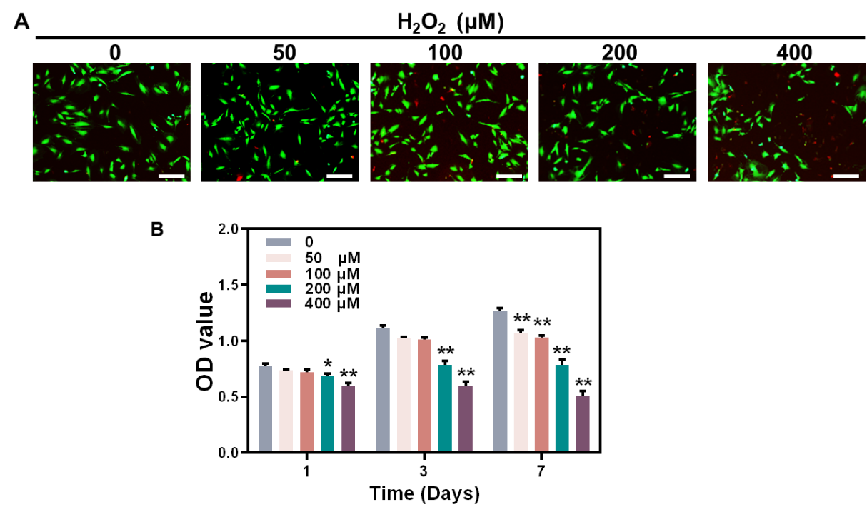
Figure S3. Selection of H₂O₂ concentration. A) Live/Dead staining of cells after treatment with different concentrations of H₂O₂ for 3 days, scale bar = 200 μm. B) CCK-8 assay of different concentrations of H₂O₂ (compared with the control group).
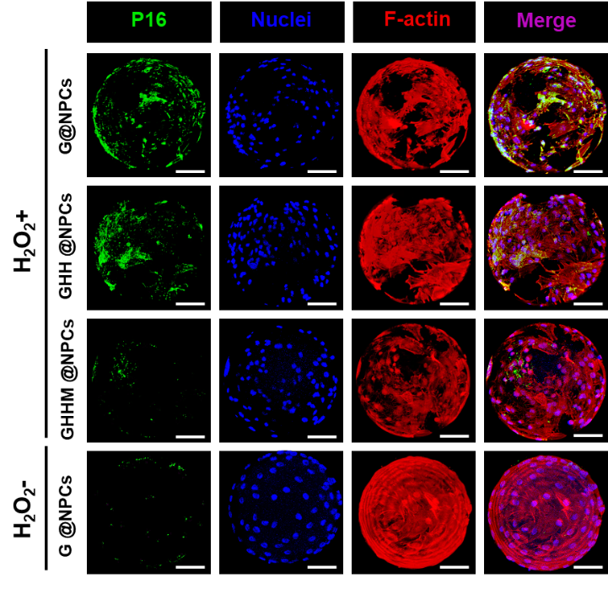
Figure S4. P21 immunofluorescence images after 200μM H₂O₂ treatment, scale bar = 50μm.
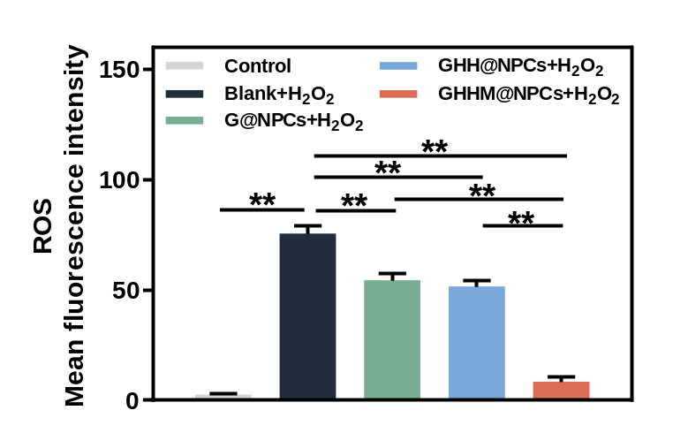
Figure S5. Quantification of ROS levels in each group of S-NPCs after 200μM H₂O₂ treatment.
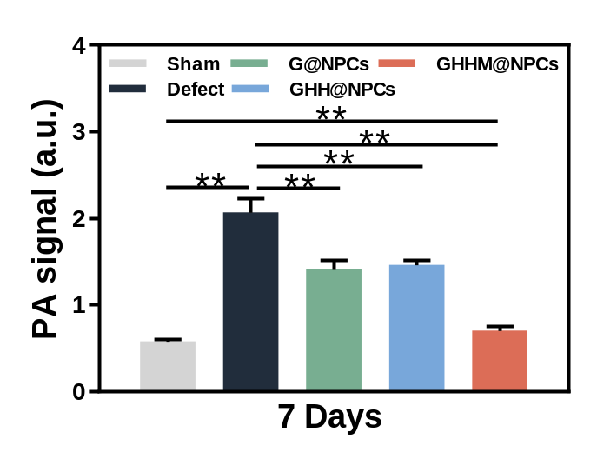
Figure S6. Quantification of ROS levels in nucleus pulposus tissue in situ 7 days after injection in different groups.
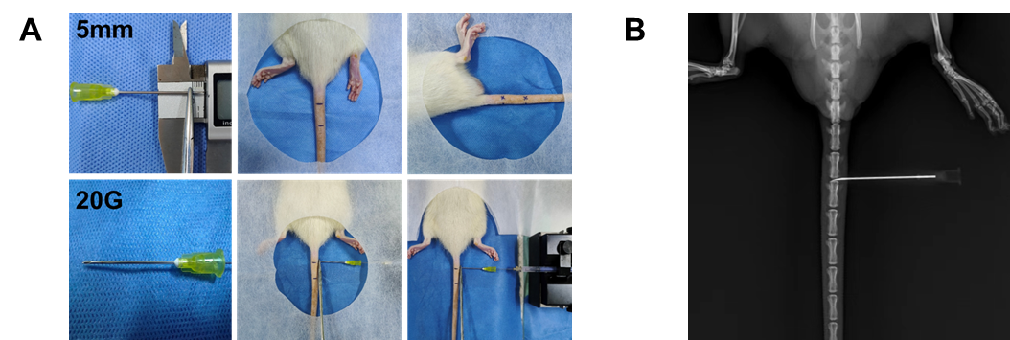
Figure S7. Establishment of a rat caudal degeneration model. A) Schematic diagram of animal experimental operations. B) Pictures of intraoperative x-ray localization.

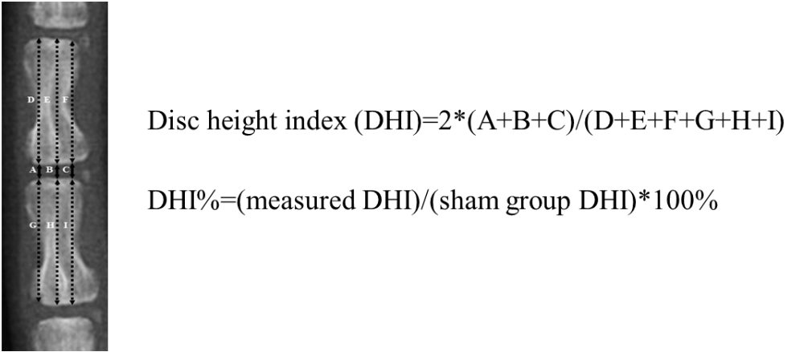 Figure S8. Calculation formula and diagram of DHI.
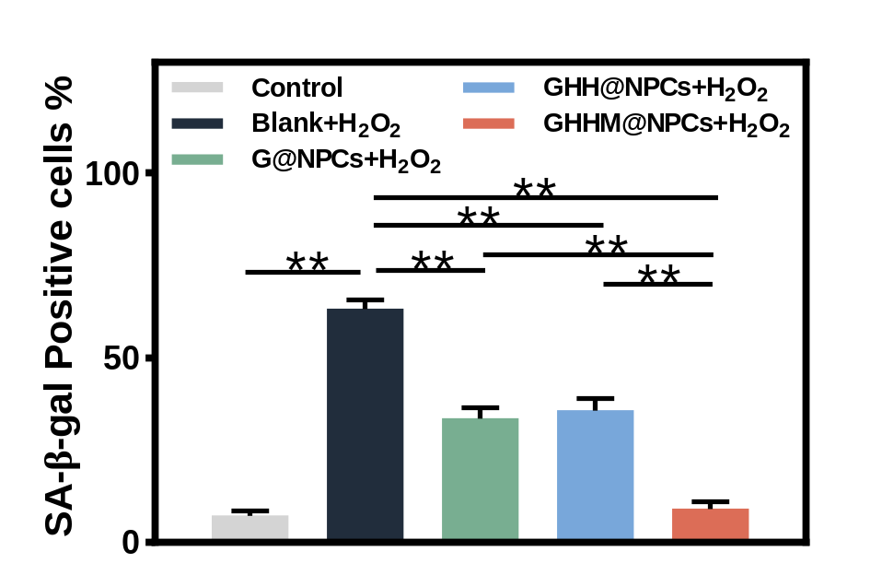
Figure S9. Quantification of the proportion of SA-β-Gal staining positive cells in each group of S-NPCs after 200μM H₂O₂ treatment.
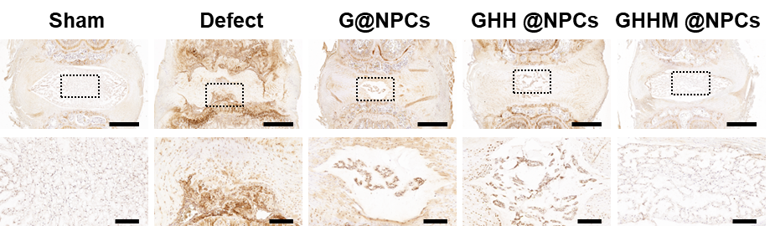
Figure S10. Immunohistochemical staining images of MMP13 at 4weeks, above scale bar = 1mm, below scale bar = 200μm.

