Supporting information for:

Lonidamine liposomes to enhance photodynamic and photothermal therapy of hepatocellular carcinoma by inhibiting glycolysis
Lei Lei^{1†}, Wenbin Dai^{2†}, Jiaping Man², Haitao Hu¹, Qiao Jin^{2*}, Bo Zhang^{3*}, Zhe Tang^{1,3*}

¹Department of Surgery, The Fourth Affiliated Hospital, International Institutes of Medicine, Zhejiang University School of Medicine, Yiwu, 322000, China
²MOE Key Laboratory of Macromolecule Synthesis and Functionalization of Ministry of Education, Department of Polymer Science and Engineering, Zhejiang University, Hangzhou, 310027, China
³Department of Surgery, The Second Affiliated Hospital, Zhejiang University School of Medicine, Hangzhou, 310058, China
E-mail: jinqiao@zju.edu.cn (Q. Jin); jjs10@zju.edu.cn (B. Zhang); 8xi@zju.edu.cn (Z. Tang)
†These authors contributed equally

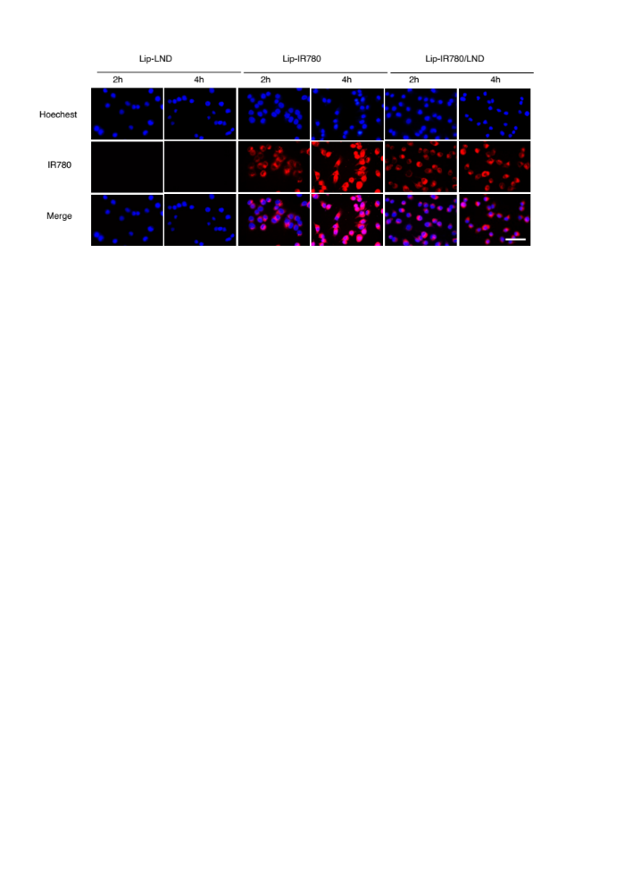
Figure S1: Confocal fluorescence micrographs of LM3 cells after incubation with Lip-LND, Lip-IR780, and Lip-IR780/LND for different periods of time. Scale bar :5 μm.

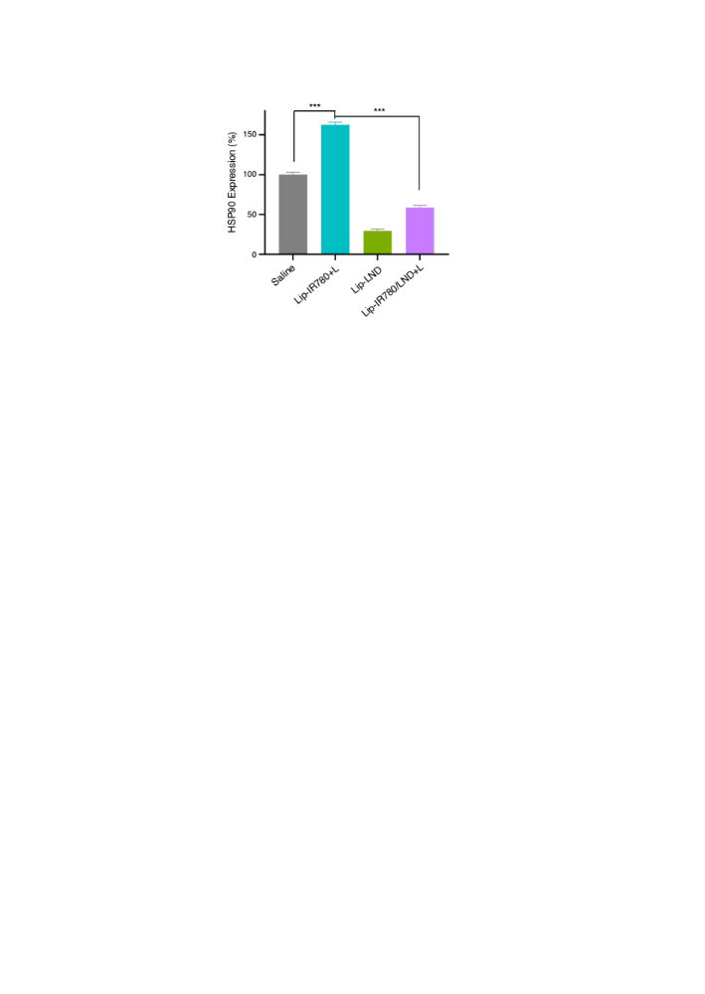
Figure S2: The expression of HSP90 after different treatments.

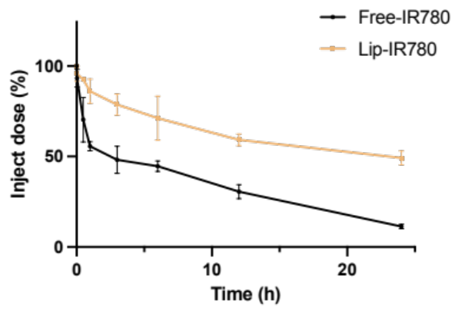
FigureS3: Pharmacokinetics profiles of IR780 in the tumor-free ICR mice after intravenous injection of IR780 formulations (n = 5).

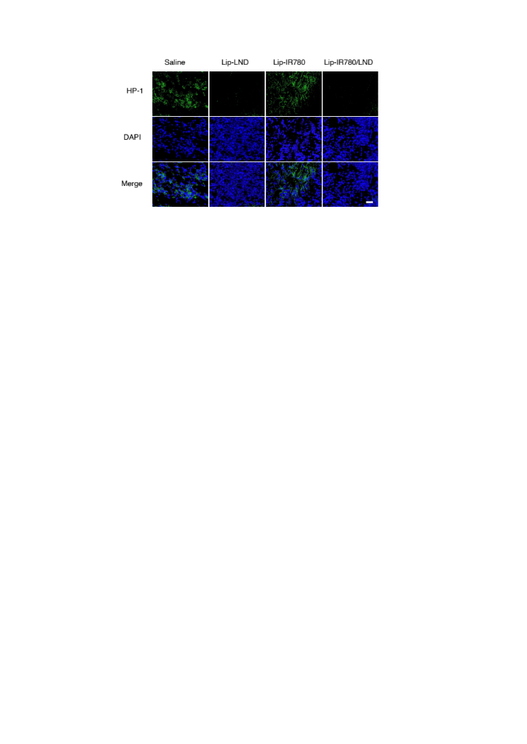
Figure S4: CLSM images of LM3 cells under HP-1 kit after incubation with saline, Lip-LND, Lip-IR780, and Lip-IR780/LND. Scale bar: 50 µm.

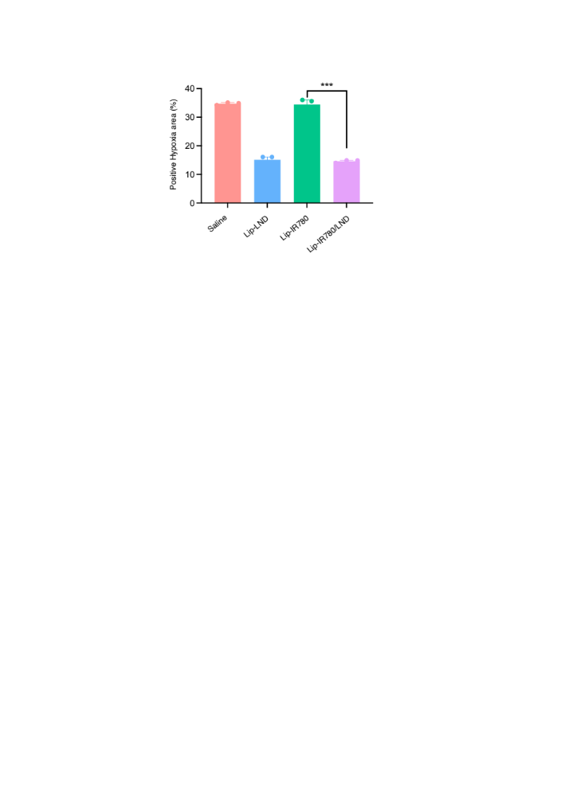
Figure S5: The area of HP-1 in different treatment groups (n=3).

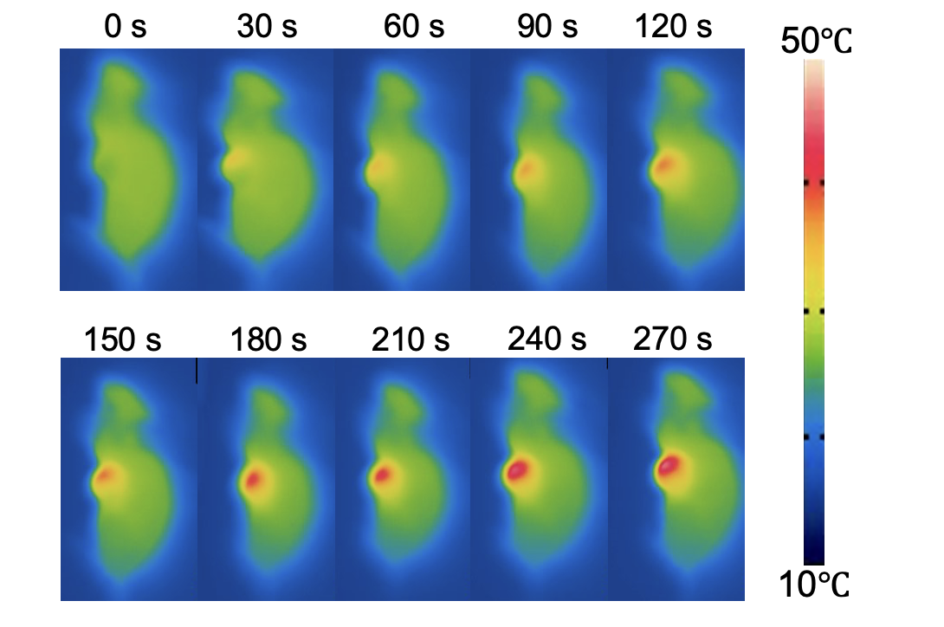
FigureS6: Near-infrared thermal imaging images of the tumor-bearing mice injected with Lip-IR780/LND and irradiated by 808 nm laser at 0.4 W cm⁻².
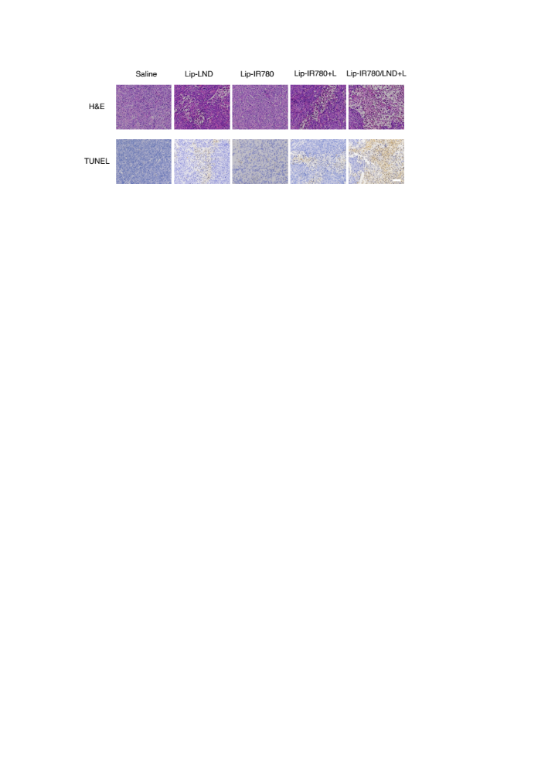
Figure S7: The immunohistochemical analysis of tumor sections after different treatments by H&E and TUNEL. Scale bar: 100 μm.

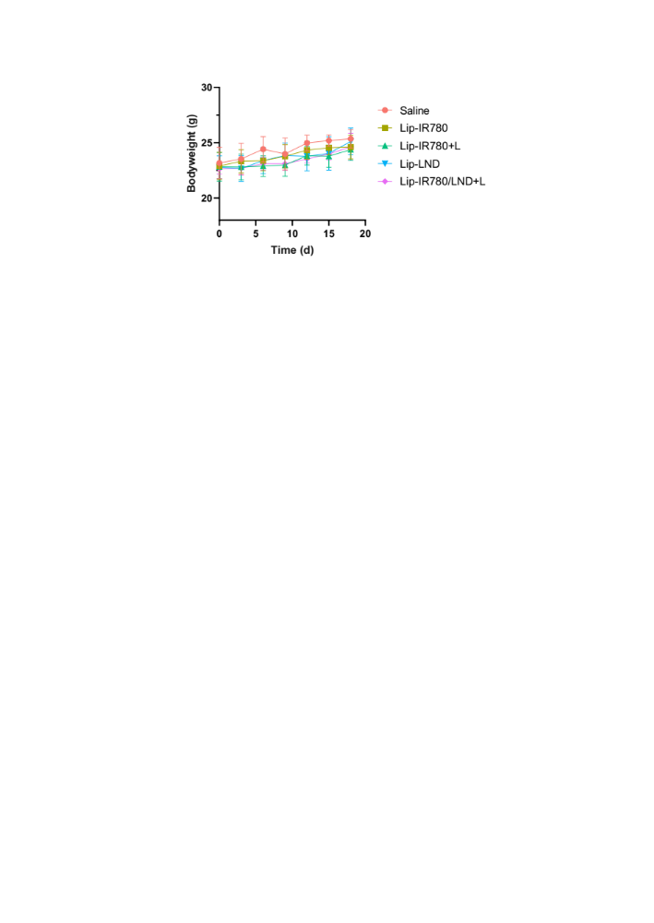
Figure S8: The weights of LM3 tumors after isolated from nude mice at Day 18 after different treatments (n = 5).

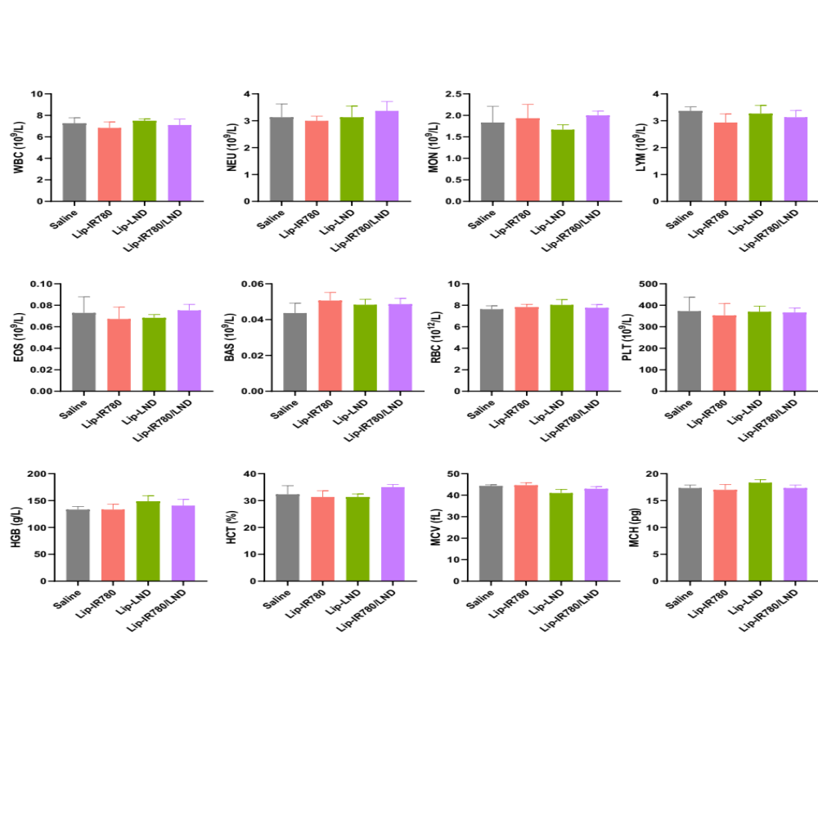
Figure S9: Blood routine indicators after different treatment groups.

Table S1: The entrapment efficiency (EE) and drug loading content (DLC).

