Supporting Information
A Continuously Efficient O₂-Supplying Strategy for Long-Term Modulation of Hypoxic Tumor Microenvironment to Enhance Long-Acting Radionuclides Internal Therapy

Jingchao Li^{1#}, Tingting Wang^{1#}, Yuanfei Shi^{3#}, Zichen Ye², Xun Zhang¹, Jiang Ming², Yafei Zhang¹, Xinyan Hu², Yun Li⁴, Dongsheng Zhang¹, Qianhe Xu¹, Jun Yang¹, Xiaolan Chen^{2*}, Nian Liu^{1*}, Xinhui Su^{1*}

¹ Department of Nuclear Medicine, The First Affiliated Hospital, Zhejiang University School of Medicine, Hangzhou 310003, China.
² State Key Laboratory for Physical Chemistry of Solid Surfaces, Collaborative Innovation Center of Chemistry for Energy Materials, and Engineering Research Center for Nano-Preparation Technology of Fujian Province, College of Chemistry and Chemical Engineering, Xiamen University, Xiamen 361005, China.
³ Department of Hematology, The First Affiliated Hospital, Zhejiang University School of Medicine, Hangzhou 310003, China.
⁴ State Key Laboratory of Molecular Vaccinology and Molecular Diagnostics & Center for Molecular Imaging and Translational Medicine, School of Public Health, Xiamen University, Xiamen 361005, China.
*Correspondence: chenxl@xmu.edu.cn, nian.liu@zju.edu.cn, suxinhui@zju.edu.cn

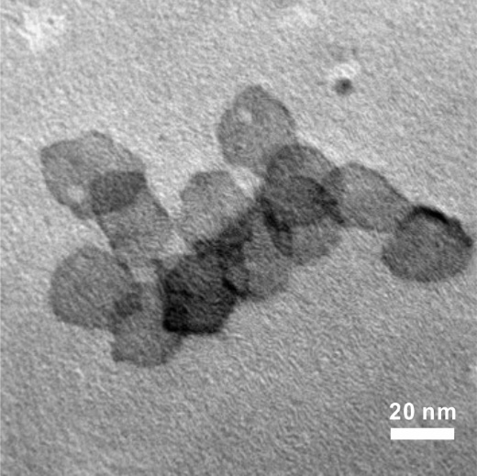
Figure S1: TEM image of 30 nm Pd NSs.

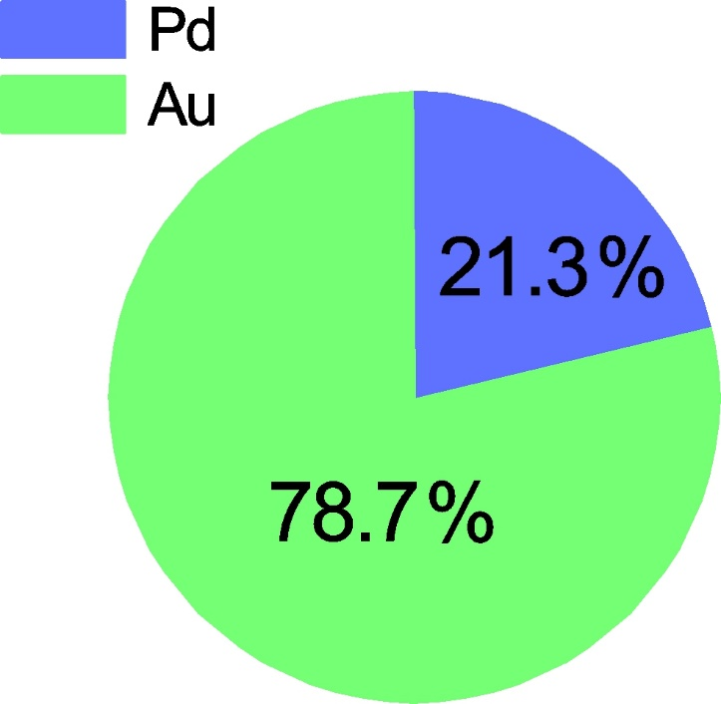
Figure S2: Quantitative content analysis of Au and Pd in Pd@Au NSs by ICP-MS analysis.

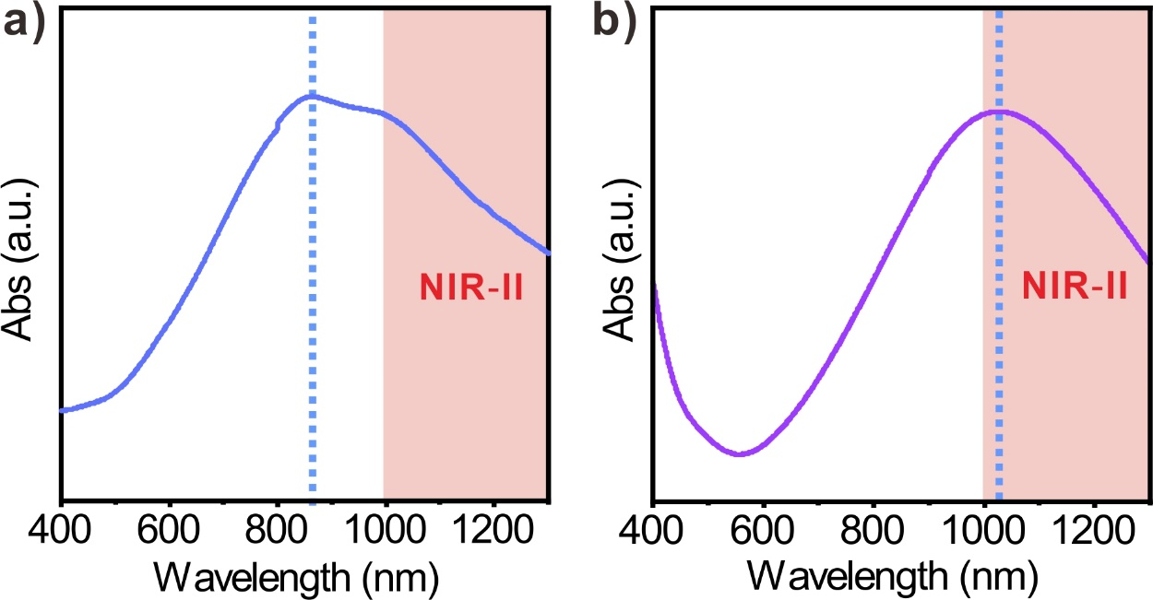
Figure S3: UV-Vis-NIR absorption spectrum of (a) Pd-PEG NSs and (b) Pd@Au-PEG NSs.

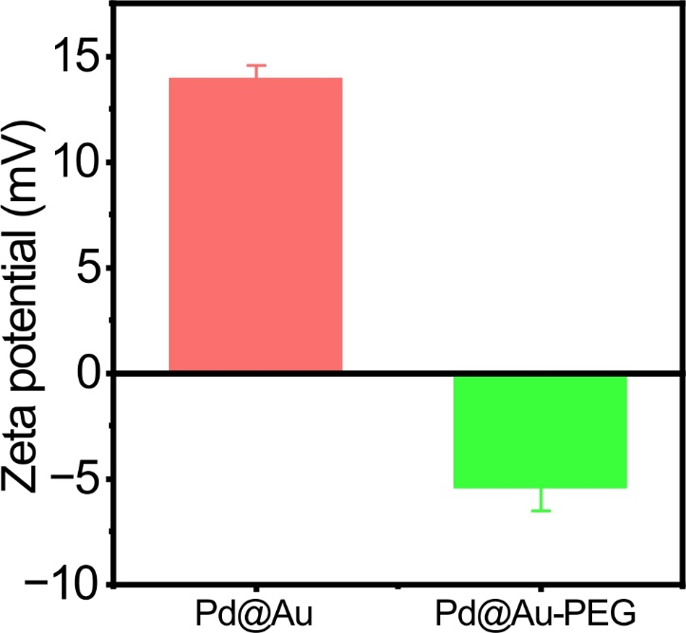
Figure S4: Zeta potentials comparison of Pd@Au NSs and Pd@Au-PEG NSs.

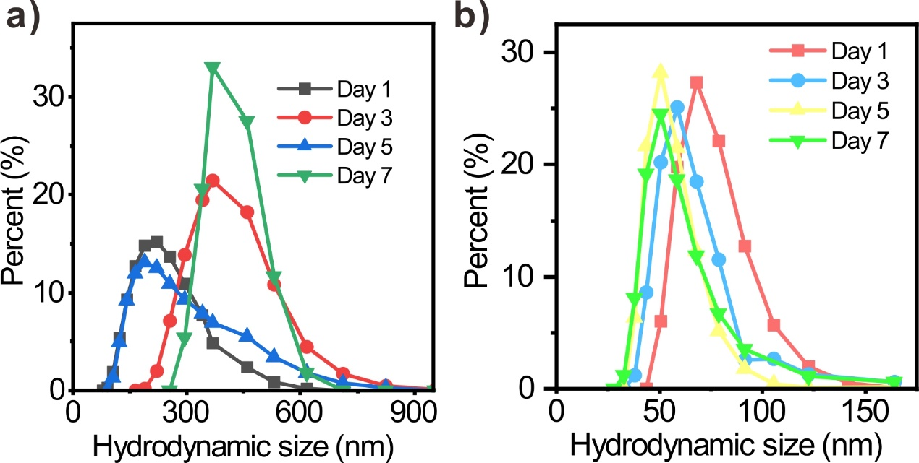
Figure S5: Hydrodynamic sizes of (a) Pd@Au NSs and (b) Pd@Au-PEG NSs incubated in the saline at day-1, -3, -5 and -7.

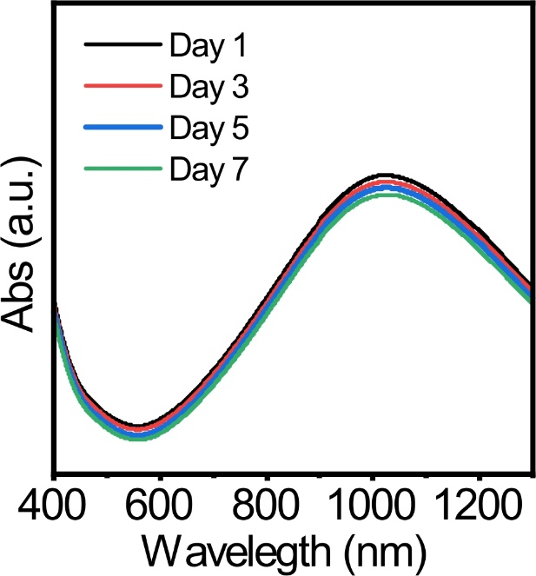
Figure S6: The absorption spectrum of Pd@Au-PEG NSs incubated in the saline at day-1, -3, -5 and -7.

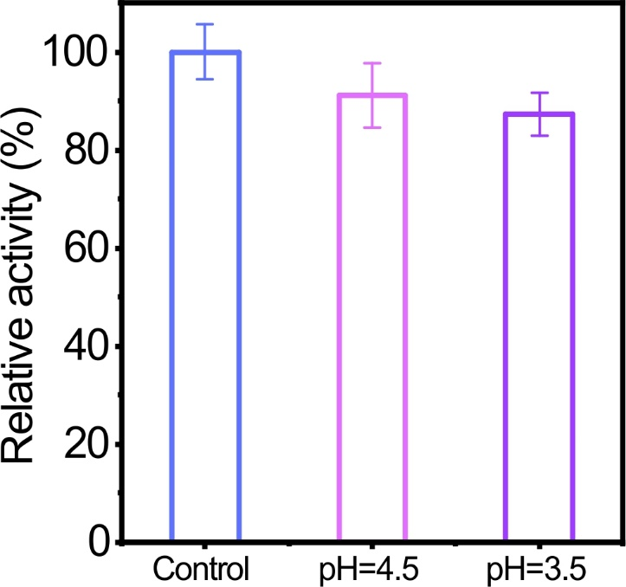
Figure S7: Enzymatic activity of Pd@Au-PEG NSs under various pH conditions.

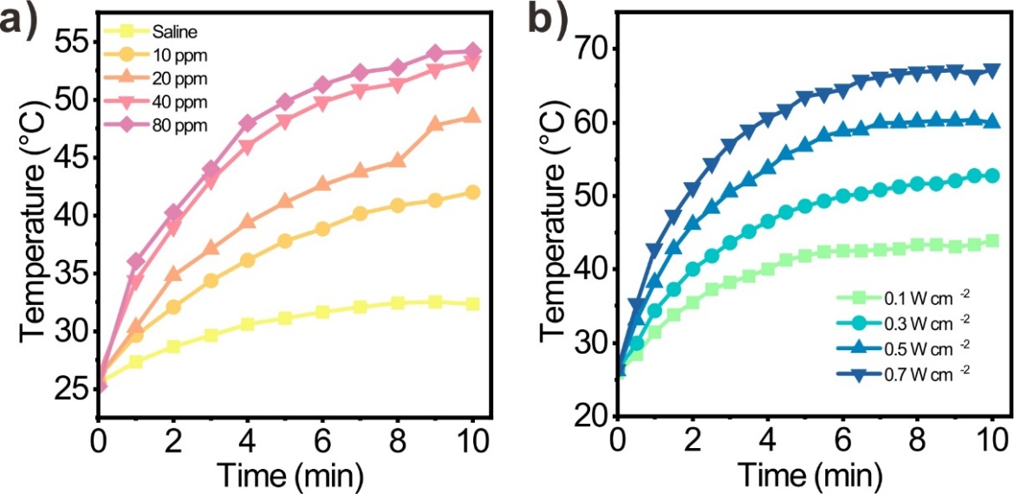
Figure S8: (a) Photothermal converting ability of Pd@Au-PEG NSs with various concentrations under the excitation of NIR-II laser (1064 nm, 0.3 W cm⁻²). (b) NIR-II photothermal converting ability of Pd@Au-PEG NSs (40 ppm) under the excitation of NIR-II laser with various power density.

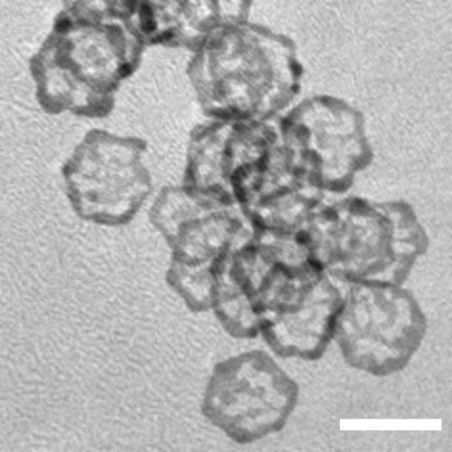
Figure S9: TEM image of Pd@Au-PEG NSs after photothermal stability test (Scale bar = 50 nm).

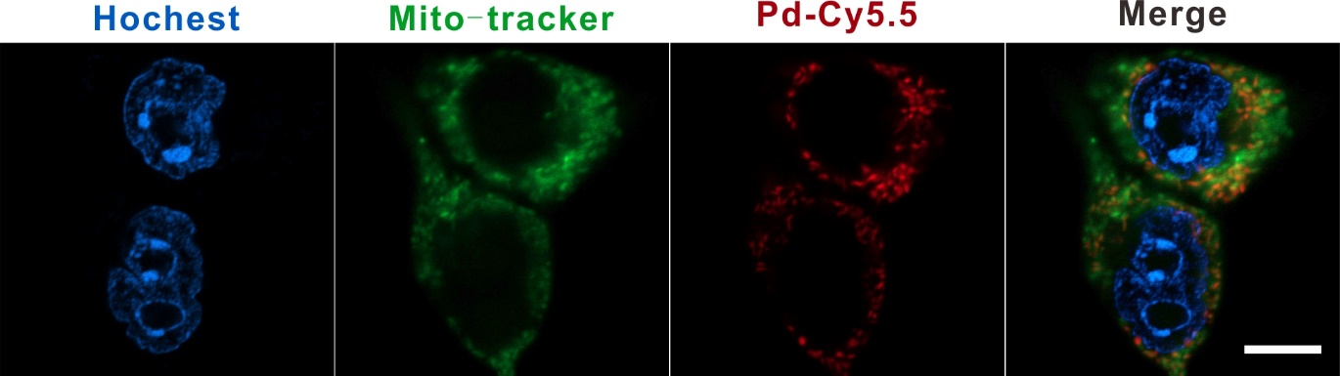
Figure S10: The subcellular localization of Cy5.5-labeled Pd NSs (Scale bar = 10 μm).

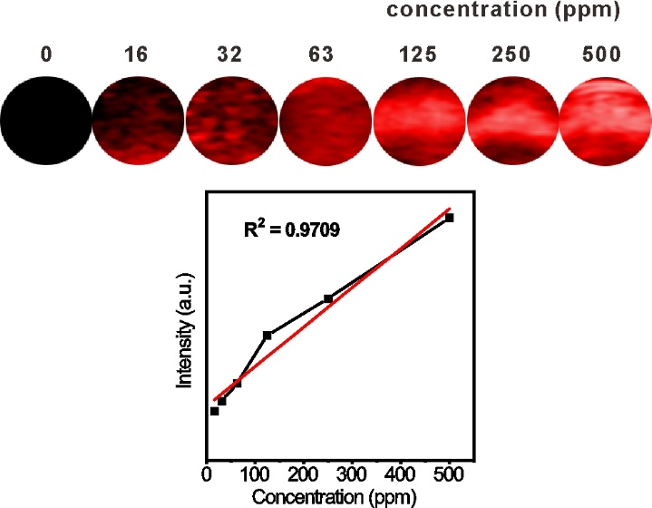
Figure S11: In vitro PA images of Pd@Au-PEG NSs with various concentrations (0, 16, 32, 63, 125, 250 and 500 ppm) and the linear relationship between the PA signal intensity and Pd@Au-PEG NSs concentration.

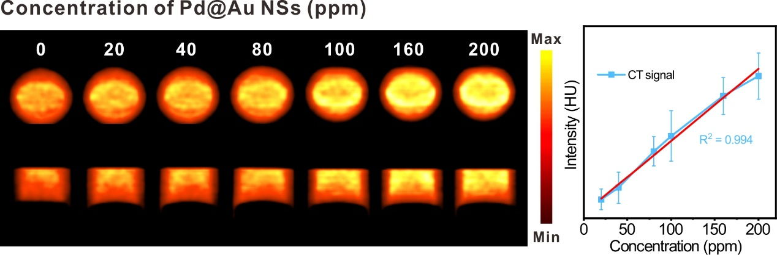
Fig. S12: In vitro CT images of Pd@Au-PEG NSs with various concentrations (0, 20, 40, 80, 100, 160 and 200 ppm) and the linear relationship between the CT signal intensity and Pd@Au-PEG NSs concentration.

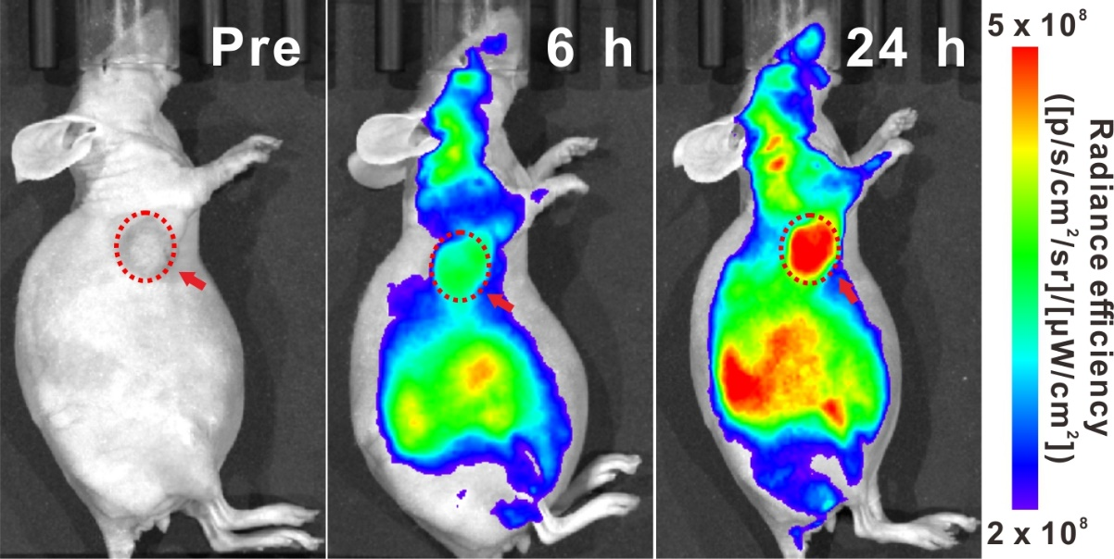
Fig. S13: Small animal living fluorescence imaging of Pd@Au-Cy5.5 NSs-injected mice at 6 h and 24 h post-injection (Red circles and arrows represent the tumor sites).

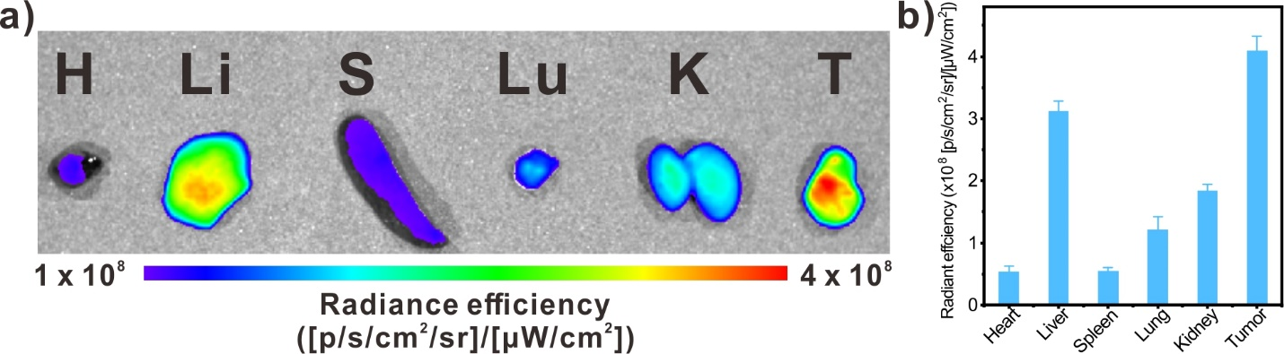
Fig. S14: (a) In vitro fluorescence images of major organs obtained from Pd@Au-Cy5.5-injected mice at 24 h post-injection (H: Heart, Li: Liver, S: Spleen; Lu: Lung, K: Kidney, T: Tumor). (b) The quantitative analysis of tissue fluorescence intensity.

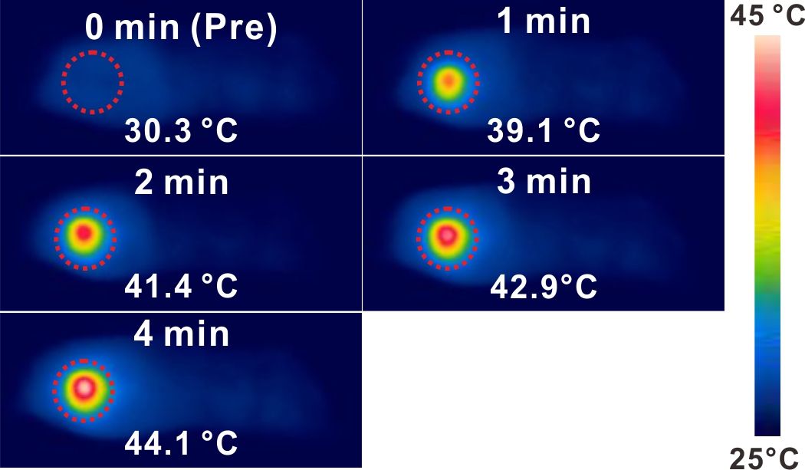
Fig. S15: In vivo NIR-II moderate PTT images of Pd@Au-PEG NSs-injected mice.

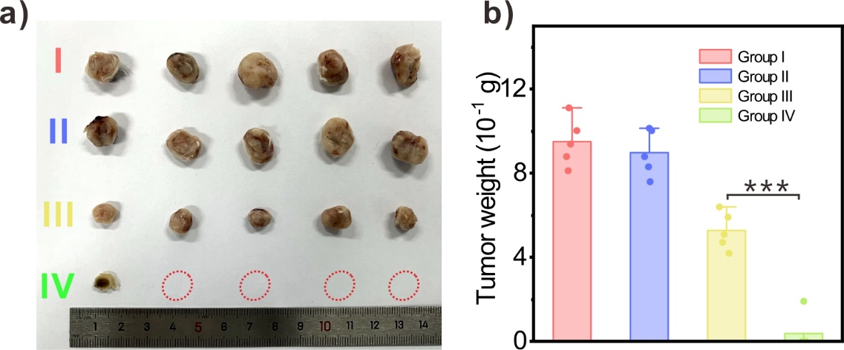
Fig. S16: (a) The size of tumors at 16th days post-treatment. (b) The weight of tumor samples at 16th days post-treatment from each treatment groups.

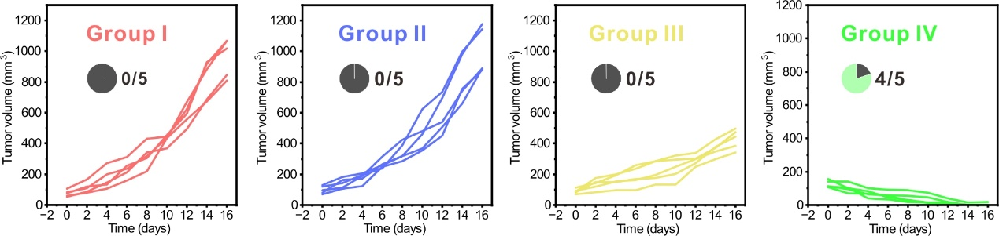
Fig. S17: The average growth curves of 4T1 subcutaneous tumors treated by different therapeutic modalities.

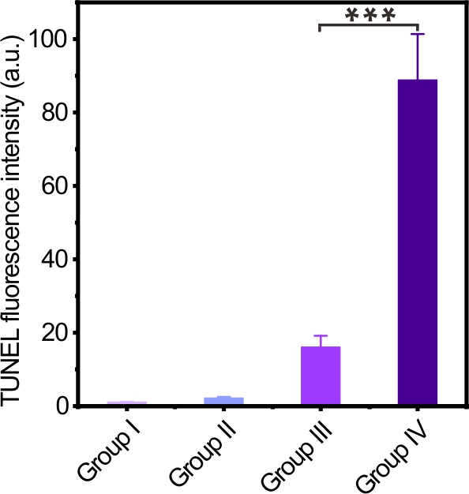
Fig. S18: The quantitative analysis of TUNEL fluorescence intensities in each treatment group.

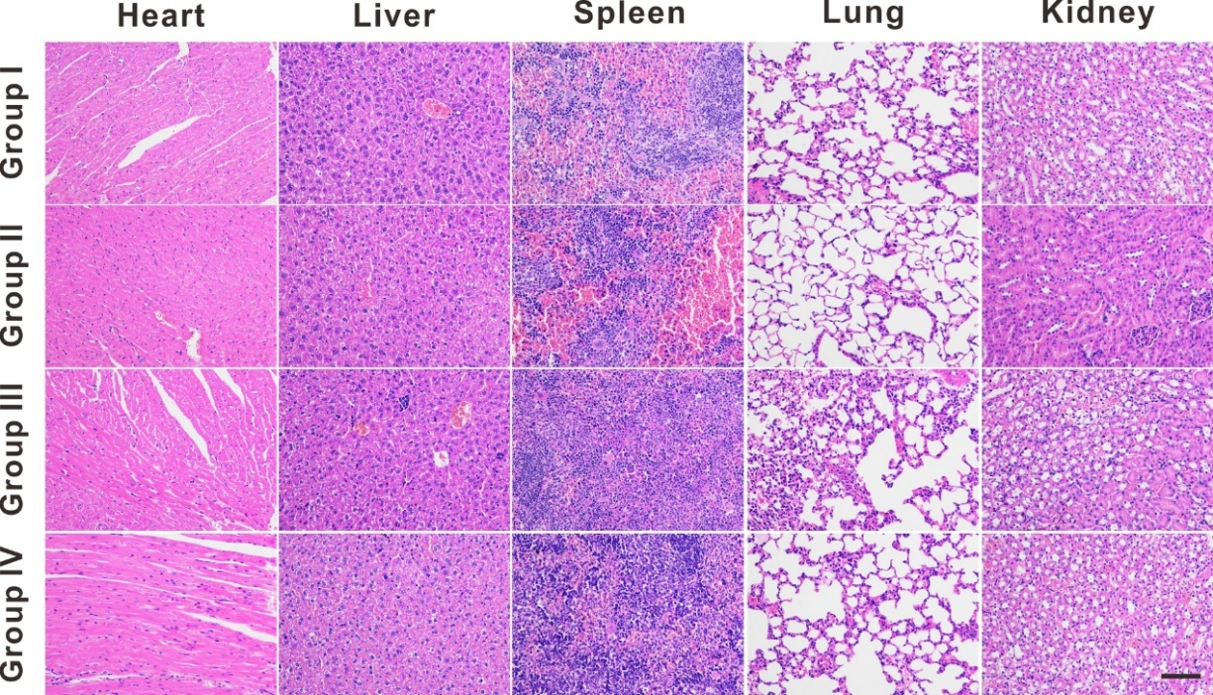
Fig. S19: H&E staining images of major health tissues including heart, liver, spleen, lung and kidney of mice in each treatment group (Scale bar = 50 μm).

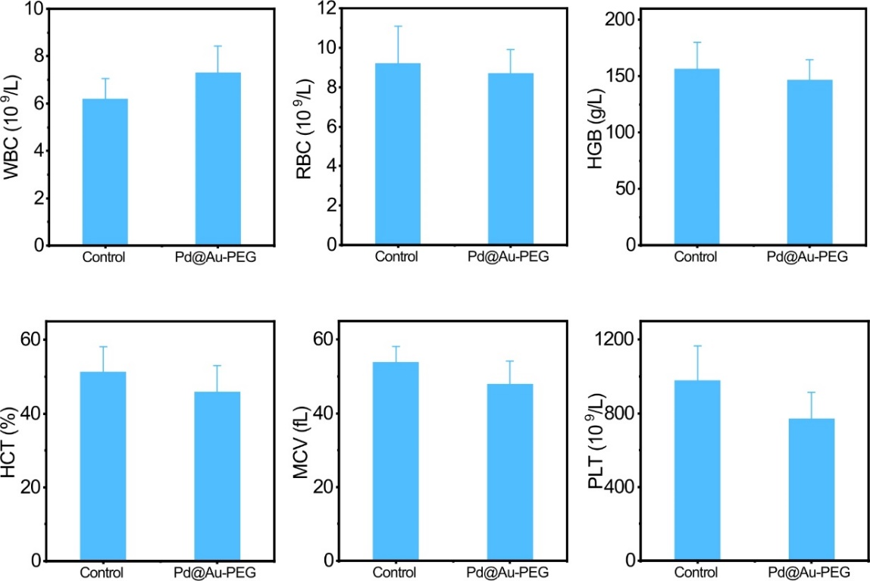
Fig. S20: Hematological index measurements of Pd@Au-PEG NSs-injected mice.

