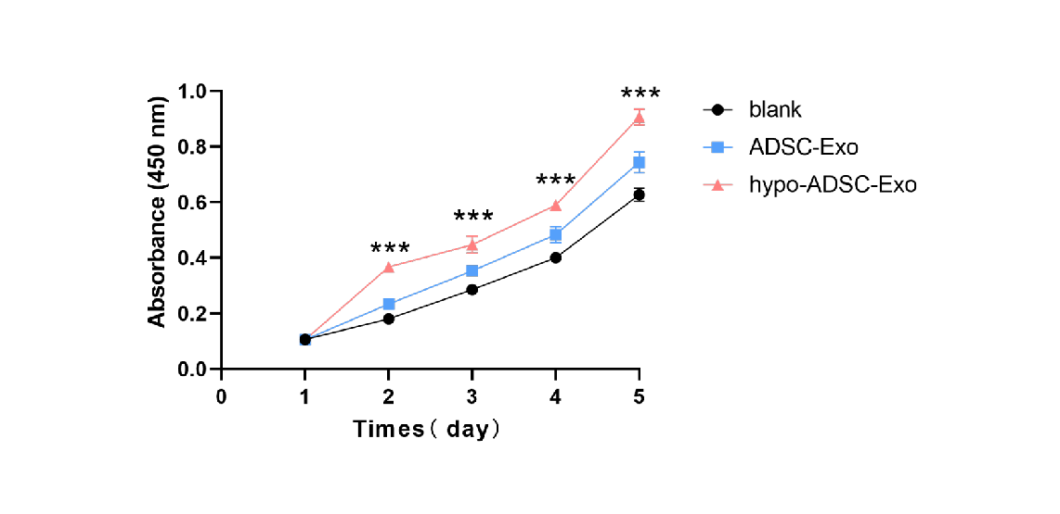
Figure S1. Cell proliferation of HUVECs after PBS, ADSC-Exo and hypo-ADSC-Exo administration as measured by CCK8 assay (n = 6).

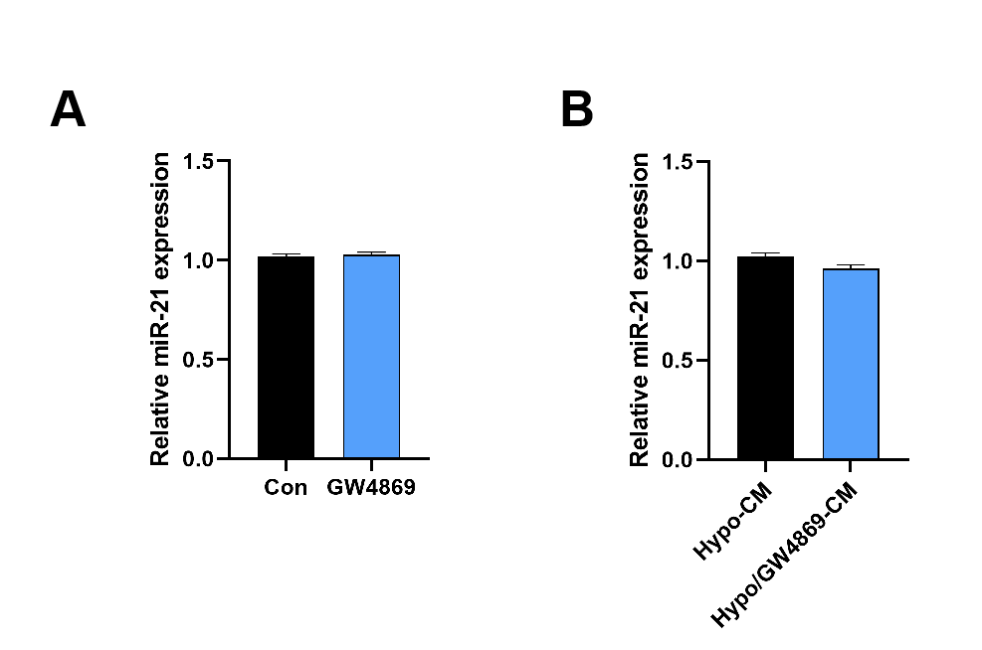
Figure S2. (A) The expression of miR-21 in the CM of ADSCs treated with or without GW4869. (B) Expression of miR-21 in the HUVECs treated with or without GW4869-CM.

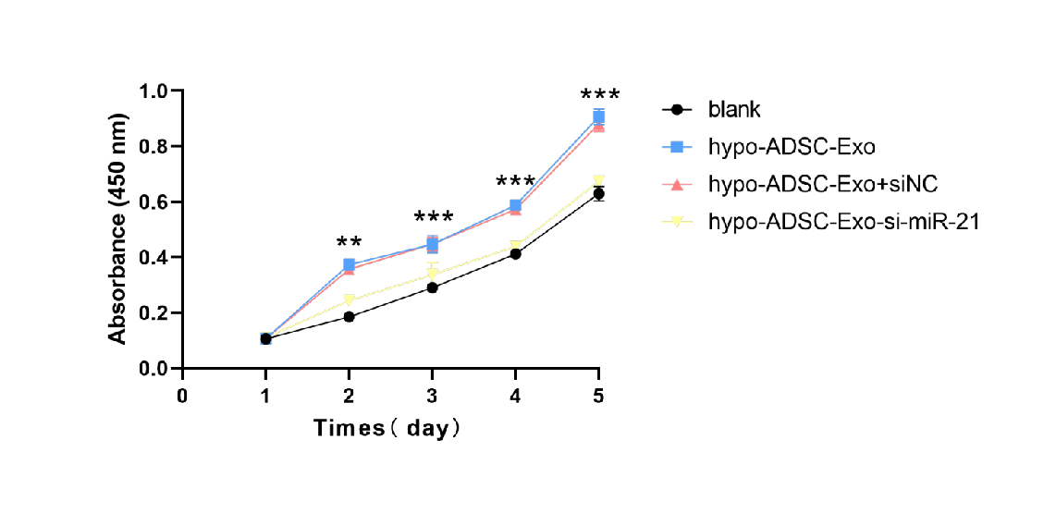
Figure S3. Cell proliferation of HUVECs after PBS, hypo-ADSC-Exo, hypo-ADSC-Exo+siNC and hypo-ADSC-Exo+si--miR-21 administration as measured by CCK8 assay (n = 6).
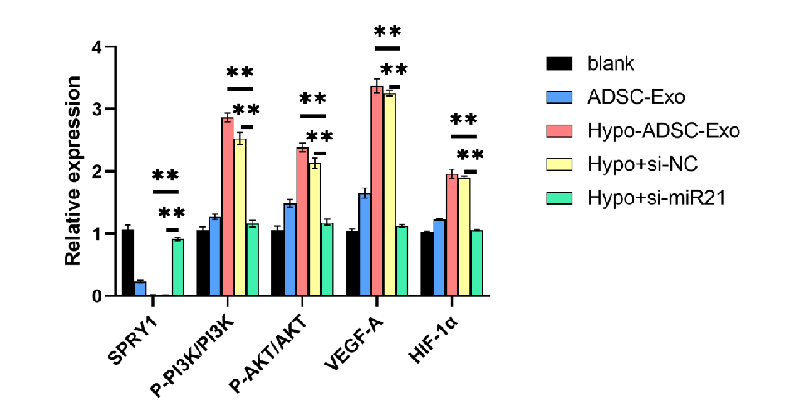
Figure S4. Quantitative results in the Western blot data (n=3).
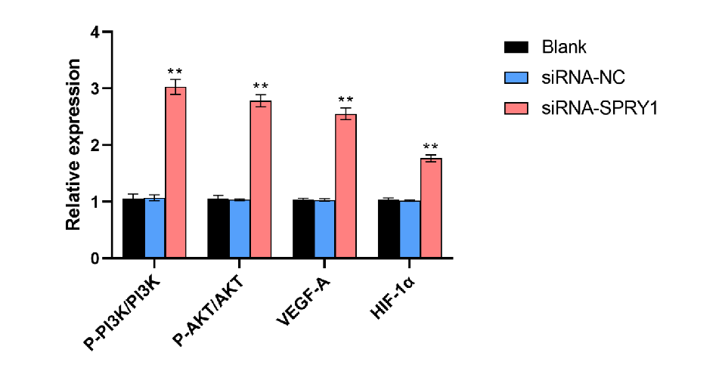
Figure S5. Quantitative results in the Western blot data (n=3).

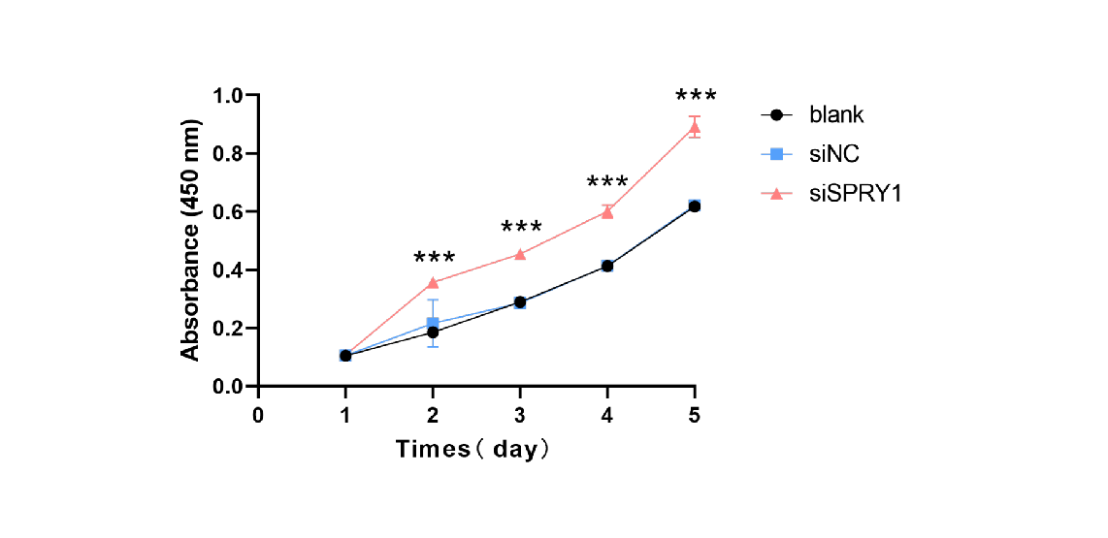
Figure S6. Cell proliferation of HUVECs after PBS, siNC and siSPRY1 administration as measured by CCK8 assay (n = 6).

Figure S7. The characteristics of GelMA. A. The GelMA placed on the fracture site. B. The structure of methacrylic acid was determined by ¹HNMR. C. The structure of methacrylic acid was determined by FT-IR. D. The photocuring performance and the malleability of the hydrogel characteristics.

