Smart Responsive Fe/Mn Nanovaccine Triggers Liver Cancer Immunotherapy via Pyroptosis and Pyroptosis-Boosted cGAS-STING Activation

Qianying Du^{1,2}, Ying Luo^{1,2}, Lian Xu^{1,2}, Chier Du², Wenli Zhang^{1,2}, Jie Xu¹, Yun Liu¹, Bo Liu¹, Sijin Chen¹, Yi Wang¹, Zhigang Wang², Haitao Ran², Junrui Wang^{1,2*}, and Dajing Guo^{1*}

- Department of Radiology, Second Affiliated Hospital of Chongqing Medical University, Chongqing 400010, P. R. China
- Chongqing Key Laboratory of Ultrasound Molecular Imaging & Department of Ultrasound, Second Affiliated Hospital of Chongqing Medical University, Chongqing 400010, P. R. China
Correspondence: guodaj@163.com (Dajing Guo), drwangjunrui@163.com (Junrui Wang).

Supplementary equations
Equation 1. Encapsulation efficiency (EE) (%) = (mass of SOR in NPs) / (total initial mass of SOR) × 100%
Equation 2. Loading capacity (LC) (% w/w) = (mass of SOR in NPs) / (total mass of SOR, MSN and MIL-100(Fe)) × 100%
3. Supplementary figures

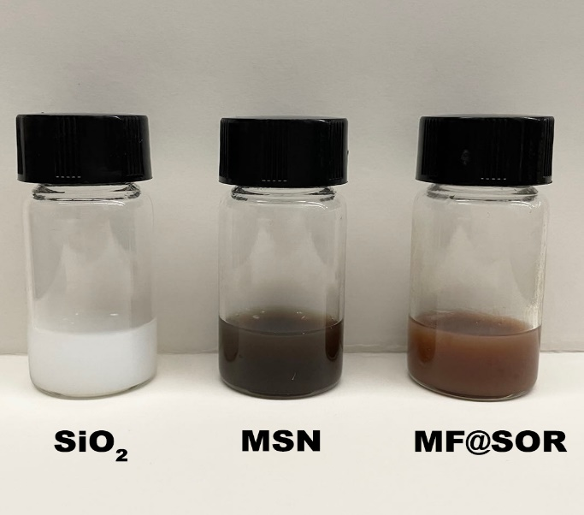
Figure S1. Representative photographs of different NPs

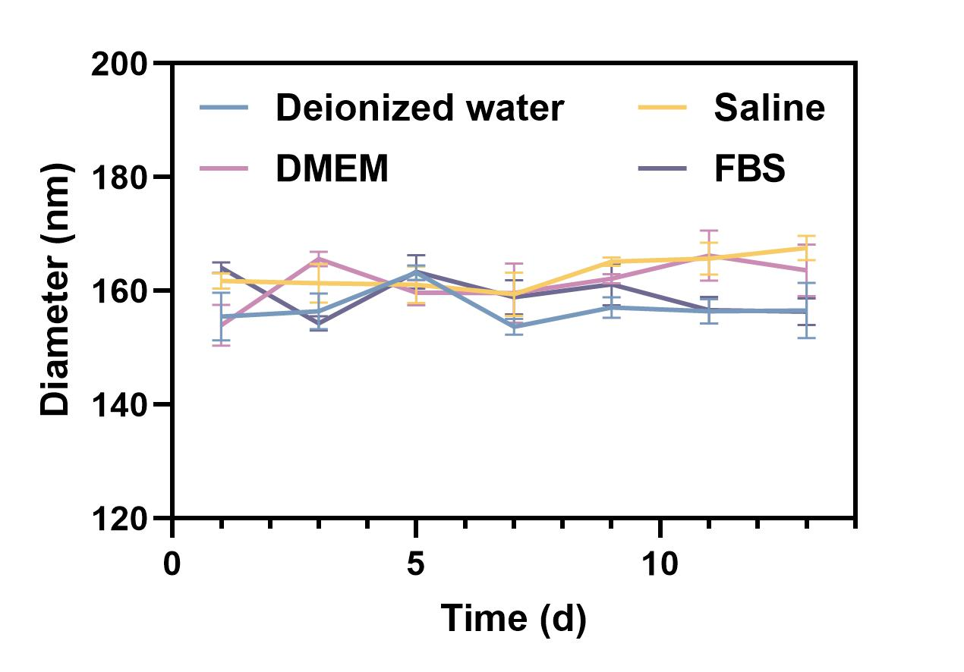
Figure S2. The colloidal stability of the MF@SOR in deionized water, saline, DMEM and FBS. Data are represented as mean ± SD (n = 3).
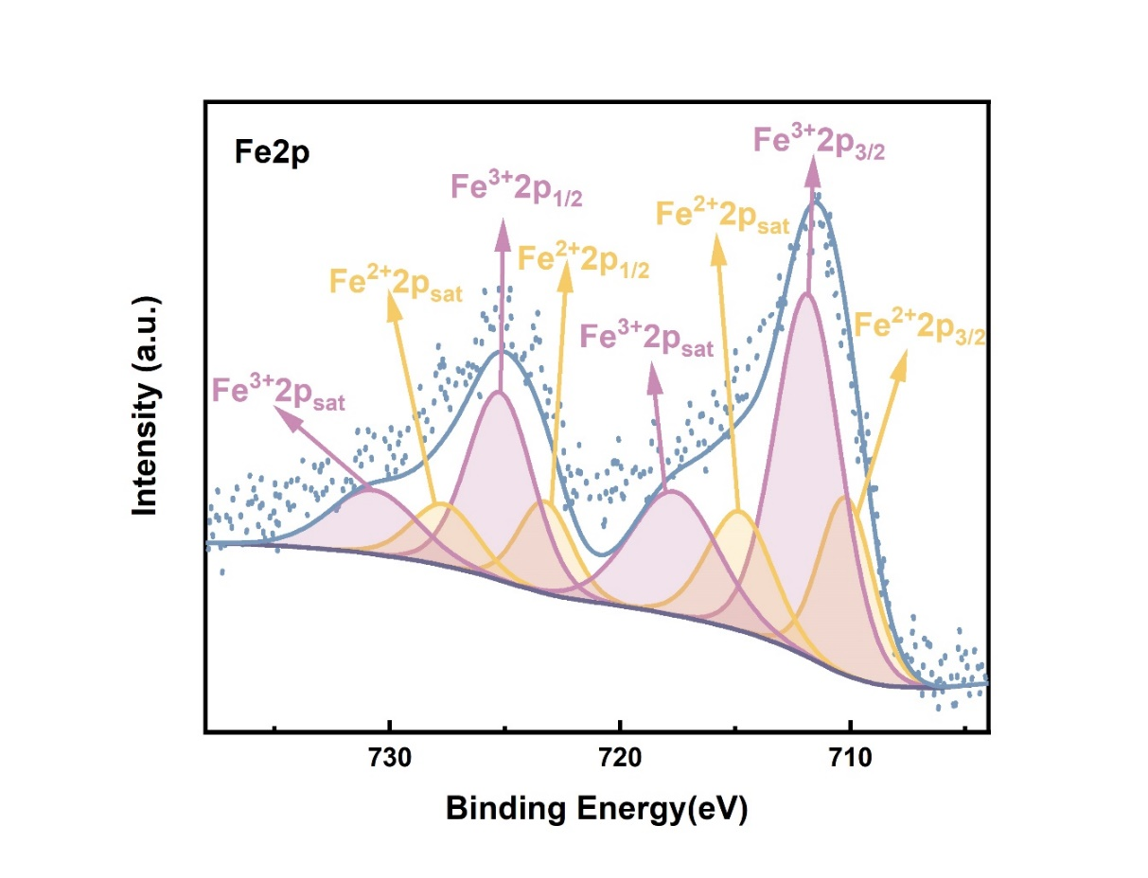
Figure S3. XPS of Fe in MF@SOR.

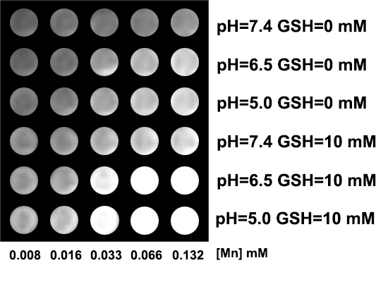
Figure S4. T1-weighted MRI images of the nanovaccines in various environments at 3.0 T MRI scanner.

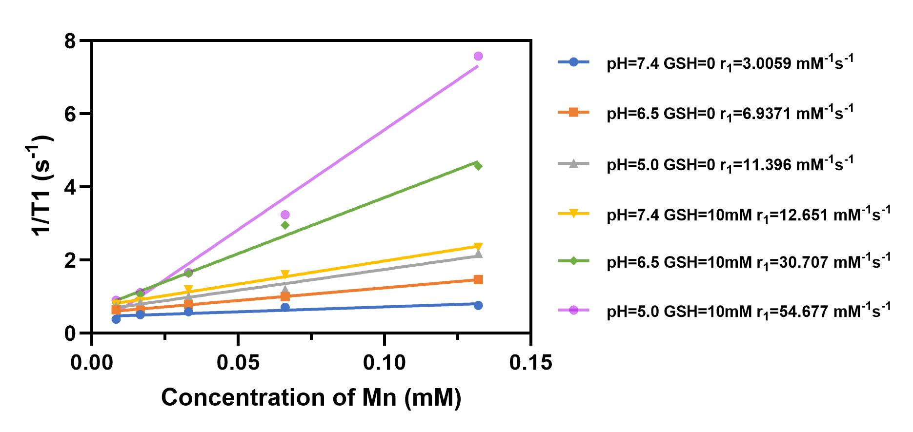
Figure S5. The r₁ values of the nanovaccines in different environments at 3.0 T MRI scanner.
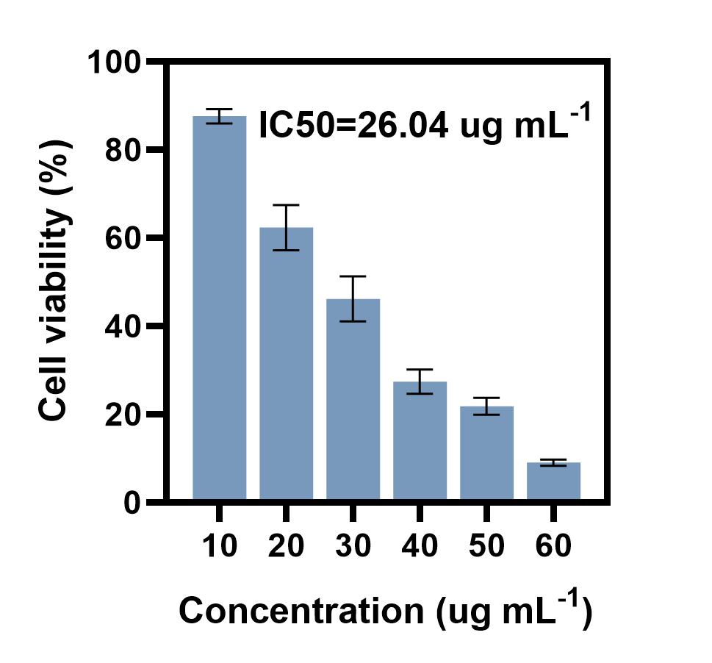
Figure S6. Cytotoxicity of SOR on Hepa1-6 cells. Data are represented as mean ± SD (n = 3).

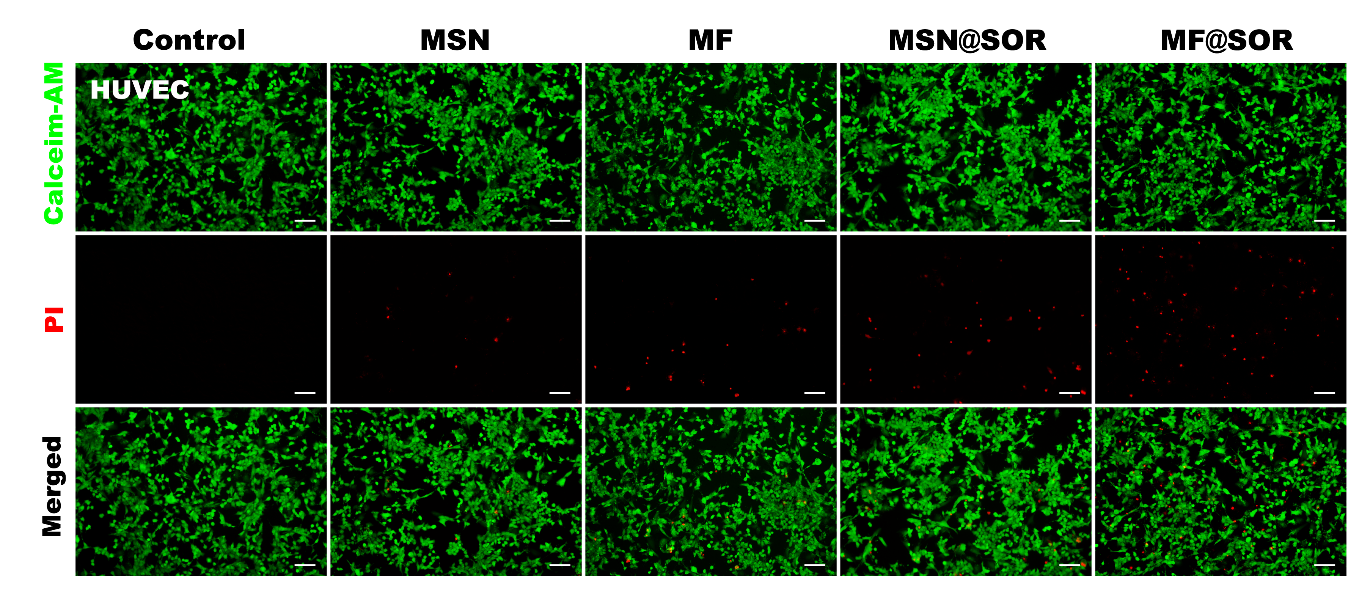
Figure S7. CLSM images of live and dead HUVECs after incubation with different NPs (scale bars: 100 μm).

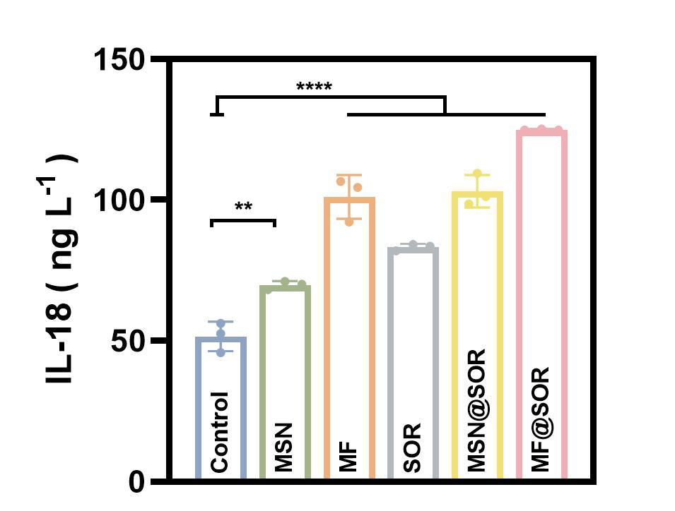
Figure S8. The levels of IL-18 measured in the supernatant after various treatments (n = 3). Data are represented as mean ± SD. All the p values were calculated by ANOVA. * p < 0.05, ** p < 0.01, *** p < 0.001, **** p < 0.0001, ns, not significant.

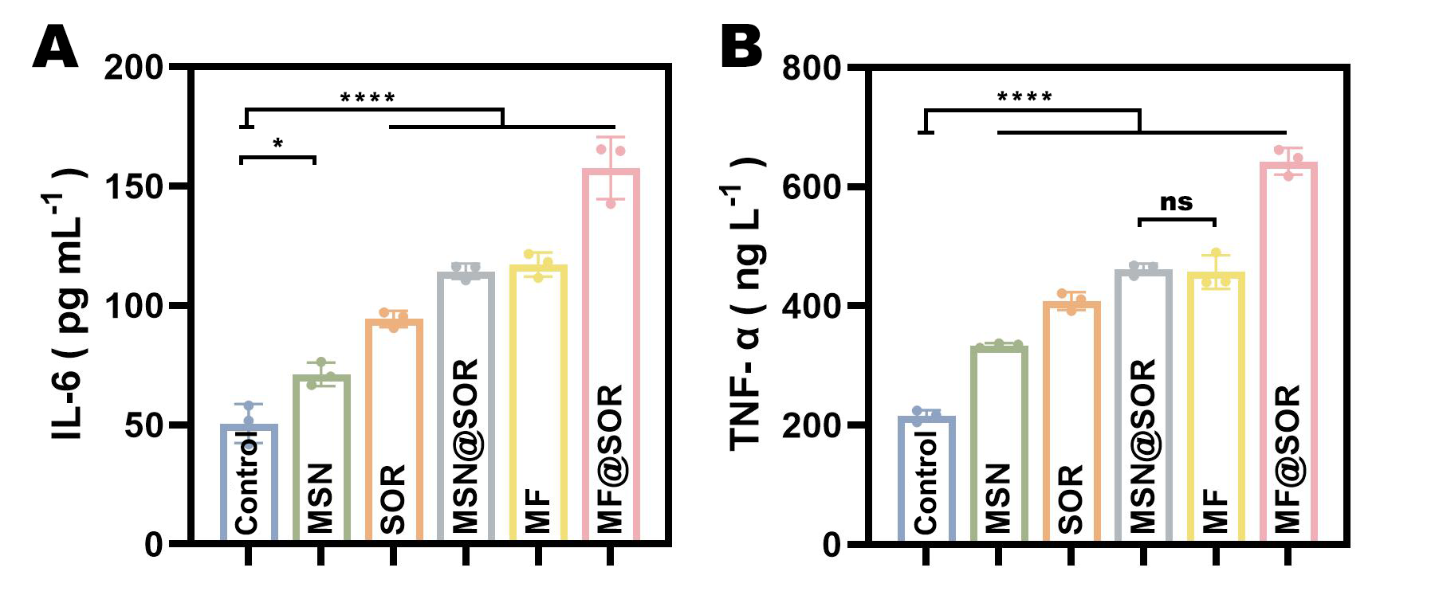
Figure S9. The concentrations of IL-6 (A) and TNF-α (B) quantified in the coculture system following different treatments (n = 3). Data are represented as mean ± SD. All the p values were calculated by ANOVA. * p < 0.05, ** p < 0.01, *** p < 0.001, **** p < 0.0001, ns, not significant.

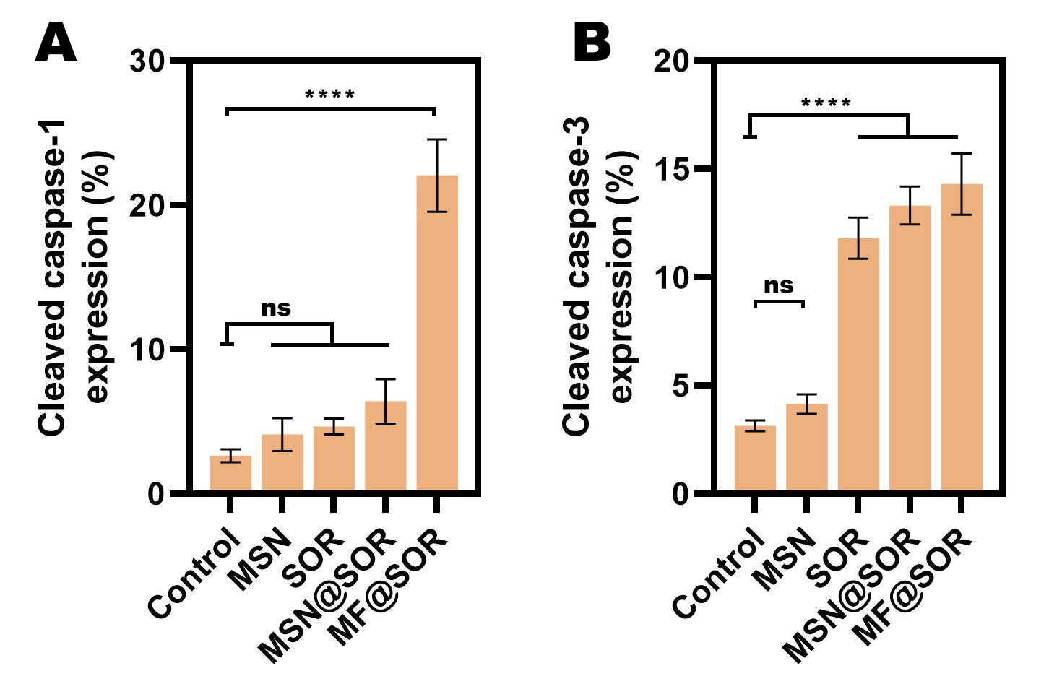
Figure S10. The quantitative analysis of (A) cleaved caspase-1 and (B) cleaved caspase-3 expression in hepa1-6 tumor upon different treatments. Data are represented as mean ± SD (n = 3). Data are represented as mean ± SD. All the p values were calculated by ANOVA. * p < 0.05, ** p < 0.01, *** p < 0.001, **** p < 0.0001, ns, not significant.

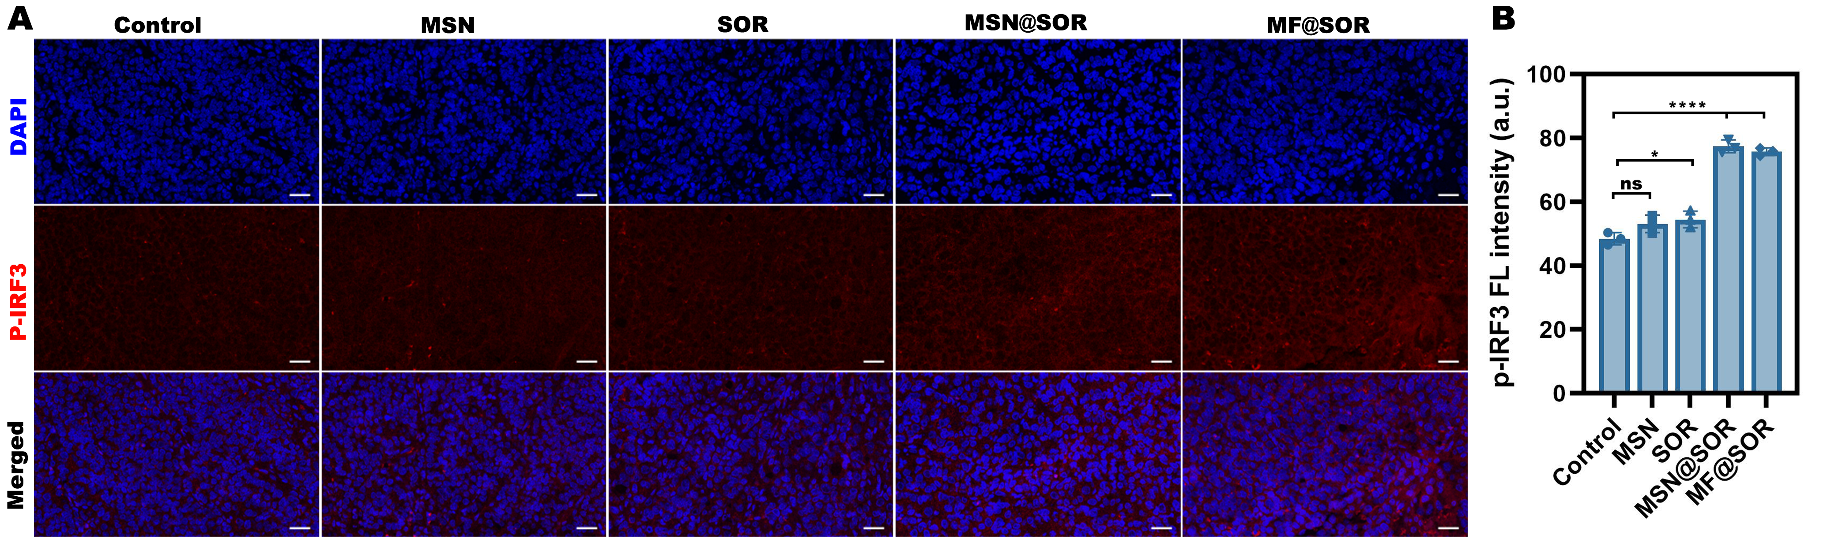
Figure S11. Immunofluorescence imaging of (A) p-IRF3 expression in hepa1-6 tumor upon different treatments (scale bar: 25 μ m) and (B) the corresponding semi-quantitative FL intensity analysis (n = 3). Data are represented as mean ± SD. All the p values were calculated by ANOVA. * p < 0.05, ** p < 0.01, *** p < 0.001, **** p < 0.0001, ns, not significant.

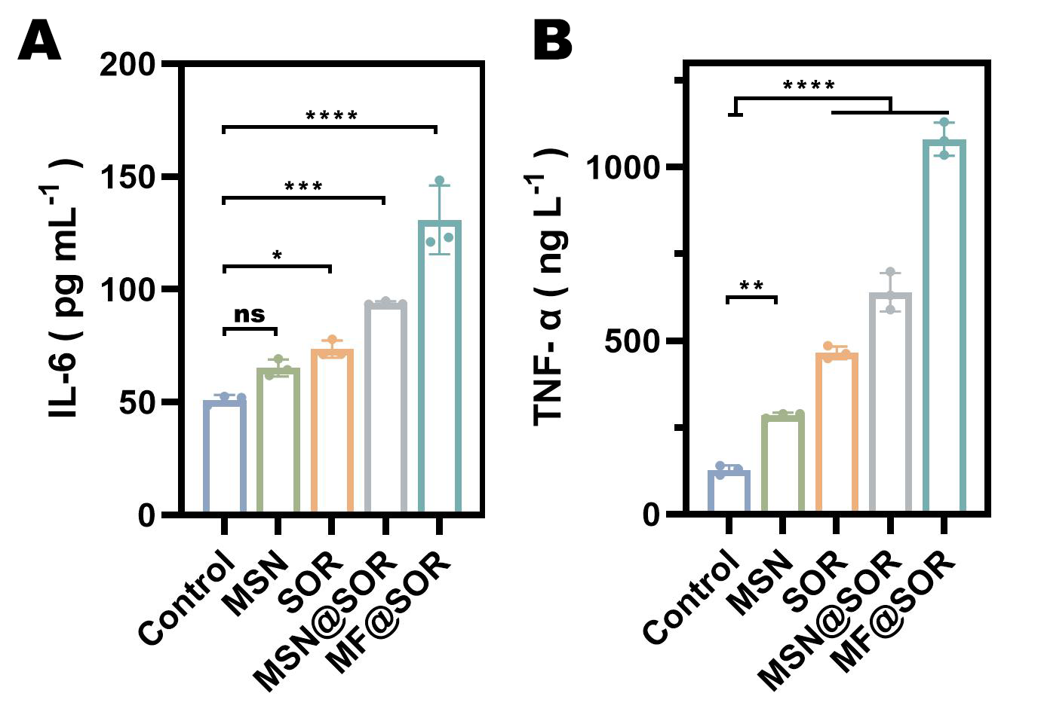
Figure S12. The level of (A) IL-6 and (B) TNF-α measured in mice serum after various treatments (n = 3). Data are represented as mean ± SD. All the p values were calculated by ANOVA. * p < 0.05, ** p < 0.01, *** p < 0.001, **** p < 0.0001, ns, not significant.

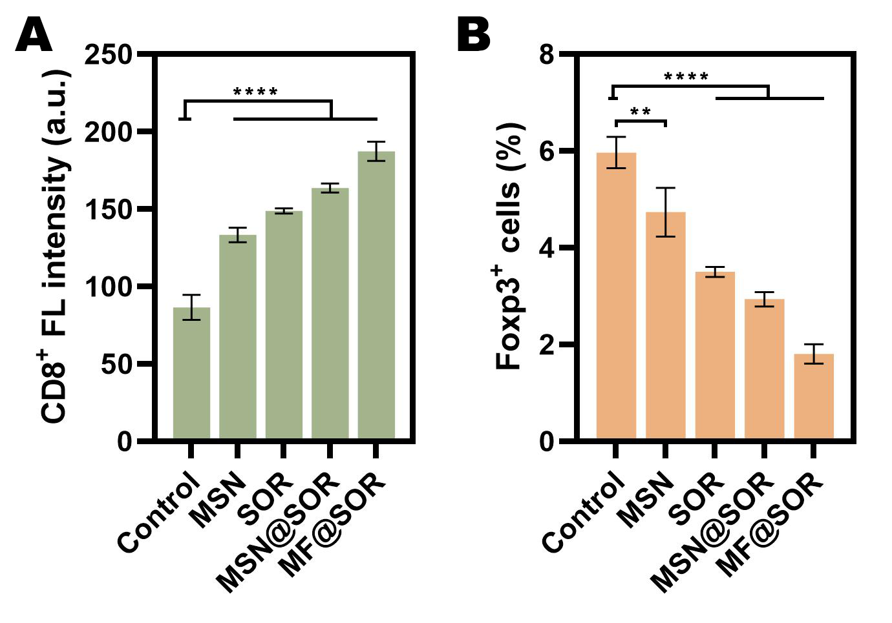
Figure S13. The quantitative analysis of (A) CD8⁺ T cells and (B) Foxp3⁺ expression in hepa1-6 tumor upon different treatments. Data are represented as mean ± SD (n = 3). All the p values were calculated by ANOVA. * p < 0.05, ** p < 0.01, *** p < 0.001, **** p < 0.0001, ns, not significant.

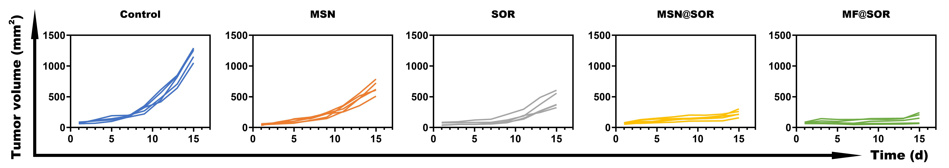
Figure S14. Tumor growth curves of individual mouse in each group.

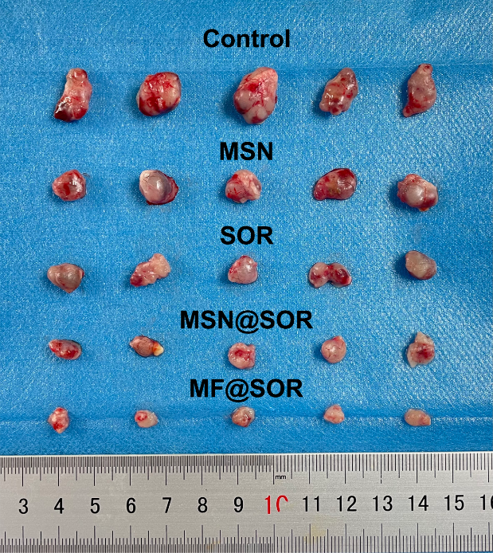
Figure S15. Digital photos of dissected tumors of tumor recurrence models in each group.
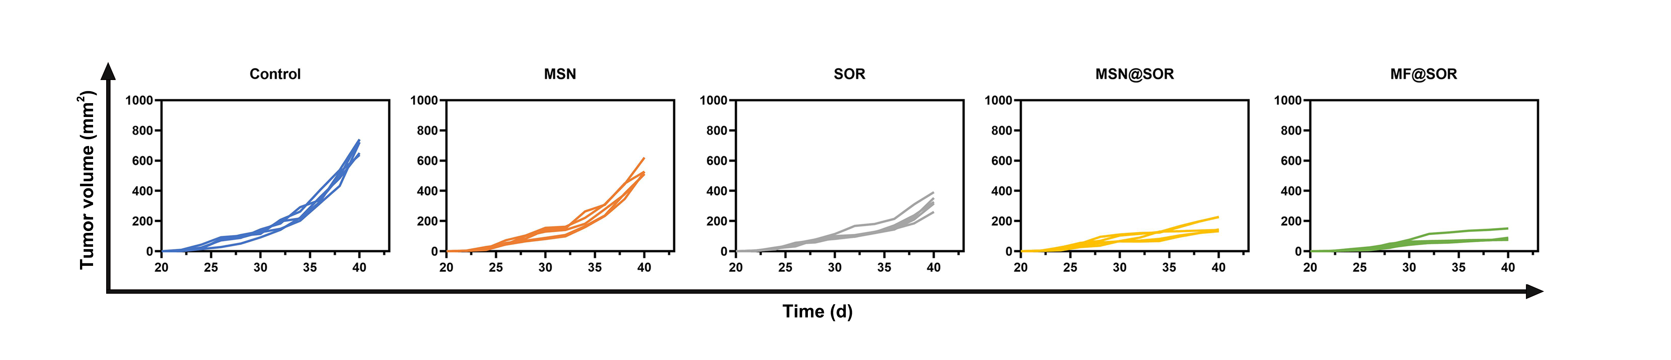 Figure S16. Tumor growth curves of individual mouse in tumor recurrence models.

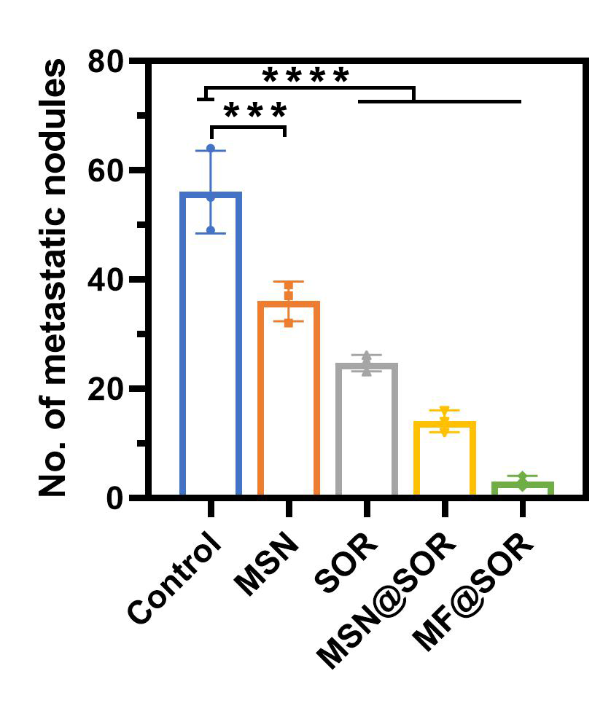
Figure S17. Quantitative analysis about the tumor nodules in lungs. Data are represented as mean ± SD (n = 3). All the p values were calculated by ANOVA. * p < 0.05, ** p < 0.01, *** p < 0.001, **** p < 0.0001, ns, not significant.

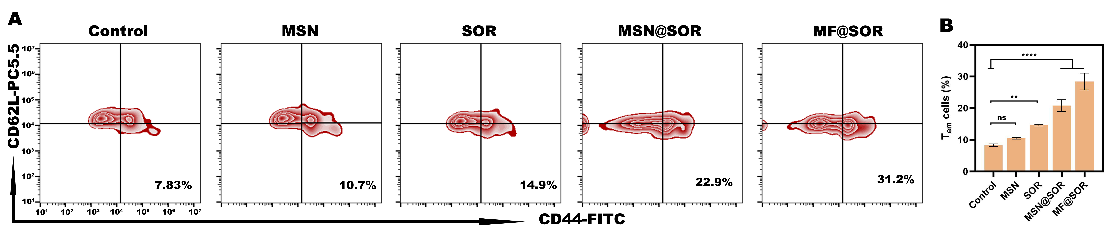
Figure S18. (A) The representative FCM images of the T_{em} cells (CD3⁺ CD8⁺ CD44⁺ CD62L⁻) proportion within the spleens in each group and (B) the quantative analysis (n = 3). Data are represented as mean ± SD. All the p values were calculated by ANOVA. * p < 0.05, ** p < 0.01, *** p < 0.001, **** p < 0.0001, ns, not significant.

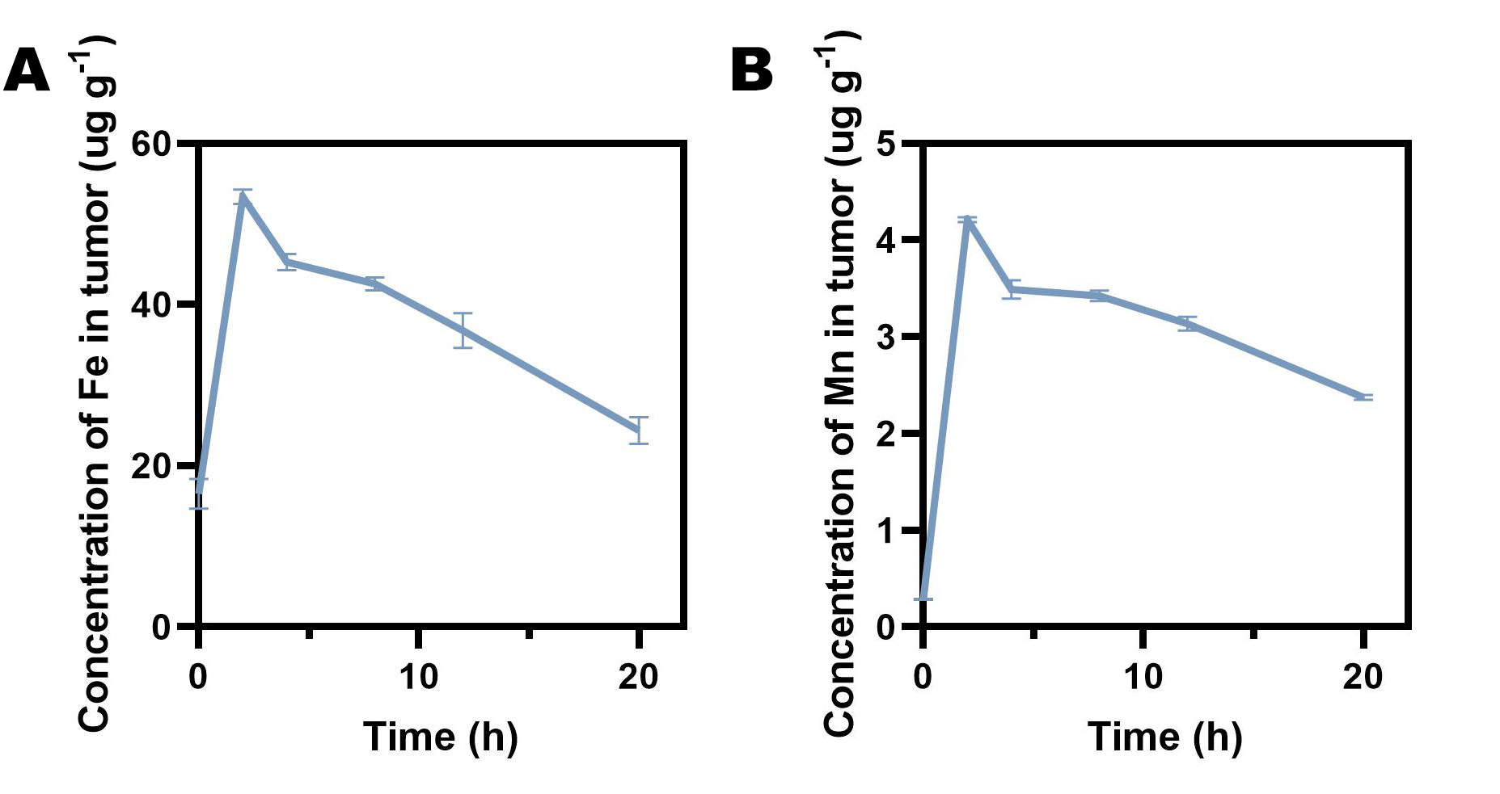
Figure S19. ICP-MS analysis of Fe (A) and Mn (B) in tumors at different time intervals post the MF@SOR injection. Data are represented as mean ± SD (n = 3).

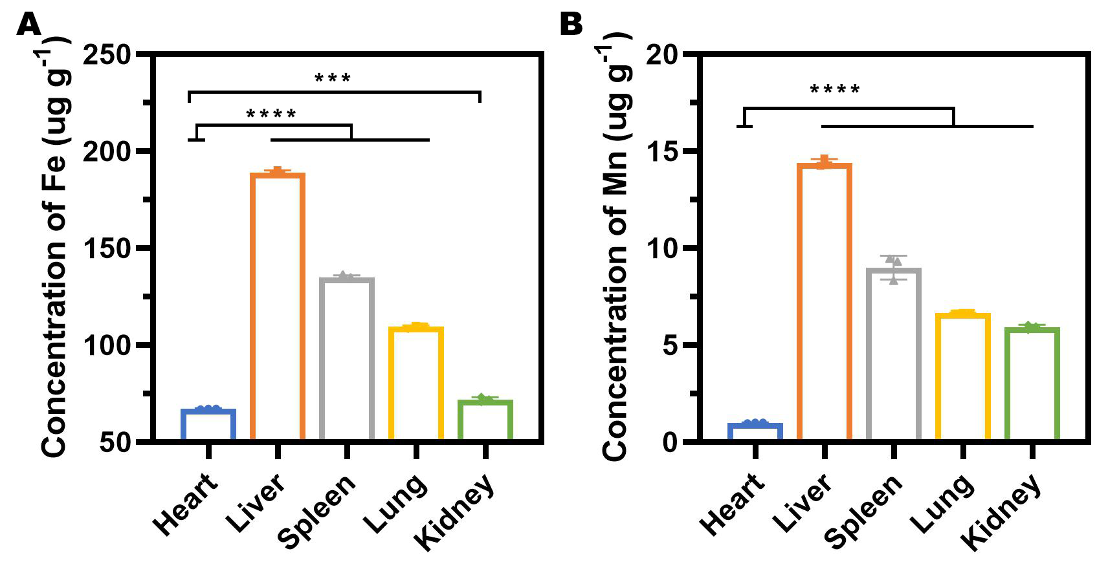
Figure S20. ICP-MS analysis of Fe (A) and Mn (B) in various organs post-treatment. Data are represented as mean ± SD (n = 3).

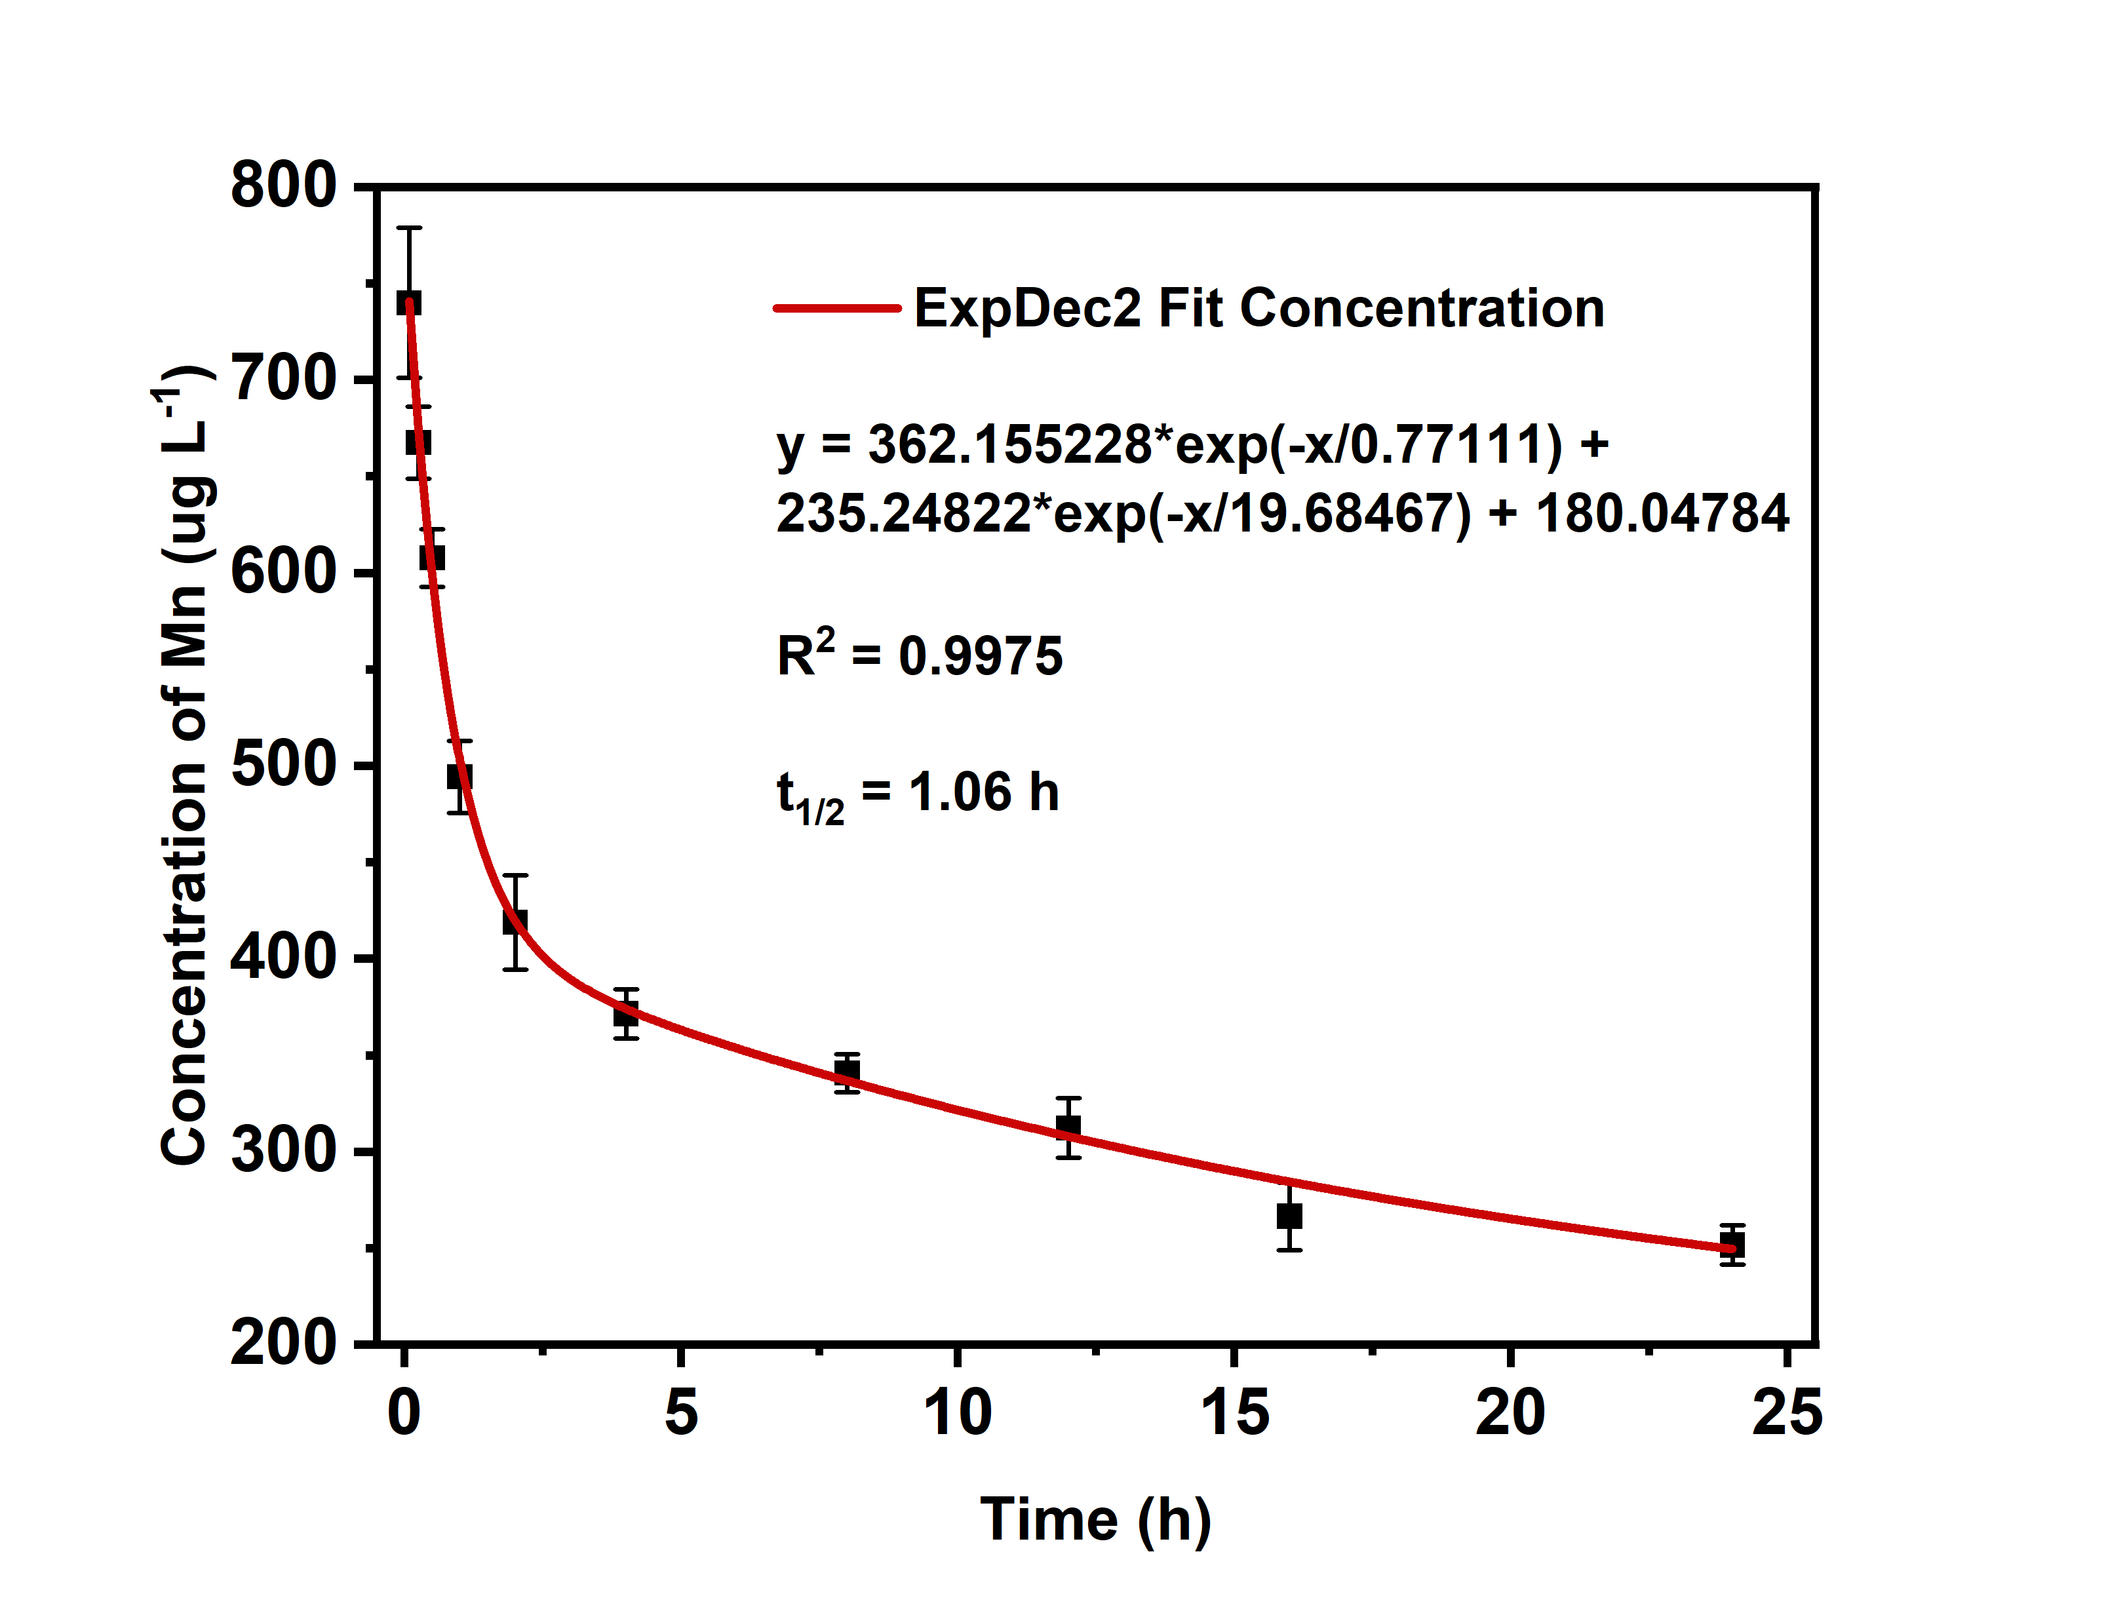
Figure S21. ICP-MS analysis of Mn in the blood at different time intervals post the MF@SOR injection. Data are represented as mean ± SD (n = 3).

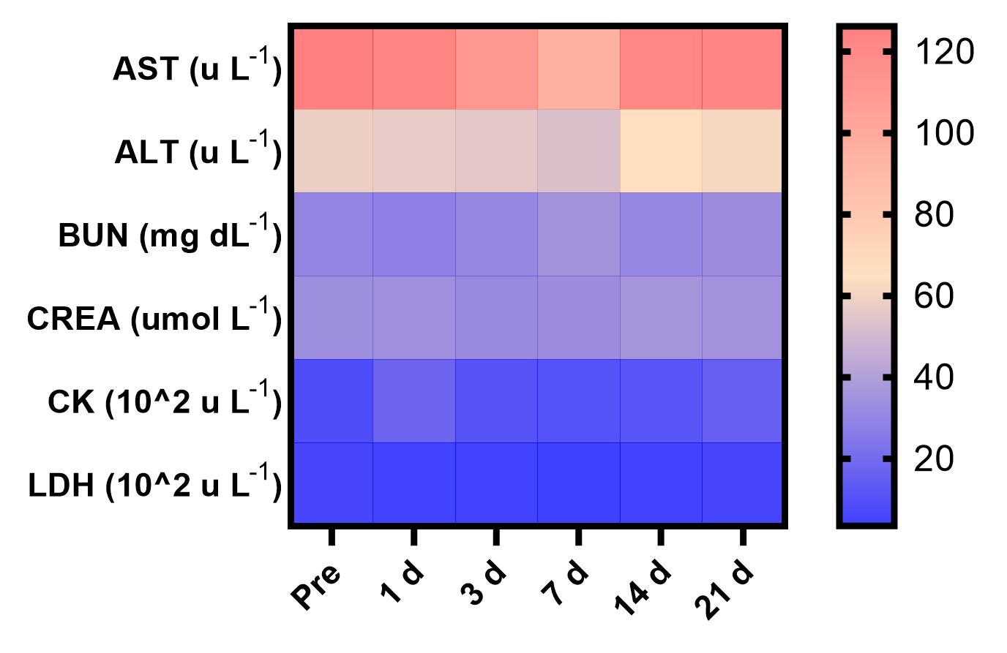
Figure S22. Blood biochemical examination of Kunming mice after intravenous injection of the MF@SOR NPs at different time points.

