Supplementary information
Young Osteocyte-derived Extracellular Vesicles Facilitate Osteogenesis by Transferring Tropomyosin-1
Zhen-Xing Wang^{1-3#}, Xiao Lin^{4#}, Jia Cao¹⁻³, Yi-Wei Liu^{1,2}, Zhong-Wei Luo^{1,2}, Shan-Shan Rao¹⁻³, Qiang Wang⁵, Yi-Yi Wang^{1,2}, Chun-Yuan Chen¹⁻³, Guo-Qiang Zhu^{1,2}, Fu-Xing-Zi Li⁴, Yi-Juan Tan^{1,2}, Yin Hu¹, Hao Yin^{1,2}, You-You Li⁶, Ze-Hui He^{1,2}, Zheng-Zhao Liu¹⁻³, Ling-Qing Yuan⁴, Yong Zhou⁶, Zheng-Guang Wang⁶*, Hui Xie¹⁻³*

* Correspondence authors: huixie@csu.edu.cn (H. Xie), wzg19830216@163.com (Z.G. Wang).

Include:
Fig. S1. Characterization of primary osteocytes for osteocytic nature and senescent status.
Fig. S2. Internalization of YO-EVs and SO-EVs by BMSCs.
Fig. S3. Identification of EV tracer transgene Dmp1^{Cre};Cd63^{loxp-mCherry-loxp-eGFP} mice.
Fig. S4. SEM images demonstrating osteoclast-induced resorption lacunae on bone slices.
Fig. S5. Distribution of YO-EVs and SO-EVs in bone tissue.
Fig. S6. The enriched molecular function (MF) terms of differentially expressed proteins between YO-EVs and SO-EVs.
Fig. S7. The enriched biological process (BP) terms of differentially expressed proteins between YO-EVs and SO-EVs.
Fig. S8. The enriched cell component (CC) terms of differentially expressed proteins between YO-EVs and SO-EVs.
Fig. S9. Impact of TPM1 Overexpression on Osteoblast and Adipogenic Differentiation of BMSCs.

Fig. S1. Characterization of primary osteocytes for osteocytic nature and senescent status. (A) Gene expression analysis for Dmp1 and Col1a1 in osteocytes (OCY) and osteoblasts (OB). (B) Gene expression analysis for P16 and P21 in young osteocytes (YO) and senescent osteocytes (SO). n = 3 per group. ** P < 0.01, *** P < 0.001.

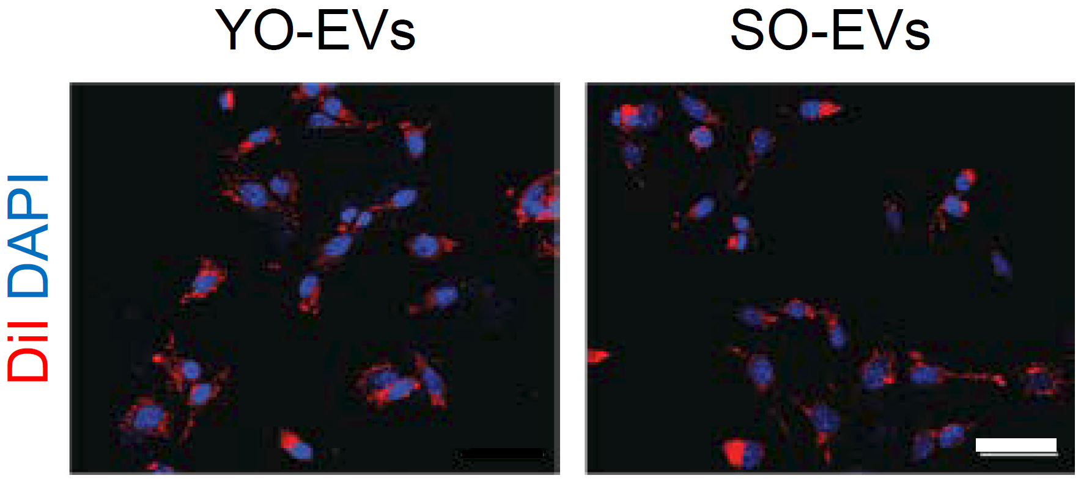
Fig. S2. Internalization of YO-EVs and SO-EVs by BMSCs. Representative fluorescent microscopic images of red florescent dye DiI-labeled YO-EVs and SO-EVs internalization by BMSCs. The cell nucleus was stained with DAPI (blue). Scale bar: 20 µm.

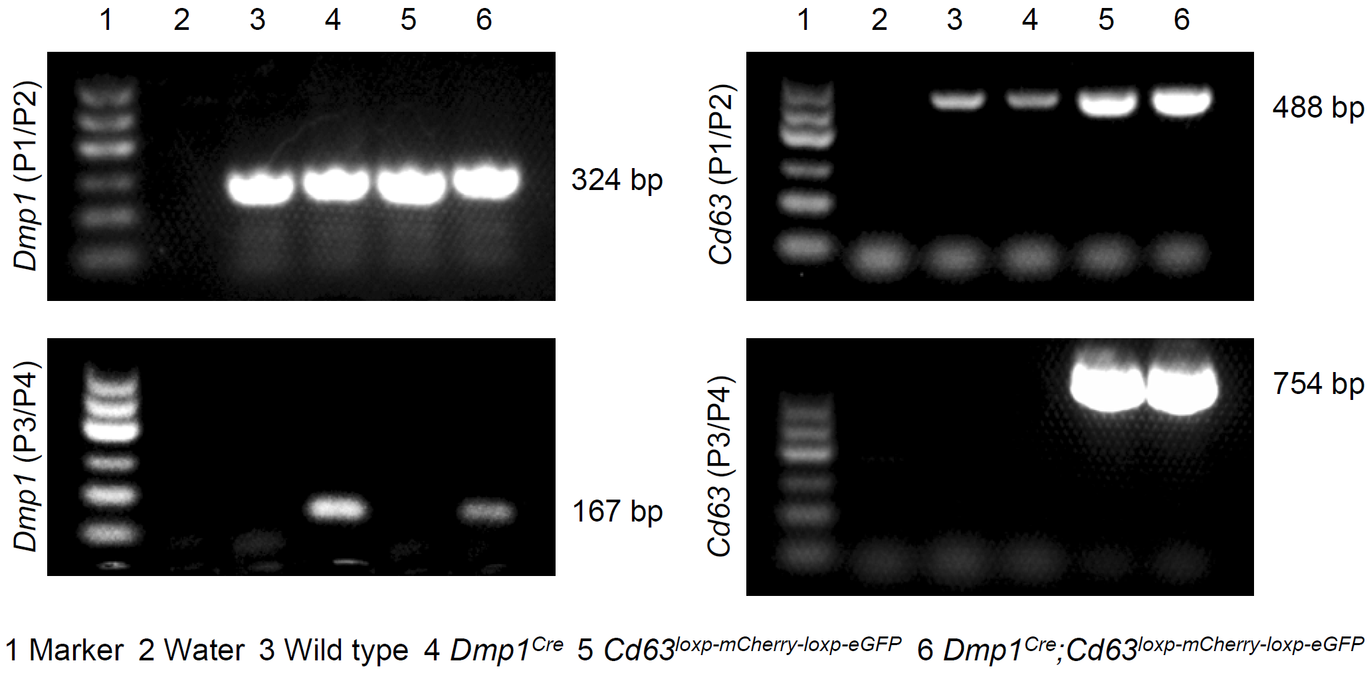
Fig. S3. Identification of EV tracer transgene Dmp1^{Cre};Cd63^{loxp-mCherry-loxp-eGFP} mice. PCR genotyping of wild type mice, Dmp1^{Cre} mice, Cd63^{loxp-mCherry-loxp-eGFP} mice, and Dmp1^{Cre};Cd63^{loxp-mCherry-loxp-eGFP} mice using primers for determining the insertion of Cre (left) and eGFP (right).

Fig. S4. SEM images demonstrating osteoclast-induced resorption lacunae on bone slices. SEM images presents the surface morphology of bone slices following exposure to osteoclast cultures for 14 days. Scale bar: 20 µm.

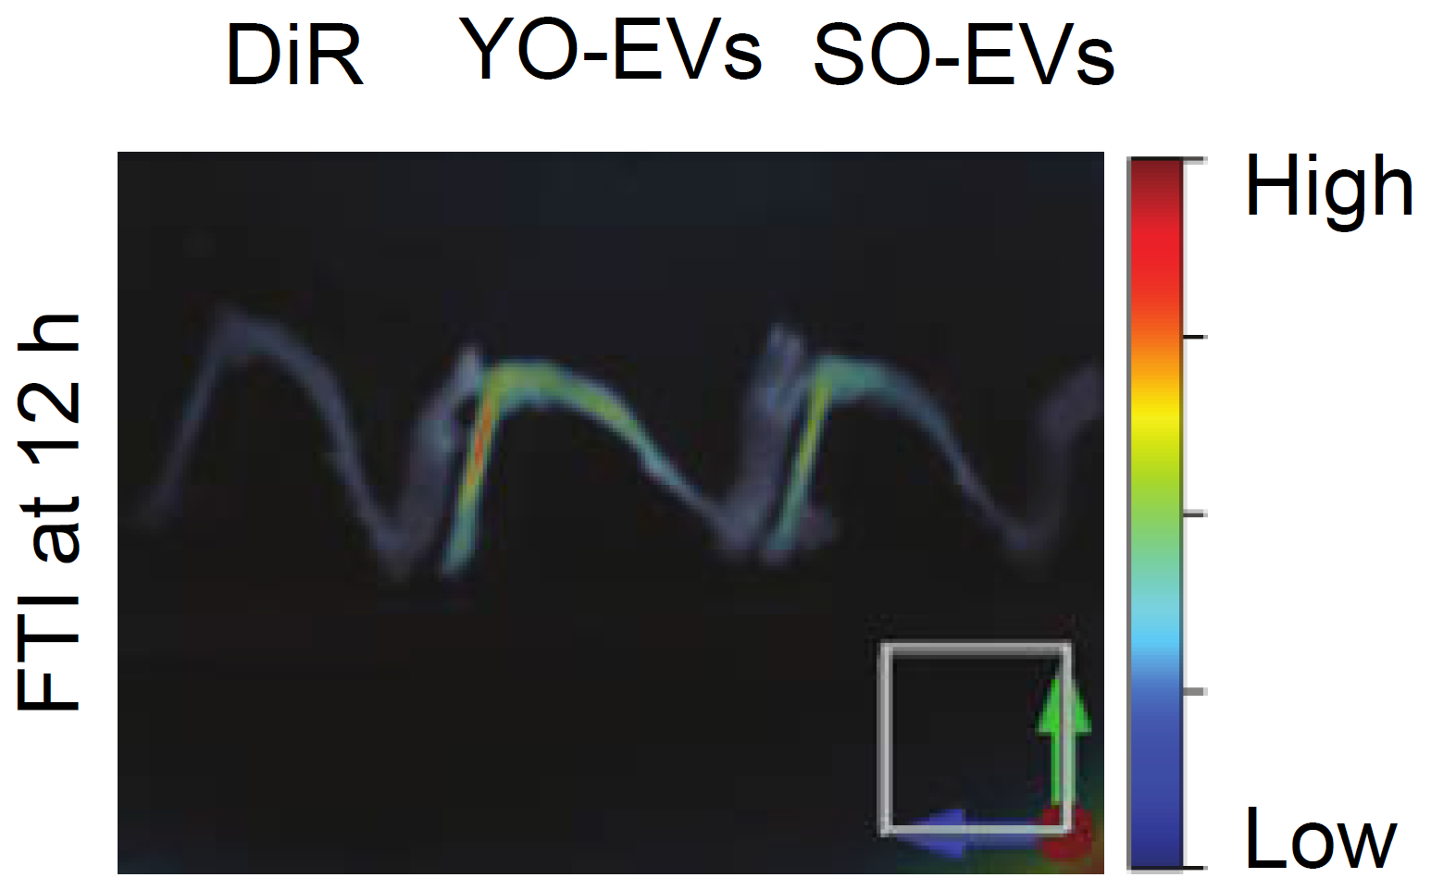
Fig. S5. Distribution of YO-EVs and SO-EVs in bone tissue. Representative ex vivo fluorescent images of lower limb bone from wild type mice treated with DiR-labeled YO-EVs and SO-EVs or solvent by intravenous administration.

Fig. S6. The enriched molecular function (MF) terms of differentially expressed proteins between YO-EVs and SO-EVs. The difference is greater than 1.5-fold, P < 0.05.
Fig. S7. The enriched biological process (BP) terms of differentially expressed proteins between YO-EVs and SO-EVs. The difference is greater than 1.5-fold, P < 0.05.

Fig. S8. The enriched cell component (CC) terms of differentially expressed proteins between YO-EVs and SO-EVs. The difference is greater than 1.5-fold, P < 0.05.

Fig. S9. Impact of TPM1 Overexpression on Osteoblast and Adipogenic Differentiation of BMSCs. (A) Illustration of the constructed lentiviral vector used for overexpressing Tropomyosin 1 (TPM1). (B-C) ARS staining (B; red) and quantification of the percentages of ARS⁺ area (C) of BMSCs treated with Solvent, LV-Mock, or LV-TPM1 under osteogenic induction. (D-E) ORO staining (D; red) and quantification of the percentages of ORO⁺ area (E) of BMSCs treated with Solvent, LV-Mock, or LV-TPM1 under adipogenic induction. Scale bar: 50 μm. n = 3 per group. PBS treatment was used in the solvent groups. *** P < 0.001, **** P < 0.0001.

