Intranasal delivery of phenytoin loaded layered double hydroxide nanoparticles improves therapeutic effect on epileptic seizures

This PDF file includes:
Fig. S1 to
Supplementary Fig. 1 Schematic representation of the method of preparation of BSA-LDHs-PHT

Fig. S2 to
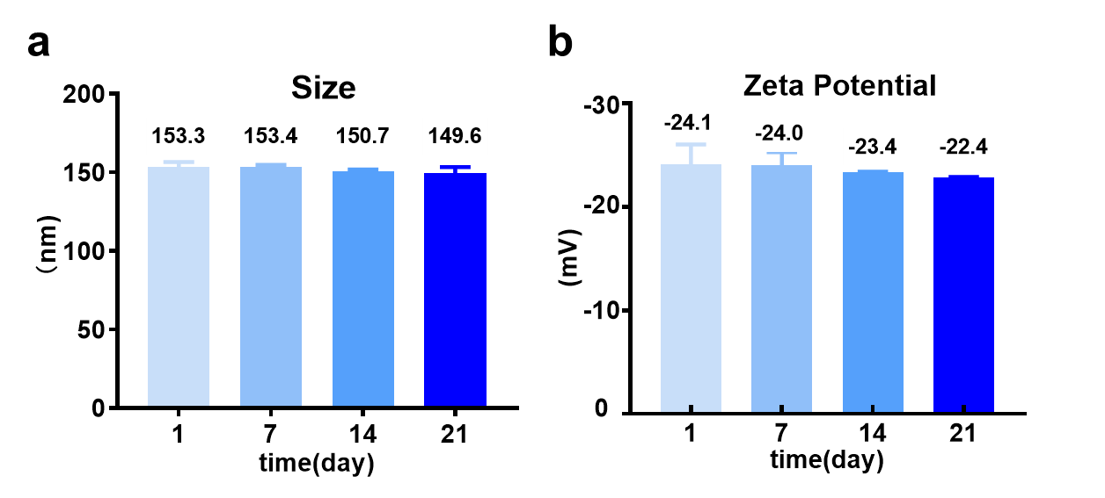
Supplementary Fig. 2 The size (a) and zeta potential (b) of BSA-LDHs-PHT within 21 days, p$\text{<}$0.05

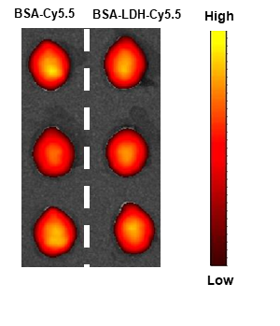
Fig. S3 to
Supplementary Fig. 3 In vitro fluorescence images of mice brains after 15 minutes of administration (n=3)

Fig. S4 to
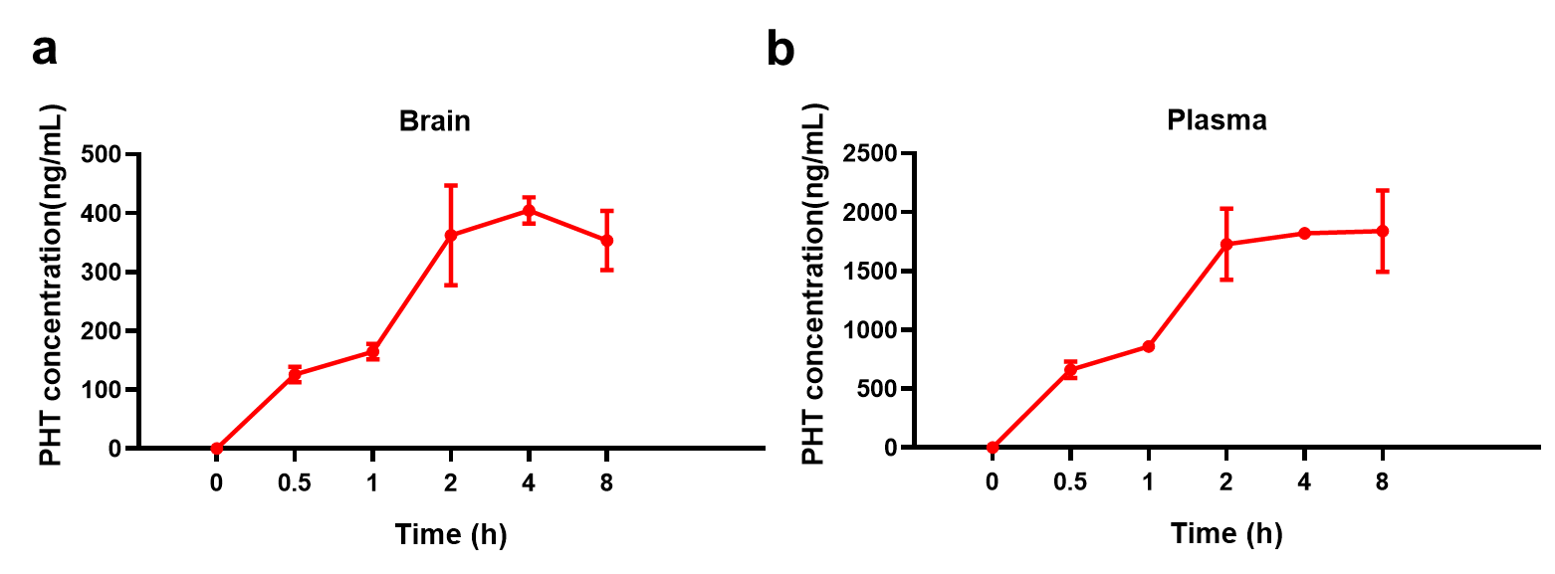
Supplementary Fig. 4 Concentration-time profiles of PHT (n=3) in brain (a) and plasma (b). a The C_{max} of phenytoin in brain is 404.3 ng/mL at 4 hours. b The C_{max} of phenytoin in plasma is 1840 ng/mL at 8 hours.

Table S1 to
Supplementary Table 1. Study design for in vivo anti-seizure effects study

Group | Total No. of animals | Animal subgroups based on different durations after administration |  | Treatment | Dose-volume | Drug amount
Group | Total No. of animals | 5 mins | 30 mins | Treatment | Dose-volume | Drug amount
1 | 20 | 10 | 10 | I.N. (Saline) | (25μL/nostril)*2 | 200 μg
2 | 20 | 10 | 10 | Oral (PHT) | (25μL/nostril)*2 | 200 μg
3 | 20 | 10 | 10 | I.N. (PHT) | (25μL/nostril)*2 | 200 μg
4 | 20 | 10 | 10 | I.N. (BSA-LDHs-PHT) | 200 μL | 200 μg

