Biomimetic MDSCs Membrane Coated Black Phosphorus Nanosheets System for Photothermal Therapy/Photodynamic Therapy Synergized Chemotherapy of Cancer

Supplementary Figures
Figure S1
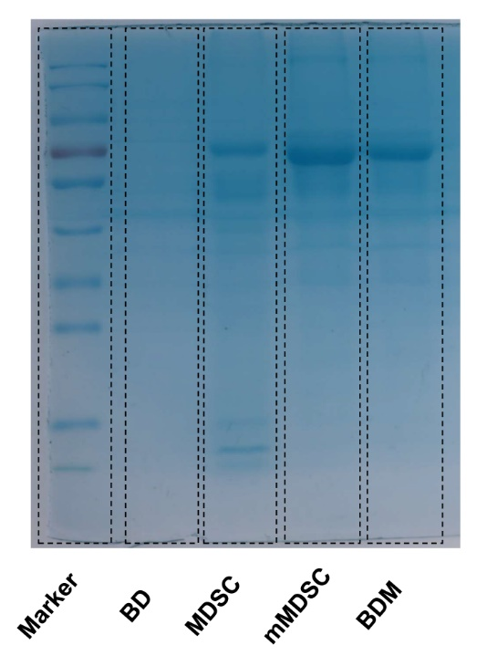

Figure S1. SDS-PAGE analysis of BD, MDSC, mMDSC and BDM.

Figure S2

Figure S2. The stability images of BP, BD and BDM observed at 0, 1, 3, 5 and 10 days.

Figure S3

Figure S3. Photothermal images of BP and BD (80 μg/mL) in different times with laser irradiation (808nm, 1.5 W/cm2).

Figure S4
Figure S4. The change of temperature (Δt) in BP, BD and BDM group.

Figure S5
Figure S5. Decitabine released from BDM at pH 5.0 with or without 808 nm irradiation (1.5 W/cm²).

Figure S6

Figure S6. TEM mapping of BP. Scale bar=200 and 250nm.

Figure S7
Figure S7. The Mass fraction of P, C, O and N element in BP and BD group.

Figure S8
Figure S8. Systemic toxicity evaluation of BDM: The body weight change of mice with or without BDM treatment (i.v. twice a week, 80 μg/mL, n=3 per group).

Figure S9
Figure S9. Systemic toxicity evaluation of BDM: ALT, ALP, ALB, GLB, CRE and BUN (n=3 per group).

Figure S10
Figure S10. Systemic toxicity evaluation of BDM: RBC, WBC, PLT, HGB, HCT, MCH, MCHC and MCV (n=3 per group).

Figure S11
Figure S11. Hematoxylin and eosin (HE) staining of organs from mice with or without BDM treatment (n=3 per group). Scale bar: 100 µm.

Figure S12
Figure S12. Representative flow cytometry data for CD11b⁺ Gr-1⁺ MDSCs in tumor microenvironment of different groups. (n=3 per group, G1: Con, G2: Laser (L), G3: BD, G4: BDM, G5: BD+L, G6: BDM+L).

Figure S13
Figure S13. Representative flow cytometry data for CD11b⁺ F4/80⁺ Macrophages in tumor microenvironment of different groups. (n=3 per group, G1: Con, G2: Laser (L), G3: BD, G4: BDM, G5: BD+L, G6: BDM+L).

Figure S14
Figure S14. Representative flow cytometry data for CD86⁺ CD11b⁺ F4/80⁺ M1-like Macrophages in tumor microenvironment of different groups. (n=3 per group, G1: Con, G2: Laser (L), G3: BD, G4: BDM, G5: BD+L, G6: BDM+L).

Figure S15
Figure S15. Representative flow cytometry data for CD206⁺ CD11b⁺ F4/80⁺ M2-like Macrophages in tumor microenvironment of different groups. (n=3 per group, G1: Con, G2: Laser (L), G3: BD, G4: BDM, G5: BD+L, G6: BDM+L).

Figure S16
Figure S16. Representative flow cytometry data for CD11b⁺ CD11c⁺ DCs in tumor microenvironment of different groups. (n=3 per group, G1: Con, G2: Laser (L), G3: BD, G4: BDM, G5: BD+L, G6: BDM+L).

Figure S17
Figure S17. Representative flow cytometry data for CD103⁺ CD11b⁺ CD11c⁺ Matured DCs in tumor microenvironment of different groups. (n=3 per group, G1: Con, G2: Laser (L), G3: BD, G4: BDM, G5: BD+L, G6: BDM+L).

Figure S18
Figure S18. Representative flow cytometry data for CD45⁺ CD4⁺ T cells in tumor microenvironment of different groups. (n=3 per group, G1: Con, G2: Laser (L), G3: BD, G4: BDM, G5: BD+L, G6: BDM+L).

Figure S19
Figure S19. Representative flow cytometry data for CD45⁺ CD8⁺ T cells in tumor microenvironment of different groups. (n=3 per group, G1: Con, G2: Laser (L), G3: BD, G4: BDM, G5: BD+L, G6: BDM+L).

Figure S20
Figure S20. Representative flow cytometry data for CD45⁺ CD8⁺ PD-1⁺ T cells in tumor microenvironment of different groups. (n=3 per group, G1: Con, G2: Laser (L), G3: BD, G4: BDM, G5: BD+L, G6: BDM+L).

