Finely tuned ionizable lipid nanoparticles for CRISPR/Cas9 ribonucleoprotein delivery and gene editing
San Hae Im^{1†}, Mincheol Jang^{2†}, Ji-Ho Park^{2,3*}, and Hyun Jung Chung^{1*}

¹ Department of Biological Sciences, Korea Advanced Institute of Science and Technology (KAIST), 291, Daehak-ro, Yuseong-gu, Daejeon, 34141, Republic of Korea
² Department of Bio and Brain Engineering, Korea Advanced Institute of Science and Technology (KAIST), 291, Daehak-ro, Yuseong-gu, Daejeon, 34141, Republic of Korea
³ KAIST Institute for Health Science and Technology, Korea Advanced Institute of Science and Technology (KAIST), 291, Daehak-ro, Yuseong-gu, Daejeon, 34141, Republic of Korea
E-mail: hyunjc@kaist.ac.kr; jihopark@kaist.ac.kr

† These authors contributed equally:
* Corresponding authors

Table S1. Primers for targeted deep sequencing to determine gene editing efficiencies, according to different sgRNAs targeting IL-10.
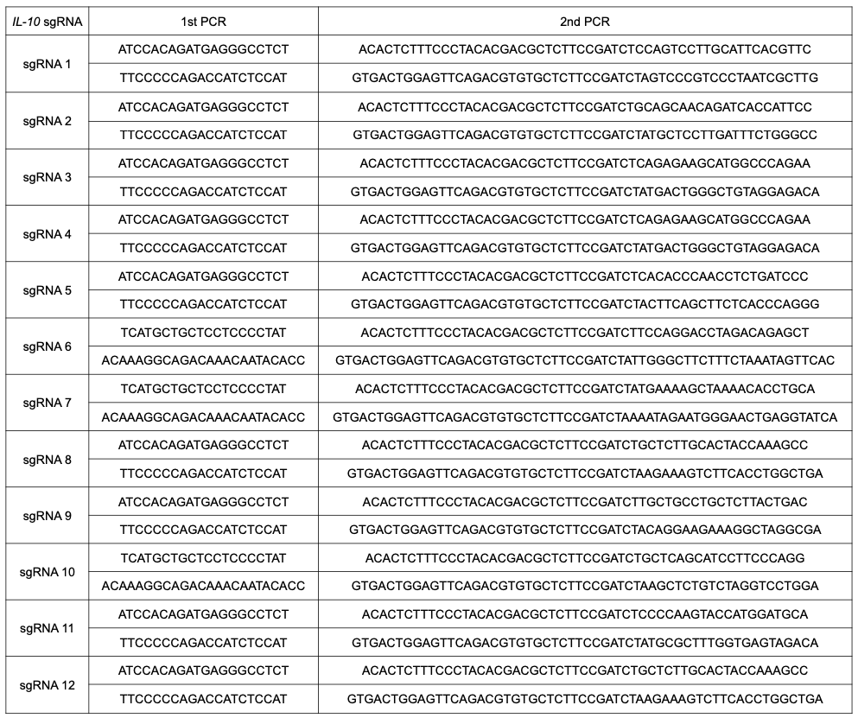

Table S2. Primers for targeted deep sequencing to determine off-target effects, according to different sgRNAs targeting IL-10.
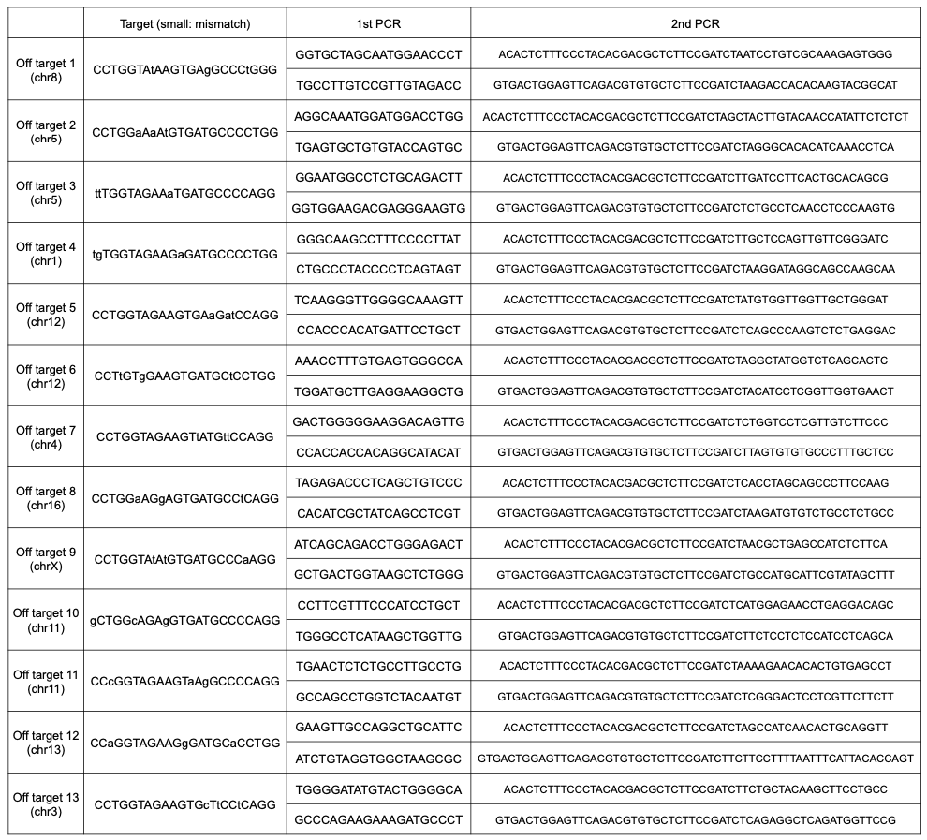

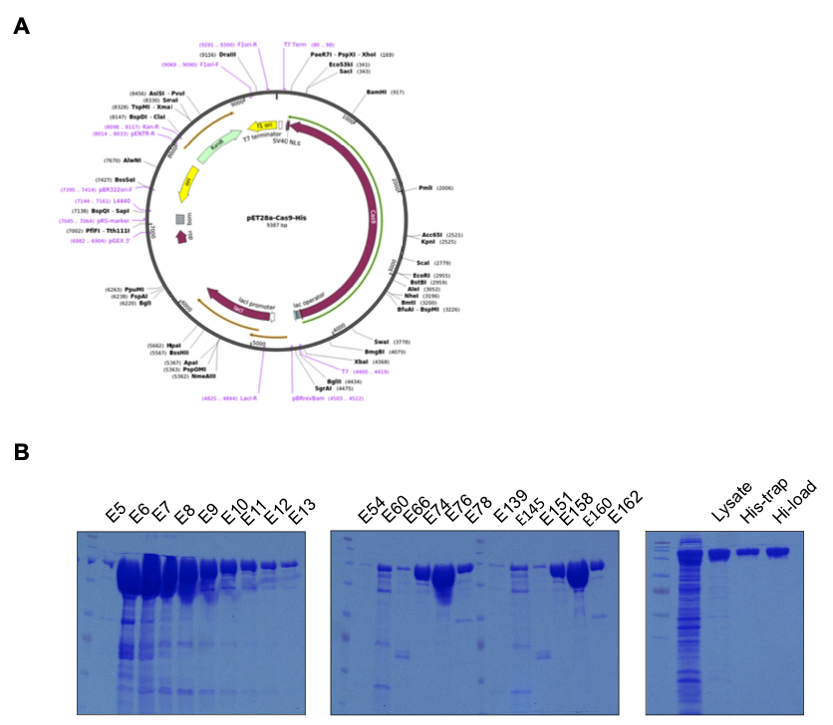
Figure S1. Purification of Cas9. A Plasmid map of Cas9 expression plasmid. B SDS-PAGE of eluents at each step during Cas9 purification.

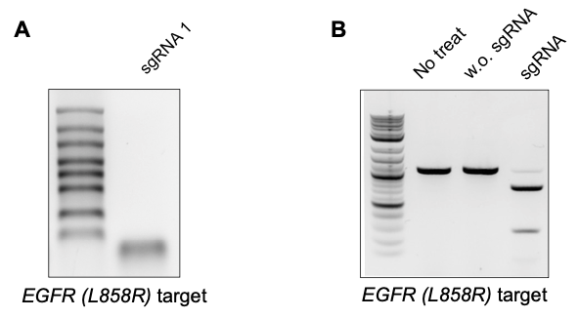
Figure S2. Synthesis and characterization of sgRNA targeting EGFR (L858R) of the surrogate reporter. A sgRNA was synthesized by IVT. B DNA cleavage activity of sgRNA by treating RNP to target DNA for 90 min, and analysis of cleaved products by gel electrophoresis.

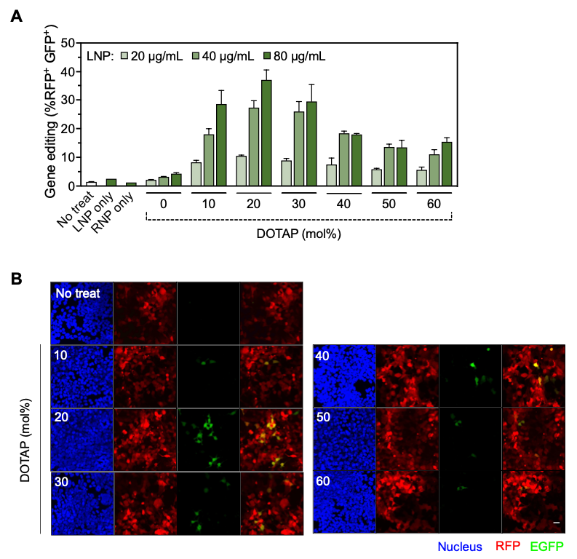
Figure S3. Gene editing by LNPs added with DOTAP in HEK293T surrogate reporter cell line. A Flow cytometry and B confocal microscopy of treated cells according to various molar ratios of DOTAP. Scale bar, 40 µm.

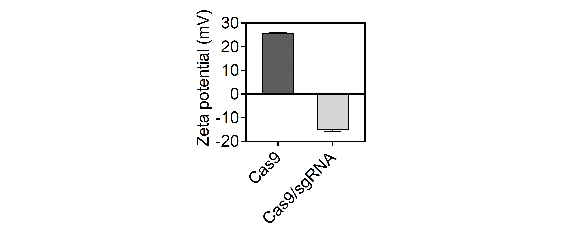
Figure S4. Zeta potential of Cas9 and Cas9/sgRNA (n = 3).

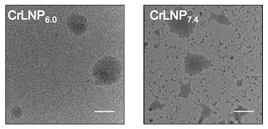
Figure S5. TEM of CrLNPs prepared at different pHs (pH 6.0 and 7.4). Scale bar, 100 nm.

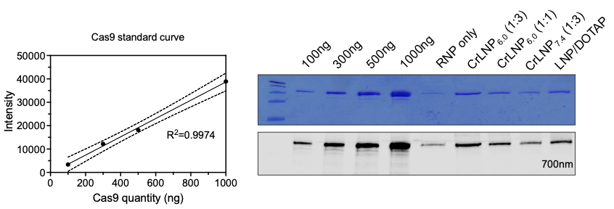
Figure S6. Loading efficiency of Cas9 in CrLNPs. Standard curve and SDS-PAGE of AF647-conjugated Cas9 after loading.

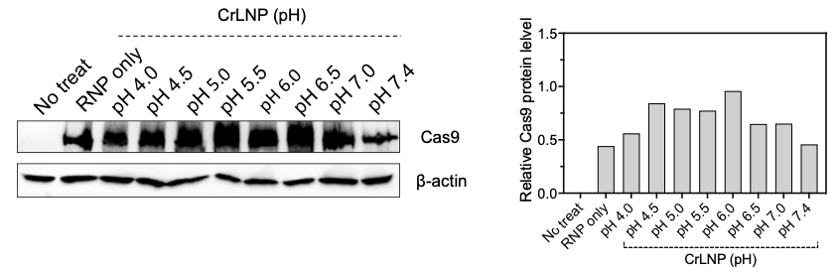
Figure S7. Western blot of Cas9 after treating HEK293T cells with CrLNP prepared at different pHs. Cells were treated for 6 h, and the total proteins were blotted on PVDF membranes and analyzed by measuring relative Cas9 protein levels normalized to actin levels.

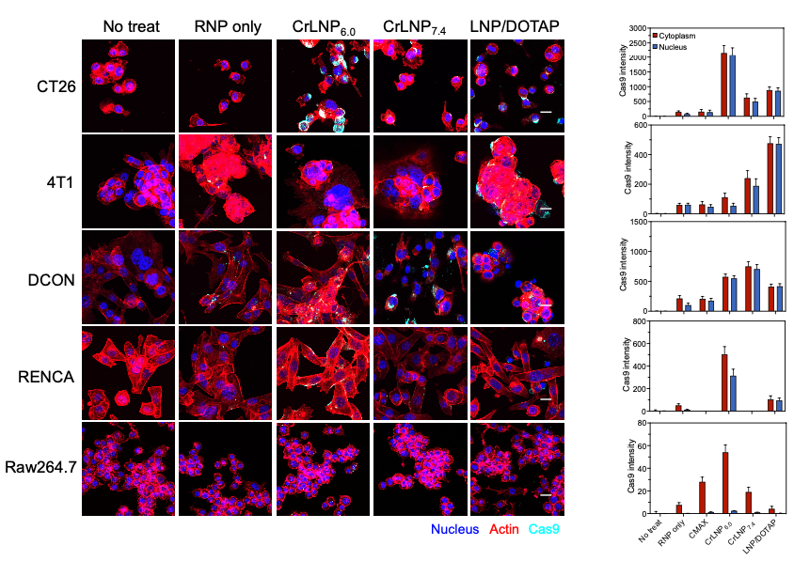
Figure S8. Confocal images and quantification of various cells (CT26, 4T1, DCON, RENCA, Raw264.7) treated with CrLNP for 6 h. Scale bar 40 µm.

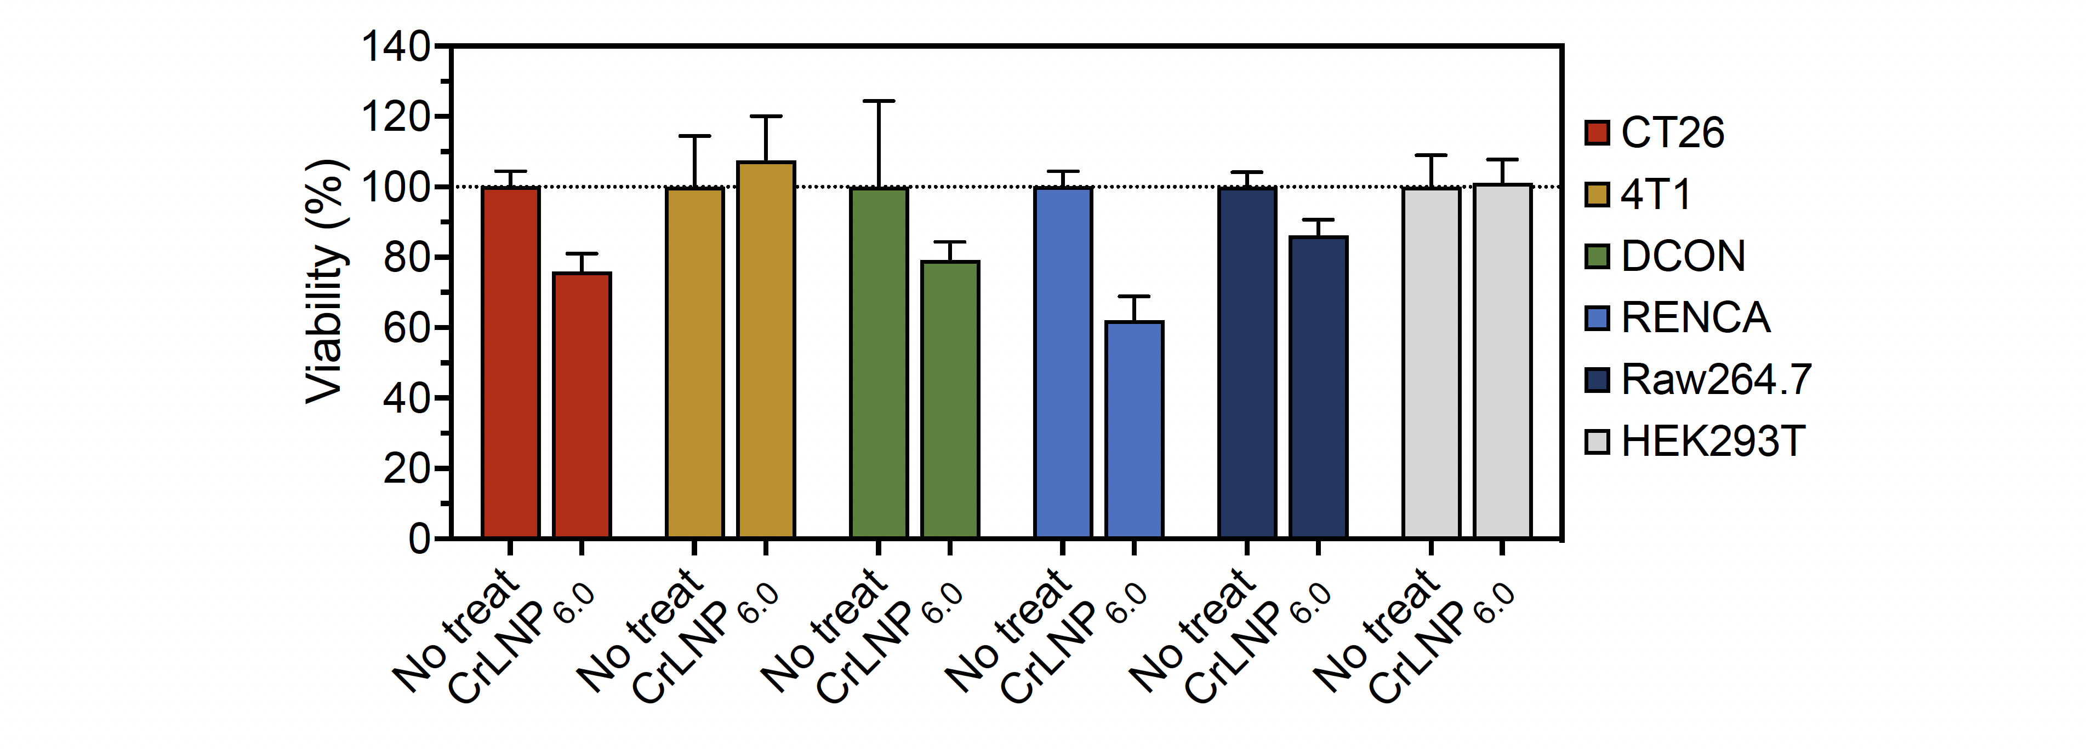
Figure S9. Cytotoxicity of CrLNP_{6.0} treated at 20 µg/mL for 6h in various cell lines (n = 3).

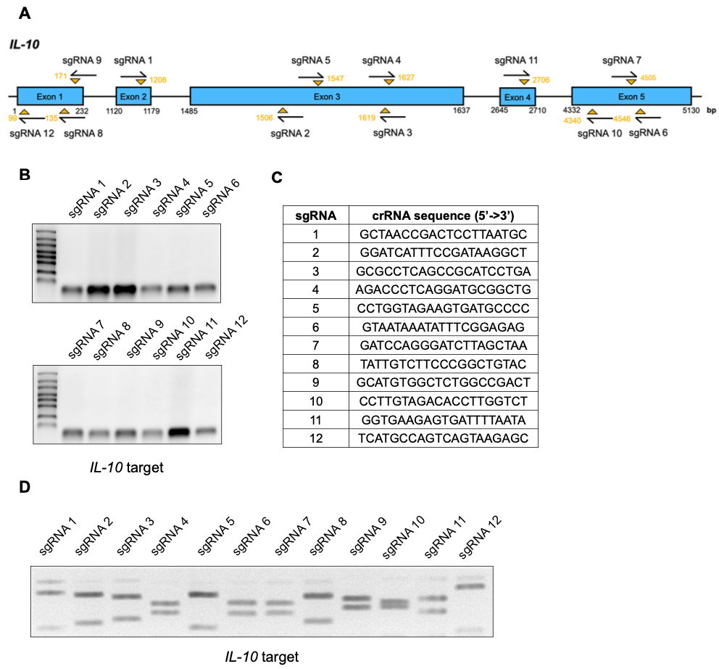
Figure S10. Synthesis and characterization of sgRNA targeting IL-10. A Scheme of IL-10 gene aligned with the designed sgRNAs targeting 12 different regions. B Synthesis of sgRNAs by IVT. C Table showing the list of 12 sgRNAs targeting IL-10. D Cleavage activity of sgRNAs by treating RNPs to IL-10 target DNA for 90 min, and analyses of cleaved products.

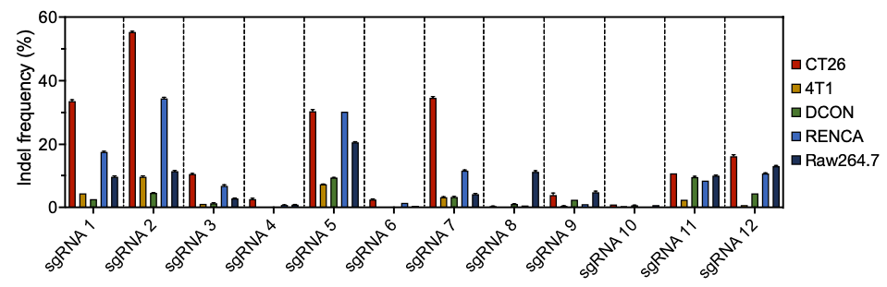
Figure S11. Gene editing efficiencies by treating different sgRNAs targeting IL-10 to various cell lines for 72 h, and analyses by targeted deep sequencing.

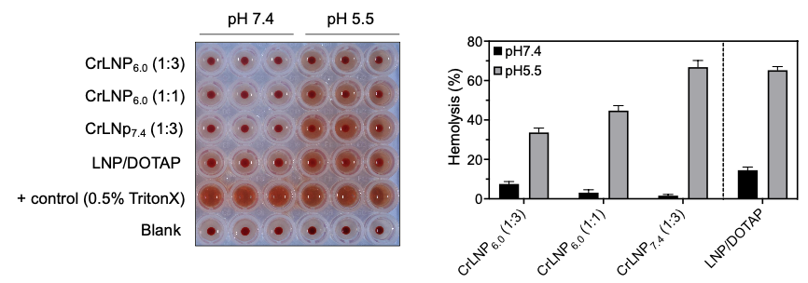
Figure S12. Hemolysis assay by treating CrLNPs to human red blood cells for 1 h, and measuring the changes in absorbance.

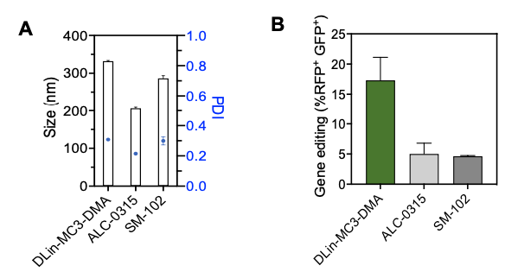
Figure S13. Evaluation of CrLNP_{6.0} prepared with various ionizable lipids. A Hydrodynamic size and B gene editing efficiency by treating to HEK293T surrogate reporter cells.

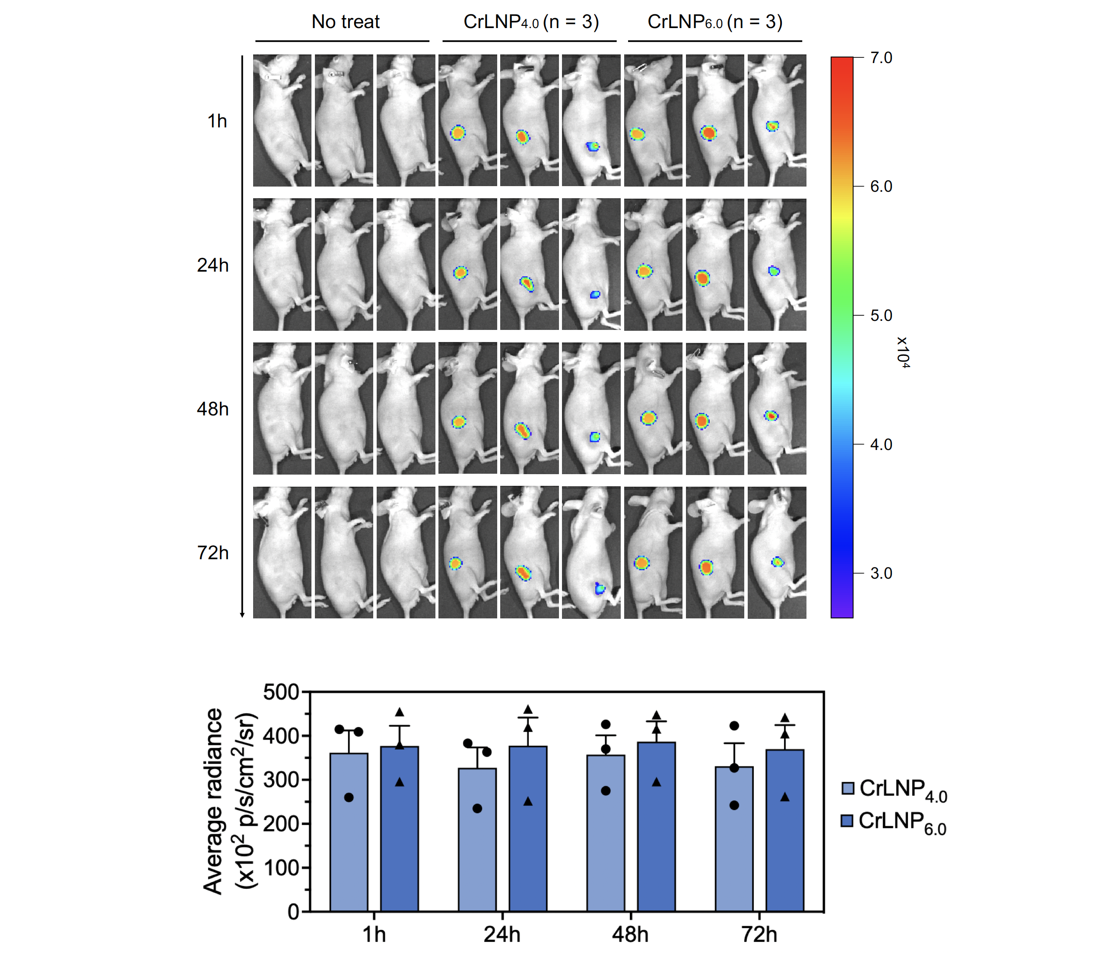

Figure S14. IVIS imaging and quantification of AF647-conjugated Cas9 signals at different time points after intratumoral injection of CrLNP_{4.0} and CrLNP_{6.0} (n = 3). Data are shown as mean ± SD.

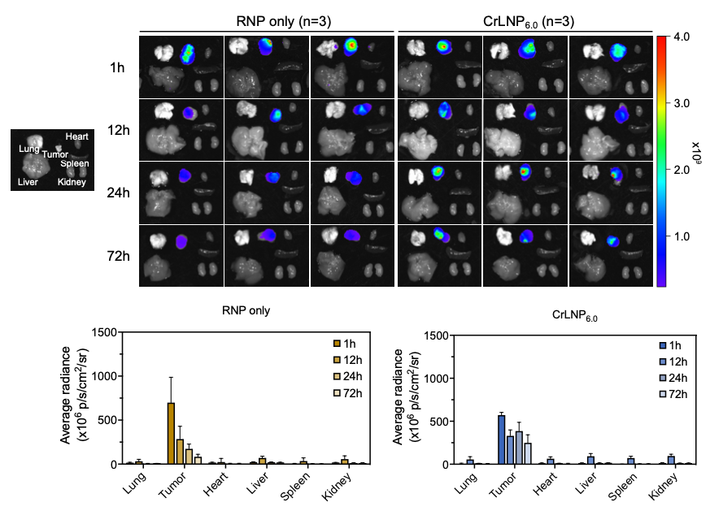
Figure S15. Biodistribution upon intratumoral injection of CrLNPs. Mice were sacrificed after each time point and signals of AF647-conjugated Cas9 were imaged using IVIS (n = 3).

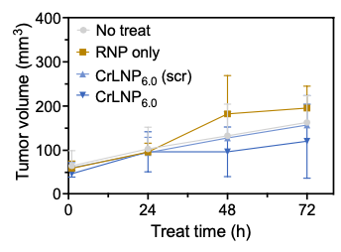
Figure S16. Measurement of tumor volumes after injection of CrLNP_{6.0} (n = 4).

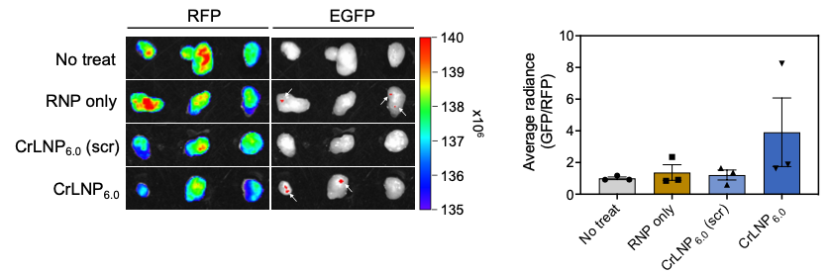
Figure S17. IVIS imaging of HEK293T tumors after treatment with CrLNP_{6.0}. Signals of the surrogate reporter (EGFP) were analyzed by excising tumors 72 h after intratumoral injection (n = 3).

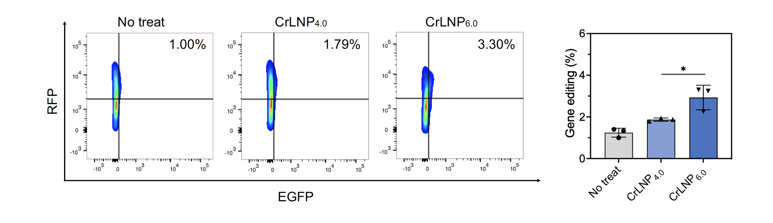
Figure S18. In vivo gene editing by treatment of CrLNP_{4.0} and CrLNP_{6.0}. Scatter plot of a representative sample from each group, and mean values for each group (n = 3). Data are shown as mean ± SD, *P < 0.05 by one-way ANOVA.

