Additional File 1
Supplementary Information

Attenuation of Inflammatory Bowel Disease by Oral Administration of Mucoadhesive Polydopamine-Coated Yeast β-glucan via ROS Scavenging and Gut Microbiota Regulation

Fan Yangª, Yuting Suª, Chi Yanª, Tianfeng Chen^{b}, Peter Chi Keung Cheung ^{a*}

ª School of Life Sciences, The Chinese University of Hong Kong, Shatin, New Territories, Hong Kong, China
^{b}College of Chemistry and Materials Science, Jinan University, Guangzhou, China

*Corresponding author: Peter Chi Keung Cheung
E-mail: petercheung@cuhk.edu.hk

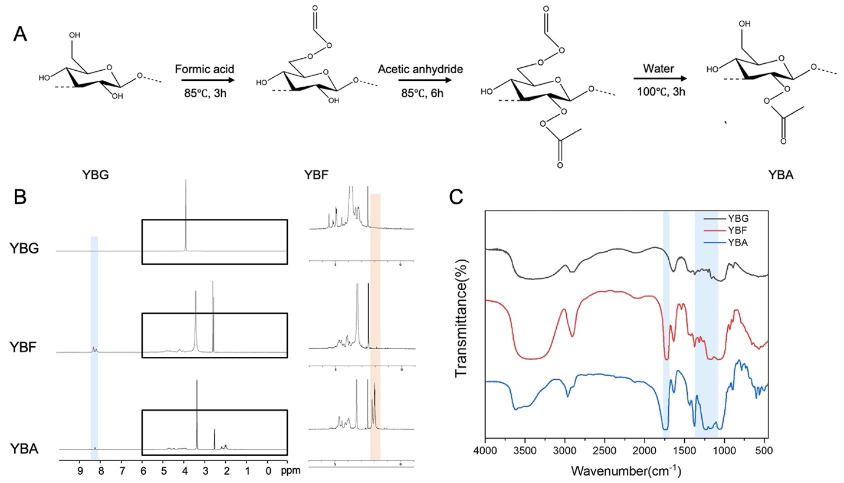
Fig. S1. Preparation of YBNs. (A) Synthesis route of yeast β-glucan formate (YBF) and yeast β-glucan acetate (YBA). (B) ¹H NMR spectra for yeast β-glucan (YBG), YBF and YBA. (C) FT-IR spectrum of YBG, YBF and YBA.

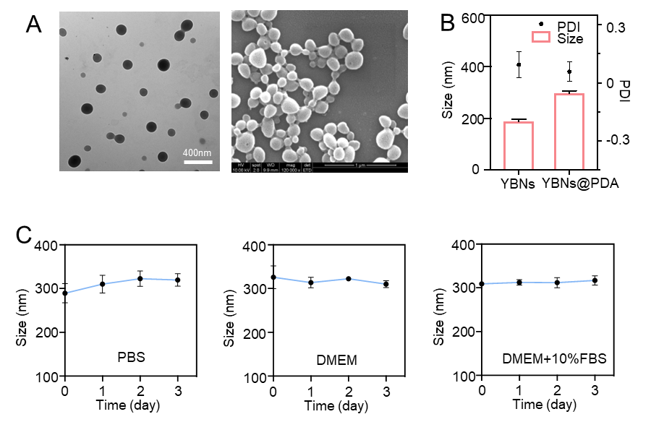

Fig. S2. Preparation and characterization of YBNs@PDA and YBNs. (A) TEM and SEM images of YBNs. (B) Size distribution and PDI of YBNs and YBNs@PDA. (C) Hydrodynamic diameter changes of YBNs@PDA in PBS, DMEM and DMEM+10% FBS, respectively.

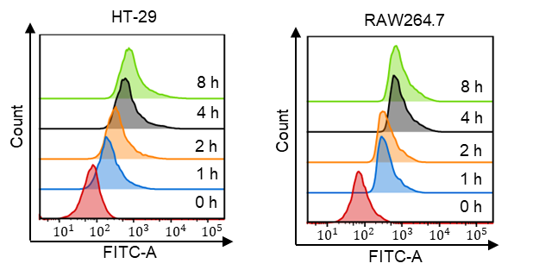

Fig. S3. Flow cytometry analysis of FITC-labeled YBNs@PDA after incubation with HT-29 or RAW264.7 cells for different time.

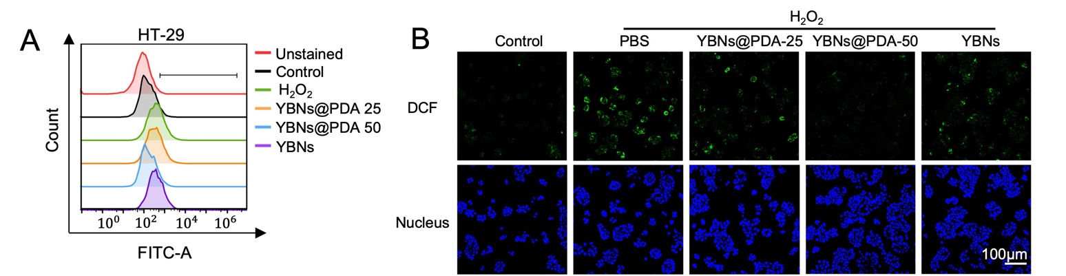

Fig. S4. Flow cytometry analysis (A) and CLSM images (B) of intracellular ROS levels of HT-29 cells after different treatments.

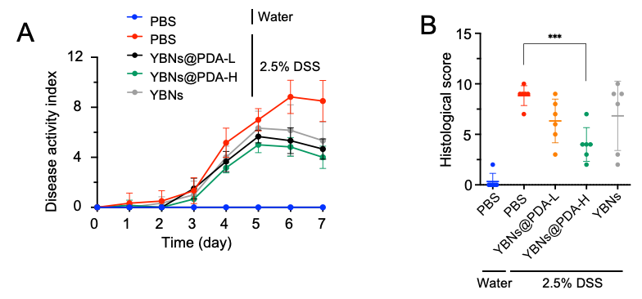

Fig. S5. Protective effect of YBNs@PDA in a DSS-induced acute colitis mice model (A) Disease activity index (DAI) score was recorded and analyzed. (B) Histological damage scores of colon tissue were measured. Data are presented as mean ± standard deviation from a representative experiment (n = 6).

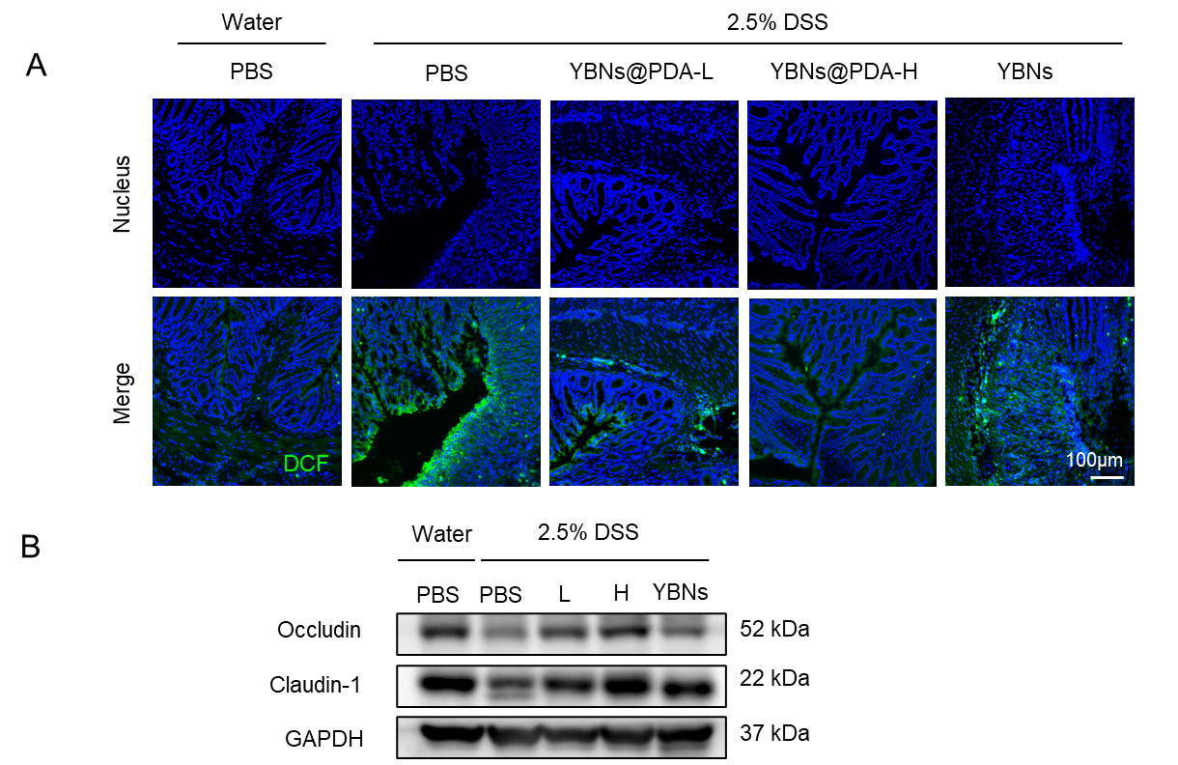

Fig. S6. (A) DCF staining of colon tissue to measure ROS level. (B) Western blot analysis of occludin and claudin-1 proteins in mice colon tissues. (L: 5 mg/kg YBNs@PDA; H: 10 mg/kg YBNs@PDA).
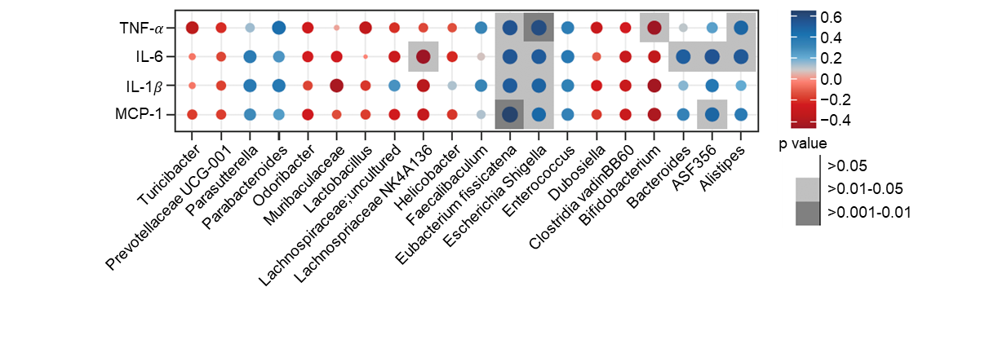

Fig. S7. Correlation analysis between colitis-related indices and specific gut microbiota composition at genus level.

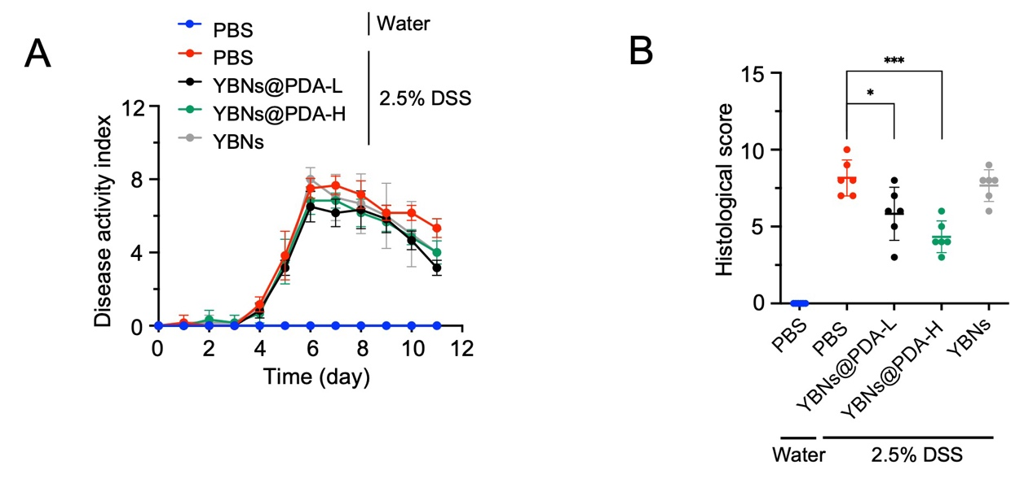

Fig. S8. Colitis alleviation effect of YBNs@PDA in a delayed therapeutic setting. (A) Disease activity index (DAI) score was recorded and analyzed. (B) Histological damage scores of colon tissue were measured (L: low dose: 5 mg/kg; H: High dose: 10mg/kg). Data are presented as mean ± standard deviation from a representative experiment (n = 6).

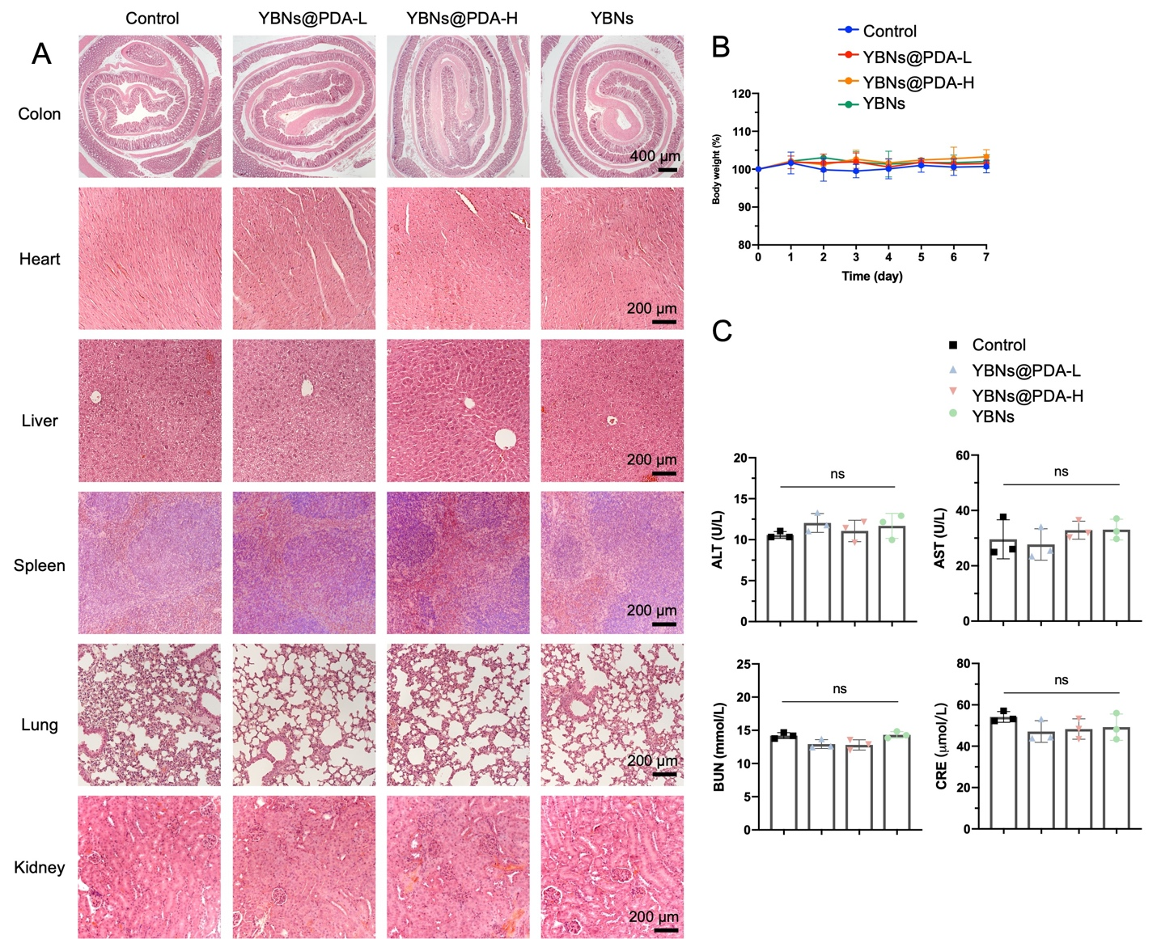

Fig. S9. Biocompatibility testing of YBNs and YBNs@PDA. (A) Histological images of H&E-stained major organ slices harvested from the mice after PBS, YBNs (10mg/kg) or YBNs@PDA (Low dose: 5 mg/kg; High dose: 10mg/kg) treatments. (B) Body weight changes of mice in each group. (C) ALT, AST, BUN and CRE levels in the serum of mice in each group. Data are presented as mean ± standard deviation from a representative experiment (n = 3). ns means not significant.

