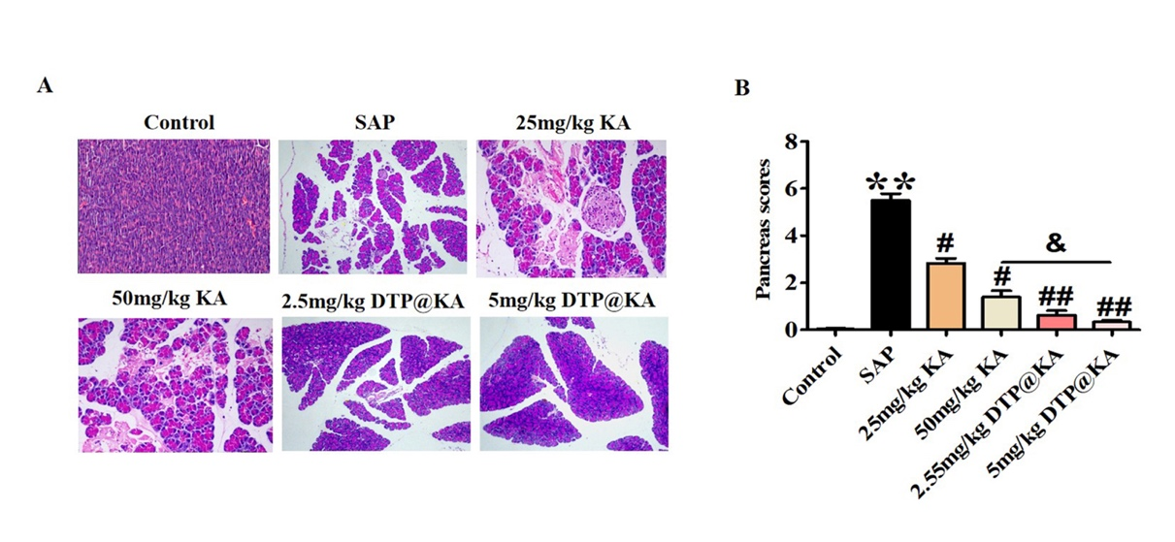
Supplementary Figure 1. 50 mg/kg KA or 5 mg/kg DTP@KA NPs was more protective in experimental SAP. (A). Typical pictures of fresh pancreatic tissues and representative H&E images of pancreas. Scar bar = 50 μm. (B). Pancreas scores. Data represent the mean ± SEM of at least three independent experiments; n=5-8/group. Significance: ** p < 0.01 vs. the control group; # p < 0.05 and ## p < 0.01 vs. the SAP model group; & p < 0.05 vs. the 50 mg/kg KA group.
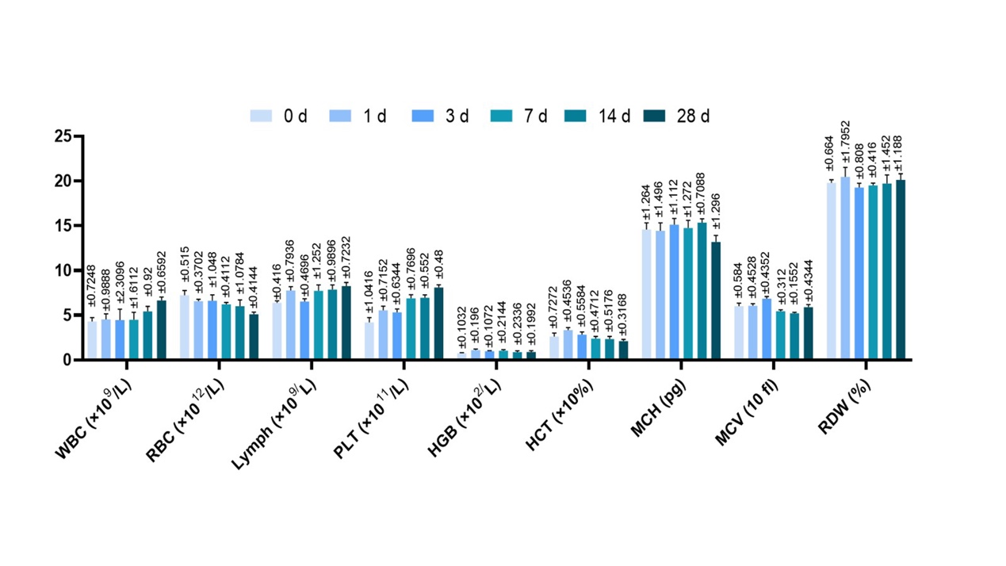
Supplementary Figure 2. Bar chart split in figure3D

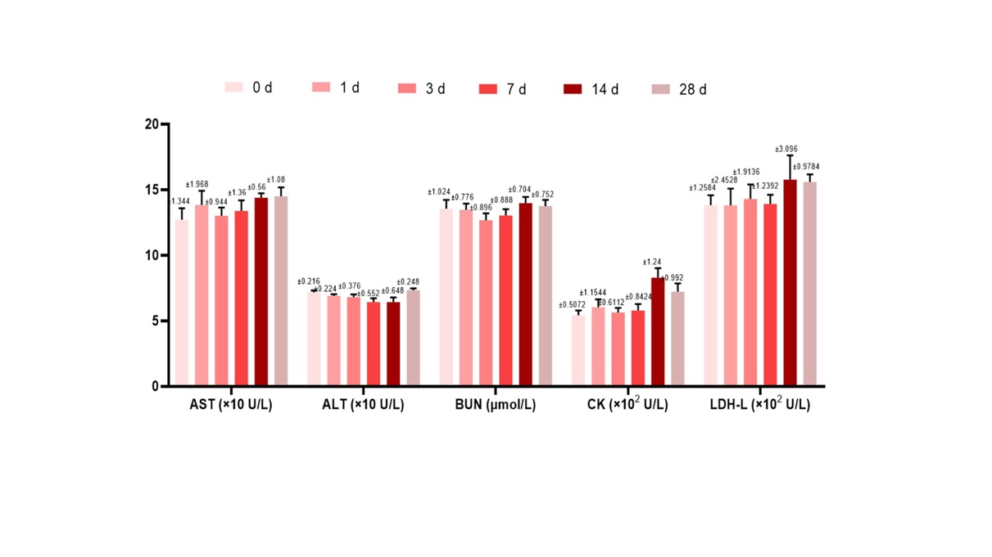
Supplementary Figure 3. Bar chart split in figure3E

