Supporting Information for
The Application of Phenylboronic Acid Pinacol Ester Functionalized ROS-Responsive Multifunctional Nanoparticles in the Treatment of Periodontitis
Jinhong Chen^{a, #}, Aihua Luo ^{a, #}, Mengmeng Xuª, Yao Zhangª, Zheng Wangª, Shuang Yuª, Li Zhu^{b,}*, Wei Wu^{b,}*, Deqin Yang^{a,}*
ª Department of Endodontics, Stomatological Hospital of Chongqing Medical University, Chongqing 404100, China,
^{b} Key Laboratory of Biorheological Science and Technology, Ministry of Education, College of Bioengineering, Chongqing University, Chongqing, 400044,China.
# These authors contributed equally to this work.
*Corresponding authors:
Email: yangdeqin@hospital.cqmu.edu.cn (Deqin Yang); david2015@cqu.edu.cn (Wei Wu); zhuli0109@126.com (Li Zhu)

This file includes:
Figures S1~S13
Tables S1~S3

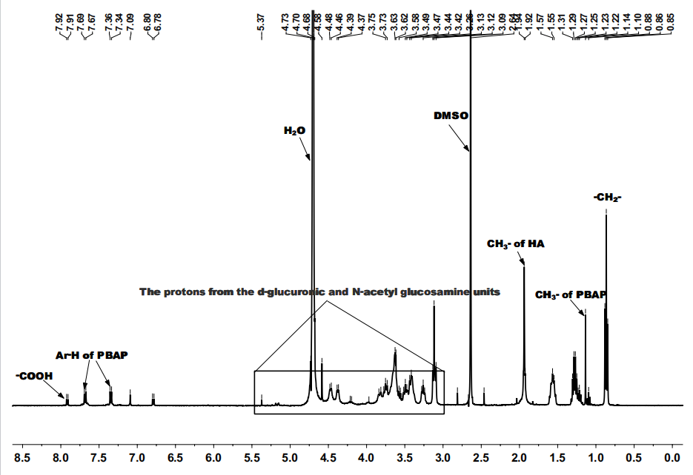
Figure S1. ¹H NMR spectrum of PBAP-CDI-HA.
Figure S2. FT-IR spectra of HA, PBAP, and HA-CDI-PBAP.
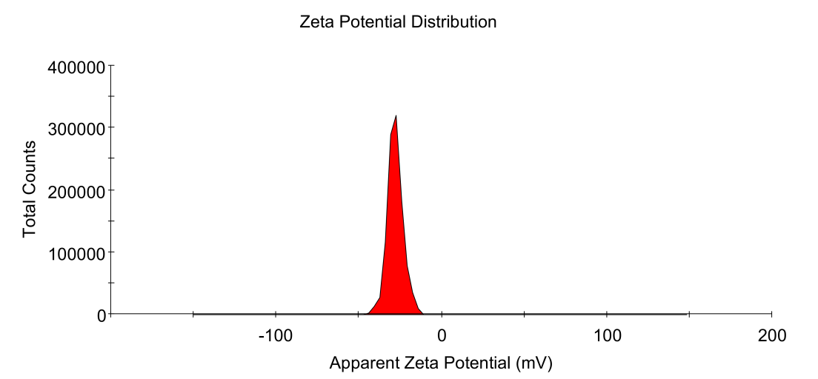
Figure S3. Zeta potential of HA@CUR NPs.

Figure S4. FT-IR spectra of HA@CUR NPs, Blank NPs and CUR.
Figure S5. XRD patterns of HA@CUR NPs, Blank NPs, and CUR.
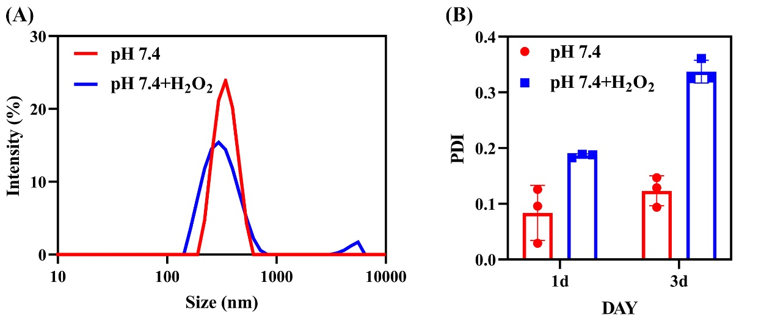
Figure S6.(A) Particle size distribution of HA@CUR NPs in pH 7.4 and pH 7.4+H₂O₂. (B) PDI of HA@CUR NPs at pH 7.4 and pH 7.4+H₂O₂ on days 1 and 3.

Figure S7. Survival of (A) RAW 264.7 macrophages and (B) HGF fibroblasts when RAW 264.7 cells and HGF cells were treated with different concentrations of HA@CUR NPs and CUR.

Figure S8. (A) Hemolysis images and (B) hemolysis rate of HA@CUR NPs.
Figure S9. Flow cytometry analysis of the expression levels of CD44 in RAW 264.7, HGFs and Caco2 cell

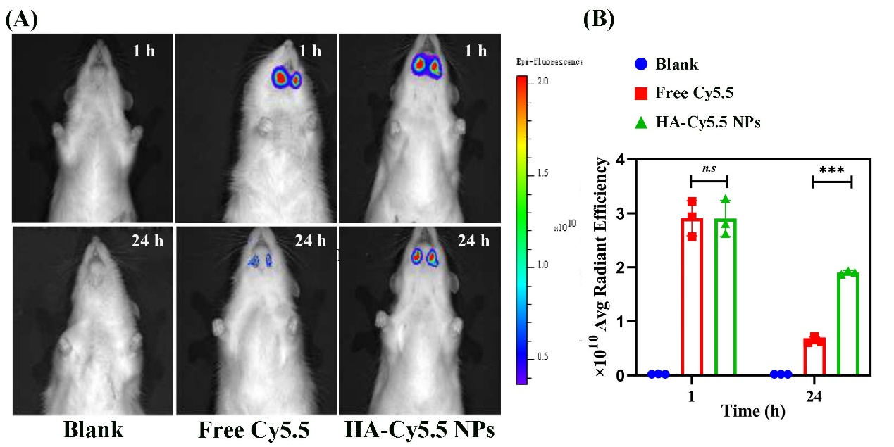
Figure S10. (A) In vivo fluorescence images and (B) fluorescence semi-quantitative values of blank, free Cy5.5, and HA-Cy5.5 NPs at different times
Figure S11. In vivo biocompatibility assessment of HA@CUR NPs and CUR. HE staining of major organs (heart, liver, spleen, lung, kidney) in different groups of animals.

Figure S12. In vivo biocompatibility assessment of HA@CUR NPs and CUR. Statistical analysis of liver and kidney function indicators (ALT, AST, CREA, UREA) in animals.
Figure S13. In vivo biocompatibility assessment of HA@CUR NPs and CUR. Statistical analysis of blood routine indicators (WBC, HGB, Lymph#, Gran#, RBC, PLT) in animals.
Figure S14. In vivo biocompatibility assessment of HA@CUR NPs and CUR. Statistical analysis of body weight changes in animals during drug injection.

Table S1. Primer sequences were applied in this study.

Gene | sequences
GADPH | 5’-GACATCAAGAAGGTGGTGAAGC-3’  5’-GAAGGTGGAAGAGTGGGAGTT-3’
TNF-α | 5’-CACCACGCTCTTCTGTCTACTG-3’  5’-GGTCTGGGCCATAGAACTGA-3’
IL-1β | 5’-TTGAAGTTGACGGACCCCA-3’  5’-GAGTGATACTGCCTGCCTGAAG-3’
IL-6 | 5’-GTTGCCTTCTTGGGACTGATG-3’  5’-TTGGGAGTGGTATCCTCTGTGA-3’
Arg1 | 5’-GCATATCTGCCAAAGACATCGT-3’  5’-CCATCACCTTGCCAATCCC-3’
iNOS | 5’-TGGAGCGAGTTGTGGATTGT-3’  5’-TCTCTGCCTATCCGTCTCGTC-3’
COX-2 | 5’-GGTCATTGGTGGAGAGGTGTATC-3’  5’-TGCTCCTGCTTGAGTATGTCG-3’
Mmp8 | 5’-GACTGTCTCCACATTTTGCCG-3’  5’-ACAGGGAGAAGCAGACATCAAC-3’
HO-1 | 5’-TTACCTTCCCGAACATCGAC-3’  5’-TCCTCTGTCAGCATCACCTG-3’
SOD | 5’-CTGGAGCCACACATTAACGC-3’  5’-CGGTGGCGTTGAGATTGTTC-3’
CAT | 5’-AGAGGAAACGCCTGTGTGAG-3’  5’-GCGTGTAGGTGTGAATTGCG-3’

Table S2. Primer sequences were applied in this study (rat).

Gene | sequences
GADPH | 5’ -ACAGTCCATGCCATCACTGCC -3’  5’-GCCTGCTTCACCACCTTCTTG-3’
TNF-α | 5’-TCC CAA CAA GGA GGA GAA GT-3’  5’-TGG TAT GAA GTG GCA AAT CG-3’
IL-1β | 5’-AACCTGCTGGTGTGTGACGTTC-3’  5’-CAGCACGAGGCTTTTTTGTTGT-3’
IL-6 | 5’- GTCTTCTGGAGTTCCGTTTCT -3’  5’- GCCGAGTAGACCTCATAGTGA -3’
CAT | 5’-GCATATCTGCCAAAGACATCGT-3’  5’-CCATCACCTTGCCAATCCC-3’
SOD | 5’-TGGAGCGAGTTGTGGATTGT-3’  5’-TCTCTGCCTATCCGTCTCGTC-3’
HO-1 | 5’-GGTCATTGGTGGAGAGGTGTATC-3’  5’-TGCTCCTGCTTGAGTATGTCG-3’

Table S3. Primer sequences were applied in this study (Bacteria)

Gene | sequences
16S rRNA | 5′-TGTAGATGACTGATGGTGAAA-3′ 5′-ACTGTTAGCAACTACCGATGT-3′
fimA | 5′-CAGCAGGAAGCCATCAAATC-3′  5′-CAGTCAGTTCAGTTGTCAAT-3′
hagA | 5′-ACAGCATCAGCCGATATTCC-3′  5′ -CGAATTCATTGCCACCTTCT-3′
hagB | 5′-TGTCGCACGGCAAATATCGCTAAAC-3′  5′-CTGGCTGTCCTCGTCGAAAGCATAC-3′
kgp | 5′-AGCTGACAAAGGTGGAGACCAAAGG-3′  5′-TGTGGCATGAGTTTTTCGGAACCGT-3′
rgpA | 5′-GCCGAGATTGTTCTTGAAGC-3′  5′ -AGGAGCAGCAATTGCAAAG-3′
rgpB | 5′-CGCTGATGAAACGAACTTGA-3′  5′ -CTTCGAATACCATGCGGTT-3′

