Supplementary material

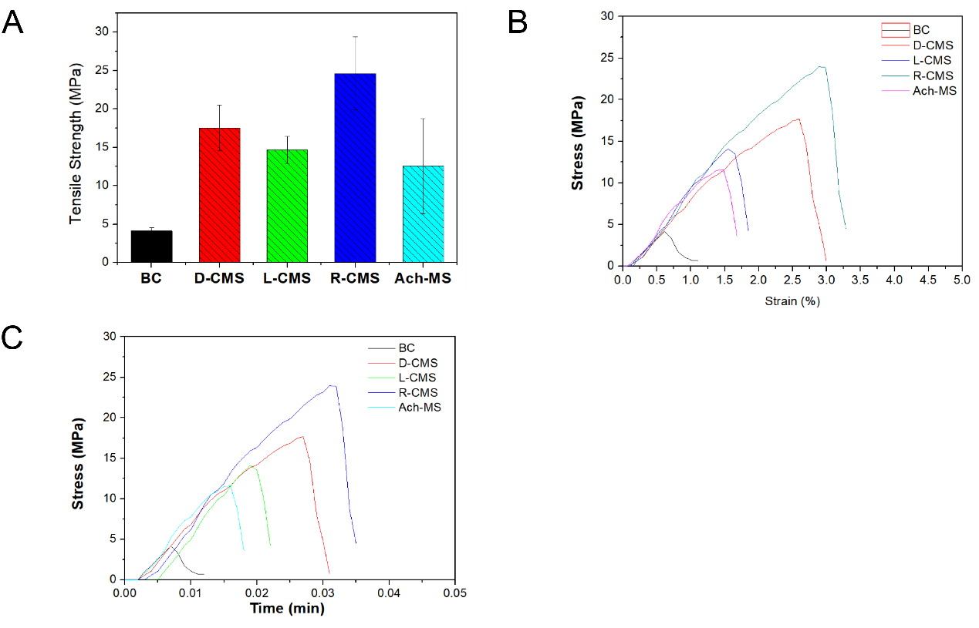
Fig. S1 Mechanical properties of BC, D-CMS, L-CMS, Ach-MS and R-CMS materials. (A) Tensile strength of BC, D-CMS, L-CMS, Ach-MS and R-CMS materials. (B) Stress-strain curves for BC, D-CMS, L-CMS, Ach-MS and R-CMS materials. (C) Stress profiles of BC, D-CMS, L-CMS, Ach-MS and R-CMS materials with time.

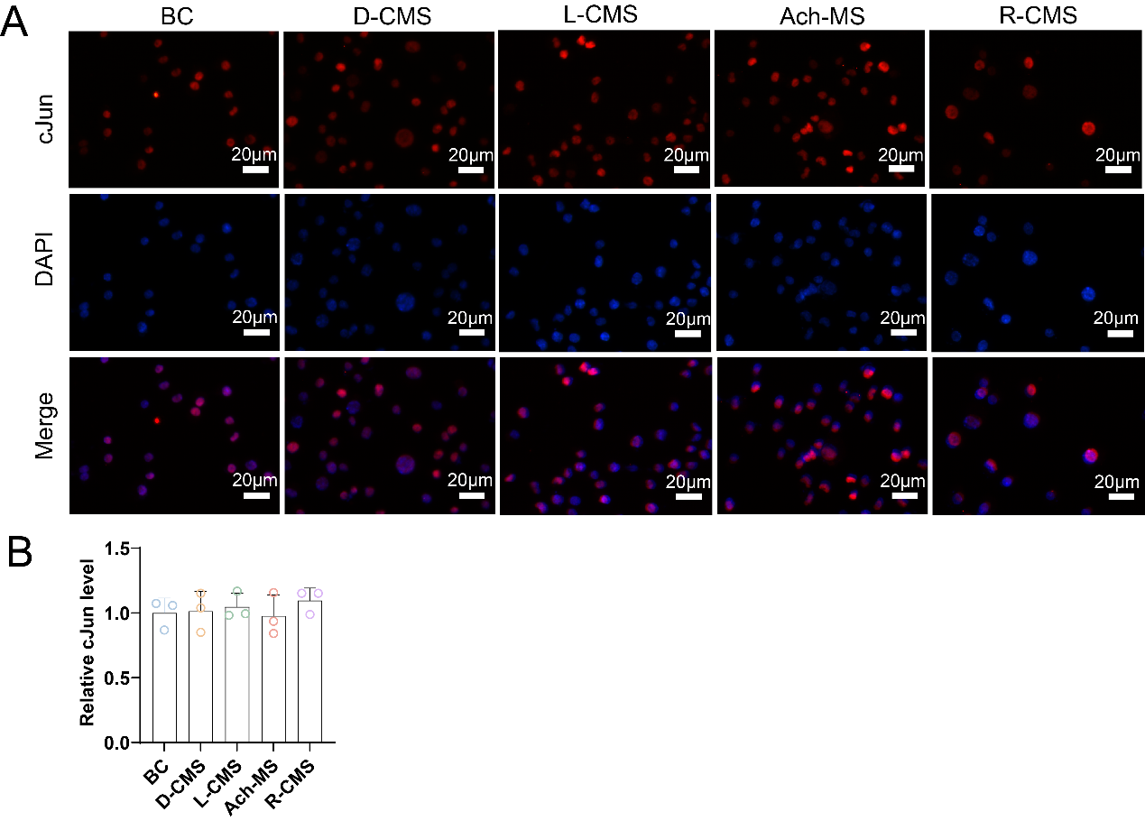
Fig. S2 Immunofluorescence of SCs on BC, D-CMS, L-CMS, Ach-MS and R-CMS scaffolds. (A) CJun immunofluorescence. (B) Relative levels of CJun (n = 3).

All the codes of the products we used and the specific models of the instruments are shown below.
Supplementary Table 1 Experimental reagents.
Experiment reagent | Code
Thioacetamide (CH₃CSNH₂; 99.0%) | Merck (T818853)
Sodium molybdate dihydrate (Na₂MO₃·2H₂O, 99.0%) | Merck (S817613)
D-2-amino-3-phenyl-1-propanol (99.9%) | Tansoole (01083250)
L-2-amino-3-phenyl-1-propanol (99.9%) | Tansoole (01060193)
Racemic-2-amino-3-phenyl-1-propanol (99.9%) | Tansoole (01083250)/ Tansoole (01060193)
BC fibrous membranes | Guilin Qihong (QH256418-32)
RSC 96 cells | Shanghai Zhongqiaoxinzhou Biotech (ZQ 0154)
Dulbecco’s Modified Eagle Medium | Gibco (C11995500BT)
Fetal bovine serum | Gibco (10099158)
penicillin/streptomycin solution | Gibco (15140122)
0.25% Trypsin-EDTA | Gibco (25200-056)
PBS | Servicebio (G4202)
Cell Counting Kit-8 | NCM Biotech (C6005)/Absin (abs50003)
Calcein-AM/PI Kit | Solarbio (CA1630)
Annexin V-FITC apoptosis assay kit | Absin (abs50001)
Anti-Ki67 antibody | Abcam (ab16667)
Anti-c-Jun antibody | Abcam (ab40766)
Anti-S100 beta antibody | Abcam(ab52642)/proteintech(15146-1-AP)
Cy3-Goat anti-Rabbit IgG | Simuwubio (SD0138)
Albumin Bovine V | Solarbio (A8020)
Triton X-100 | Solarbio (T8200)
4% paraformaldehyde | Servicebio (G1101)/Biosharp (23286549)
FITC Phalloidin | Yeasen (40735ES75)
DAPI Staining Solution | Beyotime (C1005)

The instruments used in the experiment are shown in the following table:
Supplementary Table 2 Experimental Instruments.
Instruments | Code
Scanning electron microscope | JEOL (JSM-7900F)
Contact angle measurement | SINDIN (SDC-350H)
Hydrothermal synthesis reactor | Hefei Kejing (50ml)
Circular dichroism spectrometer | JASCO (J-1500)
X-ray Powder diffractometer | Bruker (D2)
Tensile testing machine | Tophung (TH-8100ST)
Phase contrast microscope | Leica (DMIL LED)
Fluorescence microscope | Leica (DMi8)
High speed centrifuge | Beckman Coulter (20140177)
-80 ℃ medical cryogenic box | Thermo (FDE40086FV)
Flow cytometer | BD FACSCelesta (660344)

Supplementary Table 3 Mechanisms of different types of nerve conduits promoting peripheral nerve regeneration.
Serial num-ber | Scaffold | Therapeutic outcome | Mechanism
1 | Bio three-dimensional conduit | The regenerated nerve in the Bio 3D group was significantly superior to that in the silicone group based on morphology, kinematics, electrophysiology, and wet muscle weight. | By inducing angiogenesis.
2 | Black phosphorus /PCL | The black phosphorus nano scaffold induced angiogenesis and neurogenesis and stimulated calcium-dependent axon regrowth and remyelination. | By inducing angiogenesis.
3 | longitudinally oriented collagen hydrogel-grafted elastic nerve guidance conduits | The scaffolds could promote axonal regeneration and remyelination, and promote good functional recovery. | The aligned collagen hydrogels provide a preferable environment for nerve regeneration, functioning as an oriented guidance path.
4 | anisotropic micro-nanocomposite | The scaffolds could effectively induce the orientation growth of Schwann cells and up-regulate the genes and proteins relevant to myelination. | Promoting nerve regeneration by simulating the regenerative microenvironment.
5 | Nerve conduits composed of high-resolution anisotropic microfiber grid-cordes with randomly organized nanofiber sheaths | The newly regenerated nerve tissue that formed within the composite nerve conduits showed restored neurological functions that were superior compared to sheaths-only scaffolds and Neurolac nerve conduit controls. | Using synthetic biophysical cues to promote nerve regeneration.
6 | Human umbilical cord mesenchymal stem cells -ECM modified PCL-SF electrospinning materials | The dual-bionic material exerted a similar effect to that of autologous nerve transplantation in bridging peripheral nerve defects in rats. | Promoting nerve regeneration by mimicking the peripheral neural microenvironment.
7 | Dimethyl fumarate/ regenerated silk fibroin/ poly(3,4-ethylenedioxythiophene): poly (styrene sulfonate) conduit | Promoting the functional recovery of neurons. | By inhibiting SCs pyroptosis and reducing inflammatory factor release, shifting macrophage polarization from the inflammatory M1 phenotype to the tissue regenerative M2 phenotype.
8 | 3D melatonin/polycaprolactone nerve guide conduit | 3D manufacture of melatonin/polycaprolactone nerve guide conduit increased Schwann cell proliferation and neural expression in vitro and promoted functional, electrophysiological and morphological nerve regeneration in vivo. | Inhibiting oxidative stress and inflammation after traumatic insults.
9 | Bionic peptide hydrogel scaffold | The bionic scaffold promoted M2 transformation in situ and led to proliferation and migration of Schwann cells, neuron growth and motor function recovery. | By remodeling the local environment for M2 transformation and recruitment.
10 | Poly(ɛ-caprolactone)/carbon nanotubes composite fiber | Promoting the oriented growth of neural cells in vitro as well as the regeneration of injured sciatic nerves in vivo. | By aligned topography and electrical stimulation to promote neural regeneration.
11 | Poly-pyrrole/silk fibroin conductive composite scaffold | Promoting SCs viability, proliferation and migration, as well as upregulated expression of neurotrophic factors. Promoting axonal regeneration and remyelination in vivo. | Promoting peripheral nerve regeneration by electrical stimulation.
12 | R (graphene oxide / gelatin- methacrylate) | Improving muscle weight increase, electro-conduction velocity, and sciatic nerve function index. | Promoting peripheral nerve regeneration by delivering electrical signals.

