Supporting Information
Baicalin nanodelivery system based on functionalized metal-organic framework for targeted therapy of osteoarthritis by modulating macrophage polarization
Lanli Huang ^{a, d, 1}, Yi Yao ^{a, b, 1}, Zhuren Ruan ^{c, 1}, Shengqing Zhang ª, Xianjing Feng ^{d}, Chun Lu ^{e}, Jinmin Zhao ^{a, b}, Feiying Yin ^{a, b, *}, Cunwei Cao ^{c, *}, Li Zheng ^{a, b, *}
ª Guangxi Engineering Center in Biomedical Material for Tissue and Organ Regeneration, Collaborative Innovation Centre of Regenerative Medicine and Medical BioResource Development and Application Co-constructed By the Province and Ministry, Guangxi Key Laboratory of Regenerative Medicine, The First Affiliated Hospital of Guangxi Medical University, Nanning, 530021, China.
^{b} Life Sciences Institute, Guangxi Medical University, Nanning, 530021, China.
^{c} Department of Dermatology and Venereology, The First Affiliated Hospital of Guangxi Medical University, Nanning, Guangxi, China.
^{d} Pharmaceutical College, Guangxi Medical University, Nanning, 530021, China.
^{e} School of Materials and Environment, Guangxi Minzu University, Nanning, 53000, China.
¹ The authors contributed equally.
*Corresponding author: yinfeiying@yeah.net, caocunwei@yeah.net, zhengli224@163.com.

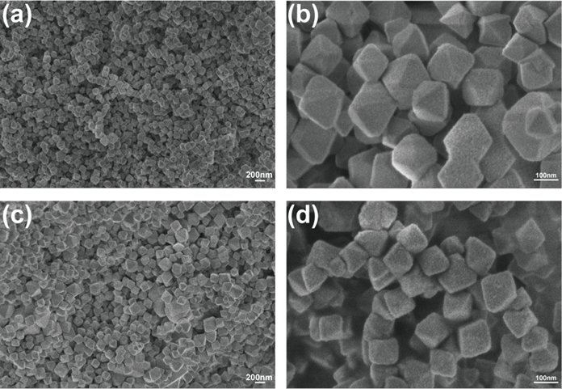
Figure. S1 SEM of UIO-66-NH₂ (a,b) and FA-UIO-66-NH₂ (c,d) under different multiple.

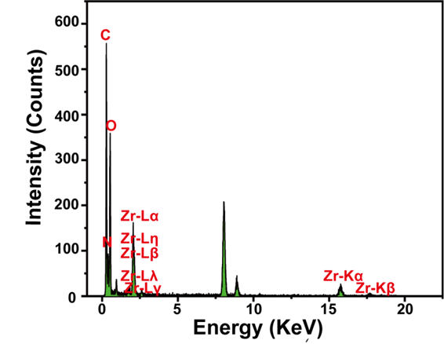
Figure. S2. EDS diagram of FA-UIO-66-NH₂.
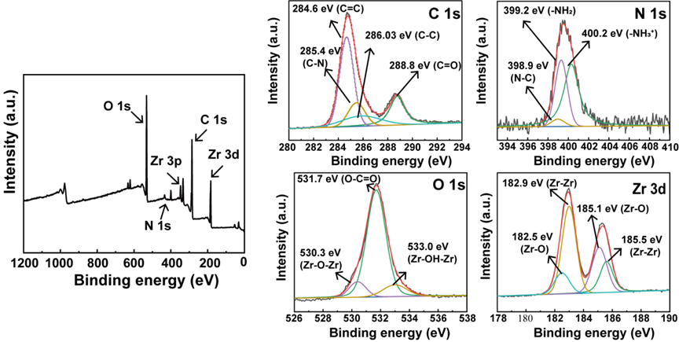
Figure. S3. XPS of UIO-66-NH₂.
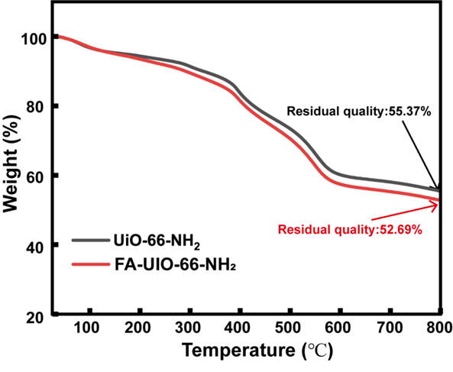
Figure. S4. TGA of UIO-66-NH₂ and FA-UIO-66-NH₂.
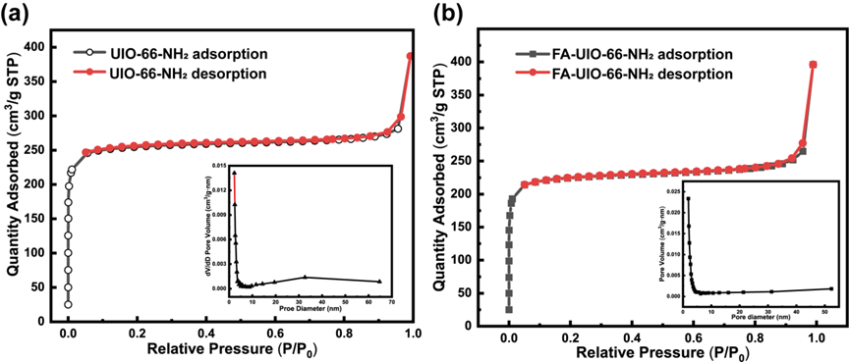
Figure. S5. BET of UIO-66-NH₂ (a) and FA-UIO-66-NH₂ (b).
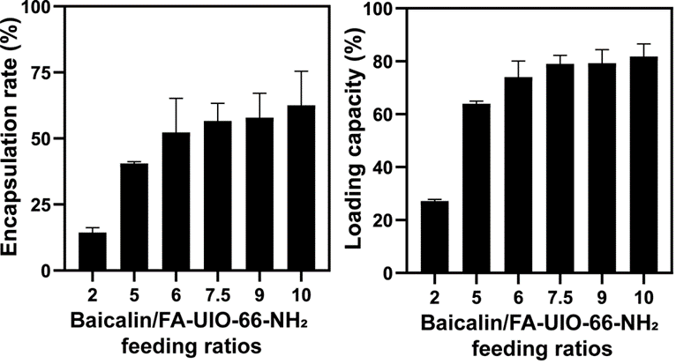
Figure. S6. Encapsulation rate (a) and loading capacity (b) of FA-UIO-66-NH₂.

Figure. S7. Representative pictures of Bai and Bai@FA-UIO-66-NH₂ in different solutions at 0, 1, 3, 5 and 7 day.
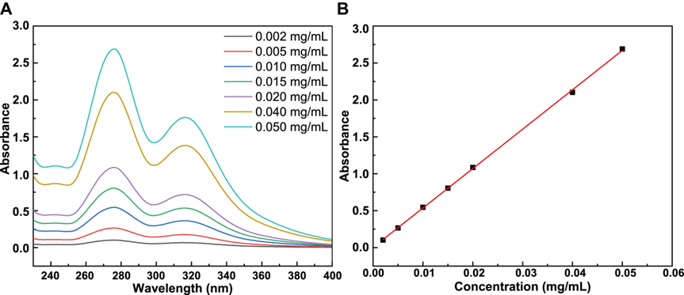
Figure. S8. UV-vis spectrums (A) and concentration absorbance standard curve of Baiclain (B).

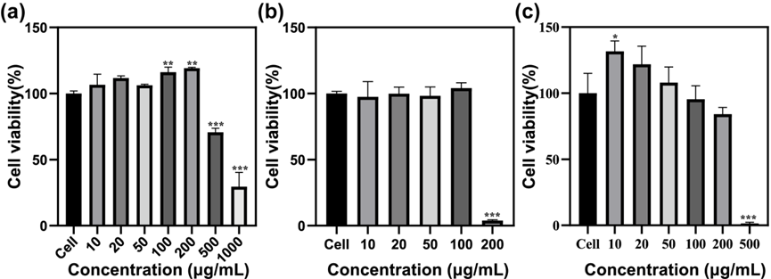
Figure. S9. CCK-8 of UIO-66-NH₂ (a), FA-UIO-66-NH₂ (b) and Bai (c). “*” symbol compared between cell and other groups, *P＜0.05, **P＜0.01, ***P＜0.001, ****P＜0.0001).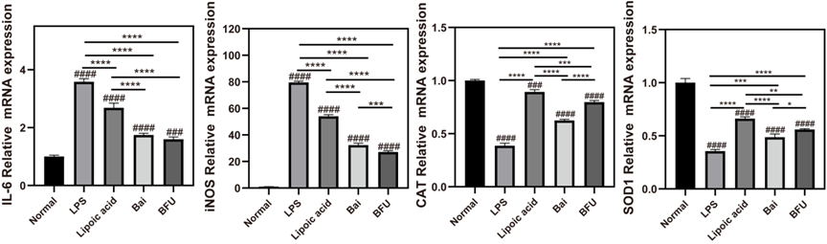
Figure. S10. In vitro mRNA expression of IL-6, iNOS, CAT and SOD1. BFU (Bai@FA-UIO-66-NH₂). (n=3, mean ± SD, “#” symbol compared with normal group, #P＜0.05, ##P＜0.01, ###P＜0.001, ####P＜0.0001 and “*” symbol compared between groups, *P＜0.05, **P＜0.01, ***P＜0.001, ****P＜0.0001).
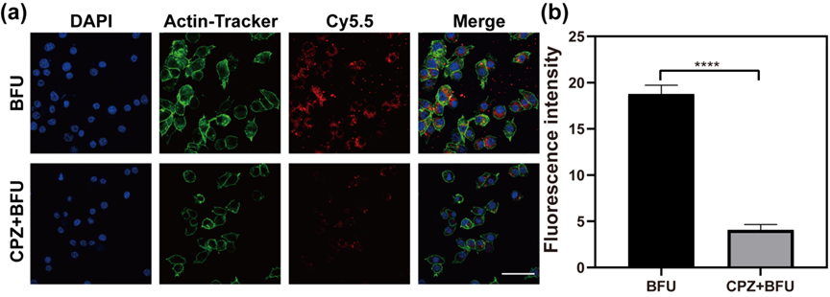
Figure. S11. Chlorpromazine (CPZ) interfered the uptake of BFU by RAW264.7 cells. FU (FA-UIO-66-NH₂), BFU (Bai@FA-UIO-66-NH₂). (a) Fluorescence image and the corresponding fluorescence intensity (b). (scale bar =50 μm). “*” symbol compared two groups, ****P＜0.0001).

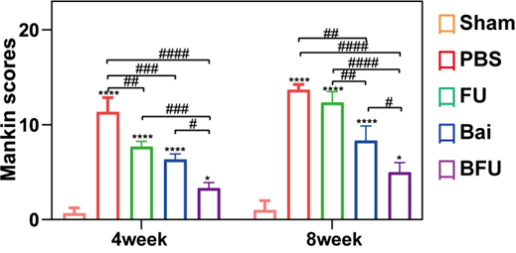
Figure. S12. Mankin scores. FU (FA-UIO-66-NH₂), BFU (Bai@FA-UIO-66-NH₂). (n=3, mean ± SD, “*” symbol compared with sham group, *P＜0.05, **P＜0.01, ***P＜0.001, ****P＜0.0001 and “#” symbol compared between groups, #P＜0.05, ##P＜0.01, ###P＜0.001, ####P＜0.0001).
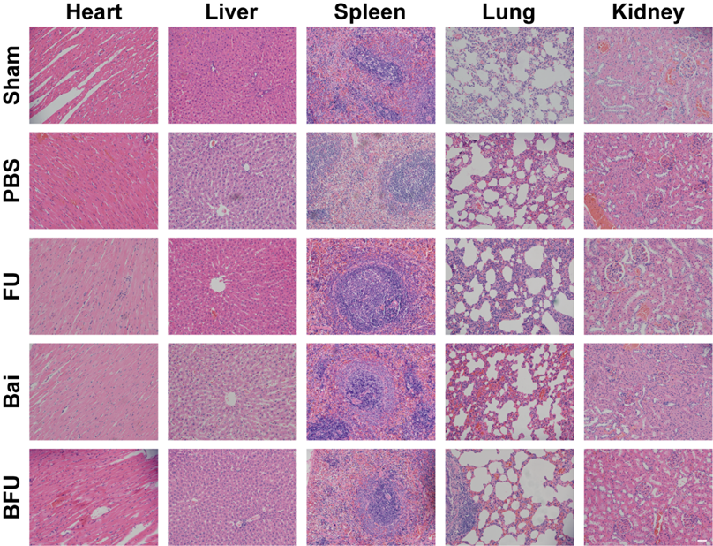
Figure. S13. Histological analysis of major organs of SD rats. FU (FA-UIO-66-NH₂), BFU (Bai@FA-UIO-66-NH₂). (scale bar =50 μm).

Table S1. Percentage change of elements of UIO-66-NH₂ and FA-UIO-66-NH₂.
Sample | C (%) | N (%) | O (%) | Zr (%)
UIO-66-NH₂ | 60.15 | 4.9 | 30.79 | 4.16
FA-UIO-66-NH₂ | 57.69 | 9.15 | 29.27 | 3.89

Table S2. Surface area, total pore volume and pore size of UIO-66-NH₂ and FA-UIO-66-NH₂.
Sample | S_{BET} (m²/g) | Total pore volume [p/p₀=0.991] | Pore size (nm)
UIO-66-NH₂ | 708.15 | 0.5986 | 26.79
FA-UIO-66-NH₂ | 626.08 | 0.6127 | 25.48

Table S3. Particle diameter distribution of UIO-66-NH₂, FA-UIO-66-NH₂ and Bai@FA-UIO-66-NH₂ (n=3).
Sample | Mean particle size ± SD nm | PDI
UIO-66-NH₂ | 274.5±17.69 | 0.263±0.030
FA-UIO-66-NH₂ | 295.4±95.18 | 0.255±0.11
Bai@FA-UIO-66-NH₂ | 283.4±10.03 | 0.326±0.01

The sequence of primers required in the experiment is shown in the following table:
Table S4 The sequence of primers of RT-PCR.
Gene | Forward-Primers | Reverse-Primers
GADPH | ACTTGAAGGGTGGAGCCAAA | GCCCTTCCACAATGCCAAAG
IL-1β | TGCCACCTTTTGACAGTGATG | ATGTGCTGCTGCGAGATTTG
IL-6 | GGAGCCCACCAAGAACGATAG | GTGAAGTAGGGAAGGCCGTG
iNOS | GTTCTCAGCCCAACAATACAAGA | GATGAATTGGATGGTCTTGGTCC
CD86 | TGTTTCCGTGGAGACGCAAG | TTGAGCCTTTGTAAATGGGCA
IL-10 | TTCAAACAAAGGACCAGC | GGATCATTTCCGATAAGG
CD206 | AGGGTGCGGTACACTAACTG | TCTGACTCTGGACACTTGCC
Arg-1 | CATATCTGCCAAGGACATCG | GGTCTCTTCCATCACTTTGC

