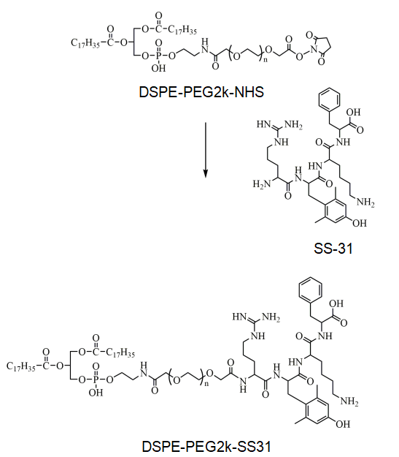
Figure S1. Illustration of the synthesis of DSPE-PEG2k-SS31.

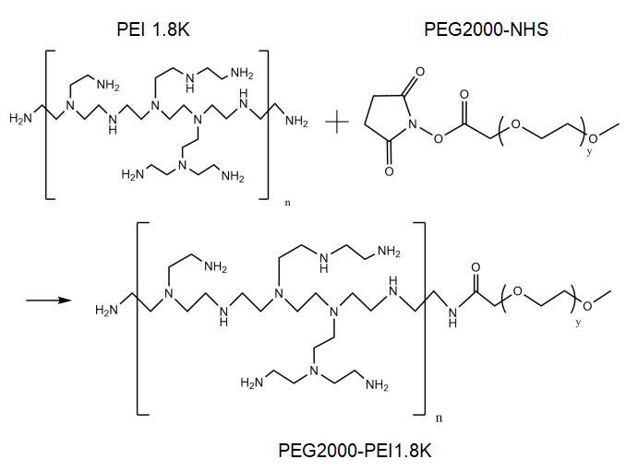

Figure S2. Illustration of the synthesis of PEG2000-PEI.

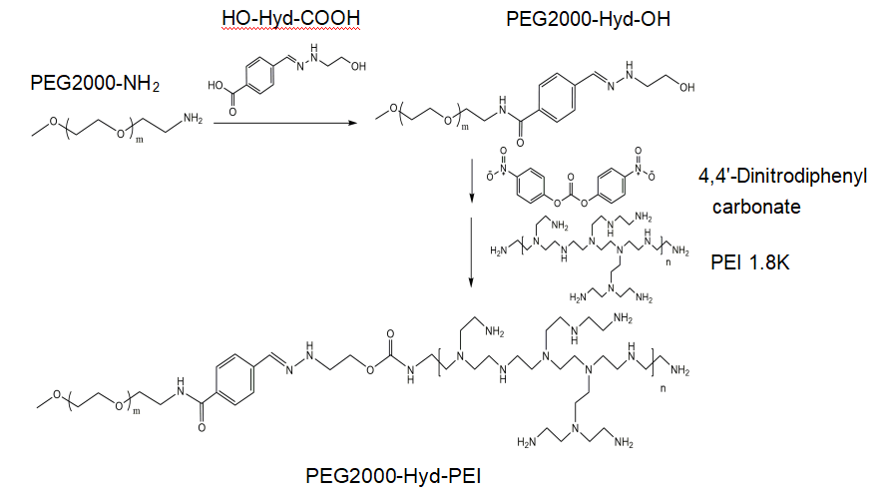
Figure S3. Illustration of the synthesis of PEG2000-Hyd-PEI.

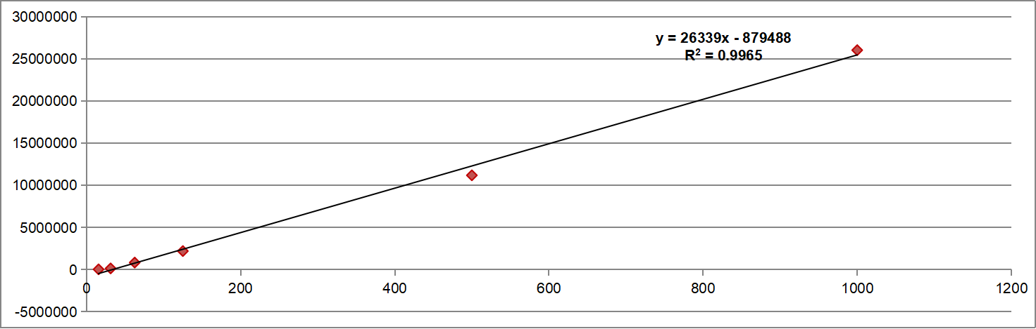
Figure S4. Calibration Curve of Insulin by Ultra-High Performance Liquid Chromatography (UHPLC).
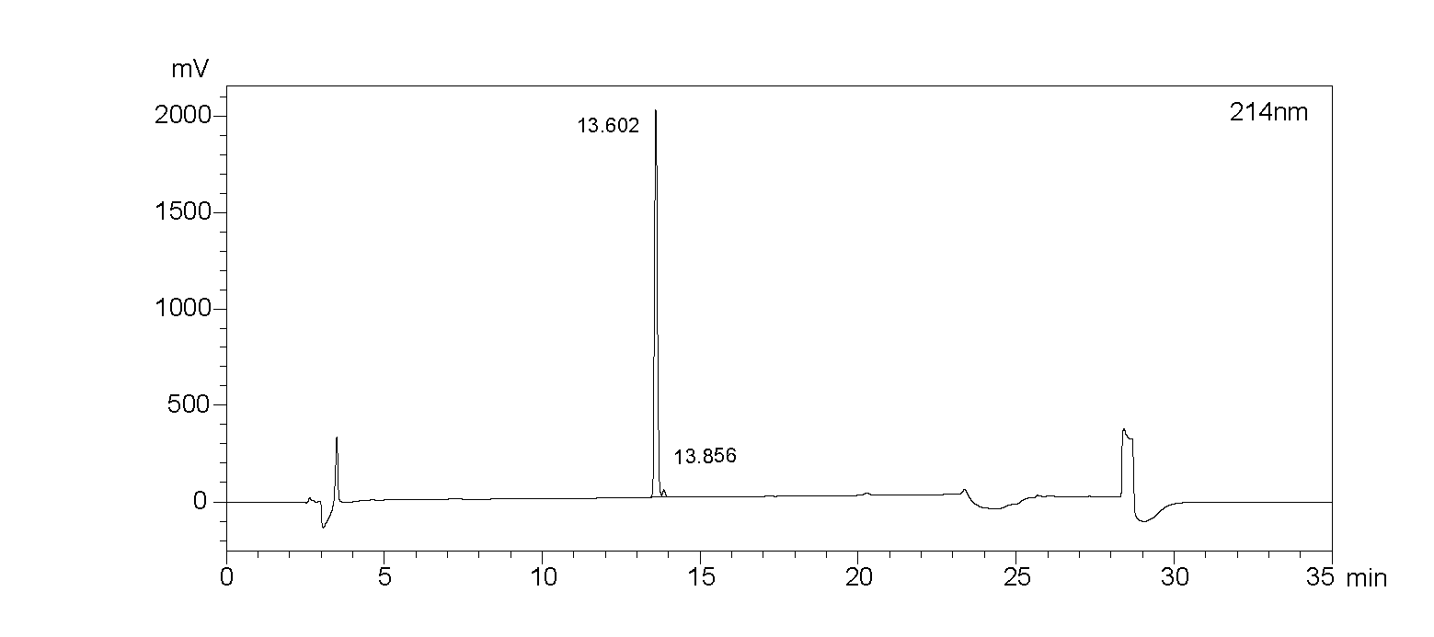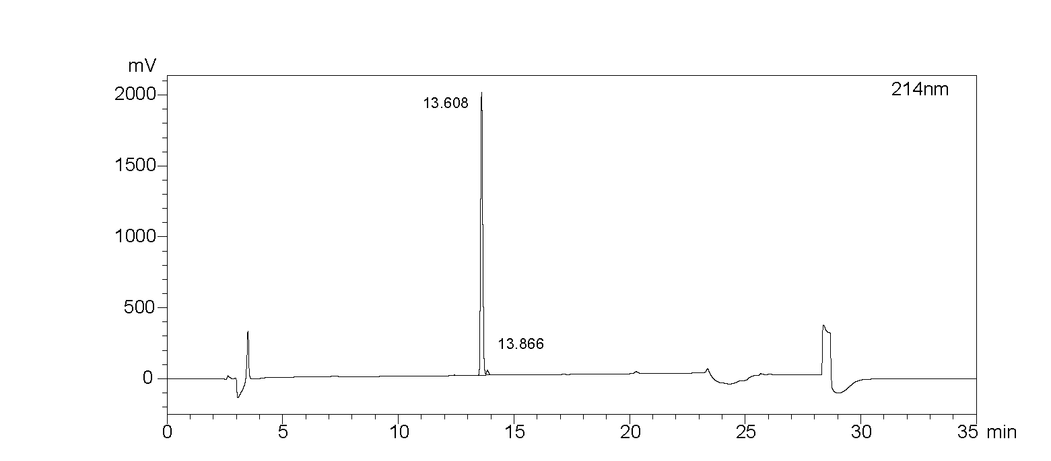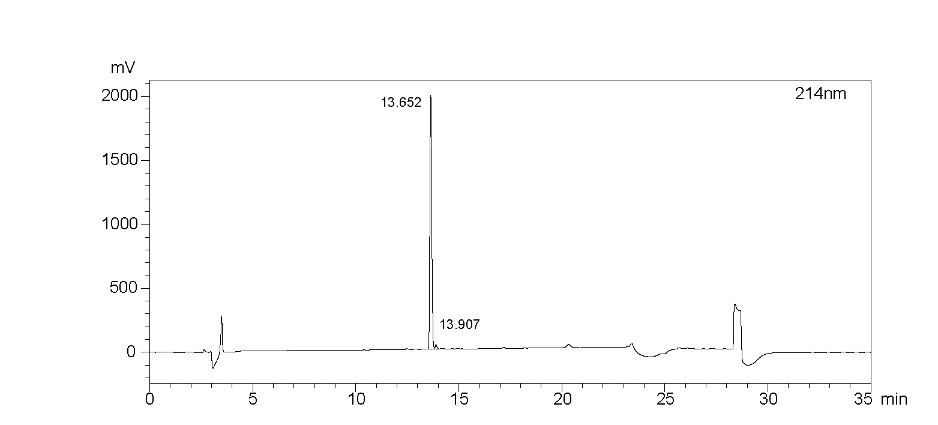
b.
a.
c.
Figure S5. UHPLC chromatogram of PHP-DPS@INS NPs loaded INS (n=3).(a).The retention time of wave peak 1 is 13.602 minutes, with an area of 12,899,615 and a height of 2,008,843. The retention time of wave peak 2 is 13.856 minutes, with an area of 204,313 and a height of 35,942.(b). The retention time of wave peak 1 is 13.608 minutes, with an area of 12,760,395 and a height of 1,992,563. The retention time of wave peak 2 is 13.866 minutes, with an area of 199,603 and a height of 34,672.(c).The retention time of wave peak 1 is 13.652 minutes, with an area of 12,720,504 and a height of 1,981,525. The retention time of wave peak 2 is 13.907 minutes, with an area of 184,253 and a height of 32,709.

Figure S6.(a)The bright field image (scale: 50 μm), (b) flow cytometry and (c)quantification of intracellular pH fluorescence between normal HCECs and HOS-cultured HCECs using BCECF-AM staining (n=3).
Figure S7.(a)Measurement of ocular surface pH values and (b)comparison between normal and DED mice using pH paper (n=6).

Table S1. Encapsulation efficiency (EE) and drug-loading capacity (DLC) of PHP-DPS@INS NPs by UHPLC (n=3).
 | EE(%) | DL (%)
1 | 49.31 | 9.86
2 | 48.78 | 9.76
3 | 48.63 | 9.73

EE:Encapsulation Efficiency;DL:Drug Loading.

Table S2.The release rate of INS from PHP-DPS@INS NPs by HPLC at 37℃for 12 h under different pH conditions.
Time  (min) | PH=4.8 |  |  |  | PH=5.8 |  |  |  | PH=7.4
Time  (min) | RR 1  (%) | RR 2  (%) | RR 3  (%) |  | RR 1  (%) | RR 2  (%) | RR 3  (%) |  | RR 1  (%) | RR 2  (%) | RR 3  (%)
0.5 | 2.21 | 2.01 | 2.05 |  | 1.69 | 1.56 | 1.64 |  | 1.63 | 1.54 | 1.48
1 | 11.79 | 10.81 | 10.65 |  | 6.62 | 6.55 | 6.66 |  | 3.21 | 3.22 | 3.22
2 | 15.21 | 13.90 | 13.90 |  | 9.78 | 10.21 | 10.24 |  | 4.29 | 4.58 | 4.51
4 | 26.59 | 25.53 | 25.50 |  | 18.21 | 18.94 | 19.39 |  | 10.77 | 10.93 | 11.07
6 | 46.62 | 45.13 | 45.65 |  | 36.05 | 38.07 | 38.42 |  | 18.30 | 17.73 | 17.79
8 | 63.14 | 62.68 | 63.15 |  | 48.10 | 51.02 | 51.83 |  | 29.85 | 28.28 | 28.50
10 | 67.25 | 67.94 | 68.47 |  | 55.47 | 59.46 | 59.89 |  | 41.49 | 39.46 | 40.14
12 | 70.29 | 72.20 | 72.44 |  | 61.06 | 66.62 | 67.05 |  | 53.08 | 50.77 | 51.41
RR：Release rate.

Figure S8.The cytotoxicity testing of (a)INS and (b)PHP-DPS@INS NPs in normal HCECs for 24 h by CCK-8 method. (c)The cell viability of the HOS-cultured HCECs incubated with PHP-DPS@INS NPs for r 6h,12 h and 24 h by CCK-8 method.(d)Fluorescence images of Calcein AM/PI staining in the Normal,HOS-cultured HCECs ,HOS-cultured HCEC treated with PHP-DPS@INS NPs for 6 h,12h and 24h.Values are presented as mean±SD(n=3；scale bars:100μm).HOS:HCECs cultured in hyperosmolar stress(450 mOsM) for 12 hours.

Figure S9.(a) Fluorescence images of normal HCECs incubated with DP@INS NPs and (b) PHP-DPS@INS NPs at different treatment times (Blue: DAPI; Red: DiI-labeled nanoparticles; scale bars: 50 μm). (c) Flow cytometric curves and quantitative results of uptake of DiI-DP@INS NPs and DiI-PHP-DPS@INS NPs at 1, 2, and 3h in normal HCECs.

Table S3. Significantly Altered Metabolites in Normal group and HOS group
Metabolite | VIP | Fold Change | P Value | Mean in Normal | Mean in HOS
Acetylcholine | 1.99 | 2.19 | 0.00 | 0.00 | 0.00
L-Phenylalanine | 1.96 | 2.62 | 0.00 | 0.04 | 0.10
L-Norleucine | 1.94 | 2.62 | 0.00 | 0.01 | 0.04
L-Leucine | 2.00 | 2.60 | 0.01 | 0.03 | 0.09
Kynurenine | 1.59 | 6.25 | 0.01 | 0.00 | 0.00
L-Tryptophan | 1.87 | 2.30 | 0.00 | 0.01 | 0.03
Glycylphenylalanine | 1.54 | 1.41 | 0.03 | 0.00 | 0.00
Pantothenic acid | 1.72 | 1.63 | 0.01 | 0.01 | 0.01
Norvaline | 1.54 | 4.09 | 0.01 | 0.00 | 0.00
Epinephrine | 1.95 | 1.99 | 0.00 | 0.05 | 0.09
L-Valine | 1.84 | 2.58 | 0.00 | 0.07 | 0.19
L-Proline | 1.75 | 2.60 | 0.01 | 0.04 | 0.11
L-Tyrosine | 1.94 | 2.82 | 0.00 | 0.04 | 0.11
Hydroxyproline | 1.91 | 2.28 | 0.00 | 0.00 | 0.00
Taurine | 1.80 | 1.77 | 0.03 | 0.01 | 0.01
L-Threonine | 1.76 | 3.06 | 0.05 | 0.01 | 0.03
L-Homoserine | 1.85 | 1.92 | 0.02 | 0.00 | 0.00
L-Histidine | 1.55 | 1.72 | 0.05 | 0.01 | 0.02
L-Glycine | 1.69 | 2.02 | 0.05 | 0.06 | 0.12
beta-Alanine | 1.85 | 2.01 | 0.00 | 0.03 | 0.05
L-Glutamine | 1.85 | 2.14 | 0.01 | 0.01 | 0.02
Glycerophosphocholine | 1.67 | 1.34 | 0.05 | 0.03 | 0.04
4-Aminobutyric acid | 1.74 | 2.10 | 0.01 | 0.00 | 0.01
L-Serine | 1.89 | 2.13 | 0.01 | 0.01 | 0.03
N-Acetyl-Neuraminic Acid | 1.87 | 1.57 | 0.01 | 0.56 | 0.88
Cysteine-S-sulfate | 1.72 | 2.17 | 0.04 | 0.00 | 0.00
NAD+ | 1.99 | 2.88 | 0.01 | 0.05 | 0.14
gamma-Glutamylalanine | 1.88 | 3.00 | 0.03 | 0.00 | 0.00
L-Glutamic acid | 2.04 | 2.38 | 0.00 | 1.17 | 2.79
L-Carnosine | 1.99 | 2.41 | 0.00 | 0.00 | 0.00
L-Aspartic acid | 1.95 | 1.71 | 0.01 | 0.47 | 0.81
N-Acetylglucosaminylasparagine | 1.98 | 1.72 | 0.00 | 0.01 | 0.01
L-2-Aminoadipic Acid | 2.03 | 2.49 | 0.00 | 0.00 | 0.00
Guanidinosuccinic acid | 1.88 | 2.40 | 0.00 | 0.00 | 0.00
S-Adenosylmethionine | 1.81 | 2.61 | 0.02 | 0.09 | 0.22
Inosinic acid | 1.92 | 1.79 | 0.00 | 0.16 | 0.29
O-Phosphoethanolamine | 1.87 | 2.14 | 0.02 | 0.00 | 0.01
Cytidine-5'-monophosphate | 1.89 | 1.81 | 0.01 | 0.02 | 0.04
Thiamine pyrophosphate | 1.76 | 1.58 | 0.03 | 0.01 | 0.01
L-Argininosuccinic Acid | 1.99 | 2.56 | 0.00 | 0.00 | 0.01
L-Homoarginine | 1.80 | 1.93 | 0.01 | 0.00 | 0.00
L-Arginine | 1.89 | 2.14 | 0.02 | 0.10 | 0.21
Nicotinamide adenine dinucleotide phosphate | 1.98 | 1.85 | 0.00 | 0.06 | 0.11
N-Formyl-L-methionine | 1.61 | 1.77 | 0.01 | 0.00 | 0.00
Hydroxyphenyllactic acid | 1.98 | 2.02 | 0.00 | 0.00 | 0.00
Orotic acid | 1.92 | 2.06 | 0.00 | 0.00 | 0.00
L-Arabitol | 1.67 | 1.58 | 0.04 | 0.00 | 0.00
N-Acetyl-L-alanine | 2.03 | 2.00 | 0.00 | 0.00 | 0.00
3-Hydroxyisobutyric acid | 1.79 | 2.31 | 0.02 | 0.00 | 0.00
L-Threonic acid | 2.00 | 2457.20 | 0.02 | 0.00 | 0.00
Inositol | 1.75 | 2.73 | 0.04 | 0.26 | 0.72
2-Methylglutaric acid | 0.95 | 2.22 | 0.03 | 0.00 | 0.00
Itaconic acid | 1.94 | 2.03 | 0.00 | 0.00 | 0.00
N-Acetyl-L-glutamic acid | 1.60 | 1.54 | 0.01 | 0.00 | 0.00
Succinic acid | 1.91 | 1.90 | 0.00 | 0.01 | 0.02
Thymidine-5'-diphosphate | 1.57 | 1.53 | 0.03 | 0.00 | 0.01
L-Malic acid | 1.90 | 2.71 | 0.03 | 0.02 | 0.04
UDP-D-glucose | 1.76 | 1.70 | 0.02 | 0.04 | 0.07
Fumaric acid | 1.87 | 2.36 | 0.01 | 0.02 | 0.05
N-carbamoyl-L-aspartate | 1.97 | 2.38 | 0.02 | 0.00 | 0.00
Uridine-5'-diphosphate | 1.83 | 1.83 | 0.01 | 0.02 | 0.04
Glutathione Disulfide | 1.70 | 1.49 | 0.03 | 0.11 | 0.16
Detected by targeted Metabolomics and UPLC-QQQ-MS analysis.HOS:HCECs cultured in hyp-erosmolar stress(450 mOsM) for 12 hours.

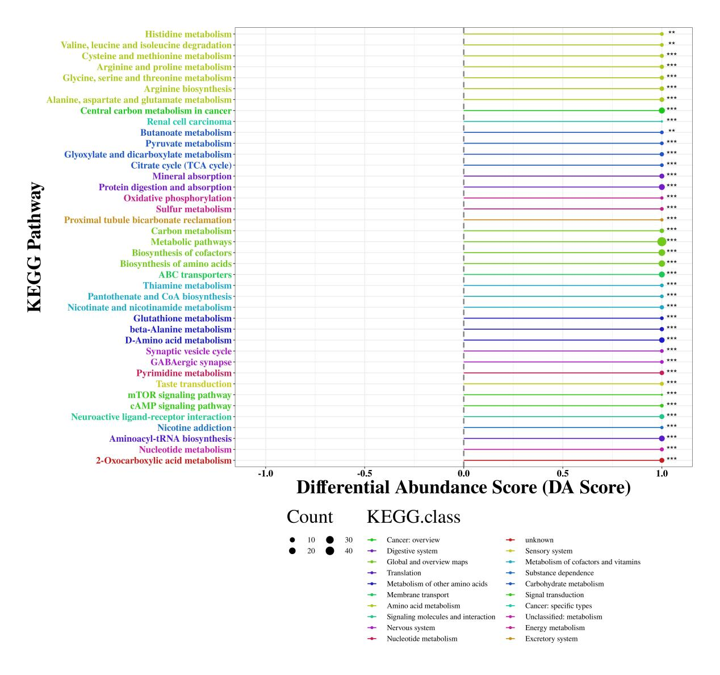
Figure S10.Differential abundance score of KEGG pathway for Normal group and HOS gro-up.Detected by targeted Metabolomics and UPLC-QQQ-MS analysis.score 1.0：the expression of metabolites in this pathway is up-regulated;score -1.0:the expression of differential metabolites in this pathway is down-regulated；the length of the line：the absolute value ofDA Score；the size of the dot：the number of differential metabolites noted in this pathway.HOS:HCECs cultured in hyperosmolar stress(450 mOsM) for 12 hours.

Table S4. Pathway Analysis for Normal group and HOS group（According to the Impact value from big to small）
Pathway | Total | Hits | P Value | Impact
Alanine, aspartate and glutamate metabolism | 24 | 7 | 0 | 0.65
Glycine, serine and threonine metabolism | 48 | 6 | 0 | 0.49
Arginine and proline metabolism | 77 | 10 | 0 | 0.36
beta-Alanine metabolism | 28 | 5 | 0 | 0.28
Pantothenate and CoA biosynthesis | 27 | 4 | 0 | 0.25
Aminoacyl-tRNA biosynthesis | 75 | 14 | 0 | 0.17
Cysteine and methionine metabolism | 56 | 5 | 0.01 | 0.14
Histidine metabolism | 44 | 4 | 0.01 | 0.14
D-Glutamine and D-glutamate metabolism | 11 | 2 | 0.02 | 0.14
Phenylalanine metabolism | 45 | 4 | 0.02 | 0.12
Pyrimidine metabolism | 60 | 7 | 0 | 0.09
Propanoate metabolism | 35 | 3 | 0.04 | 0.09
Citrate cycle (TCA cycle) | 20 | 3 | 0.01 | 0.08
Valine, leucine and isoleucine degradation | 40 | 4 | 0.01 | 0.08
Lysine biosynthesis | 32 | 3 | 0.03 | 0.07
Tyrosine metabolism | 76 | 5 | 0.02 | 0.05
Butanoate metabolism | 40 | 4 | 0.01 | 0.04
Thiamine metabolism | 24 | 3 | 0.01 | 0.03
Valine, leucine and isoleucine biosynthesis | 27 | 3 | 0.02 | 0.03
Glutathione metabolism | 38 | 4 | 0.01 | 0.02
Phenylalanine, tyrosine and tryptophan biosynthesis | 27 | 3 | 0.02 | 0.01
Nitrogen metabolism | 39 | 9 | 0 | 0
Cyanoamino acid metabolism | 16 | 3 | 0 | 0
Nicotinate and nicotinamide metabolism | 44 | 4 | 0.01 | 0
Detected by targeted Metabolomics and UPLC-QQQ-MS analysis.Impact:the influence factors obtained from the topological analysis.HOS:HCECs cultured in hyperosmolar stress(450 mOsM) for 12 hours.

Table S5. Significantly Altered Metabolites for HOS+INS group and HOS group
Metabolite | VIP | Fold Change | P Value | Mean in HOS+INS | Mean in HOS
Erucamide | 1.48 | 0.34 | 0.00 | 0.14 | 0.05
Calcifediol | 1.18 | 2.73 | 0.04 | 0.22 | 0.59
Nicotinamide | 1.43 | 2.70 | 0.04 | 0.11 | 0.29
2'-Deoxyadenosine | 1.47 | 0.29 | 0.00 | 0.00 | 0.00
Acetylcholine | 1.47 | 10.21 | 0.00 | 0.00 | 0.00
Deoxyinosine | 0.98 | 0.31 | 0.02 | 0.00 | 0.00
L-Phenylalanine | 1.50 | 2.92 | 0.00 | 0.03 | 0.10
L-Norleucine | 1.57 | 3.36 | 0.00 | 0.01 | 0.04
Trimethylamine | 1.32 | 2.30 | 0.02 | 0.21 | 0.49
L-Leucine | 1.55 | 3.87 | 0.00 | 0.02 | 0.09
Kynurenine | 1.11 | 3.20 | 0.03 | 0.00 | 0.00
1-Methyladenosine | 1.30 | 2.04 | 0.02 | 0.00 | 0.00
L-Tryptophan | 1.36 | 2.43 | 0.01 | 0.01 | 0.03
Pyridoxamine | 1.36 | 6.61 | 0.01 | 0.00 | 0.00
Pantothenic acid | 1.26 | 1.91 | 0.02 | 0.01 | 0.01
Glycyl-L-Leucine | 1.19 | 1.55 | 0.03 | 0.00 | 0.00
3,4-Dihydroxymandelic acid | 1.35 | 0.65 | 0.03 | 0.01 | 0.00
L-Valine | 1.48 | 3.12 | 0.00 | 0.06 | 0.19
Ethanolamine | 1.69 | 70925.35 | 0.04 | 0.00 | 0.00
L-Tyrosine | 1.54 | 3.73 | 0.00 | 0.03 | 0.11
N-Acetylglutamine | 1.44 | 3.87 | 0.04 | 0.00 | 0.00
Taurine | 1.46 | 2.63 | 0.01 | 0.01 | 0.01
L-Threonine | 1.44 | 3.66 | 0.03 | 0.01 | 0.03
L-Homoserine | 1.55 | 2.52 | 0.00 | 0.00 | 0.00
gamma-Glutamylmethionine | 1.56 | 50.10 | 0.04 | 0.00 | 0.00
L-Histidine | 1.21 | 1.77 | 0.04 | 0.01 | 0.02
L-Glycine | 1.51 | 2.54 | 0.01 | 0.05 | 0.12
beta-Alanine | 1.25 | 2.06 | 0.02 | 0.03 | 0.05
L-Glutamine | 1.59 | 3.61 | 0.00 | 0.01 | 0.02
Glycerophosphocholine | 1.64 | 4.05 | 0.00 | 0.01 | 0.04
L-Asparagine | 1.41 | 1.81 | 0.03 | 0.01 | 0.01
gamma-L-Glutamyl-L-valine | 1.65 | 3.01 | 0.00 | 0.00 | 0.00
L-Serine | 1.62 | 2.99 | 0.00 | 0.01 | 0.03
N-Acetyl-Neuraminic Acid | 1.66 | 8.38 | 0.00 | 0.11 | 0.88
5-Aminovaleric acid | 1.50 | 3.14 | 0.00 | 0.00 | 0.00
Cysteine-S-sulfate | 1.29 | 15.17 | 0.00 | 0.00 | 0.00
NAD+ | 1.62 | 6.08 | 0.01 | 0.02 | 0.14
gamma-Glutamylalanine | 1.63 | 15.52 | 0.01 | 0.00 | 0.00
D-Glucosamine-6-sulfate | 1.36 | 8.61 | 0.02 | 0.00 | 0.00
L-Glutamic acid | 1.63 | 4.07 | 0.00 | 0.68 | 2.79
L-Carnosine | 1.66 | 4.27 | 0.00 | 0.00 | 0.00
L-Aspartic acid | 1.66 | 7.25 | 0.00 | 0.11 | 0.81
N-Acetylglucosaminylasparagine | 1.65 | 4.73 | 0.00 | 0.00 | 0.01
N,N-Dimethylarginine | 1.66 | 4.92 | 0.01 | 0.00 | 0.00
Guanidinosuccinic acid | 1.37 | 2.53 | 0.00 | 0.00 | 0.00
S-Adenosylmethionine | 1.63 | 6.59 | 0.02 | 0.03 | 0.22
Inosinic acid | 1.68 | 3.99 | 0.00 | 0.07 | 0.29
5-Methyltetrahydrofolic acid | 1.67 | 7.36 | 0.01 | 0.00 | 0.00
Citicoline | 1.48 | 2.27 | 0.03 | 0.01 | 0.02
L-Saccharopine | 1.47 | 2.04 | 0.01 | 0.00 | 0.00
O-Phosphoethanolamine | 1.57 | 7.10 | 0.00 | 0.00 | 0.01
Cytidine-5'-monophosphate | 1.62 | 6.50 | 0.00 | 0.01 | 0.04
Ciliatine | 1.35 | 9.20 | 0.03 | 0.00 | 0.00
Thiamine pyrophosphate | 1.63 | 4.91 | 0.00 | 0.00 | 0.01
Thiamine monophosphate | 1.57 | 5.37 | 0.01 | 0.00 | 0.00
Phosphorylcholine Chloride | 1.53 | 2.25 | 0.00 | 0.70 | 1.57
O-Phospho-L-Serine | 1.56 | 2.40 | 0.00 | 0.10 | 0.24
L-Argininosuccinic Acid | 1.48 | 2.29 | 0.00 | 0.00 | 0.01
L-Homoarginine | 1.59 | 2.79 | 0.00 | 0.00 | 0.00
N6,N6,N6-Trimethyl-L-lysine | 1.67 | 4.85 | 0.00 | 0.00 | 0.00
L-Arginine | 1.58 | 4.73 | 0.00 | 0.04 | 0.21
Nicotinamide adenine dinucleotide phosphate | 1.64 | 3.52 | 0.00 | 0.03 | 0.11
L-Lysine | 1.55 | 4.08 | 0.00 | 0.10 | 0.40
5-Hydroxylysine | 1.29 | 2.94 | 0.01 | 0.00 | 0.00
3-Hydroxydecanoic acid | 1.20 | 0.50 | 0.05 | 0.00 | 0.00
Uridine | 1.51 | 6.15 | 0.00 | 0.00 | 0.02
N-Formyl-L-methionine | 0.88 | 2.74 | 0.00 | 0.00 | 0.00
Inosine | 1.48 | 3.87 | 0.01 | 0.01 | 0.04
3-Hydroxyisobutyric acid | 1.51 | 4.13 | 0.02 | 0.00 | 0.00
L-Sorbose | 1.25 | 3.27 | 0.02 | 0.01 | 0.02
Galactitol | 1.22 | 2.11 | 0.04 | 0.00 | 0.00
Uric acid | 1.36 | 4.36 | 0.01 | 0.00 | 0.00
L-Threonic acid | 1.67 | 1880.07 | 0.02 | 0.00 | 0.00
Cellobiose | 1.58 | 4.32 | 0.02 | 0.04 | 0.18
Gluconolactone | 1.10 | 2.08 | 0.05 | 0.22 | 0.45
Thymidine-5'-phosphate | 1.50 | 5.49 | 0.00 | 0.00 | 0.01
Inositol | 1.50 | 4.46 | 0.01 | 0.16 | 0.72
Trehalose | 1.58 | 3.46 | 0.00 | 0.00 | 0.01
Isomaltose | 1.47 | 3.99 | 0.01 | 0.33 | 1.31
Malonic acid | 1.05 | 4.65 | 0.04 | 0.00 | 0.00
2-Methylglutaric acid | 1.44 | 14.46 | 0.00 | 0.00 | 0.00
Itaconic acid | 1.54 | 2.82 | 0.00 | 0.00 | 0.00
D-Glucuronate | 1.26 | 1.84 | 0.01 | 0.00 | 0.01
N-Acetyl-L-glutamic acid | 1.31 | 1.62 | 0.02 | 0.00 | 0.00
Succinic acid | 1.57 | 3.11 | 0.00 | 0.01 | 0.02
Dihydroxyacetone phosphate | 1.62 | 0.15 | 0.02 | 2.26 | 0.34
Thymidine-5'-diphosphate | 1.45 | 3.57 | 0.00 | 0.00 | 0.01
Xylulose 5-phosphate | 1.49 | 0.48 | 0.00 | 2.28 | 1.10
N-Acetyl-D-Glucosamine 6-Phosphate | 1.36 | 2.33 | 0.01 | 0.00 | 0.00
2'-Deoxyguanosine 5'-monophosphate | 1.69 | 2294.43 | 0.01 | 0.00 | 0.00
Ribose-5-Phosphate | 1.41 | 0.50 | 0.02 | 0.05 | 0.02
Cytidine 5'-monophosphate-N-acetylneuraminic acid | 1.26 | 1.84 | 0.02 | 0.01 | 0.01
UDP-D-glucose | 1.20 | 1.56 | 0.04 | 0.05 | 0.07
Fumaric acid | 1.14 | 2.20 | 0.05 | 0.02 | 0.05
Guanosine-5'-monophosphate | 1.27 | 3.28 | 0.01 | 0.01 | 0.03
Deoxyuridine monophosphate (dUMP) | 1.50 | 0.55 | 0.00 | 0.03 | 0.02
N-carbamoyl-L-aspartate | 1.59 | 4.25 | 0.01 | 0.00 | 0.00
Uridine-5'-diphosphate | 1.21 | 1.99 | 0.03 | 0.02 | 0.04
GDP-L-Fucose | 1.32 | 1.69 | 0.02 | 0.00 | 0.01
Glutathione Disulfide | 1.31 | 1.53 | 0.02 | 0.11 | 0.16
Guanosine-5'-diphosphate | 1.42 | 2.98 | 0.01 | 0.02 | 0.07
Detected by targeted Metabolomics and UPLC-QQQ-MS analysis.HOS:HCECs cultured in hyp-erosmolar stress(450 mOsM) for 12 hours.HOS+INS:HOS-cultured HCECs treated with 20μg/ml insulin for 12 h.

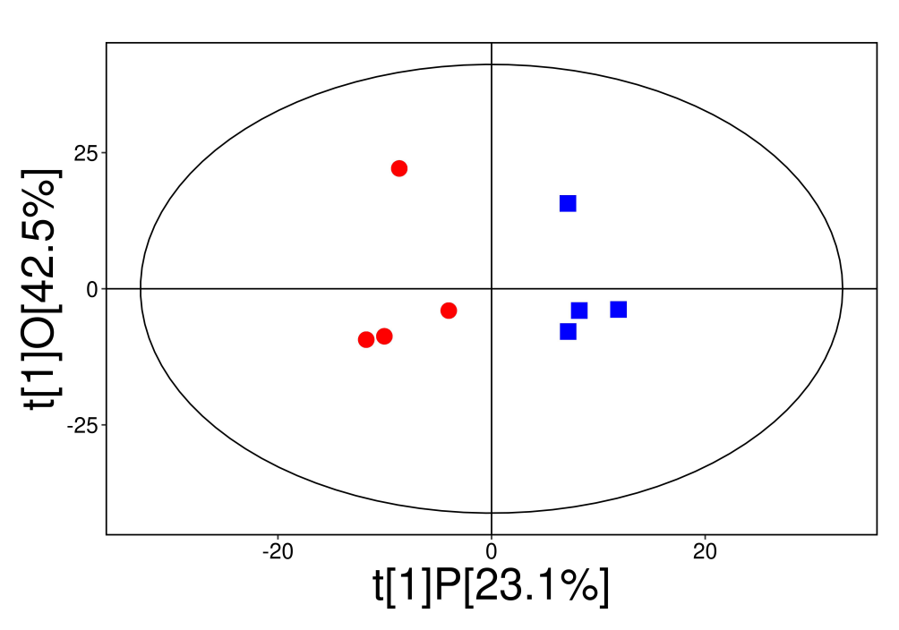
Figure S11.Score scatter plot of OPLS-DA model for Normal group and HOS group.Red:Normal group; Blue:HOS group.HOS：HCECs cultured in hyperosmolar stress(450 mOsM) for 12hours.OPLS-DA:orthogonal projections to latent structures- discriminant analysis.

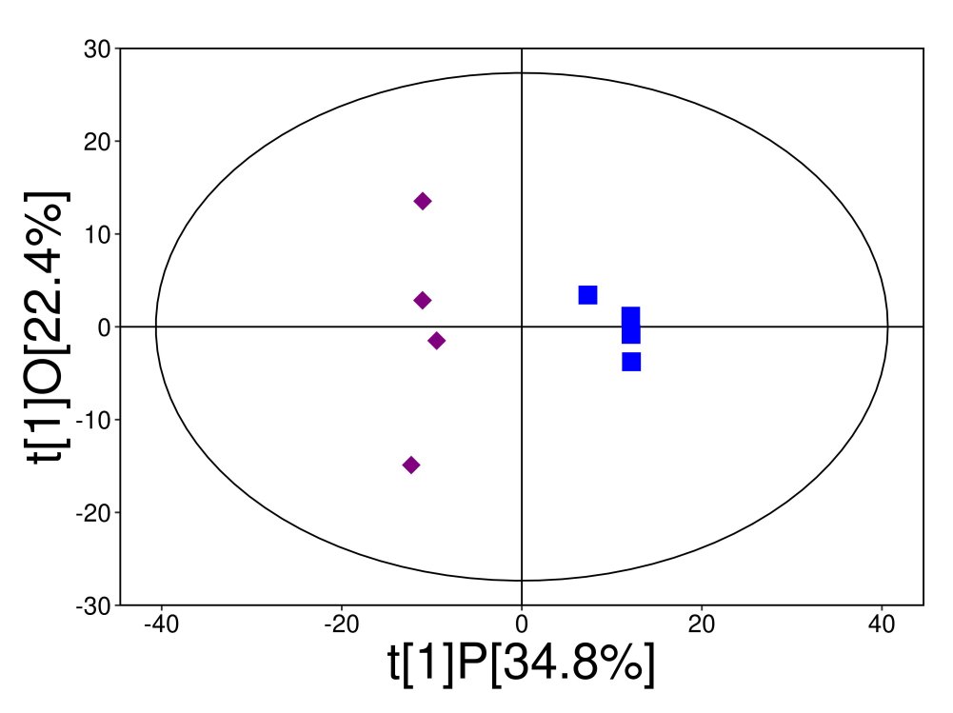
Figure S12.Score scatter plot of OPLS-DA model for HOS+INS group and HOS group.Purple:HOS+INS group; Blue:HOS group.HOS：HCECs cultured in hyperosmolar stress(450 mOsM) for 12 hours.HOS+INS：HOS-cultured HCECs treated with 20μg/ml insulin for 12 h.OPLS-DA:orthogonal projections to latent structures- discriminant analysis;
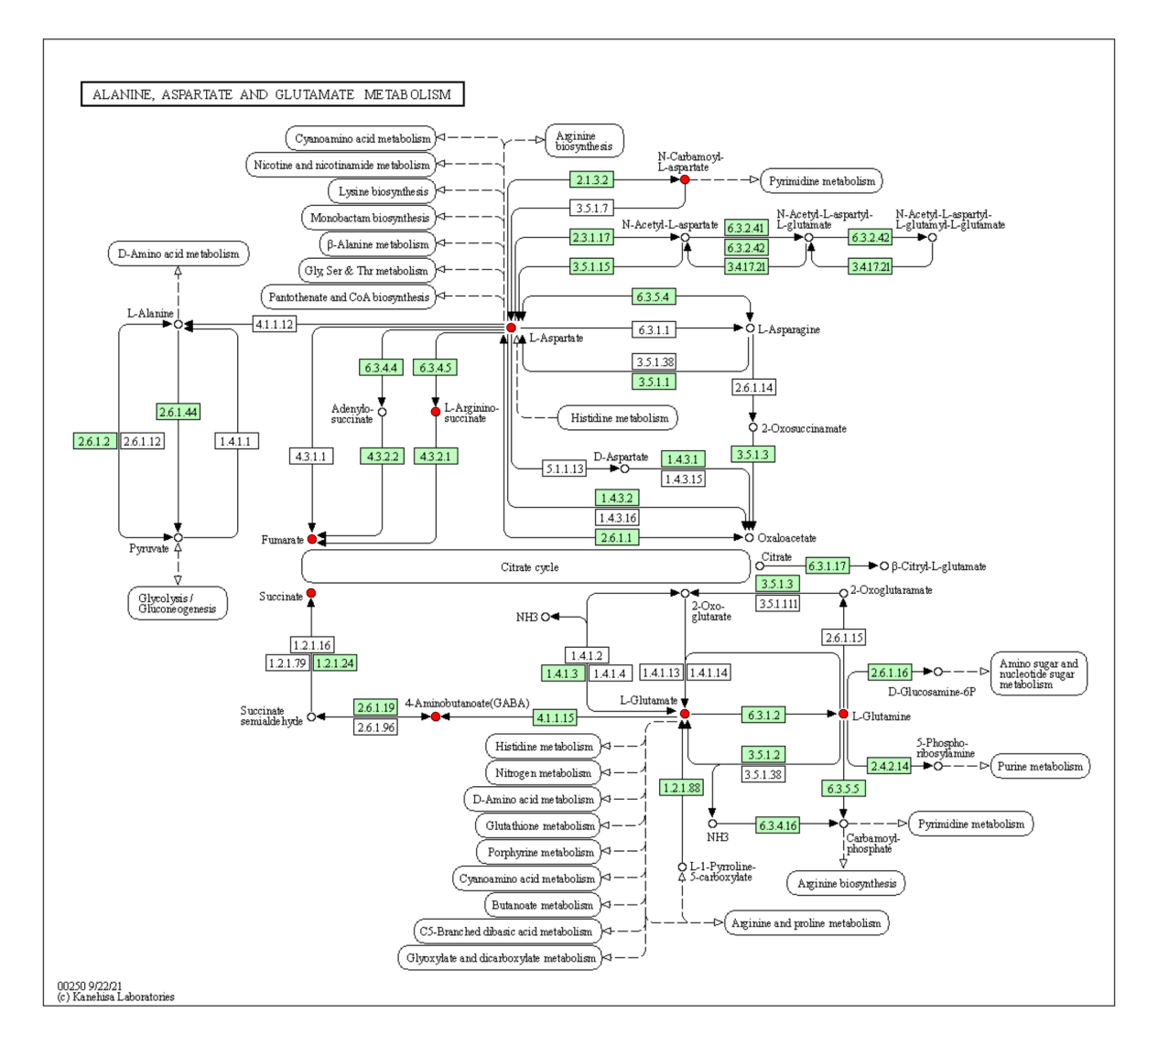
Figure S13.KEGG pathways plotted of Alanine,aspartate and glutamate metabolism.Red dots: up-regulated significantly different metabolites; Blue dots: down-regulated significantly different metabolites; Box:the genes (proteins) involved in the pathway;Line:the flow direction of the metabolic reaction.

Table S6.Blood routine test results of mice on the 30th day
Parameters | Concentration | Reference
ALT (U/L) | 70.38±18.93 | 10.06-96.47
AST (U/L) | 132.17±52.87 | 36.31-235.48
BUN（mg/dL） | 15.09±2.05 | 10.81-34.74
CRE（μmol/L） | 12.63±5.47 | 10.91-85.09
PHP-DPS@INS NPs were administered to the eyes of normal Babl/c mice, 2 times a day, 5 μL each time.Values are presented as mean±SD(n=5).

Table S7. Biochemical parameters of mice on the 30th day
Parameters | Concentration | Reference
WBC（10⁹/L） | 4.39±1.79 | 0.8-6.8
Lymphocyte（10⁹/L） | 2.50±1.16 | 0.7-5.7
Monocyte（10⁹/L） | 0.24±0.18 | 0.0-0.3
RBC（10¹²/L） | 8.60±0.85 | 6.36-9.42
HGB(g/L) | 136.67±5.72 | 110-143
MCHC(g/L) | 308.13±7.18 | 302-353
RDW（%） | 15.75±0.85 | 13-17
PLT（10⁹/L） | 1034.38±272.02 | 450-1590
MPV(fL) | 4.99±0.35 | 3.8-6.0
PHP-DPS@INS NPs were administered to the eyes of normal Babl/c mice, 2 times a day, 5 μL each time.Values are presented as mean±SD(n=5).

