Supplementary material
Integrated oral microgel system ameliorates renal fibrosis by hitchhiking co-delivery and targeted gut flora modulation
Yu Hou^{1#}, Lin Zhu^{1#}, Xiaofeng Ye¹, Qiaoying Ke¹, Qibin Zhang¹, Xiaowei Xie¹, Ji-gang Piao^{1*}, Yinghui Wei^{1*}
- School of Pharmaceutical Sciences, Zhejiang Chinese Medical University, Hangzhou, 311402, China
#Yu Hou and Lin Zhu contributed equally to this work.
*Correspondence: Ji-gang Piao
jgpiao@zcmu.edu.cn
Yinghui Wei
yhw_nn@zcmu.edu.cn
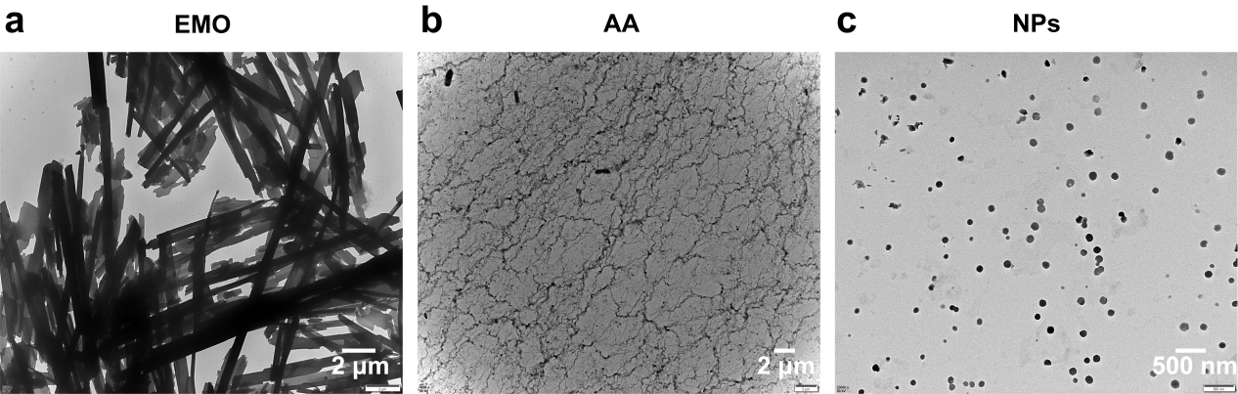
Figure S1. Representative TEM micrographs. (a) EMO. (b) AA. (c) NPs.
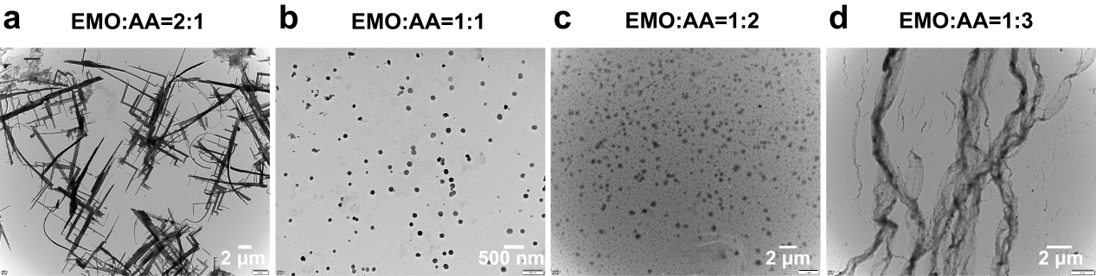
Figure S2. Representative TEM micrographs of NPs with different ratios of EMO to AA. (a) 2:1. (b) 1:1. (c) 1:2. (d) 1:3.
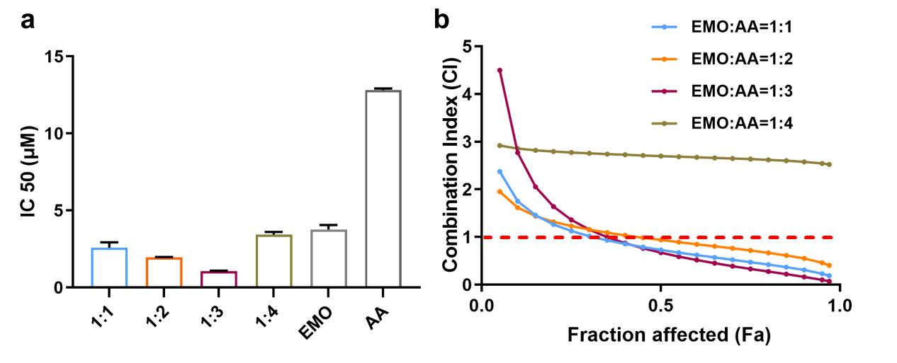
Figure S3. The inhibitory effect of EMO combined with AA at different molar ratios on the proliferation of HK-2 cells. (a) IC₅₀. (b) CI.
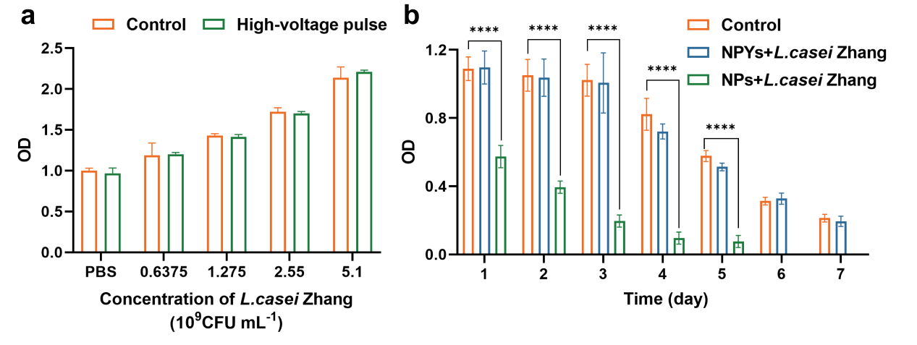
Figure S4. The viability of L. casei Zhang. (a) Growth curves of L. casei Zhang under rated voltage of or not (n = 3). (b) Growth curves of L. casei Zhang when treated with NPs and NPYs (n = 6, ****P < 0.0001).
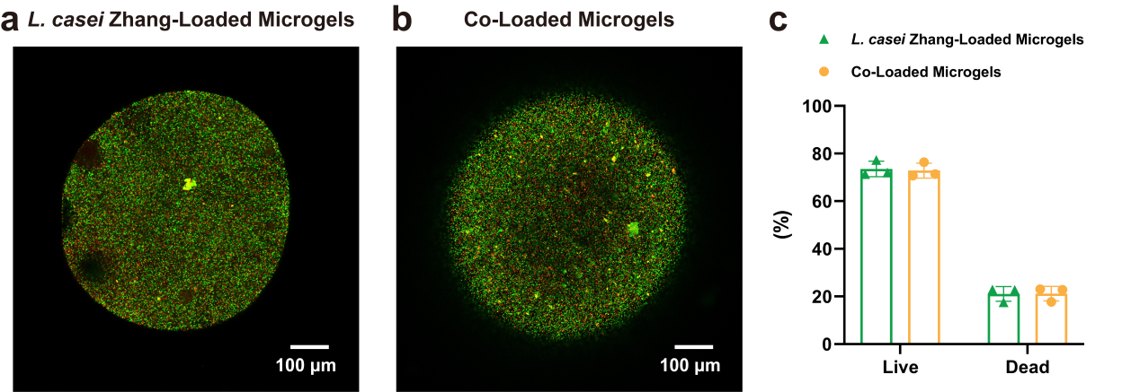
Figure S5. The distribution of L. casei Zhang within microgels. (a, b) Confocal images of live (green) and dead (red) L. casei Zhang within microgels. (c) The ratio of live and dead L. casei Zhang within microgels detected by FCM (n = 3).

