Self-assembled copper-based nanoparticles for enzyme catalysis-enhanced chemodynamic/photodynamic/antiangiogenic tritherapy against hepatocellular carcinoma

Supplementary Material

Figure S1. UV-vis spectra of TMB solutions after incubation with pristine H₂O₂, TCCHA and H₂O₂/TCCHA mixed solutions.

Figure S2. The relative GSH concentration after treatment with different concentrations of TCCHA. n = 3, *** p < 0.001.

Figure S3. Photographs of TCCHA with or without 20 mM GSH incubation under UV light irradiation.

Figure S4. Cumulative release profiles of Cu²⁺ from TCCHA dispersed in in GSH solutions of varying concentrations. n = 3, * p < 0.05, *** p < 0.001.

Figure S5. Cumulative release profiles of Ce6 from TCCHA dispersed in in GSH solutions of varying concentrations. n = 3, ** p < 0.01, *** p < 0.001.

Figure S6. Cumulative release profiles of AL3818 from TCCHA dispersed in in GSH solutions of varying concentrations. n = 3, ** p < 0.01, *** p < 0.001.

Figure S7. Quantitative analysis on the relative changes of intracellular Ce6 levels in HepG2 cells group or HA pretreatment HepG2 cells group (HepG2 + HA) for 1, 4, and 8 h. n = 3, ** p < 0.01, *** p < 0.001.

Figure S8. The results of the quantitative analysis of the apoptosis rates are shown in Figure 3H. n = 3, *** p < 0.001.

Figure S9. Quantitative analysis of H₂O₂ levels in HepG2 cells after treatment with various concentrations of TCCHA with or without H₂O₂ pretreatment. n = 3, ** p < 0.01.
Figure S10. Quantitative analysis of HIF-1α levels after various concentrations of TCCHA treatment with or without hypoxia pre-treatment. n = 3, ** p < 0.01.

Figure S11. The fluorescence intensity of DCF in Figure 4E

Figure S12. Pharmacokinetic profile of TCCHA. The data were determined by ICP-MS analysis of the Cu content in blood and are presented as a percentage of the injected dose (%ID).

Figure S13. Quantitative biodistribution of TCCHA in major organs and tumors at 24 h postinjection, as determined by HPLC analysis of Ce6 content and presented as a percentage of the injected dose (%ID).

Figure S14. Quantitative biodistribution of TCCHA in major organs and tumors at 24 h postinjection, as determined by HPLC analysis of AL3818 content and presented as a percentage of the injected dose (%ID).

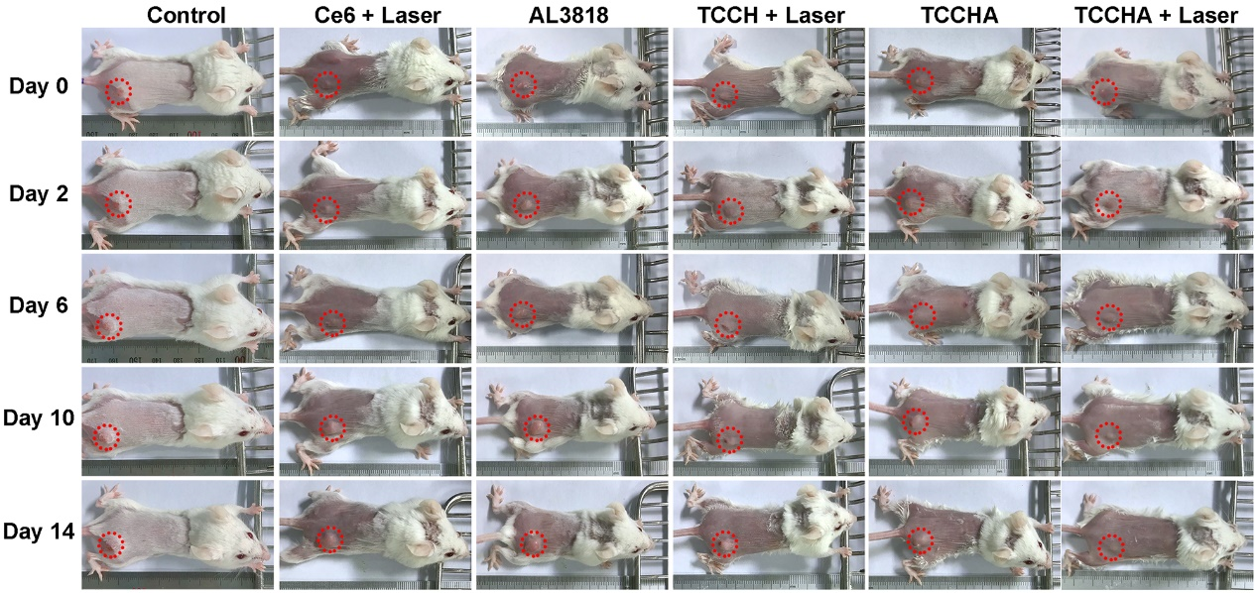
Figure S15. Digital photographs of mice taken at 0 d, 2 d, 6 d, 10 d and 14 d after treatment with different formulations of Ce6 + laser, AL3818, TCCH + laser, TCCHA, or TCCHA + laser. The tumor sites are marked with red circles.

Figure S16. Tumor growth curves of H22 tumor-bearing mice in different treatment groups. n = 6, ***p < 0.001.

Figure S17. Body weight of H22 tumor-bearing mice received different treatments within 14 days.

Figure S18. Immunofluorescence staining of HIF-1α in tumor sections after treatment with various concentrations of TCCHA for 14 days. (Blue: Hoechst-stained nuclei. Green: HIF-1α)

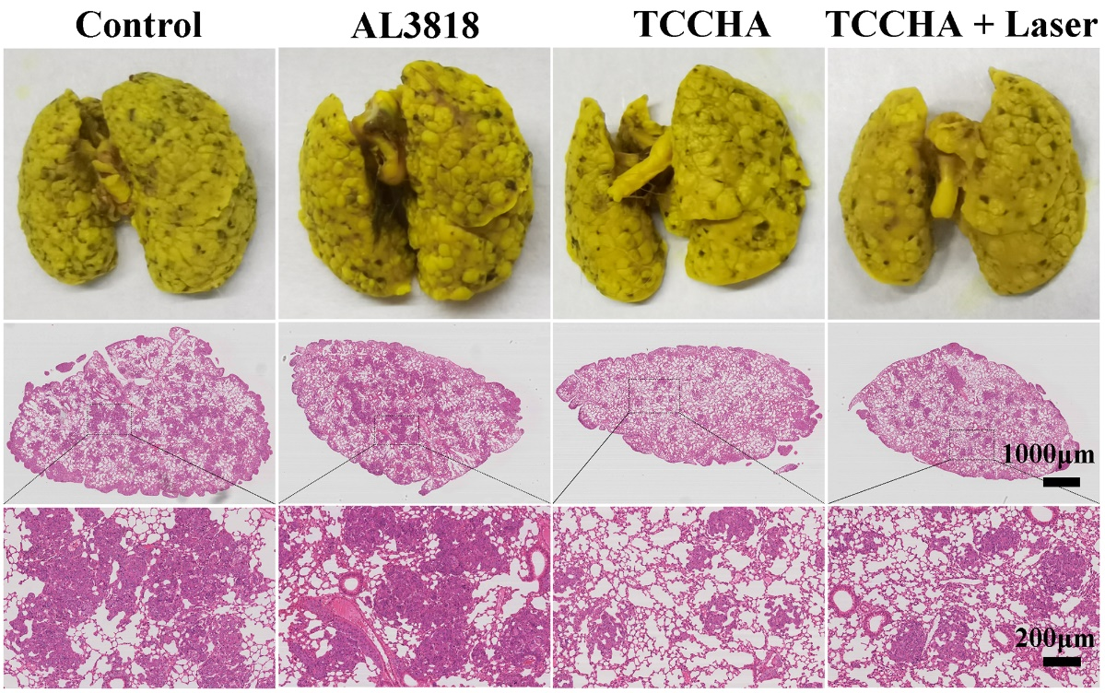
Figure S19. Representative photographs of lungs fixed by Bouin’s solution (upper panel) and H&E images of lung tissues in different groups. The black dotted squares denote metastatic nodules.

Figure S20. Numbers of lung metastatic nodules in Hepa1-6 lung metastatic mice in different treatment groups. n = 5, * p < 0.05, ** p < 0.01, “ns” represents no statistical significance.

Figure S21. Relative lung metastasis inhibition rates in different treatment groups. n = 5, * p < 0.05, ** p < 0.01, “ns” represents no statistical significance.

