Supplementary material

Supplementary Figure

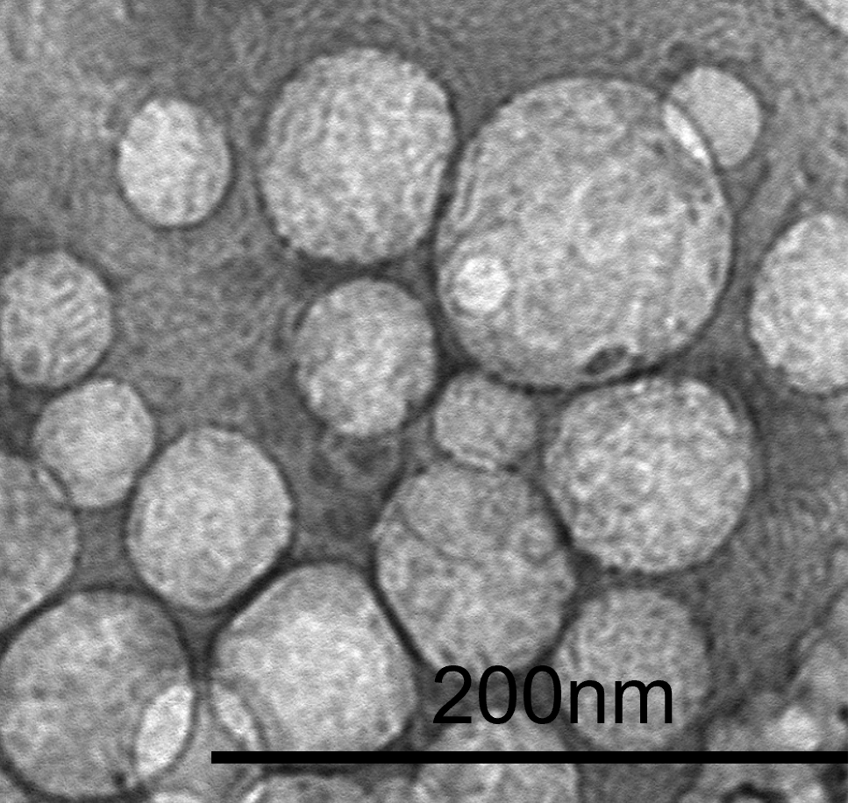
Supplementary Figure1 TEM images of LPs

A.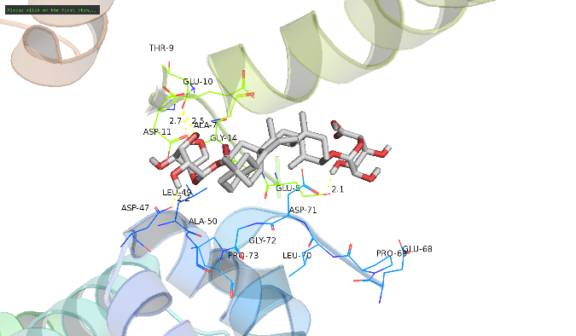B.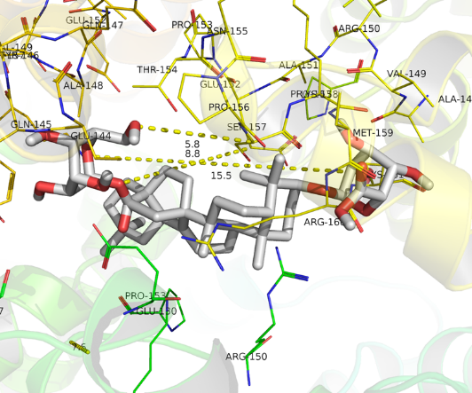
Supplementary Figure 2 Molecular docking diagram of C-IVa with GSDMD (A) and ASC (B).

Supplementary Table

Supplementary Table 1 Characterization of liposomes
 | C-IVa-LP | C-IVa-LP-THRre
EE% | 77.67±0.536 | 76.05±0.678
DL% | 12.345±0.849 | 12.042±0.142
size | 119.3±0.21 | 122.3±2.65
PDI | 0.182±0.021 | 0.272±0.015
ζ-potential | -25.4±0.95 | -20.5±3.66

