Supporting information
Potentiating Dual-Directional Immunometabolic Regulation with Nanomedicine to Enhance Anti-Tumor Immunotherapy Following Incomplete Photothermal Ablation

Qinqin Jiang ^{1#}, Bin Qiao ^{1#} , Jun Zheng ¹ , Weixiang Song ², Nan Zhang ³ , Jie Xu ², Jia Liu ² , Yixin Zhong ² , Qin Zhang ⁴, Weiwei Liu ¹ , Lanlan You ⁵, Nianhong Wu ¹, Yun Liu ² , Pan Li ¹ , Haitao Ran ¹ , Zhigang Wang ¹* and Dajing Guo ²*

¹ Department of Ultrasound, Chongqing Key Laboratory of Ultrasound Molecular Imaging, the Second Affiliated Hospital of Chongqing Medical University, Chongqing 400010, P. R. China
² Department of Radiology, the Second Affiliated Hospital of Chongqing Medical University, Chongqing 400010, P. R. China
³ Department of Medical Ultrasonics, the First Affiliated Hospital of Sun Yat-sen University, Guangzhou, 510080, P. R. China
⁴ Department of Radiology, Chongqing Hospital of Traditional Chinese Medicine, Chongqing 400021, P. R. China
⁵ Department of Ultrasound, Clinical Medical College and the First Affiliated Hospital of Chengdu Medical College, Chengdu, 610500, P. R. China
Qinqin Jiang and Bin Qiao are co-first authors who contributed equally to this work.
Corresponding authors: Dajing Guo, E-mail: guodaj@hospital.cqmu.edu.cn
Zhigang Wang, E-mail: wzg62942443@163.com

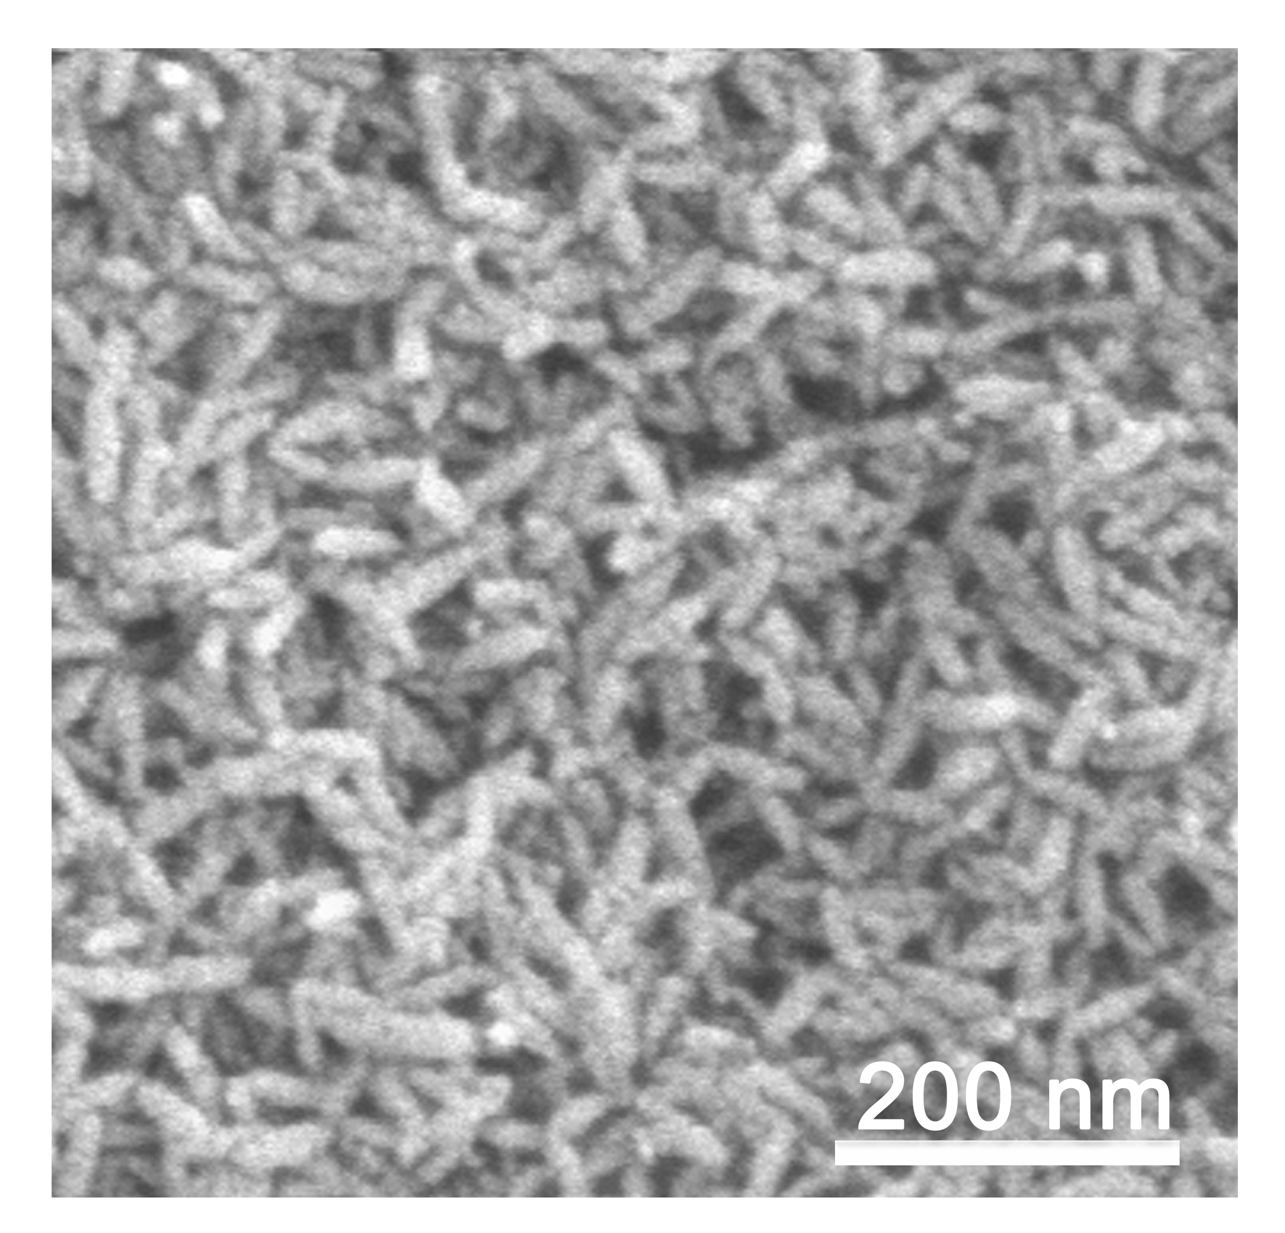
Figure S1 SEM image of FI.
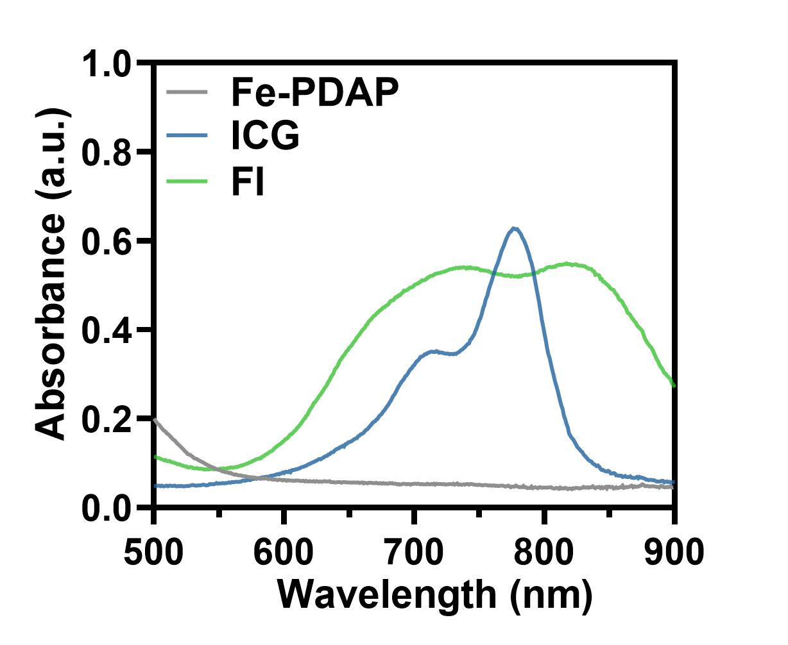
Figure S2 UV/vis absorption spectra of Fe-PDAP, ICG and FI.
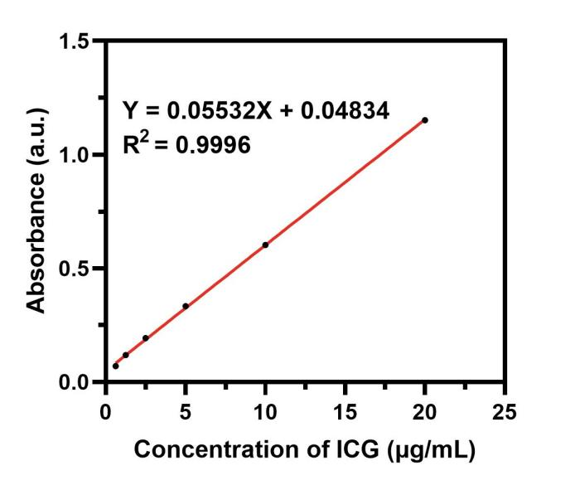
Figure S3 The relative absorbance intensity of ICG in the UV-vis-NIR spectrum at a wavelength of 776nm.

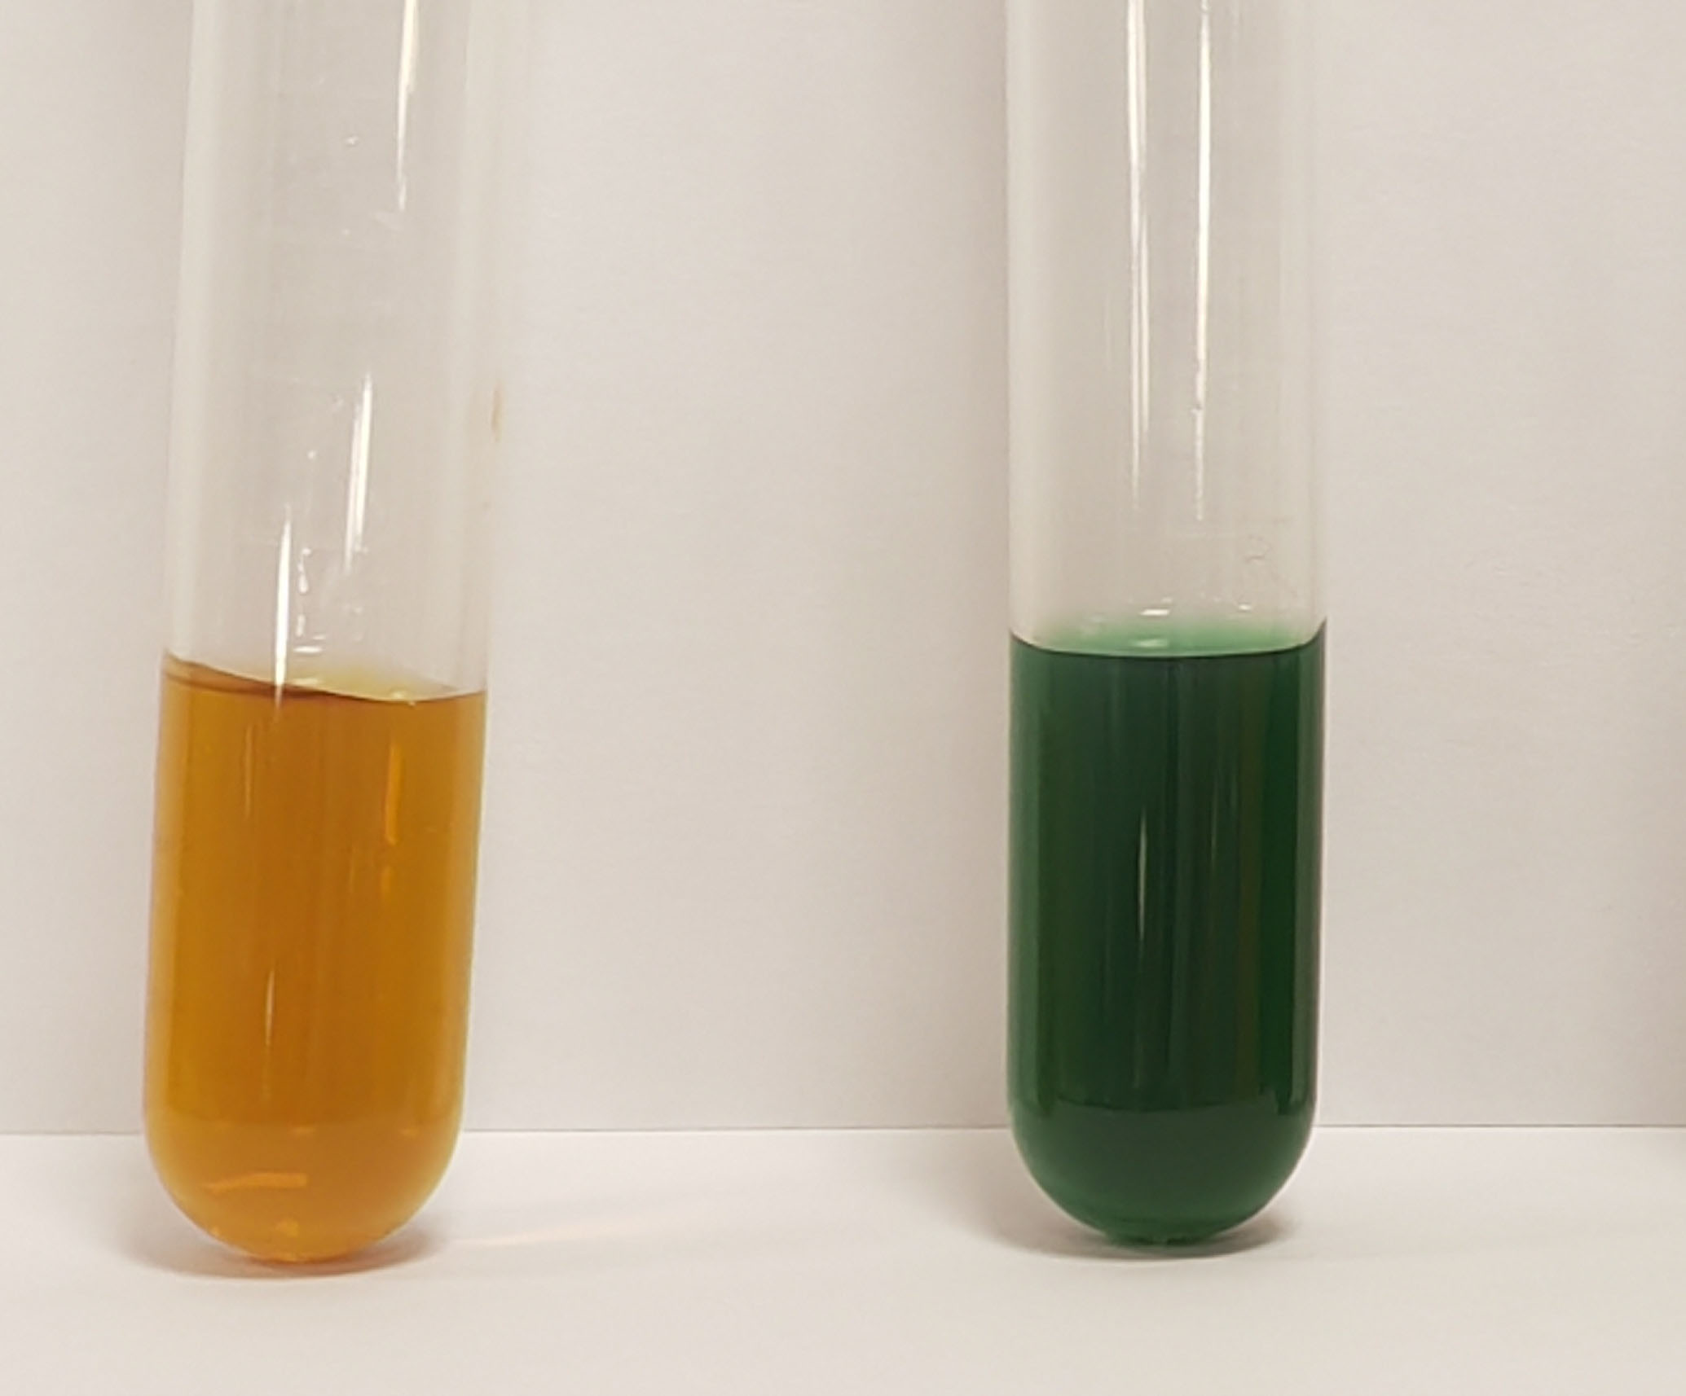
Figure S4 Digital images of Fe-PDAP (left) and FI (right).
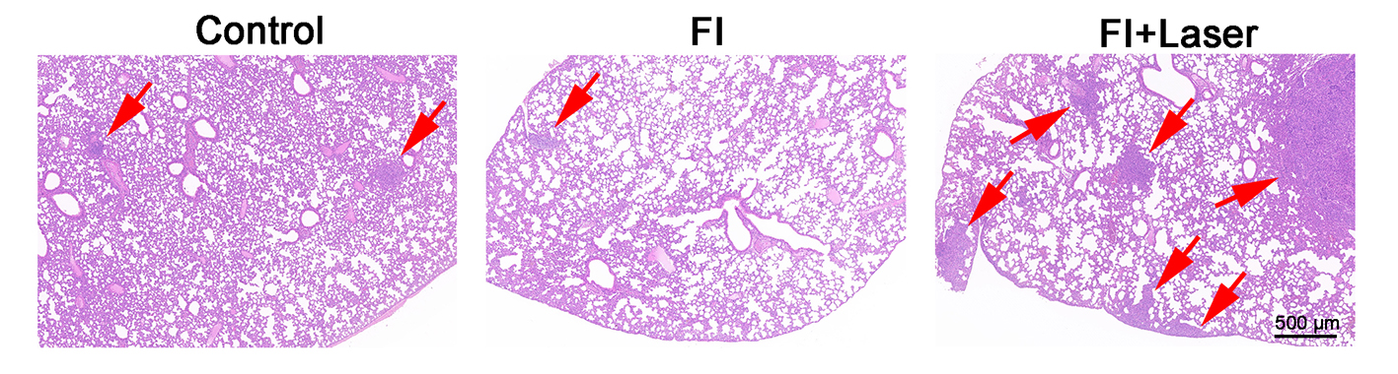
Figure S5 Representative H&E staining images of lung tissues collected at the end of the study.

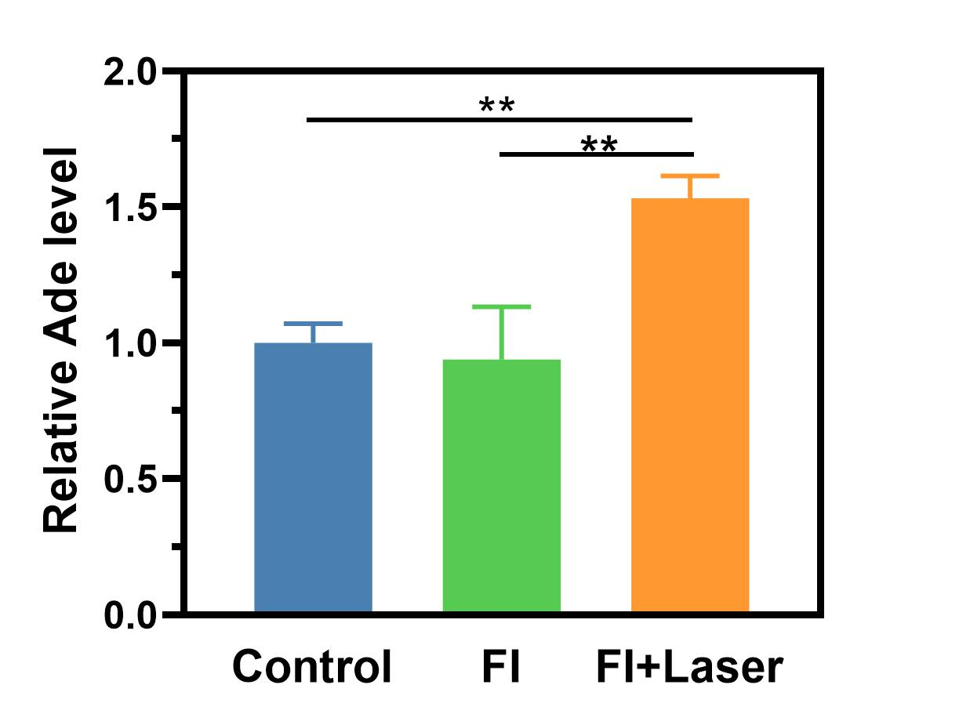
Figure S6 Ade level in the tumor tissue after different treatments.
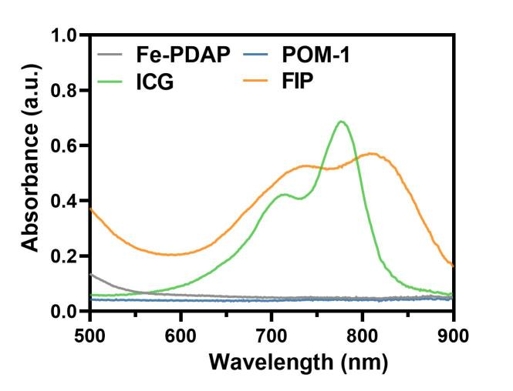
Figure S7 UV/vis absorption spectra of Fe-PDAP, ICG, POM-1 and FIP.
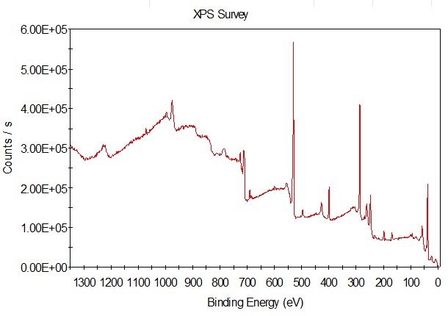
Figure S8 Full survey XPS spectrum of FIP.
Figure S9 Infrared thermal images in vitro of FIP at various powers.
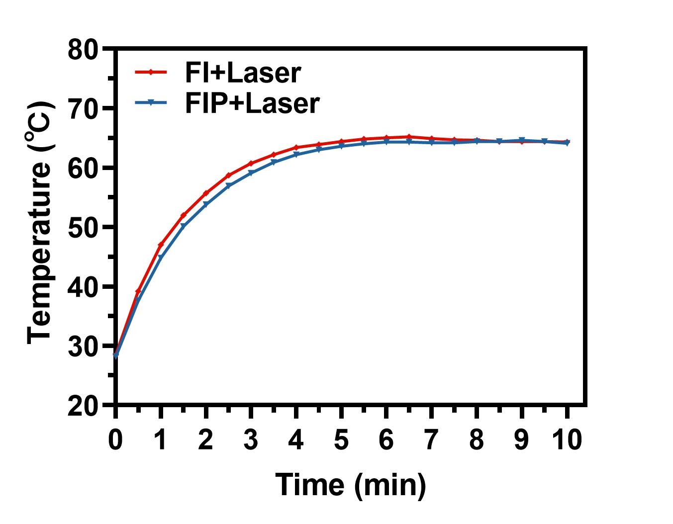
Figure S10 Temperature change curves of FIP and FI under exposure to the 808 nm laser.

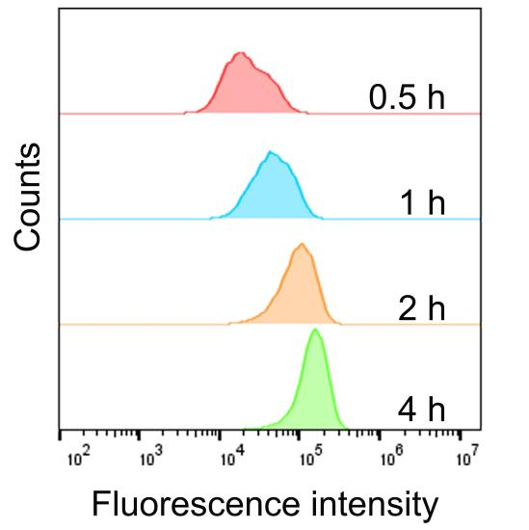
Figure S11 Flow cytometry analysis of intracellular uptake of FIP.

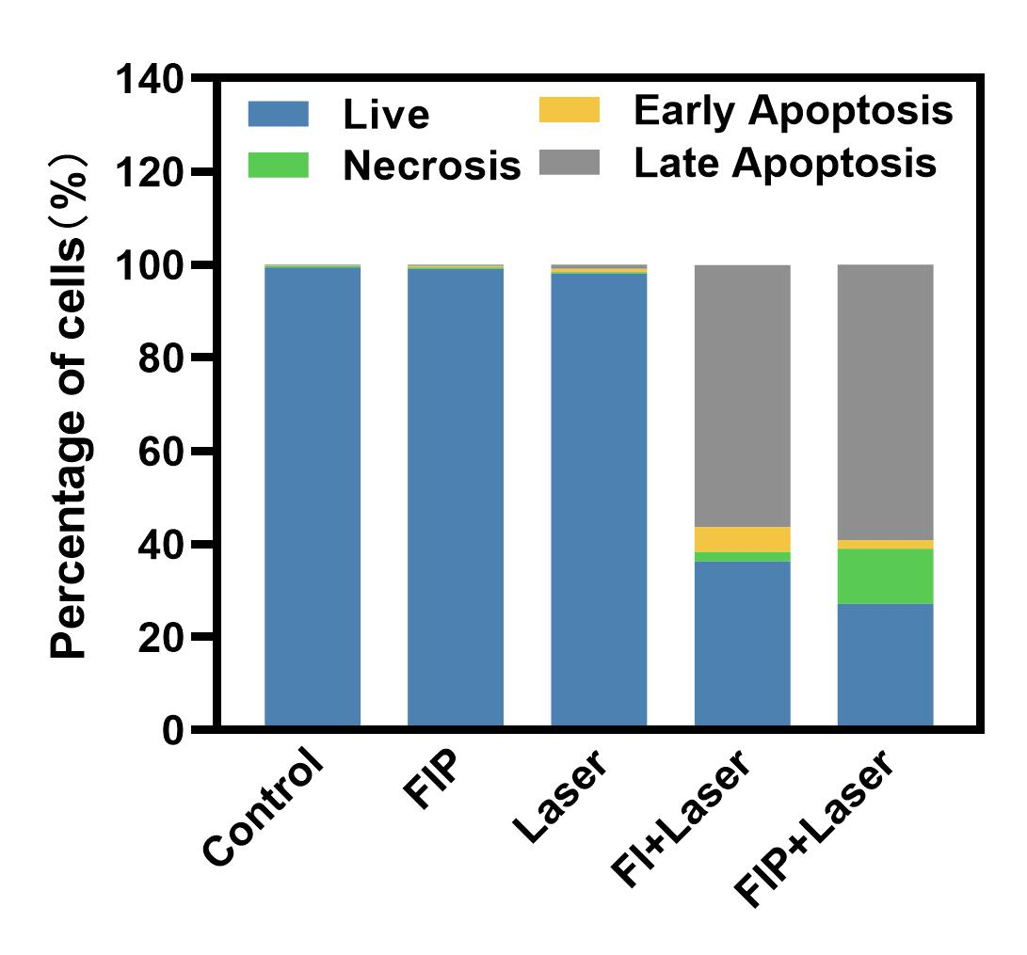
Figure S12 Flow cytometry analysis of the cell apoptosis of 4T1 cells after different treatments.

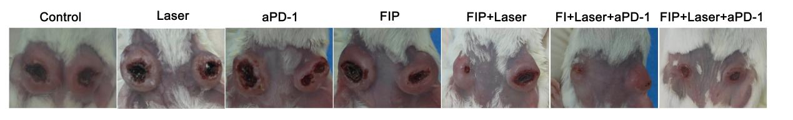
Figure S13 Representative digital photos of 4T1 tumors on both sides of BALB/c mice in different groups on day 16.

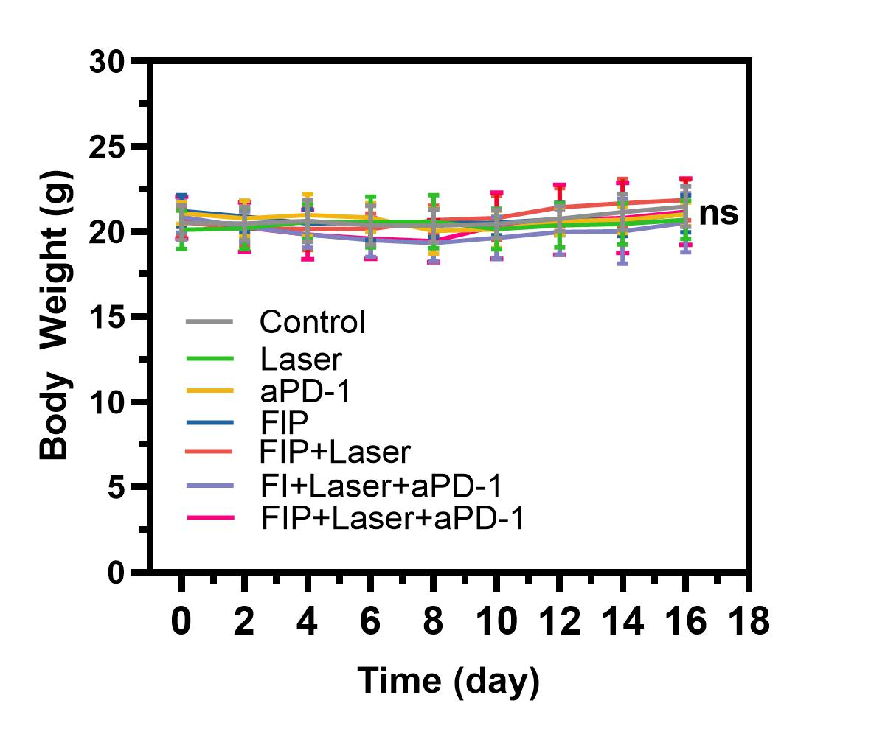
Figure S14 Time-dependent body weight curves of the 4T1 tumor-bearing mice after different treatments.

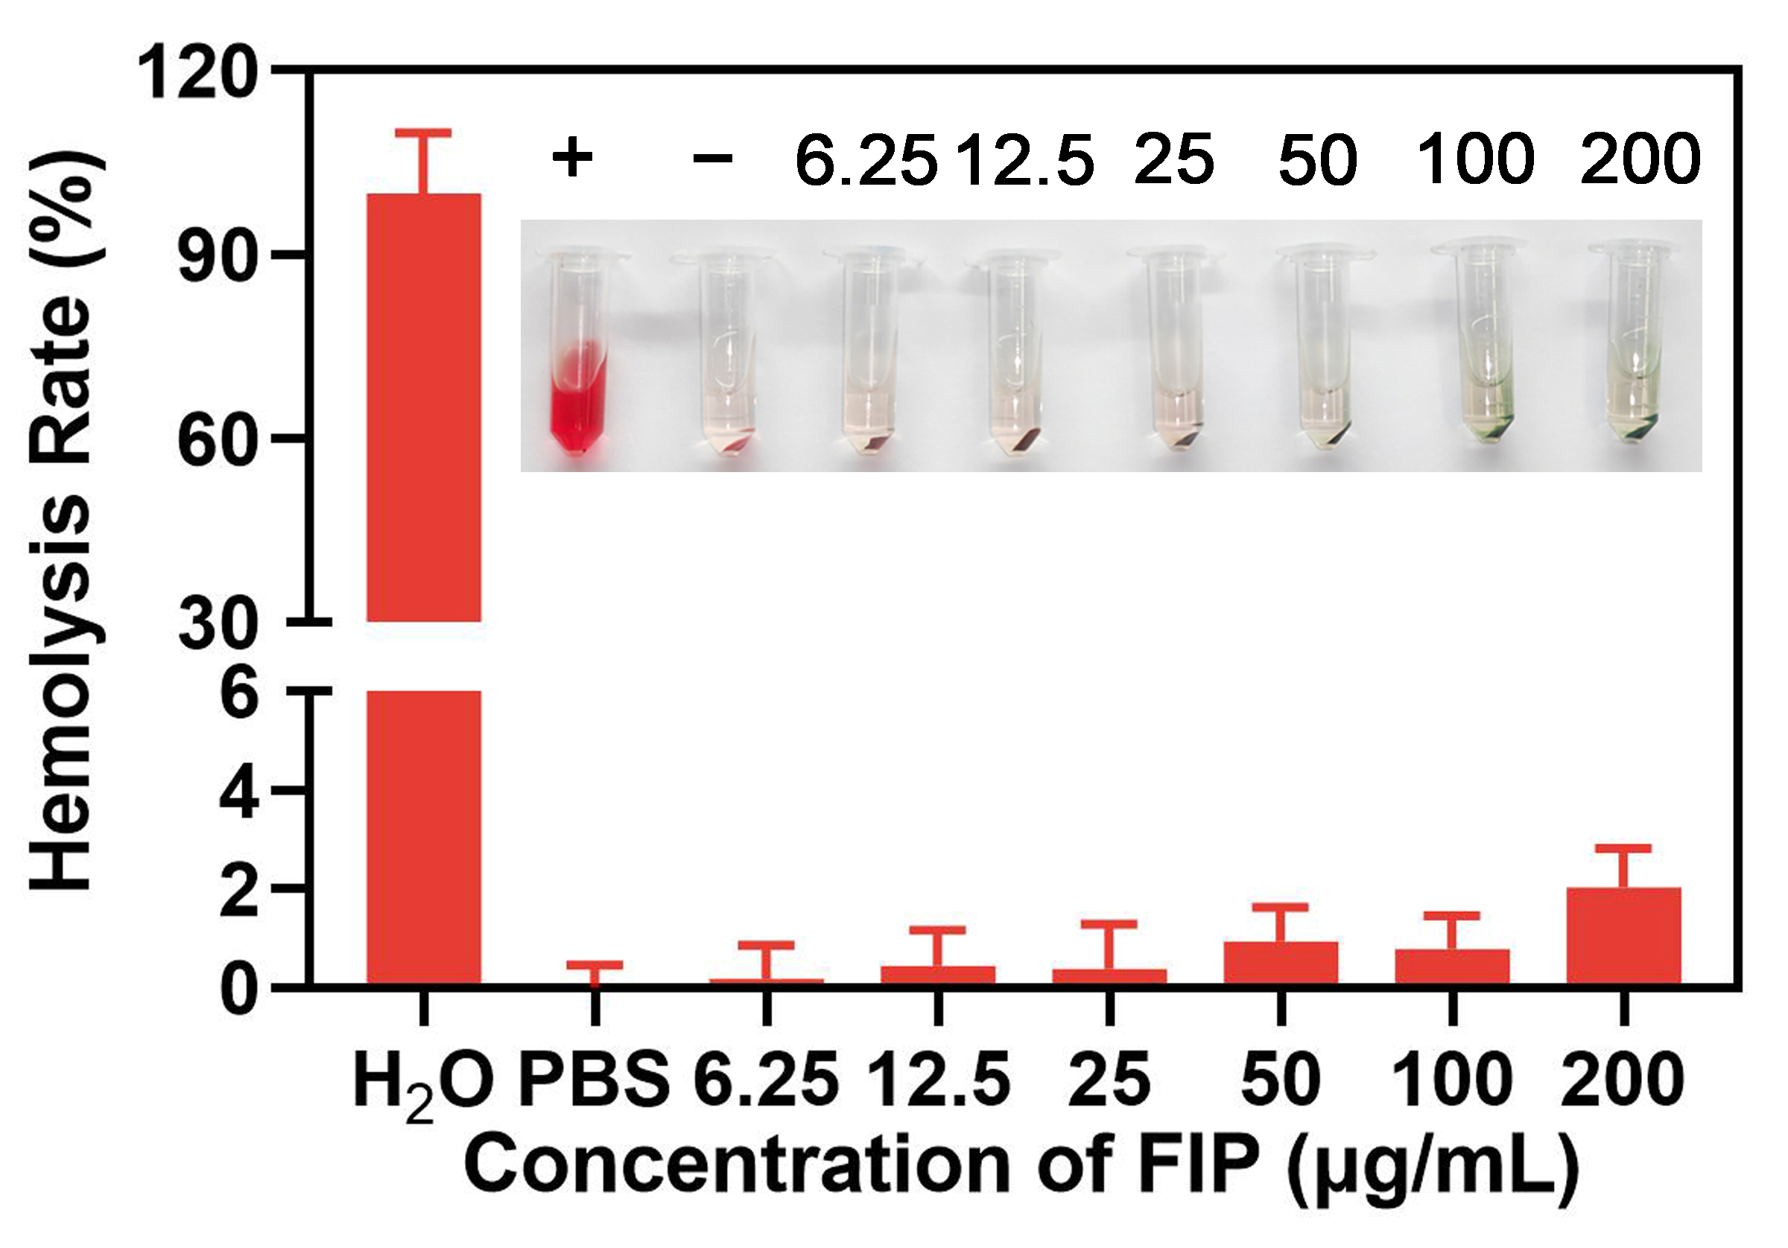
Figure S15 Hemolysis rate of RBCs treated with FIP at various concentrations.

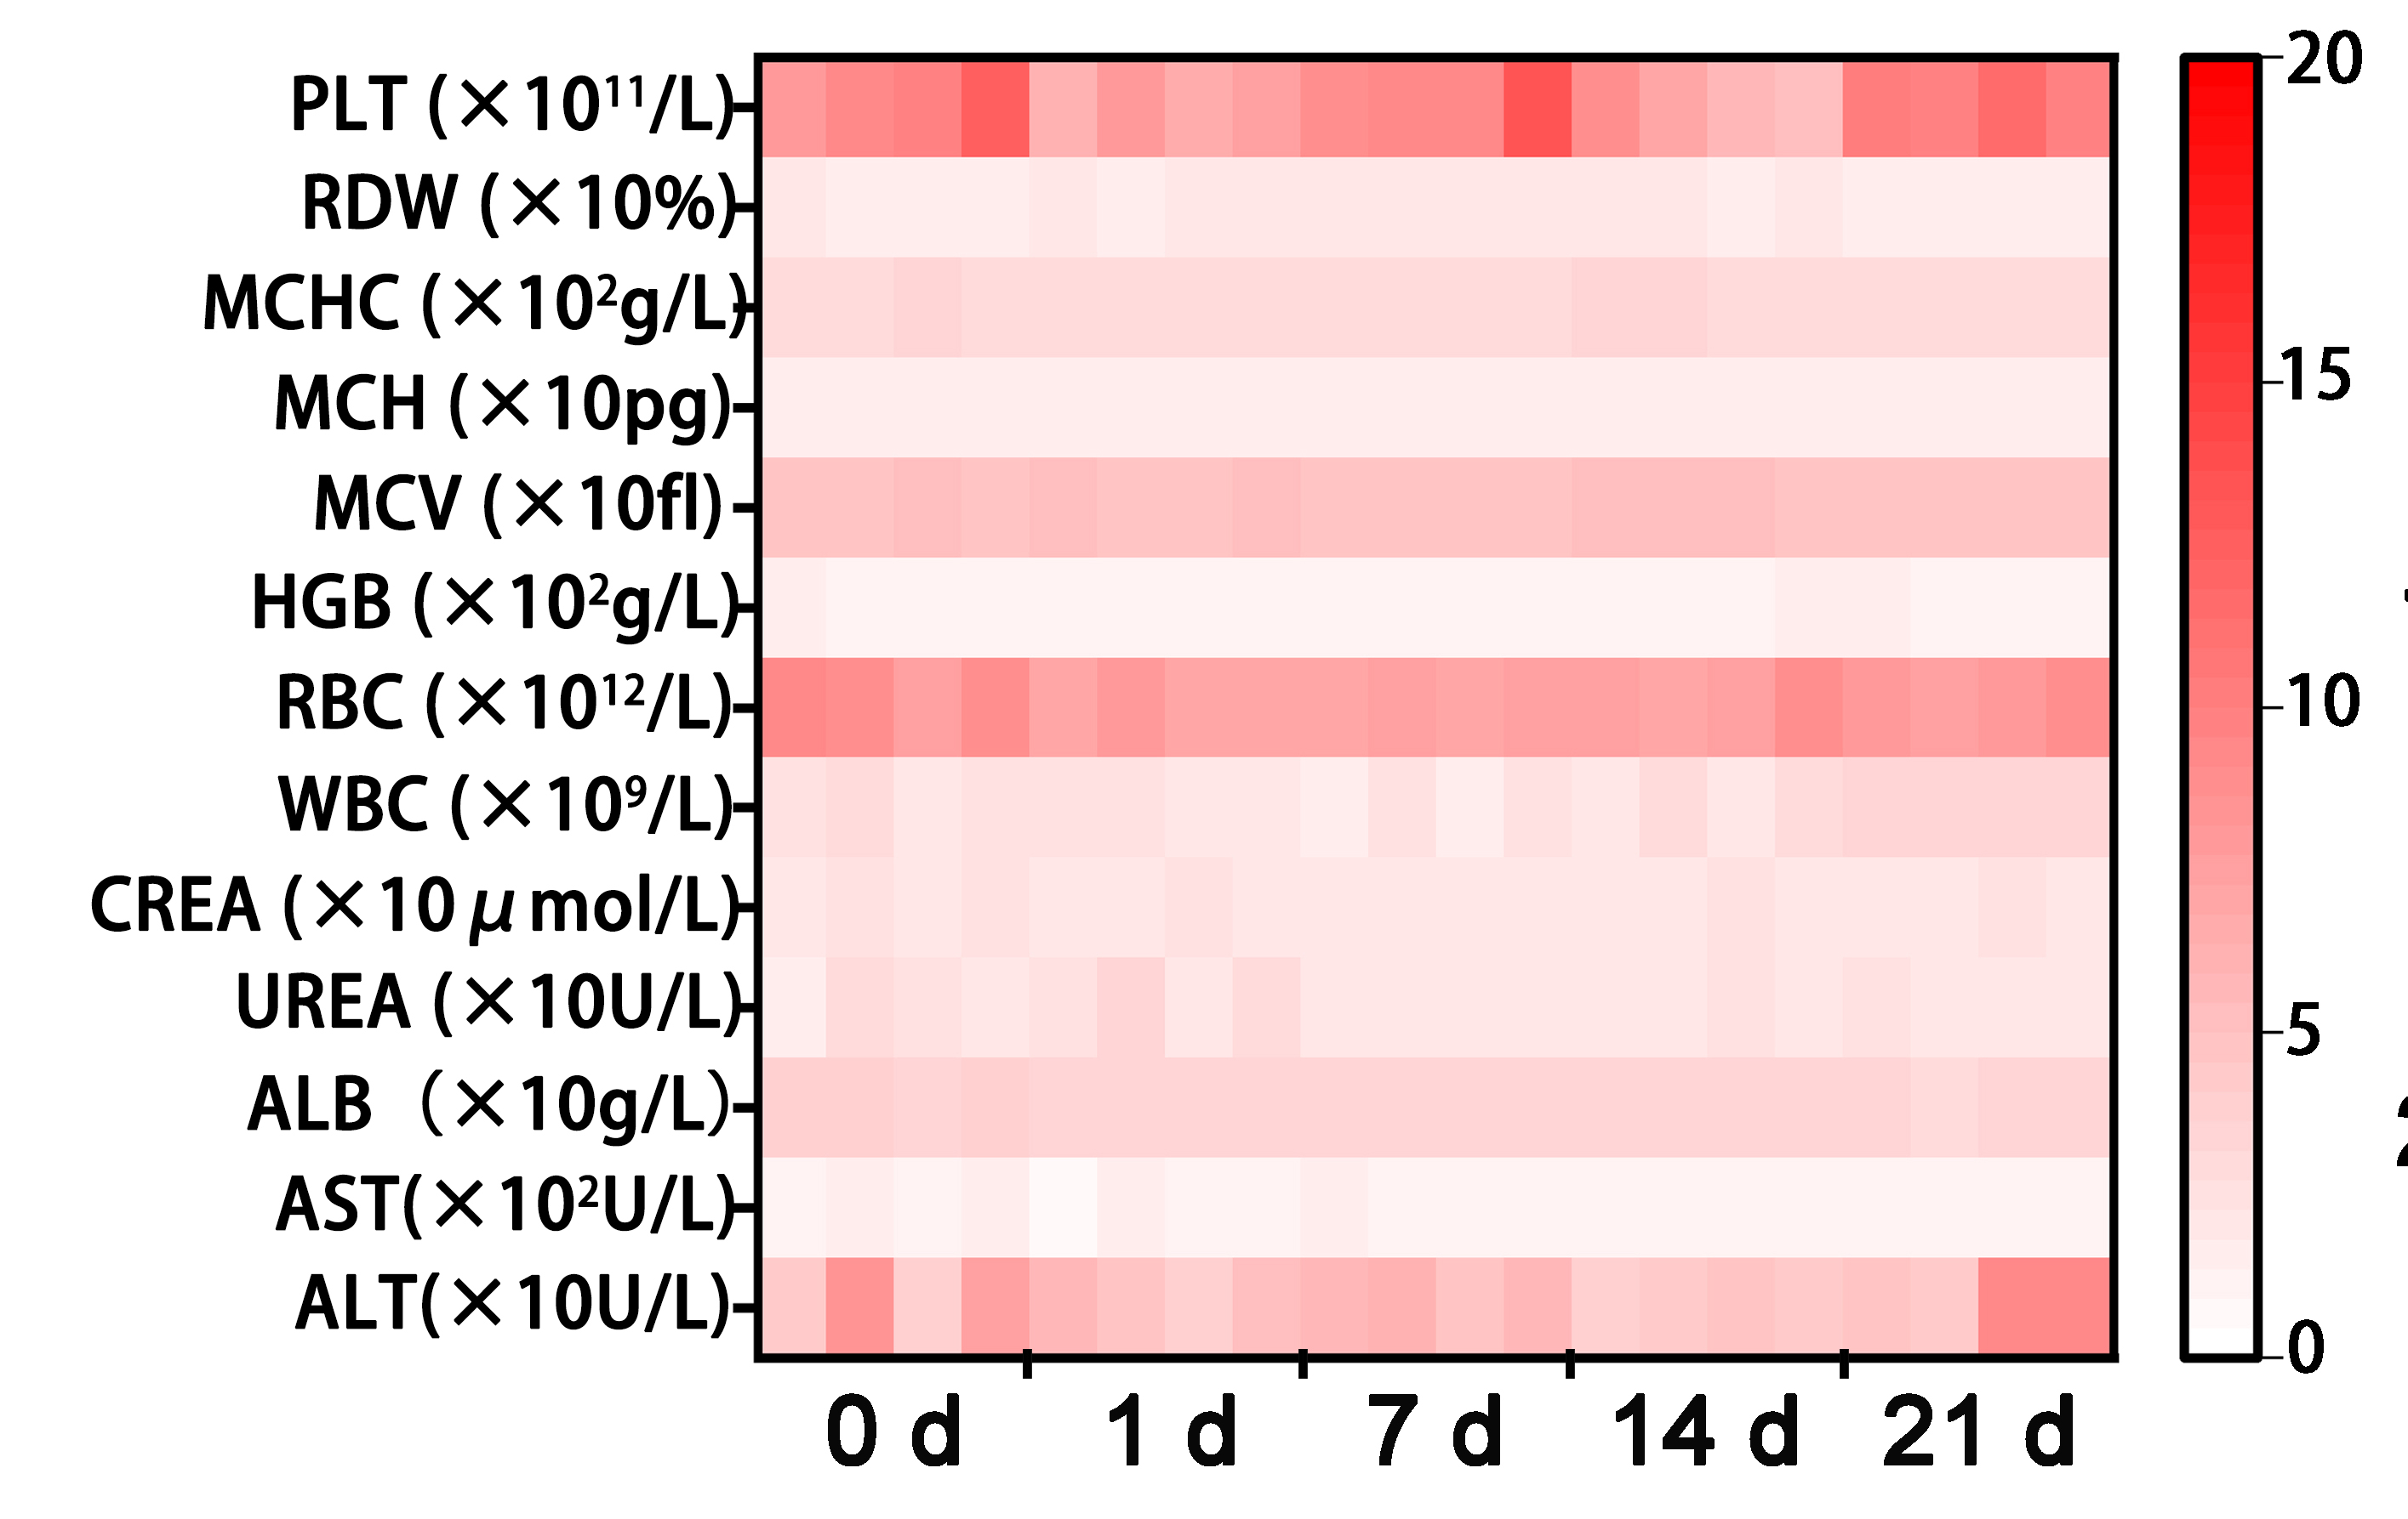
Figure S16 Hematological and blood biochemical tests were performed on mice following intravenous injection of FIP at various times.

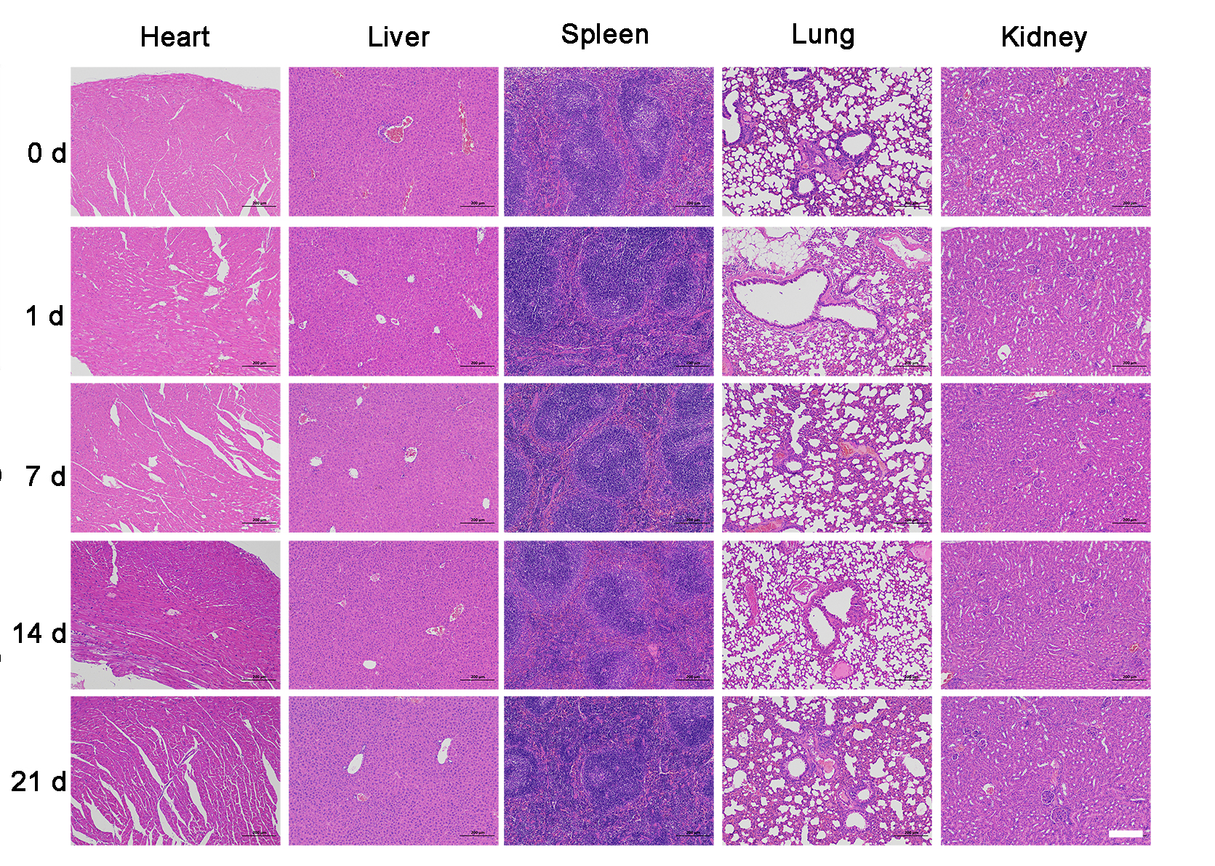
Figure S17 H&E staining of major organs of mice after different treatments.

