Supporting Information

Injectable hybrid hydrogels enable enhanced combination chemotherapy and roused anti-tumor immunity in the synergistic treatment of pancreatic ductal adenocarcinoma

Hao Zhouª, Wei Wangª, Zedong Caiª, Zhou-Yan Jiaª, Yu-Yao Liª, Wei He^{b, c,*}, Chen Li^{b} and Bang-Le Zhang^{a, b, *}
ª Department of Pharmaceutics, School of Pharmacy, Fourth Military Medical University, Xi’an, 710032, China; ^{b} Key Laboratory of Pharmacology of the State Administration of Traditional Chinese Medicine, Fourth Military Medical University, Xi’an, 710032, China; ^{c} Department of Chemistry, School of Pharmacy, Fourth Military Medical University, Xi’an, 710032, China
*Corresponding authors: blezhang@fmmu.edu.cn (BL Zhang); weihechem@fmmu.edu.cn (W He).

Figure S1. Fluorescence IVIS imaging depicting the in vivo degradation of Cy5.5@CS/β-GP
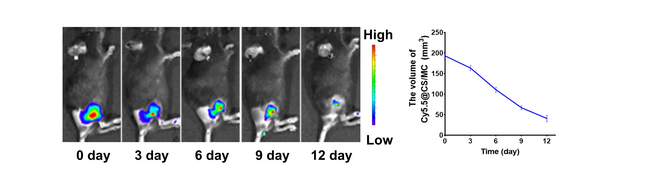
FigureS2. Fluorescence IVIS imaging of Cy5.5@CS/MC hydrogels in vivo and the change of hydrogel volume in vivo (n = 3)
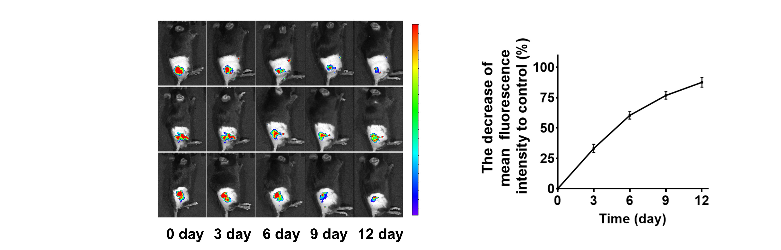
Figure S3. The cumulative release profiles of the Cy3-M@CS/MC hydrogels in vivo (n = 3)
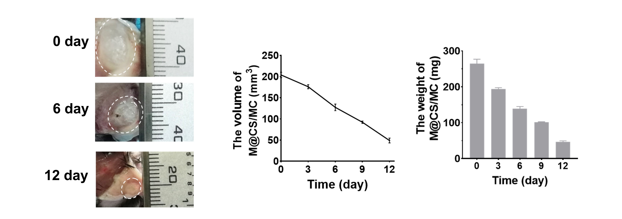
Figure S4. The degradation of M@CS/MC hydrogels in vivo by testing the change of the volume and weight (n = 3)
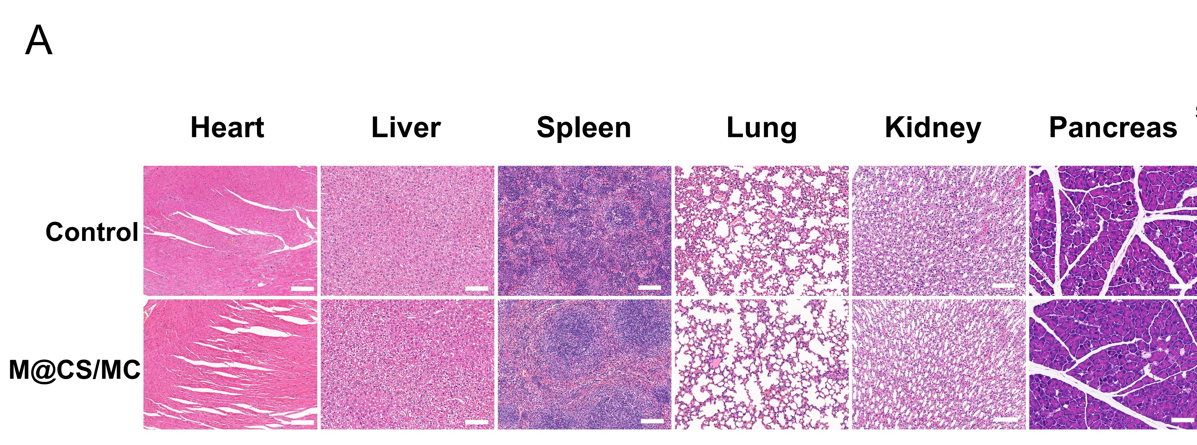
Figure S5. H&E staining analysis of major organs from the C57BL/6 mice after treated with M@CS/MC. Scale bar: 50 μm.
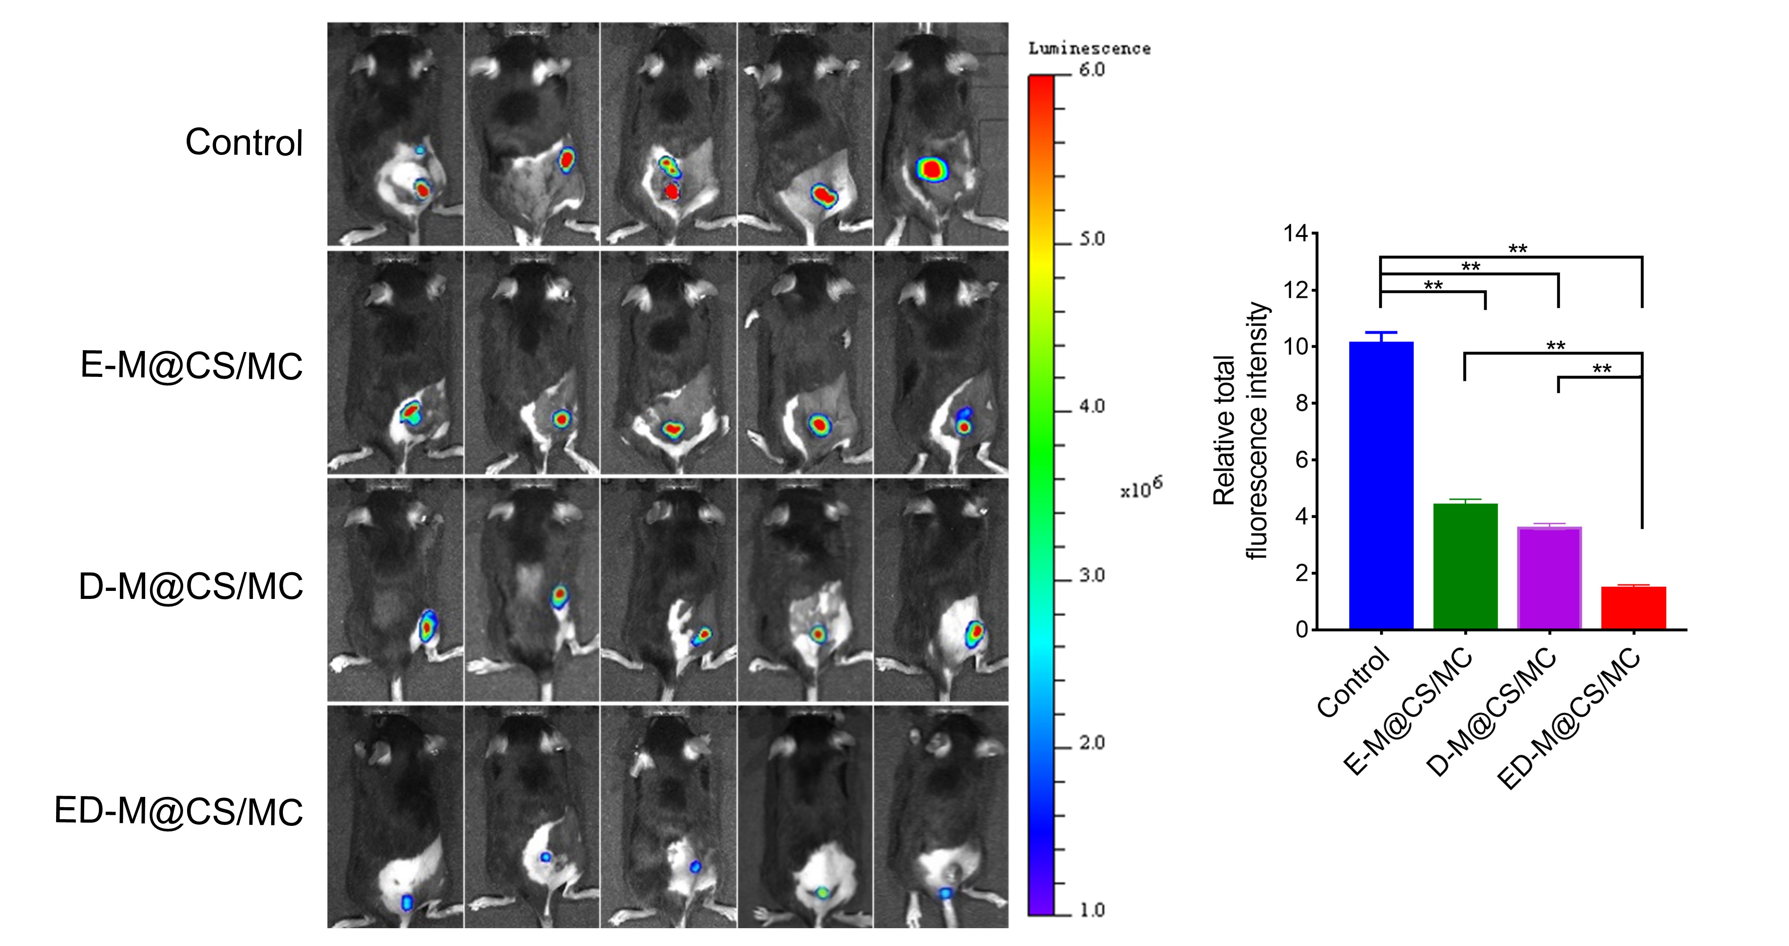
Figure S6. Tumor bioluminescence images and bioluminescence intensity after different treatments (n = 5, Mean ± SD, ** P < 0.01)
Figure S7. Body weight change curve after different treatments (n = 5)
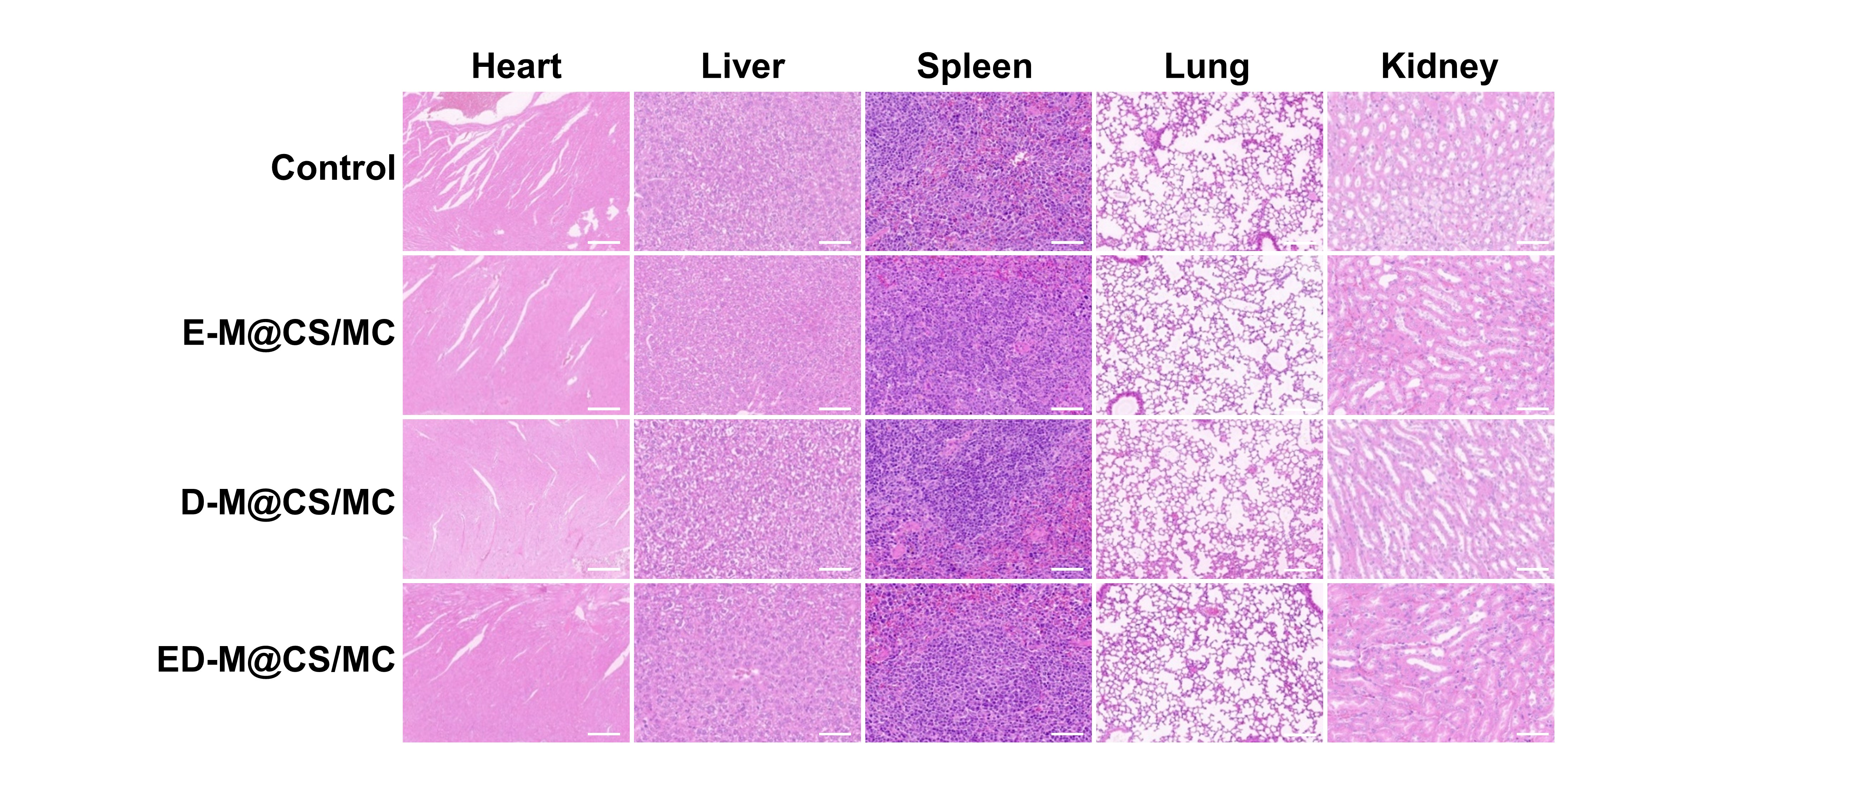
Figure S8. H&E staining analysis of the major organs after different treatments. Scale bar: 50 μm.
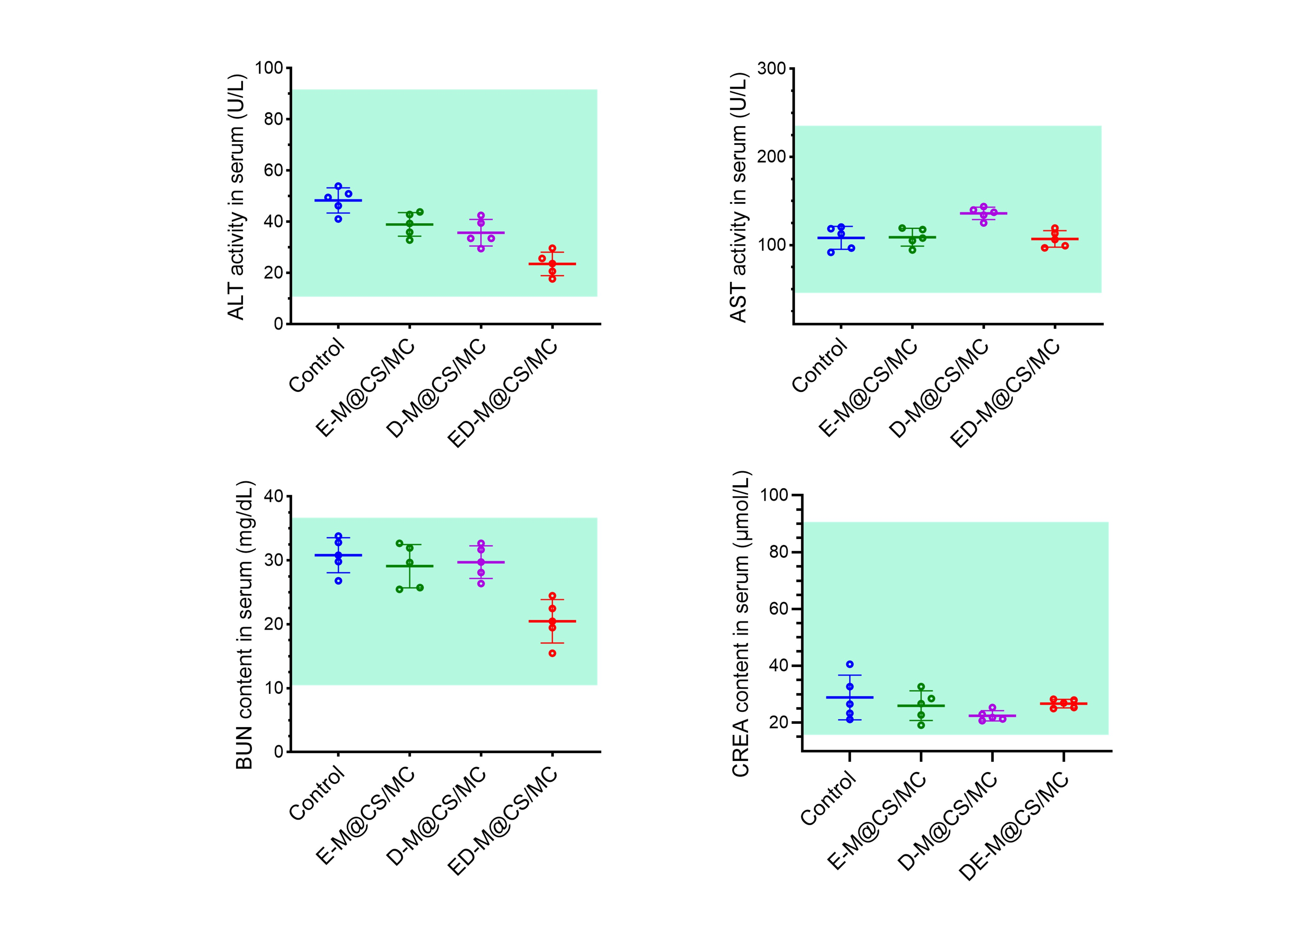
Figure S9. The serum concentrations of ALT, AST, BUN and CREA after different treatments in the xenograft mice (n = 5, Mean ± SD).
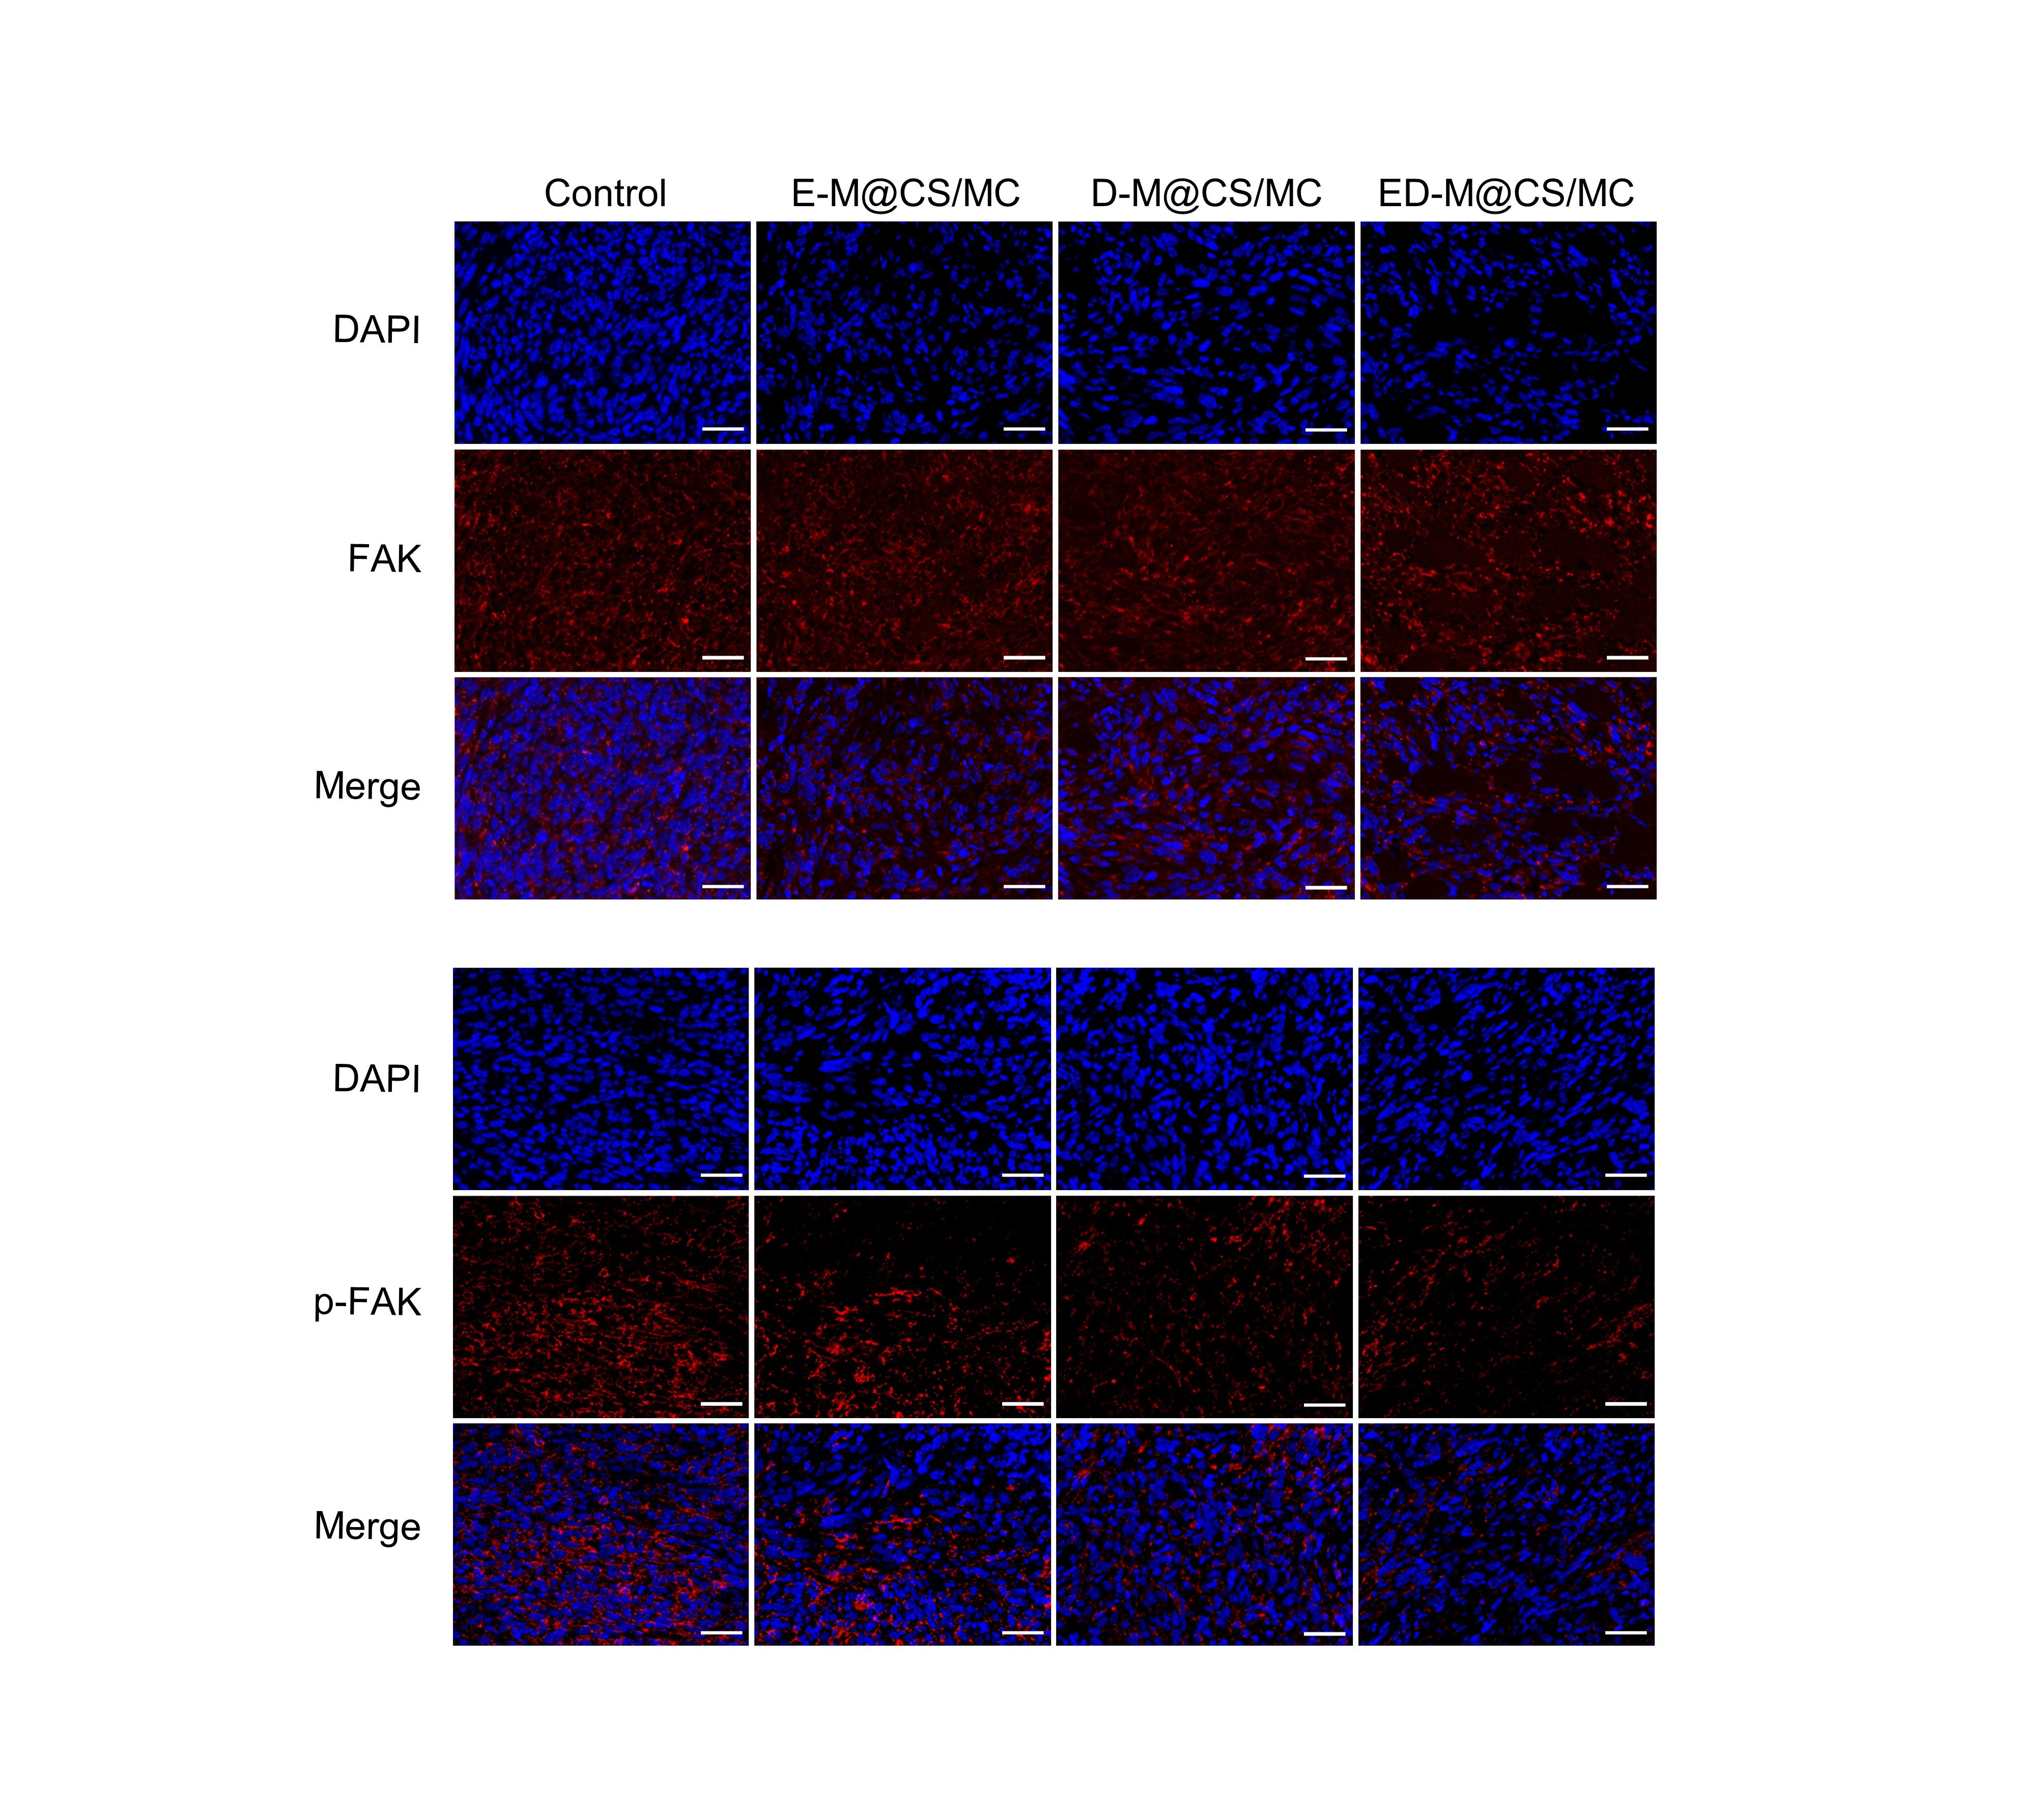
Figure S10. Representative immunofluorescence staining images of FAK and p-FAK in tumor tissue after different treatments. Scale bar: 50 μm.
Figure S11. CRT and HMGB1 in tumor tissue after different treatments analyzed by ImageJ (n = 3, Mean ± SD, *P< 0.05)
Figure S12. The proportion of M2 macrophages was analyzed by ImageJ (n = 3, Mean ± SD, * P < 0.05, **P < 0.01, ns, not significant)
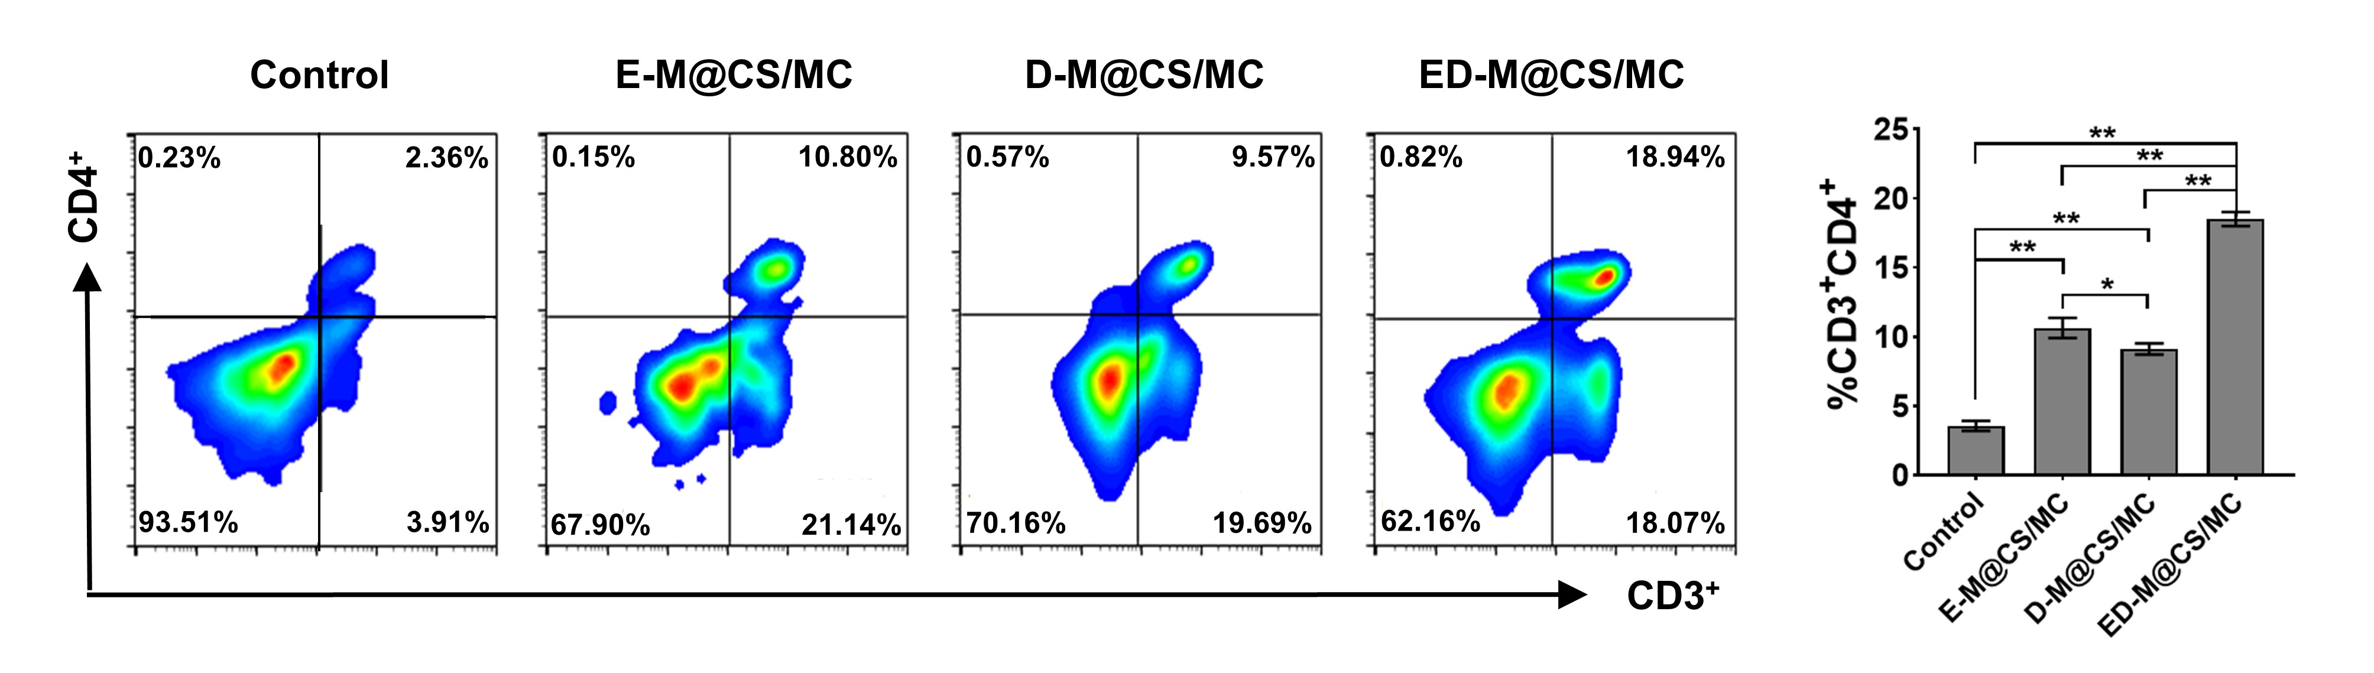
Figure S13. Representative flowcharts of CD3⁺CD4⁺ T cells and FCM analysis of CD3⁺CD4⁺ T cells in the tumor tissue (n = 3, Mean ± SD, *P< 0.05, **P< 0.01)
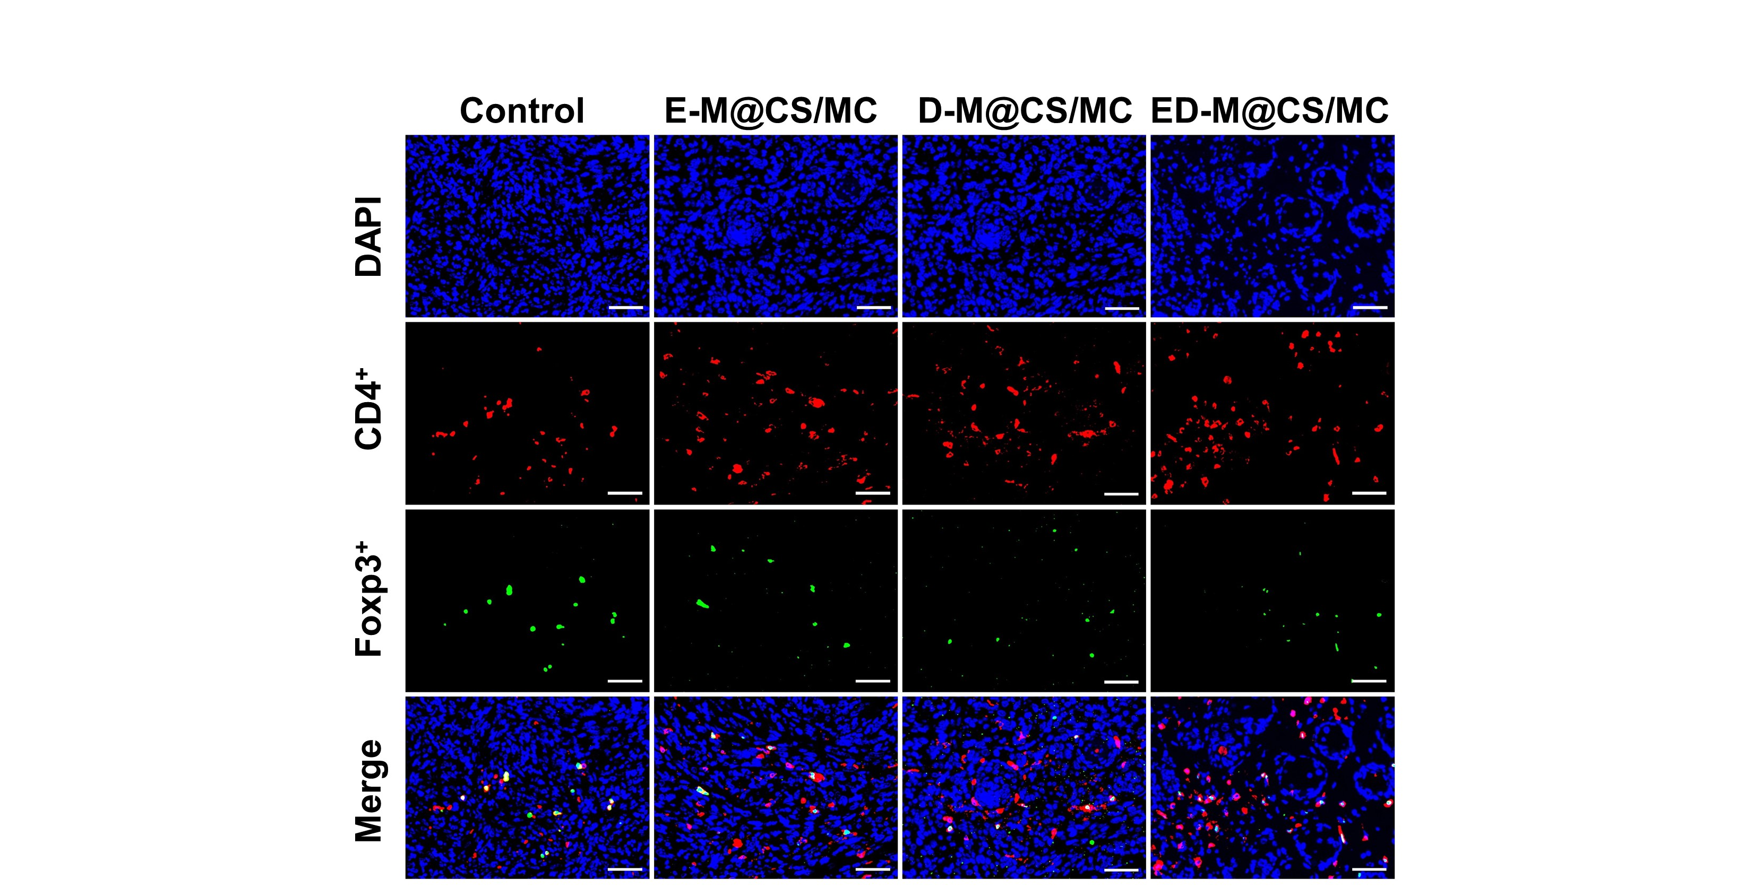
Figure S14. Representative immunofluorescence staining images of Treg (CD4⁺Foxp3⁺). Scale bar: 50 μm.
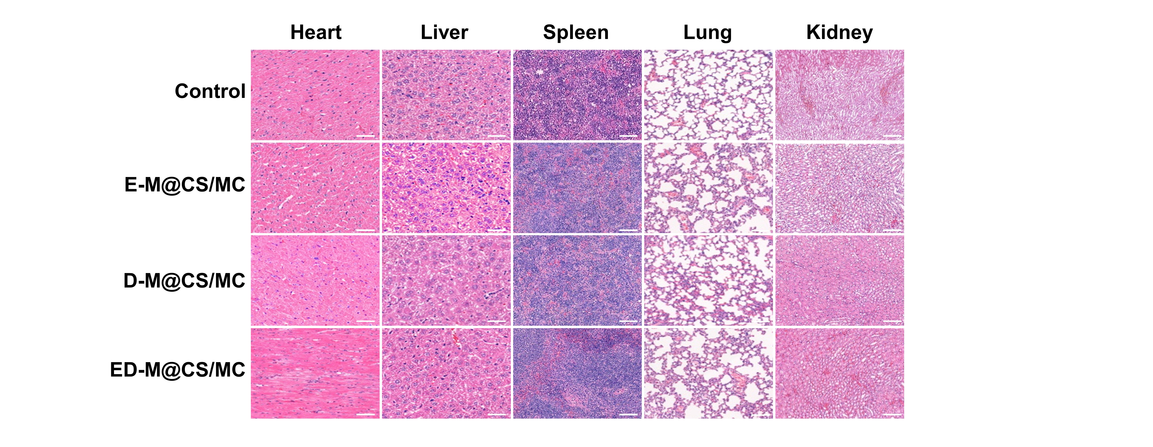
Figure S15. H&E staining of the major organs from the Kras^{G12D}-engineering mice after different treatments. Scale bar: 100 μm.
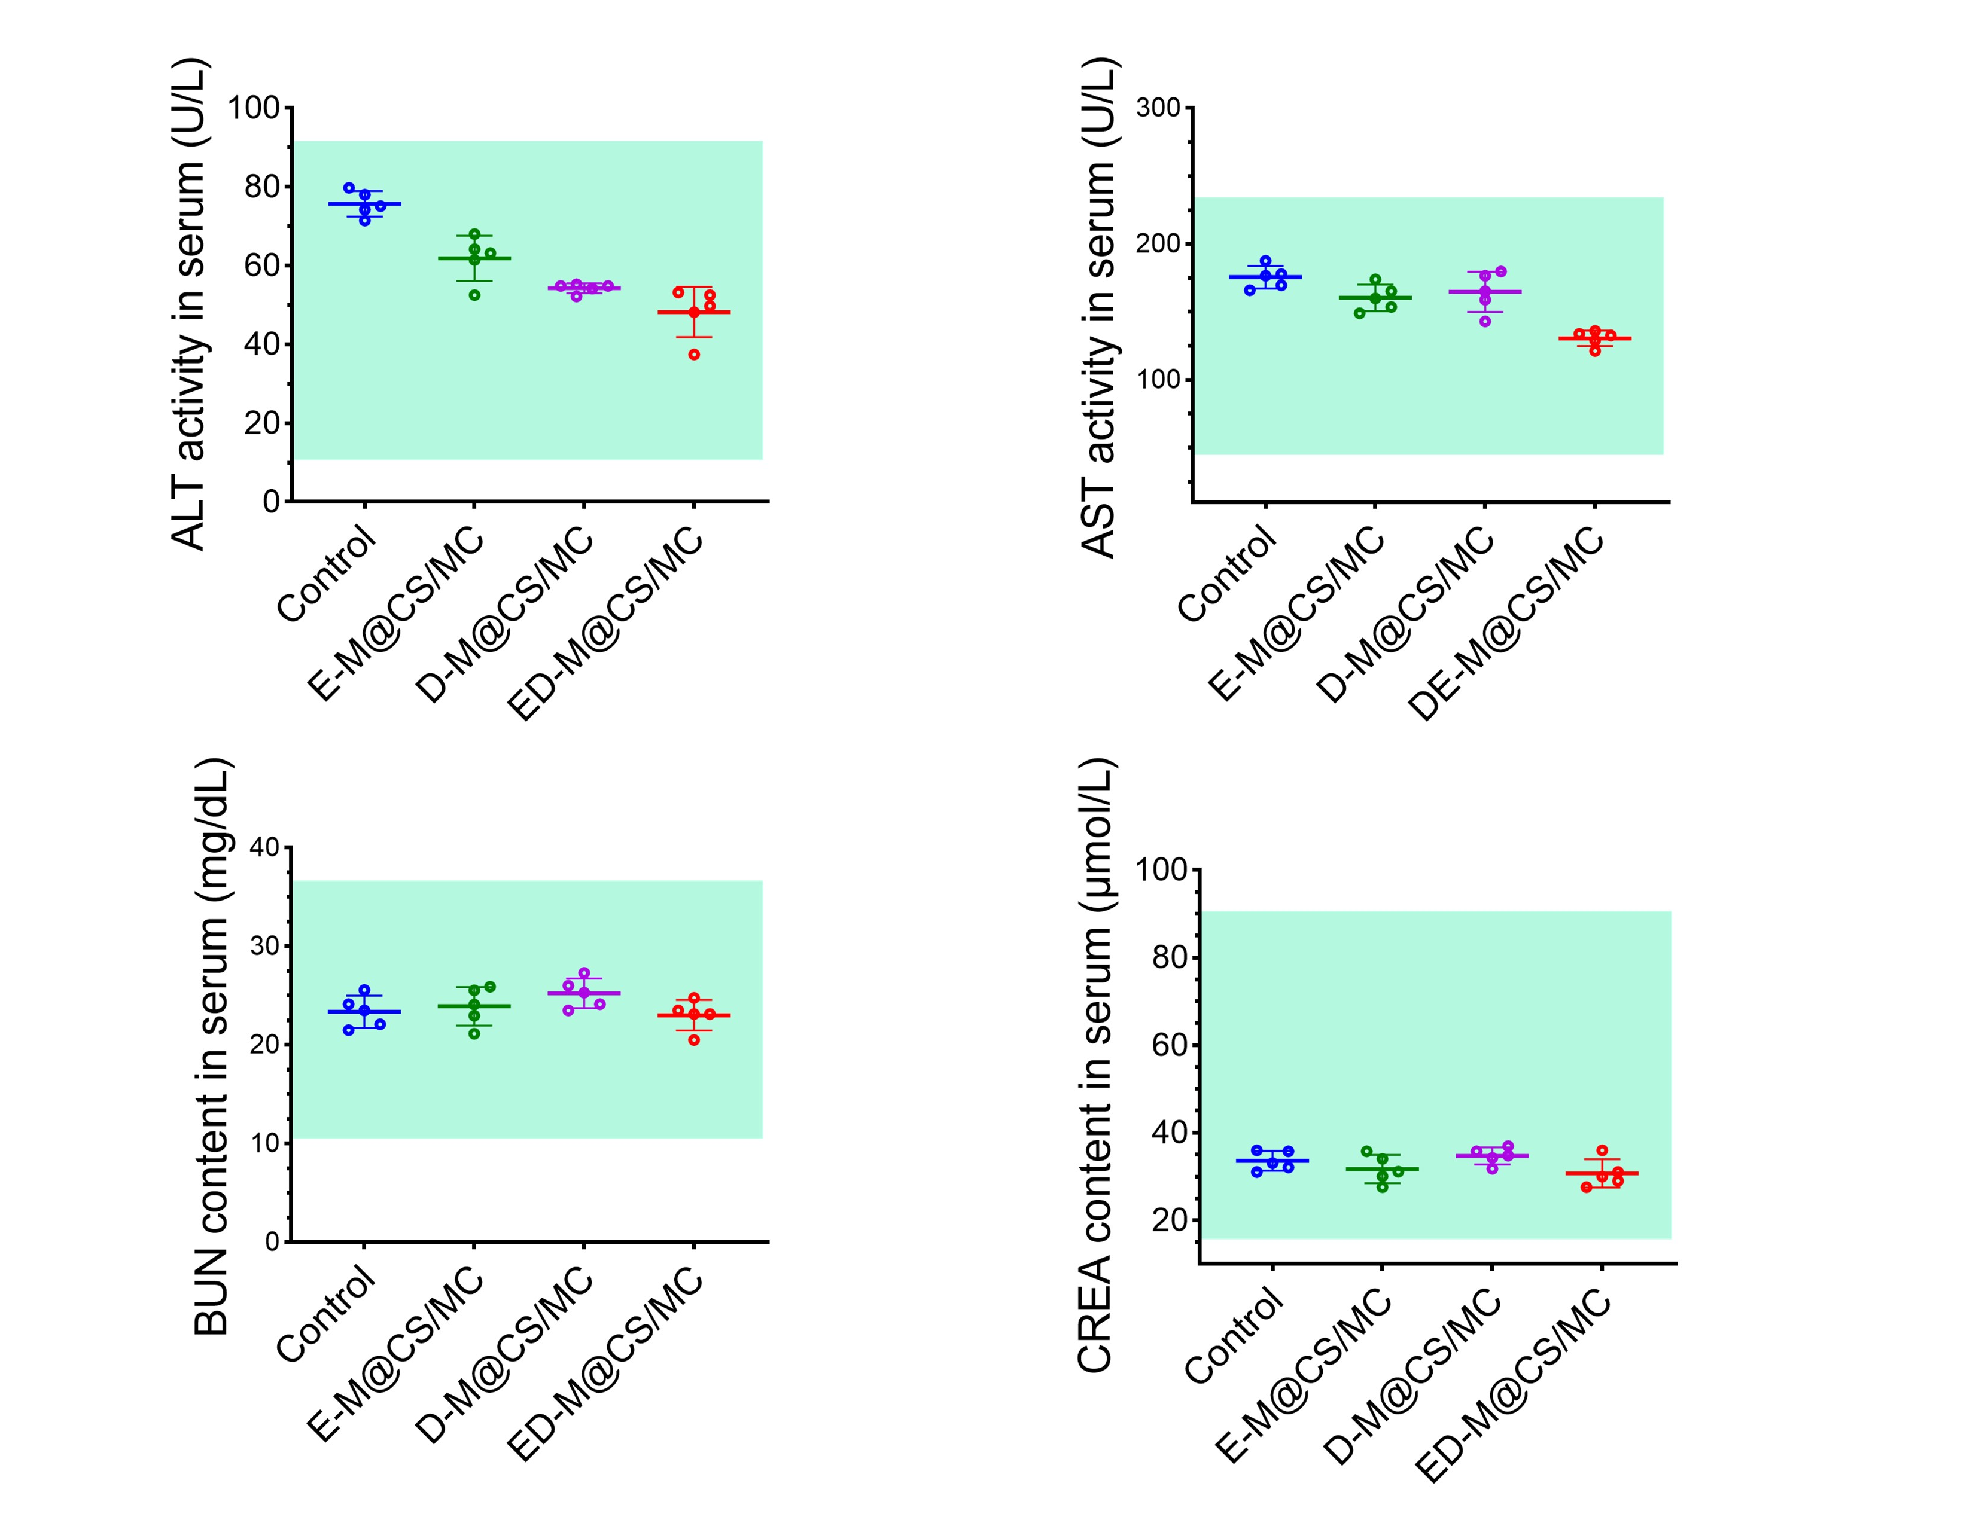
Figure S16. The serum concentrations of ALT, AST, BUN, and CREA in Kras^{G12D}-engineering mice after different treatments (n = 5, Mean ± SD).
Figure S17. The proportion of M2 macrophages was analyzed by ImageJ (n = 3, Mean ± SD, * P < 0.05, ** P < 0.01, ns, not significant).
Figure S18. The proportion of M2 macrophages was analyzed by ImageJ (n = 3, Mean ± SD, * P < 0.05, ** P < 0.01).
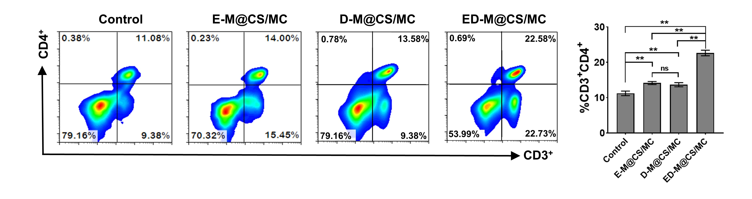
Figure S19. Representative flowcharts of CD3⁺CD4⁺ T cells and FCM analysis of CD3⁺CD4⁺ T cells in the tumor tissue (n = 3, Mean ± SD, *p < 0.05, **p < 0.01).
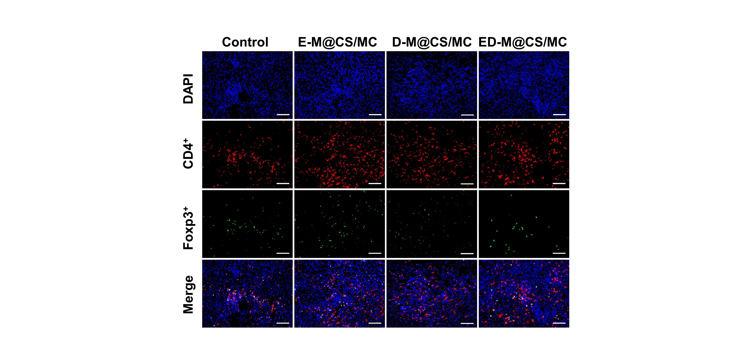
Figure S20. Representative immunofluorescence staining images of Treg (CD4⁺Foxp3⁺). Scale bar: 100 μm.
Table S1. The gelation time of the CS/β-GP solution at 37°C
Chitosan (w/v%) | β-GP (w/v%) | t_{gel} (min)
2 | 2.0 | > 20
2 | 4.0 | > 20
2 | 5.0 | > 20
2 | 5.2 | 20
2 | 5.4 | 11
2 | 5.6 | 9
2 | 5.8 | 15

Table S2. The gelation time of CS/MC solution at 37°C
CS/β-GP (w/v%) | MC (w/v%) | t_{gel} (min)
2.00/5.60 | 2.50 | 4
2.00/5.60 | 3.75 | 1
2.00/5.60 | 5.00 | 0.5

Table S3. The composition of each formulation
Formulation | Erastin  (%, w/v) | Defactinib  (%, w/v) | mPEG₂₀₀₀-b-PDLLA₂₀₀₀ (%, w/v) | CS  (%, w/v) | β-GP  (%, w/v) |  |  | MC  (%, w/v)
E-M@CS/MC | 0.056 | 0 | 0.625 | 2.00 |  | 5.60 | 5.00
D-M@CS/MC | 0 | 0.054 | 0.625 | 2.00 |  | 5.60 | 5.00
ED-M@CS/MC | 0.056 | 0.054 | 0.625 | 2.00 |  | 5.60 | 5.00

