Photosynthetic bacteria-based whole-cell inorganic-biohybrid system for multimodal enhanced tumor radiotherapy

Shiyuan Hua ^{a, e, f, 1}, Jun Zhao ^{c,1}, Lin Li ^{b,1}, Chaoyi Liu ^{f}, Lihui Zhou ^{h}, Kun Li ^{d, *}, Quan Huang ^{b, *}, Min Zhou ^{a, e, f, g, *}, Kai Wang ^{a, *}

ª Department of Respiratory and Critical Care Medicine, The Fourth Affiliated Hospital, Zhejiang University School of Medicine, Yiwu 322000, China
^{b} Department of Orthopedic Oncology, Spine Tumor Center, Changzheng Hospital, Naval Medical University, 415 Fengyang Road, Shanghai 200003, China.
^{c} School of Basic Medicine, Tongji Medical College, Huazhong University of Science and Technology, Wuhan, Hubei 430030, China.
^{d} Department of Musculoskeletal Oncology, Fudan University Shanghai Cancer Center, Shanghai, 200032, China
^{e} University-University of Edinburgh Institute (ZJU-UoE Institute), Zhejiang University School of Medicine, Zhejiang University, Haining, 314400, China.
^{f} Institute of Translational Medicine, Zhejiang University, Hangzhou, 310009, China.
^{g} Research Center for Life Science and Human Health, Binjiang Institute of Zhejiang University, Hangzhou, 310053, China.
^{h} Department of Neuro Surgery, The First Affiliated Hospital, Zhejiang University School of Medicine, Hangzhou 320000, China

¹ These authors contributed equally to this work.
* Corresponding author.
E-mail addresses: kaiw@zju.edu.cn (Kai Wang), zhoum@zju.edu.cn (Min Zhou), Kunli12345@163.com (Kun Li), huangquan0625@163.com (Quan Huang)

Supplementary Fig.s

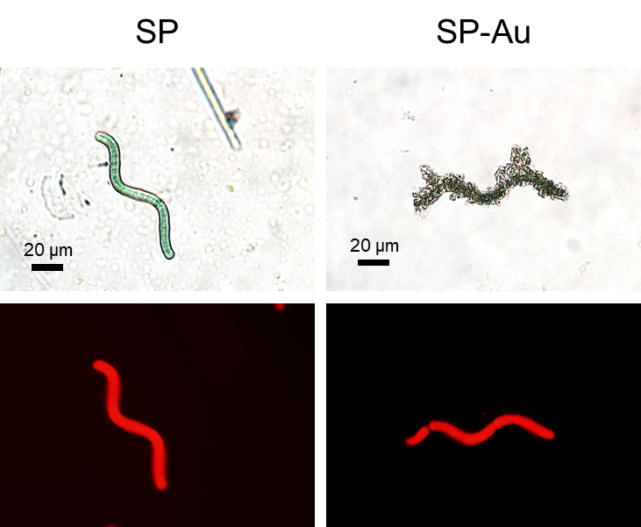
Fig. S1. Bright-field and fluorescence images of SP and SP-Au.

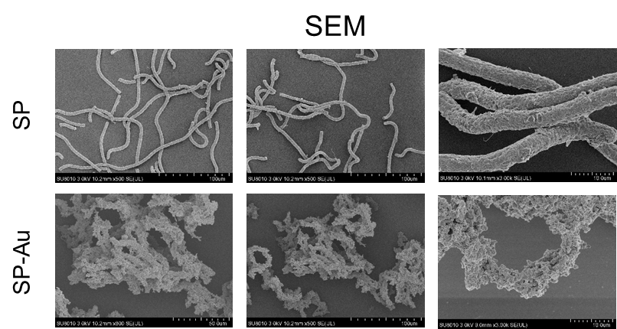
Fig. S2. SEM images of SP and SP-Au.

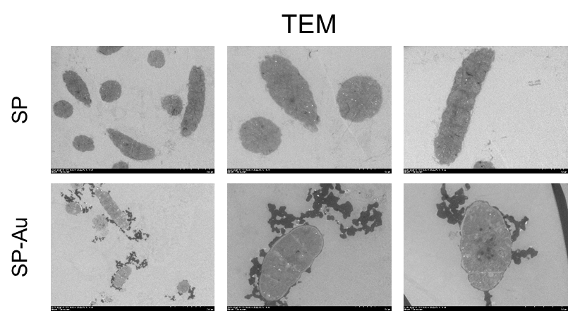
Fig. S3. TEM images of SP and SP-Au.

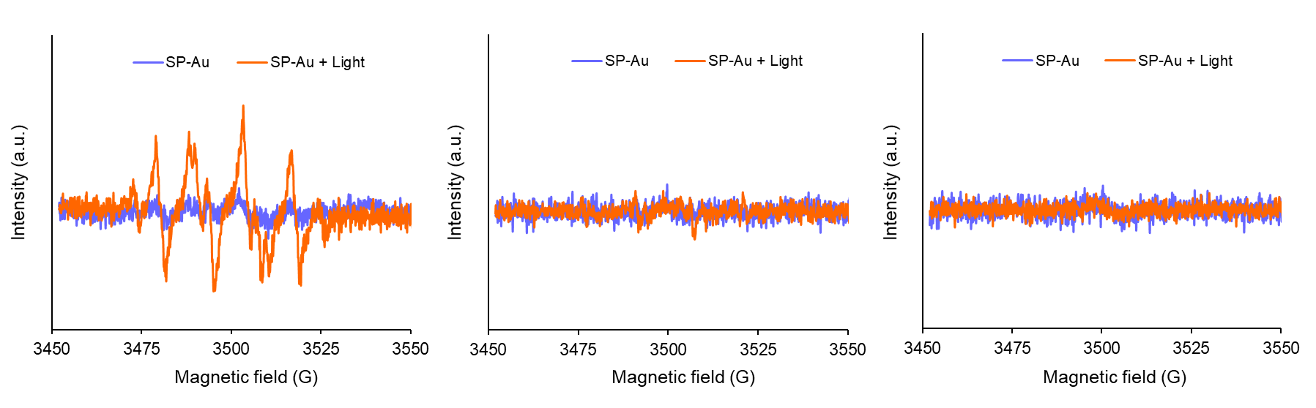
Fig. S4. ESR spectra of •O₂⁻, •OH and ¹O₂ generated by SP-Au before and after red light illumination (4600 lux, 15 min).

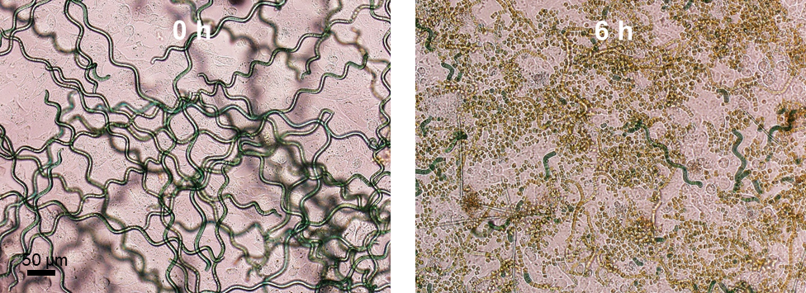
Fig. S5. Representative Bright-field images of SP before and after incubated with 4T1 cells for 6 h.

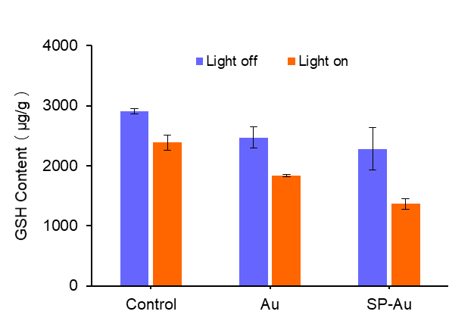
Fig. S6. GSH consumption in the tumor with different catalyzers before and after red light illumination (4600 lux, 15 min). All data were presented as the mean ± standard deviation.

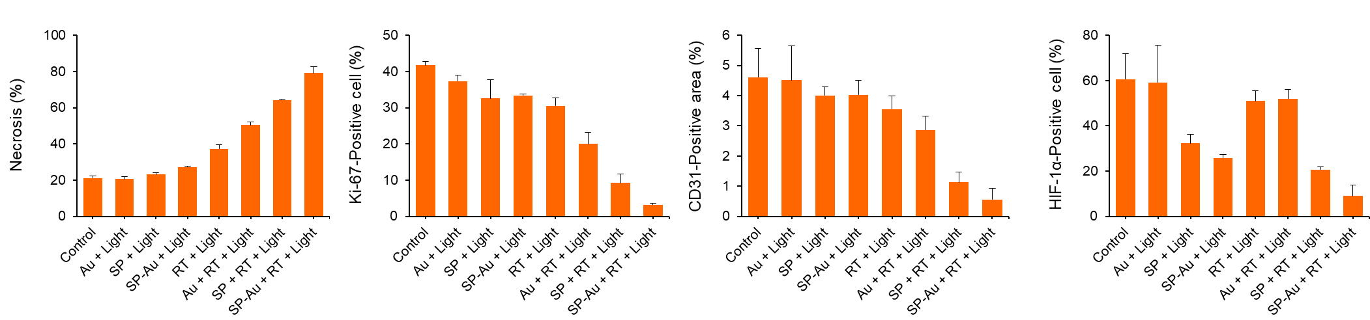
Fig. S7. The percentages of 4T1 tumor necrosis, Ki-67 positive cell, CD31 positive area and HIF-1α positive cell after different treatments. All data were presented as the mean ± standard deviation.

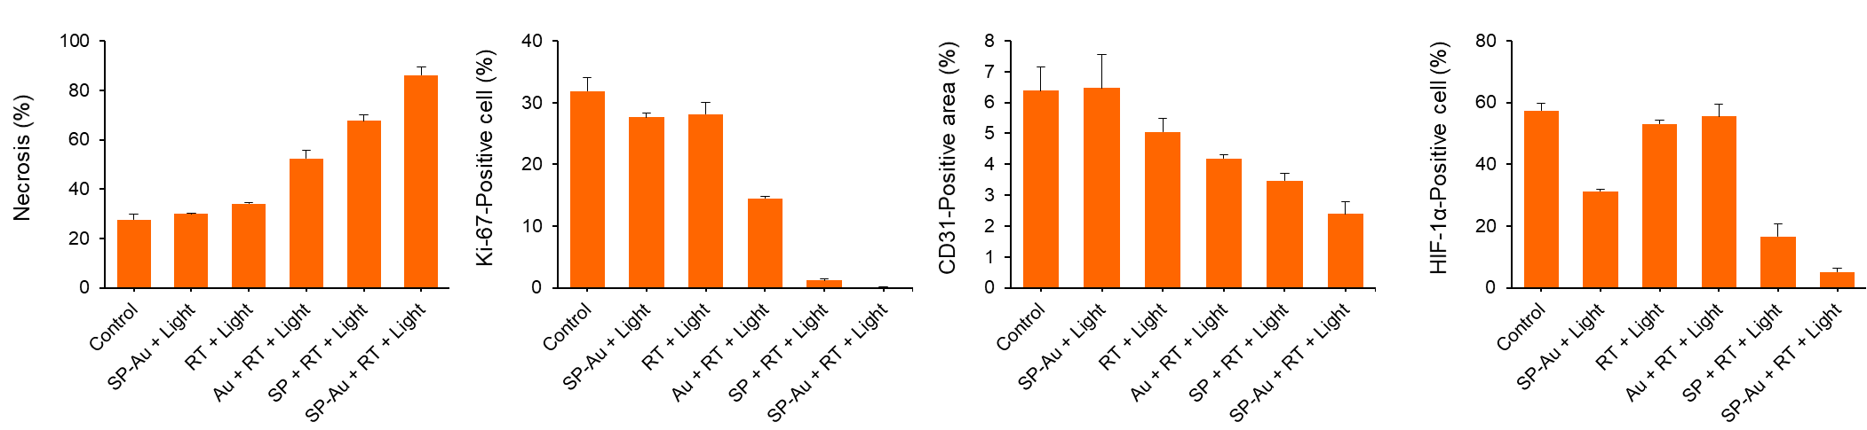
Fig. S8. The percentages of A549 tumor necrosis, Ki-67 positive cell, CD31 positive area and HIF-1α positive cell after different treatments. All data were presented as the mean ± standard deviation.

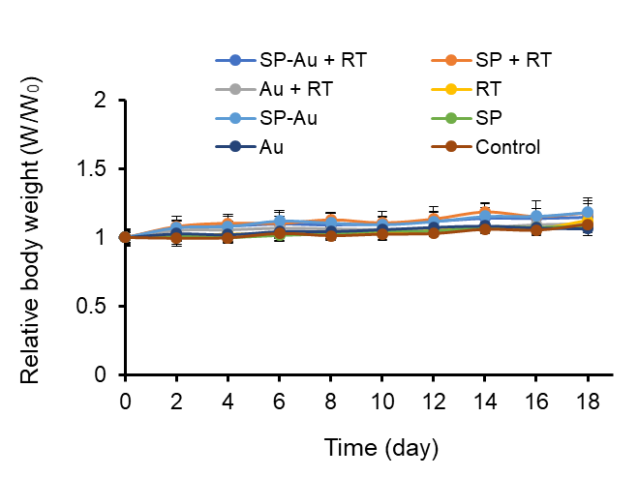
Fig. S9. Body weight of 4T1 tumor-bearing mice after given various treatments (n = 5). All data were presented as the mean ± standard deviation.

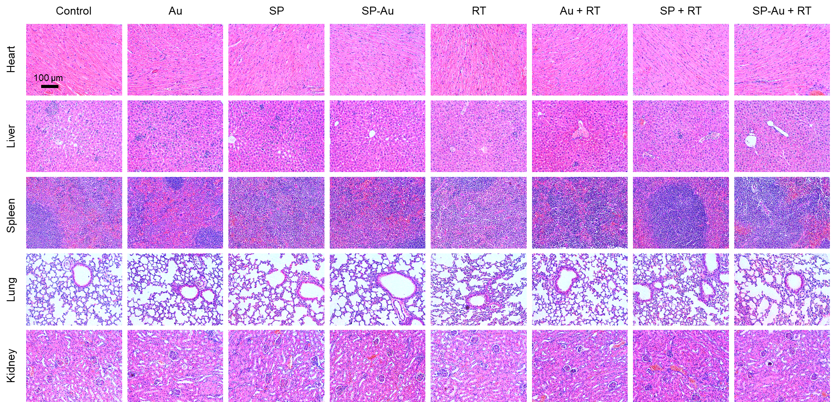
Fig. S10. Representative H&E staining images of major organs (heart, liver, spleen, lung, and kidney) from 4T1 tumor-bearing mice after given various treatments.

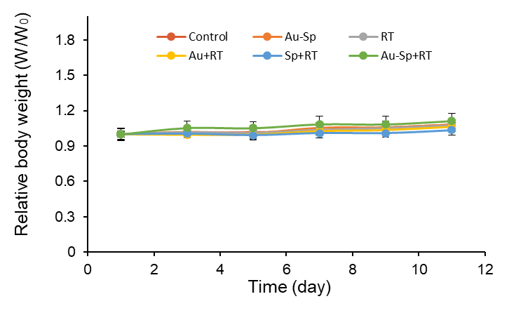
Fig. S11. Body weight of CT26 tumor-bearing mice after given various treatments (n = 5). All data were presented as the mean ± standard deviation.

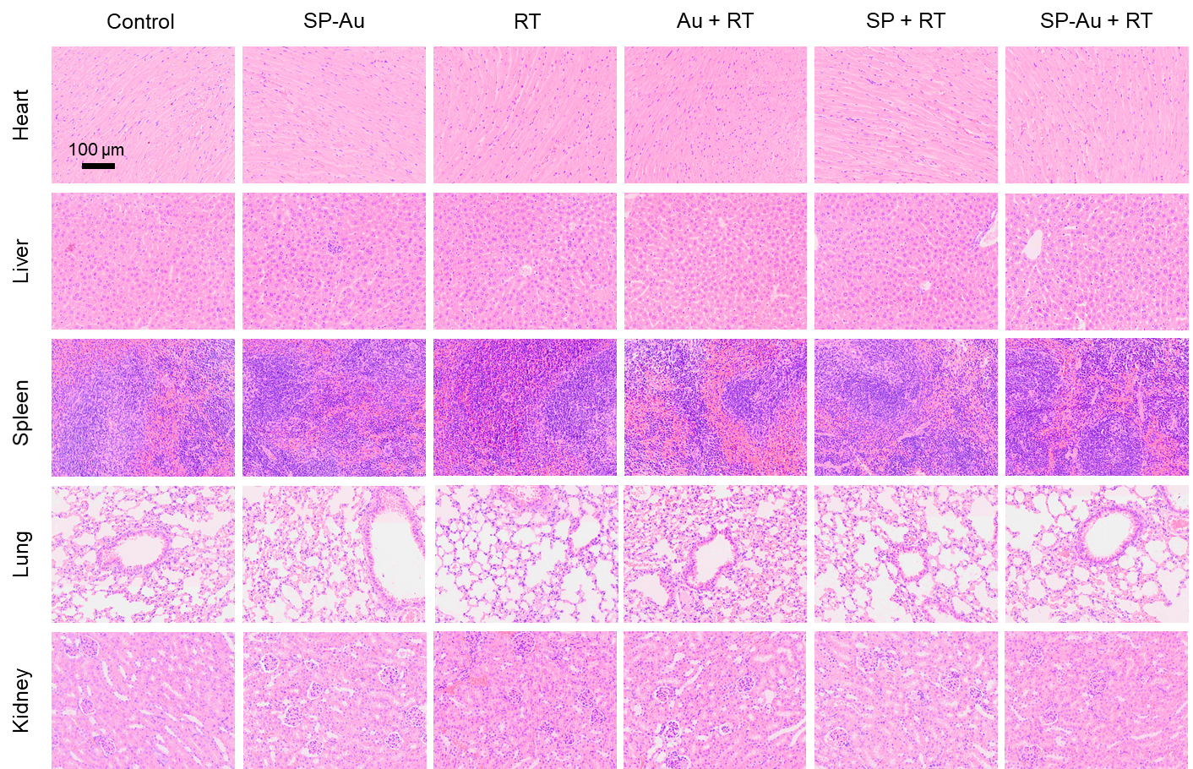
Fig. S12. Representative H&E staining images of major organs (heart, liver, spleen, lung, and kidney) from CT26 tumor-bearing mice after given various treatments.

