Figure S1 ALP staining and Transwell Assay
(A) Alizarin red (lower) staining of control and treated groups;(B) by Transwell Assay and crystal violet dying, migration was observed in Control, Exo-MSC, Exo-Yoda1, and Yoda1 groups, the scale was 50um; (C) the statistical analysis of migration, * p<0.5, **p<0.01, *** p<0.001, **** p<0.0001

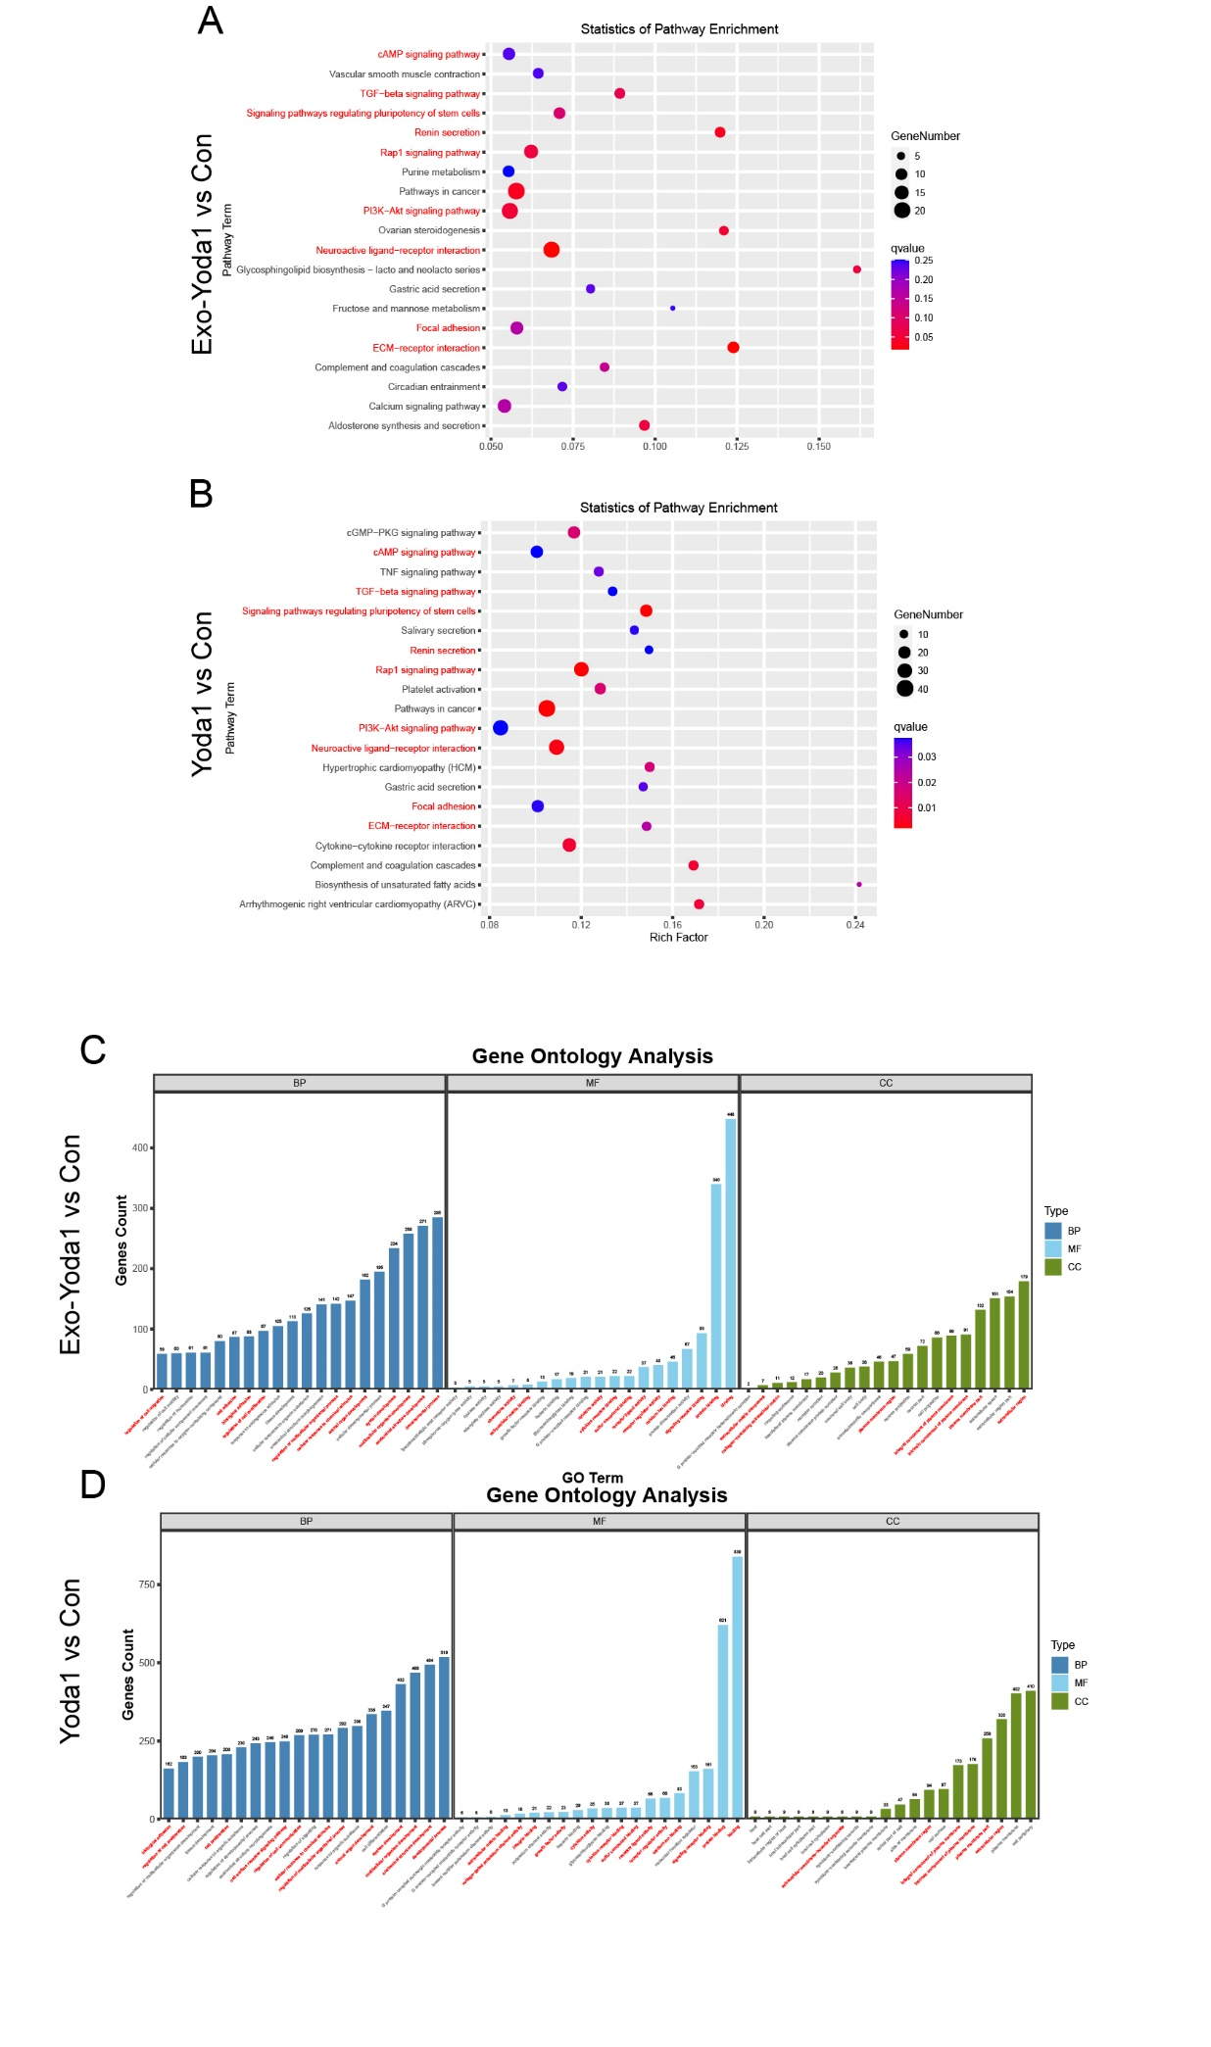

Figure S2 KEGG and GO analysis of Exo-Yoda1 and Yoda1 treated BMSCs
(A) and (B) KEGG analysis of Exo-Yoda1 and Yoda1; (C) andd (D) GO analysis of Exo-Yoda1 and Yoda1

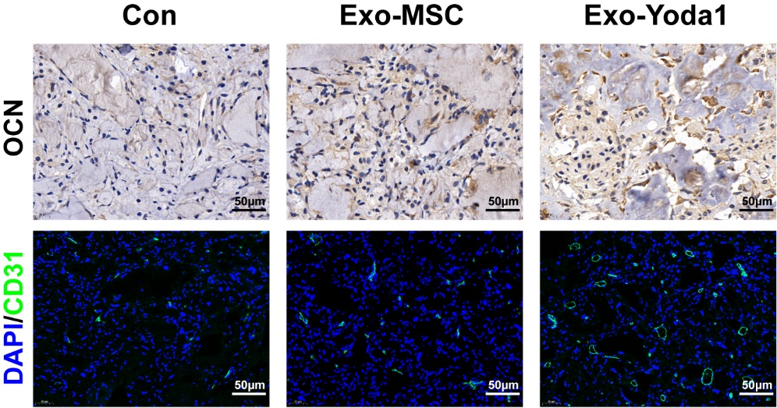
Figure S3 OCN and CD31(marker of vessels) staining in subcutaneous ectopic osteogenesis nude mice models

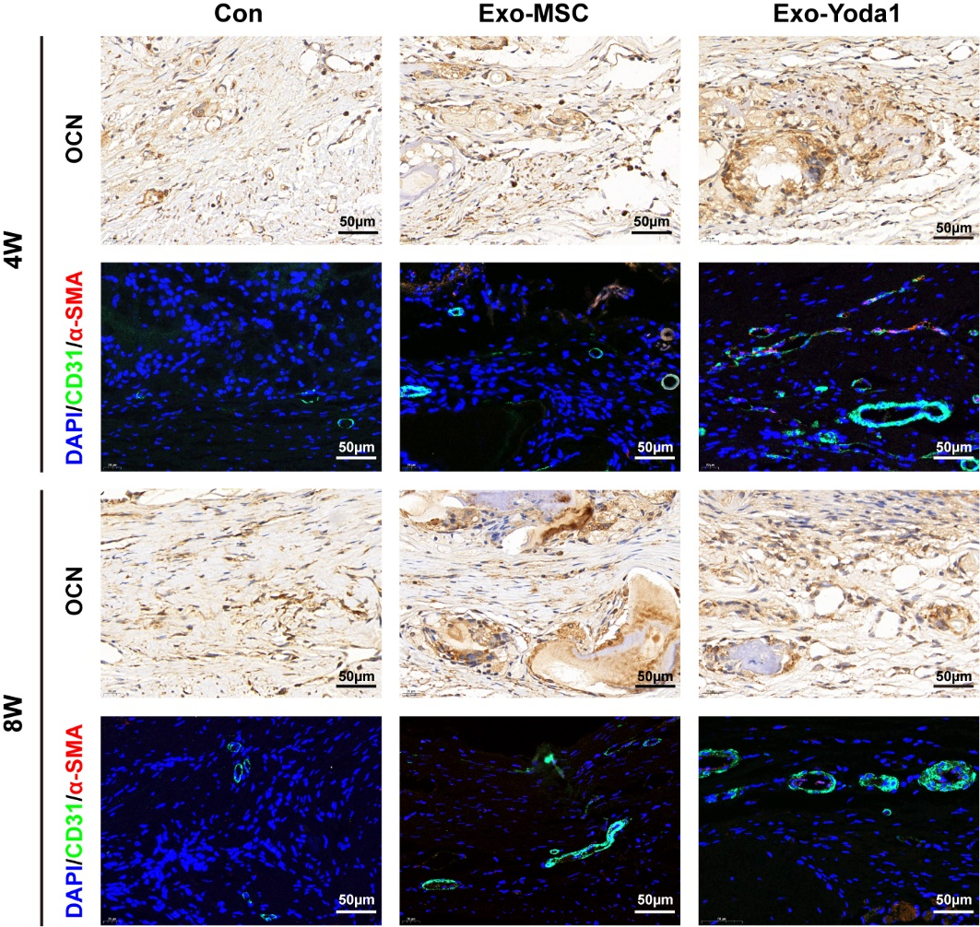
Figure S4 OCN and CD31(marker of vessels) staining in bone defect of rat skull models
Primers | Sequence (5’-3’)
OPN-RAT-F | AGCTTGGCTTACGGACTGAG
OPN- RAT-R | AGGTCCTCATCTGTGGCATC
COL1A1-RAT-F | GTCATCGTGGCTTCTCTGGT
COL1A1- RAT-R | ACCGTTGAGTCCATCTTTGC
OCN-RAT-F | AATAGACTCCGGCGCTACCT
OCN- RAT-R | GAGCTCACACACCTCCCTGT
ALP-RAT-F | GCACAACATCAAGGACATCG
ALP- RAT-R | TCAGTTCTGTTCTTGGGGTACAT
BMP2-RAT-F | TGAACACAGCTGGTCTCAGG
BMP2- RAT-R | GCTGTTTGTGTTTGGCTTGA
Gapdh-Rat-F | TGGAGTCTACTGGCGTCTT
Gapdh-Rat-R | TGTCATATTTCTCGTGGTTCA
Table S1 primers used in this study

Table S2 GO analysis of MAPK-ERK1/2 pathway
Groups | Term | P value and q value | Genes
Exo-Yoda1 VS Con | GO:0070372  regulation of ERK1 and ERK2 cascade | p= 0.0000013, q= 0.000037066969282284 | Ackr3|Angpt1|Bmp4|Ccl2|Ccl7|Ccr1|Ceacam1|Ceacam4|Clcf1|Cx3cl1|Ednra|Errfi1|Fgf2|Fgfr3|Gcnt2|Gcnt6|Gper1|Gpr183|Kdr|LOC100909750|Nox4|Pdgfd|Pkhd1|Spry2|Xcl1
Exo-Yoda1 VS Con | GO:0000165 MAPK cascade | p= 0.000011, q= 0.0001675958094383 | Ackr3|Adra1b|Angpt1|Bmp4|Bmp6|Camk2a|Ccl2|Ccl7|Ccr1|Ceacam1|Ceacam4|Clcf1|Cx3cl1|Dact1|Diras2|Dusp2|Dusp5|Ednra|Errfi1|Fgd2|Fgf2|Fgfr3|Gcnt2|Gcnt6|Gdf6|Gper1|Gpr183|Grem1|Grik2|Id1|Igfbp3|Ighv|Il1rn|Inhbb|Kdr|LOC100909750|LOC102549344|Lpar2|Lpar3|Map3k7|Mdfi|Nox4|Pdgfd|Pkhd1|Sfrp1|Sh2d3c|Spry2|Xcl1|Zfp622
Yoda1 VS Con | GO:0070372  regulation of ERK1 and ERK2 cascade | p= 0.000000022, q= 7.89162481170248E-07 | Ackr3|Angpt1|Atf3|Bmp4|Btn2a2|C5ar1|C5ar2|Ccl2|Ccl7|Ccr1|Ceacam4|Clcf1|Cx3cl1|Dusp1|Ednra|Epha7|Errfi1|Fgf10|Fgf18|Fgf2|Fgfr3|Gcnt2|Gcnt6|Gper1|Gpr183|Klf4|LOC103689974|Lgals9|Mif|Ndrg2|Nox4|P2ry1|Pdgfd|Rasgrp1|Scimp|Spry1|Spry2|Tgfbr3|Trem2|Wnk2|Xcl1
Yoda1 VS Con | GO:0000165 MAPK cascade | P= 0.0000000087, q= 3.61201261899261E-07 | Ackr3|Actn2|Adra1b|Angpt1|Atf3|Bdnf|Bmp3|Bmp4|Bmp6|Btn2a2|C5ar1|C5ar2|Cav2|Ccl2|Ccl7|Ccr1|Cd24|Ceacam4|Clcf1|Cx3cl1|Dact1|Dusp1|Dusp2|Dusp5|Dusp9|Ednra|Epha4|Epha7|Errfi1|Fgf10|Fgf14|Fgf18|Fgf2|Fgfr3|Flt1|Fzd5|Gcnt2|Gcnt6|Gdf6|Gdnf|Gper1|Gpr183|Grem1|Id1|Igfbp3|Ighv|Il11|Il17rd|Il1rn|Inhba|Inhbb|Itga1|Kit|Klf4|Kng1l1|LOC100910021|LOC100912585|LOC102549344|LOC103689974|Lemd2|Lgals9|Lpar2|Lpar3|Map3k7|Map3k7cl|Mapk11|Mdfi|Mif|Ndrg2|Nox4|Nrg1|Nrk|P2ry1|Pdgfd|Peli2|Pik3r5|Plce1|Rasgrp1|Rgs3|Scimp|Sfrp4|Sh2d3c|Spry1|Spry2|Tgfbr3|Tnfrsf25|Trem2|Wnk2|Wnt5a|Xcl1

