Figure6 D
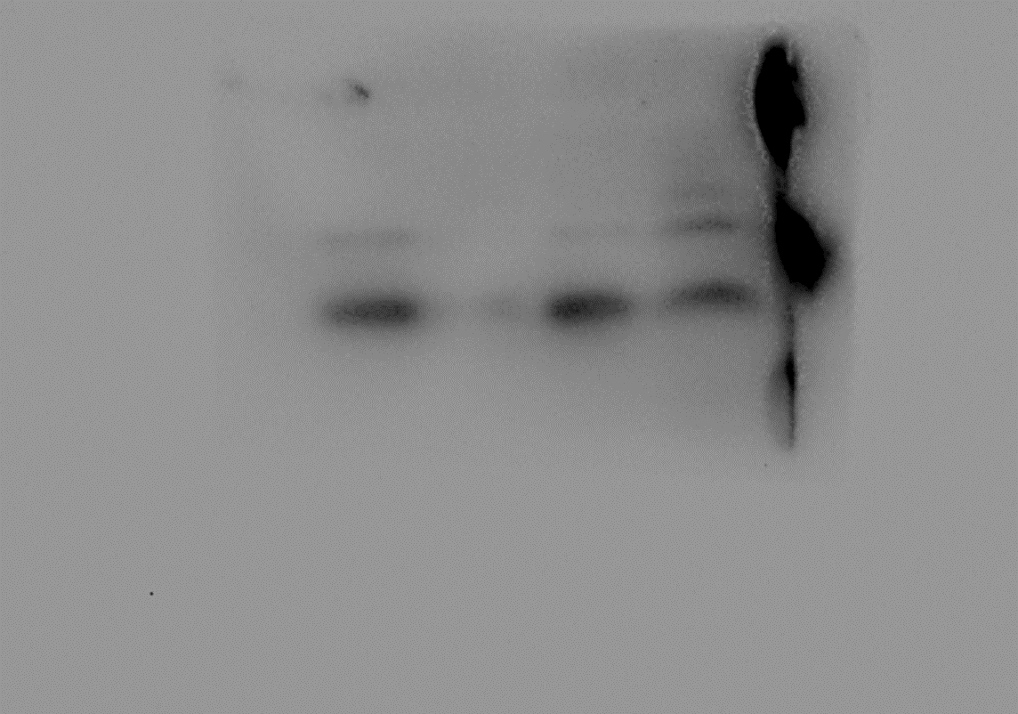
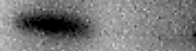
37kDa
21kDa
22kDa
70kDa
43kDa
NCOA4
β-actin
FTH1
GPx4
SLC7A11
+
+
-
-
-
-
+
+
Fer-1
ZnO NPs
Figure6 K
37kDa
21kDa
22kDa
70kDa
43kDa
NCOA4
β-actin
FTH1
GPx4
SLC7A11
37kDa
21kDa
22kDa
70kDa
43kDa
NCOA4
β-actin
FTH1
GPx4
SLC7A11
37kDa
21kDa
22kDa
70kDa
43kDa
Control
ZnO NPs
NCOA4
β-actin
FTH1
GPx4
SLC7A11
Figure7 D
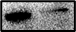
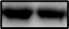
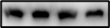
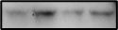
43kDa
128kDa
Erc1
β-actin
si-Erc1
si-NC
43kDa
128kDa
Erc1
β-actin
Figure7 F
43kDa
128kDa
Erc1
β-actin
+
-
+
-
-
-
+
+
ZnO NPs
Fer-1
43kDa
128kDa
Erc1
β-actin
37kDa
21kDa
22kDa
70kDa
43kDa
NCOA4
β-actin
FTH1
GPx4
SLC7A11
Figure7 M
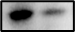
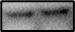
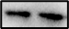
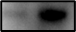
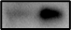
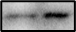
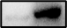
65kDa
43kDa
65kDa
p-p65
β-actin
p65
37kDa
43kDa
70kDa
si-NC
si-Erc1
NCOA4
β-actin
SLC7A11
Figure7 N
37kDa
21kDa
22kDa
70kDa
43kDa
si-NC
si-Erc1
NCOA4
β-actin
FTH1
GPx4
SLC7A11

