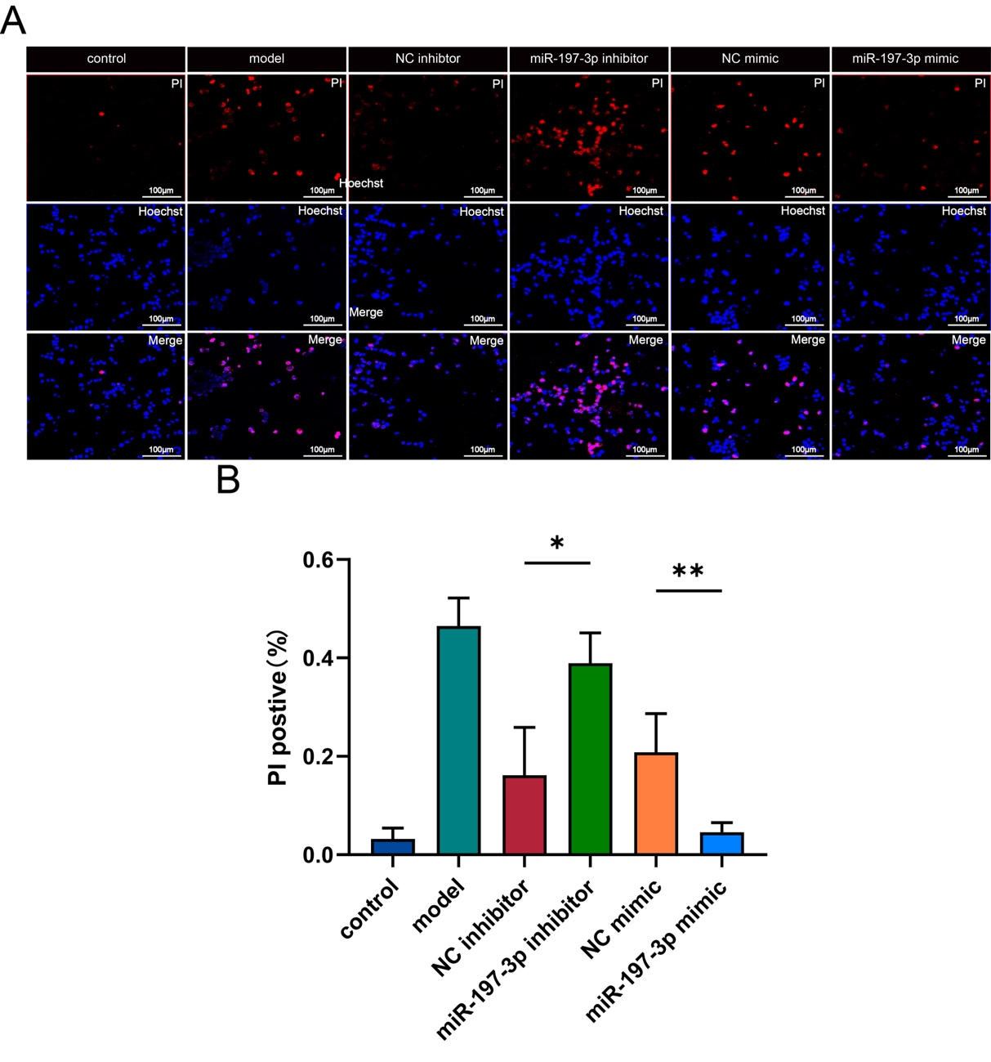
Supplementary Figure 1. Pyroptosis rate in BV2 cells pre-treated with exosomes of miR-197-3p inhibitor or miR-197-3p mimic. Images showing Hoechst 33342/PI staining. (*P<0.05, **P<0.01)

