Supplementary Materials

A bioinspired supramolecular nanoprodrug for precision therapy of B-cell non-Hodgkin’s lymphoma

Qixiong Zhang ^{1, *}, Yuhan Tian ², Yanrui Yang ², Qiuying Huang ², Haibo Feng ³, Rui Zeng ⁴, Shanshan Li ^{2, 4, *}

- Department of Pharmacy, Personalized Drug Therapy Key Laboratory of Sichuan Province, Sichuan Academy of Medical Science & Sichuan Provincial People’s Hospital, School of Medicine, University of Electronic Science and Technology of China, Chengdu 610072, China
- College of Pharmacy, Southwest Minzu University, Chengdu 610041, China
- College of Animal & Veterinary Science, Southwest Minzu University, Chengdu 610041, China
- Key Laboratory of Research and Application of Ethnic Medicine Processing and Preparation on the Qinghai-Tibet Plateau, Southwest Minzu University, Chengdu 610041, China

*Corresponding authors:
Qixiong Zhang, PhD, Prof.,
Department of Pharmacy, Personalized Drug Therapy Key Laboratory of Sichuan Province, Sichuan Academy of Medical Science & Sichuan Provincial People’s Hospital, School of Medicine, University of Electronic Science and Technology of China, Chengdu 610072, China
E-mail: qixiongzhang@outlook.com, zhangqixiong@uestc.edu.cn

Shanshan Li, PhD, Prof.,
College of Pharmacy, Southwest Minzu University, Chengdu 610000, China
E-mail: sslscu2009@163.com

Figure S1. The ¹H NMR spectra of ATK-CDI in DMSO-d₆. δ 1.59 (4H, -CH₂-CH₂-CH₂-S-), δ 2.36 (4H, -CH₂-CH₂-CH₂-S-), δ 2.94 (4H, -CH₂-CH₂-CH₂-S-), δ 7.04 (2H, -CH=CH- from imidazole), δ 7.33-7.41 (4H, Ar-H), δ 7.61-7.86 (6H, -CH=CH- from imidazole, and Ar-H), δ 8.32 (2H, Ar-H).

Figure S2. The ESI-MS spectrum of ATK-CDI. ESI-MS m/z: calculated for ATK-CDI [M+H]⁺ 503.15, found: 503.1.
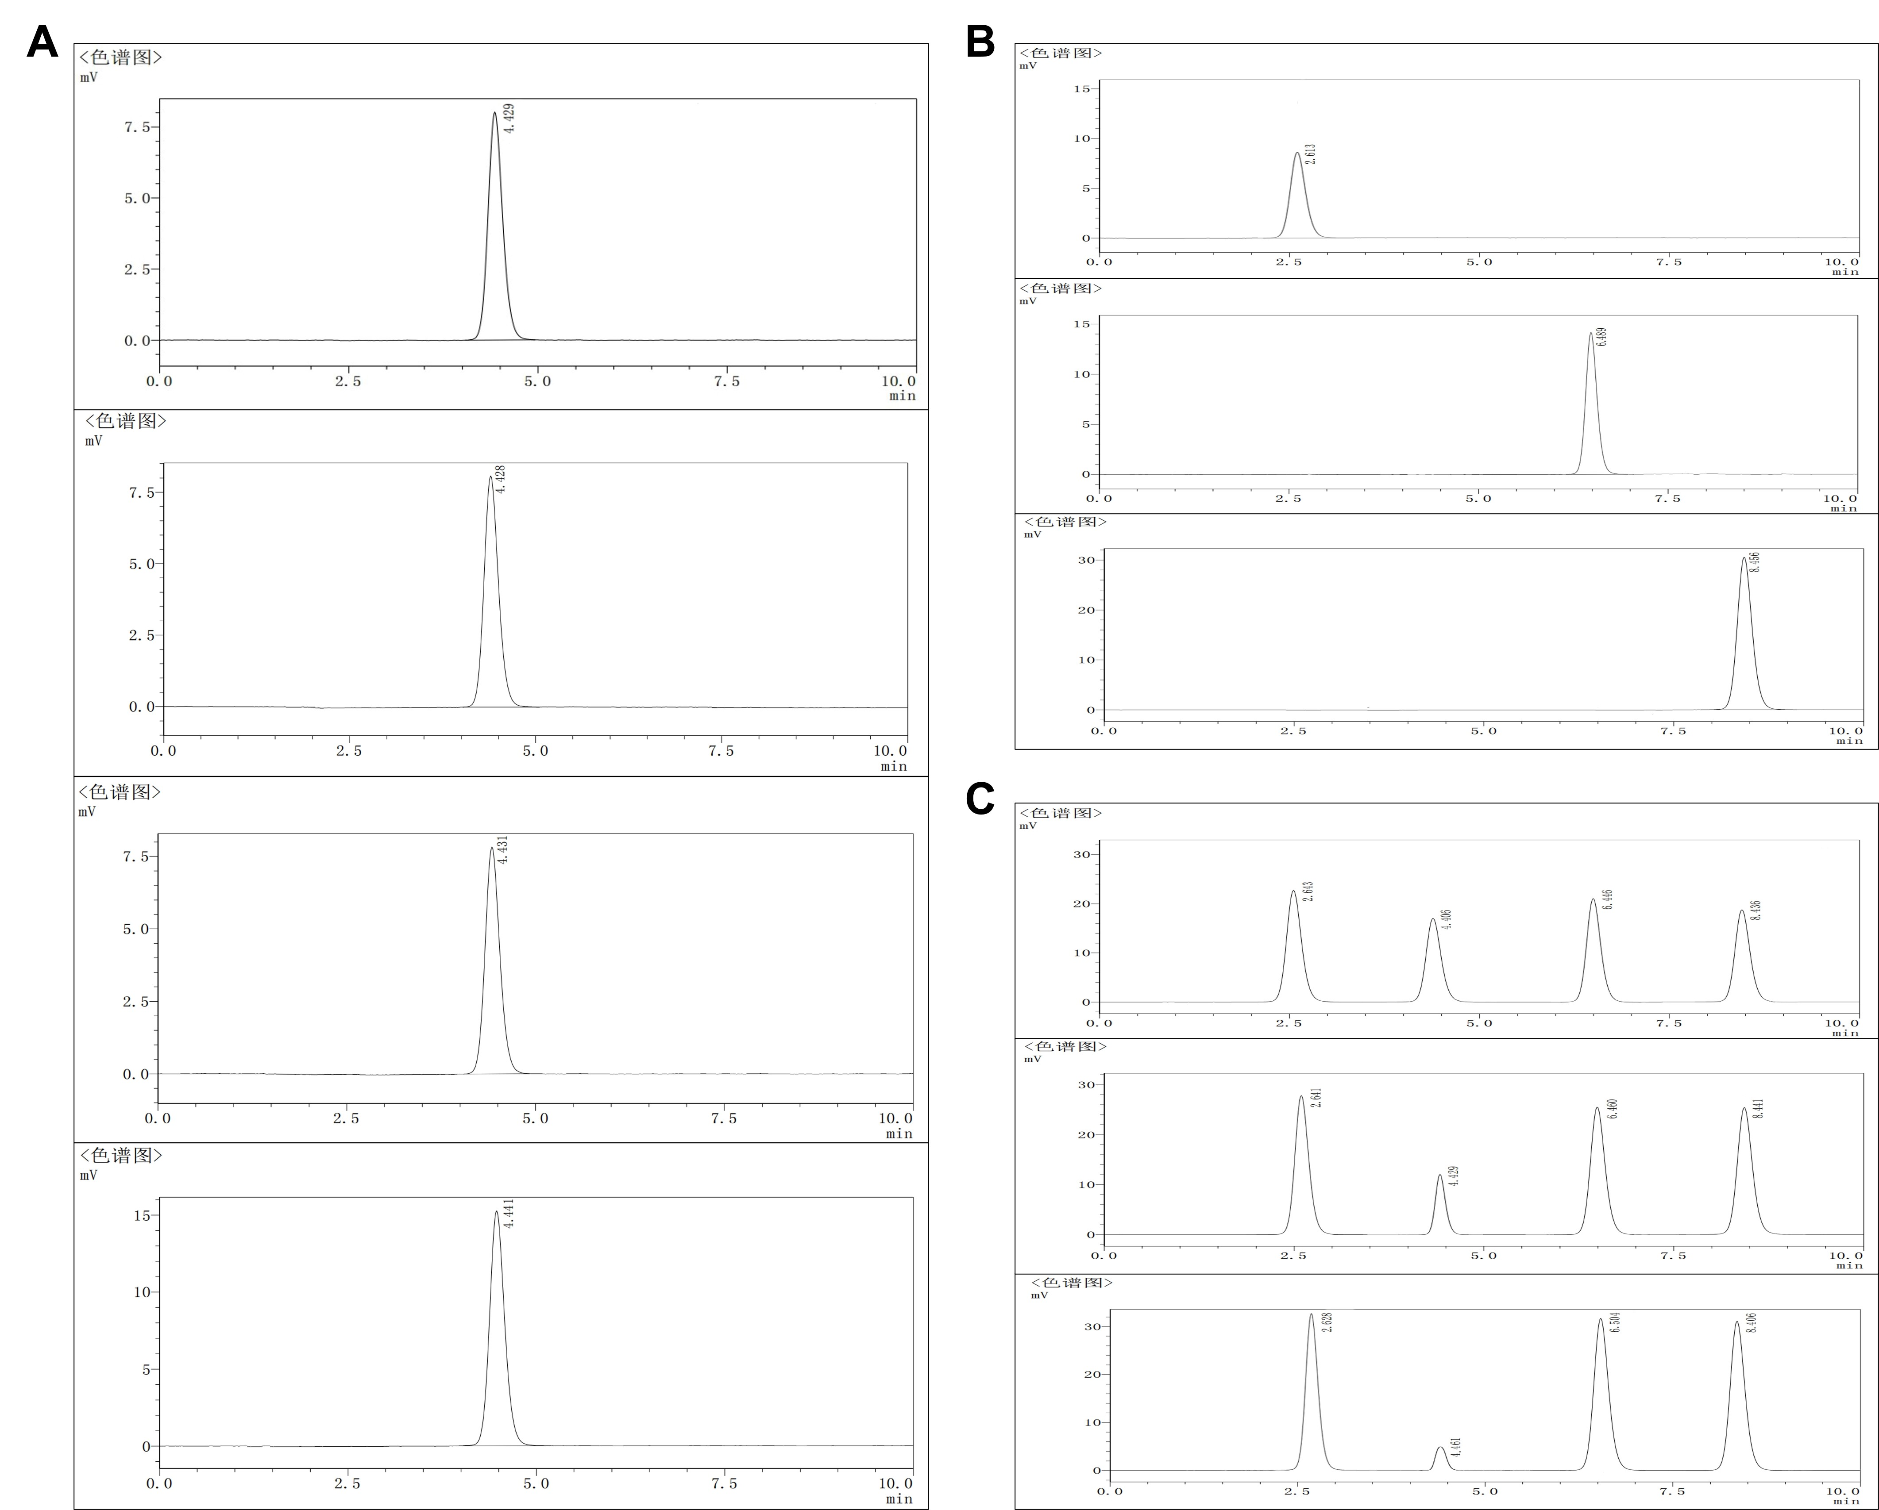
Figure S3. The HPLC chromatograms. A, F₂A incubated in PBS for different times. From top to bottom are 72 hours, 24 hours, 12 hours, and 0 hours, respectively. B, From top to bottom are FA, 9-fluorenone, and gamma thiobutyrolactone, respectively. C, F₂A was incubated in 1 mM H₂O₂ for different times. From top to bottom are 15 mins, 30 mins, and 60 mins, respectively.

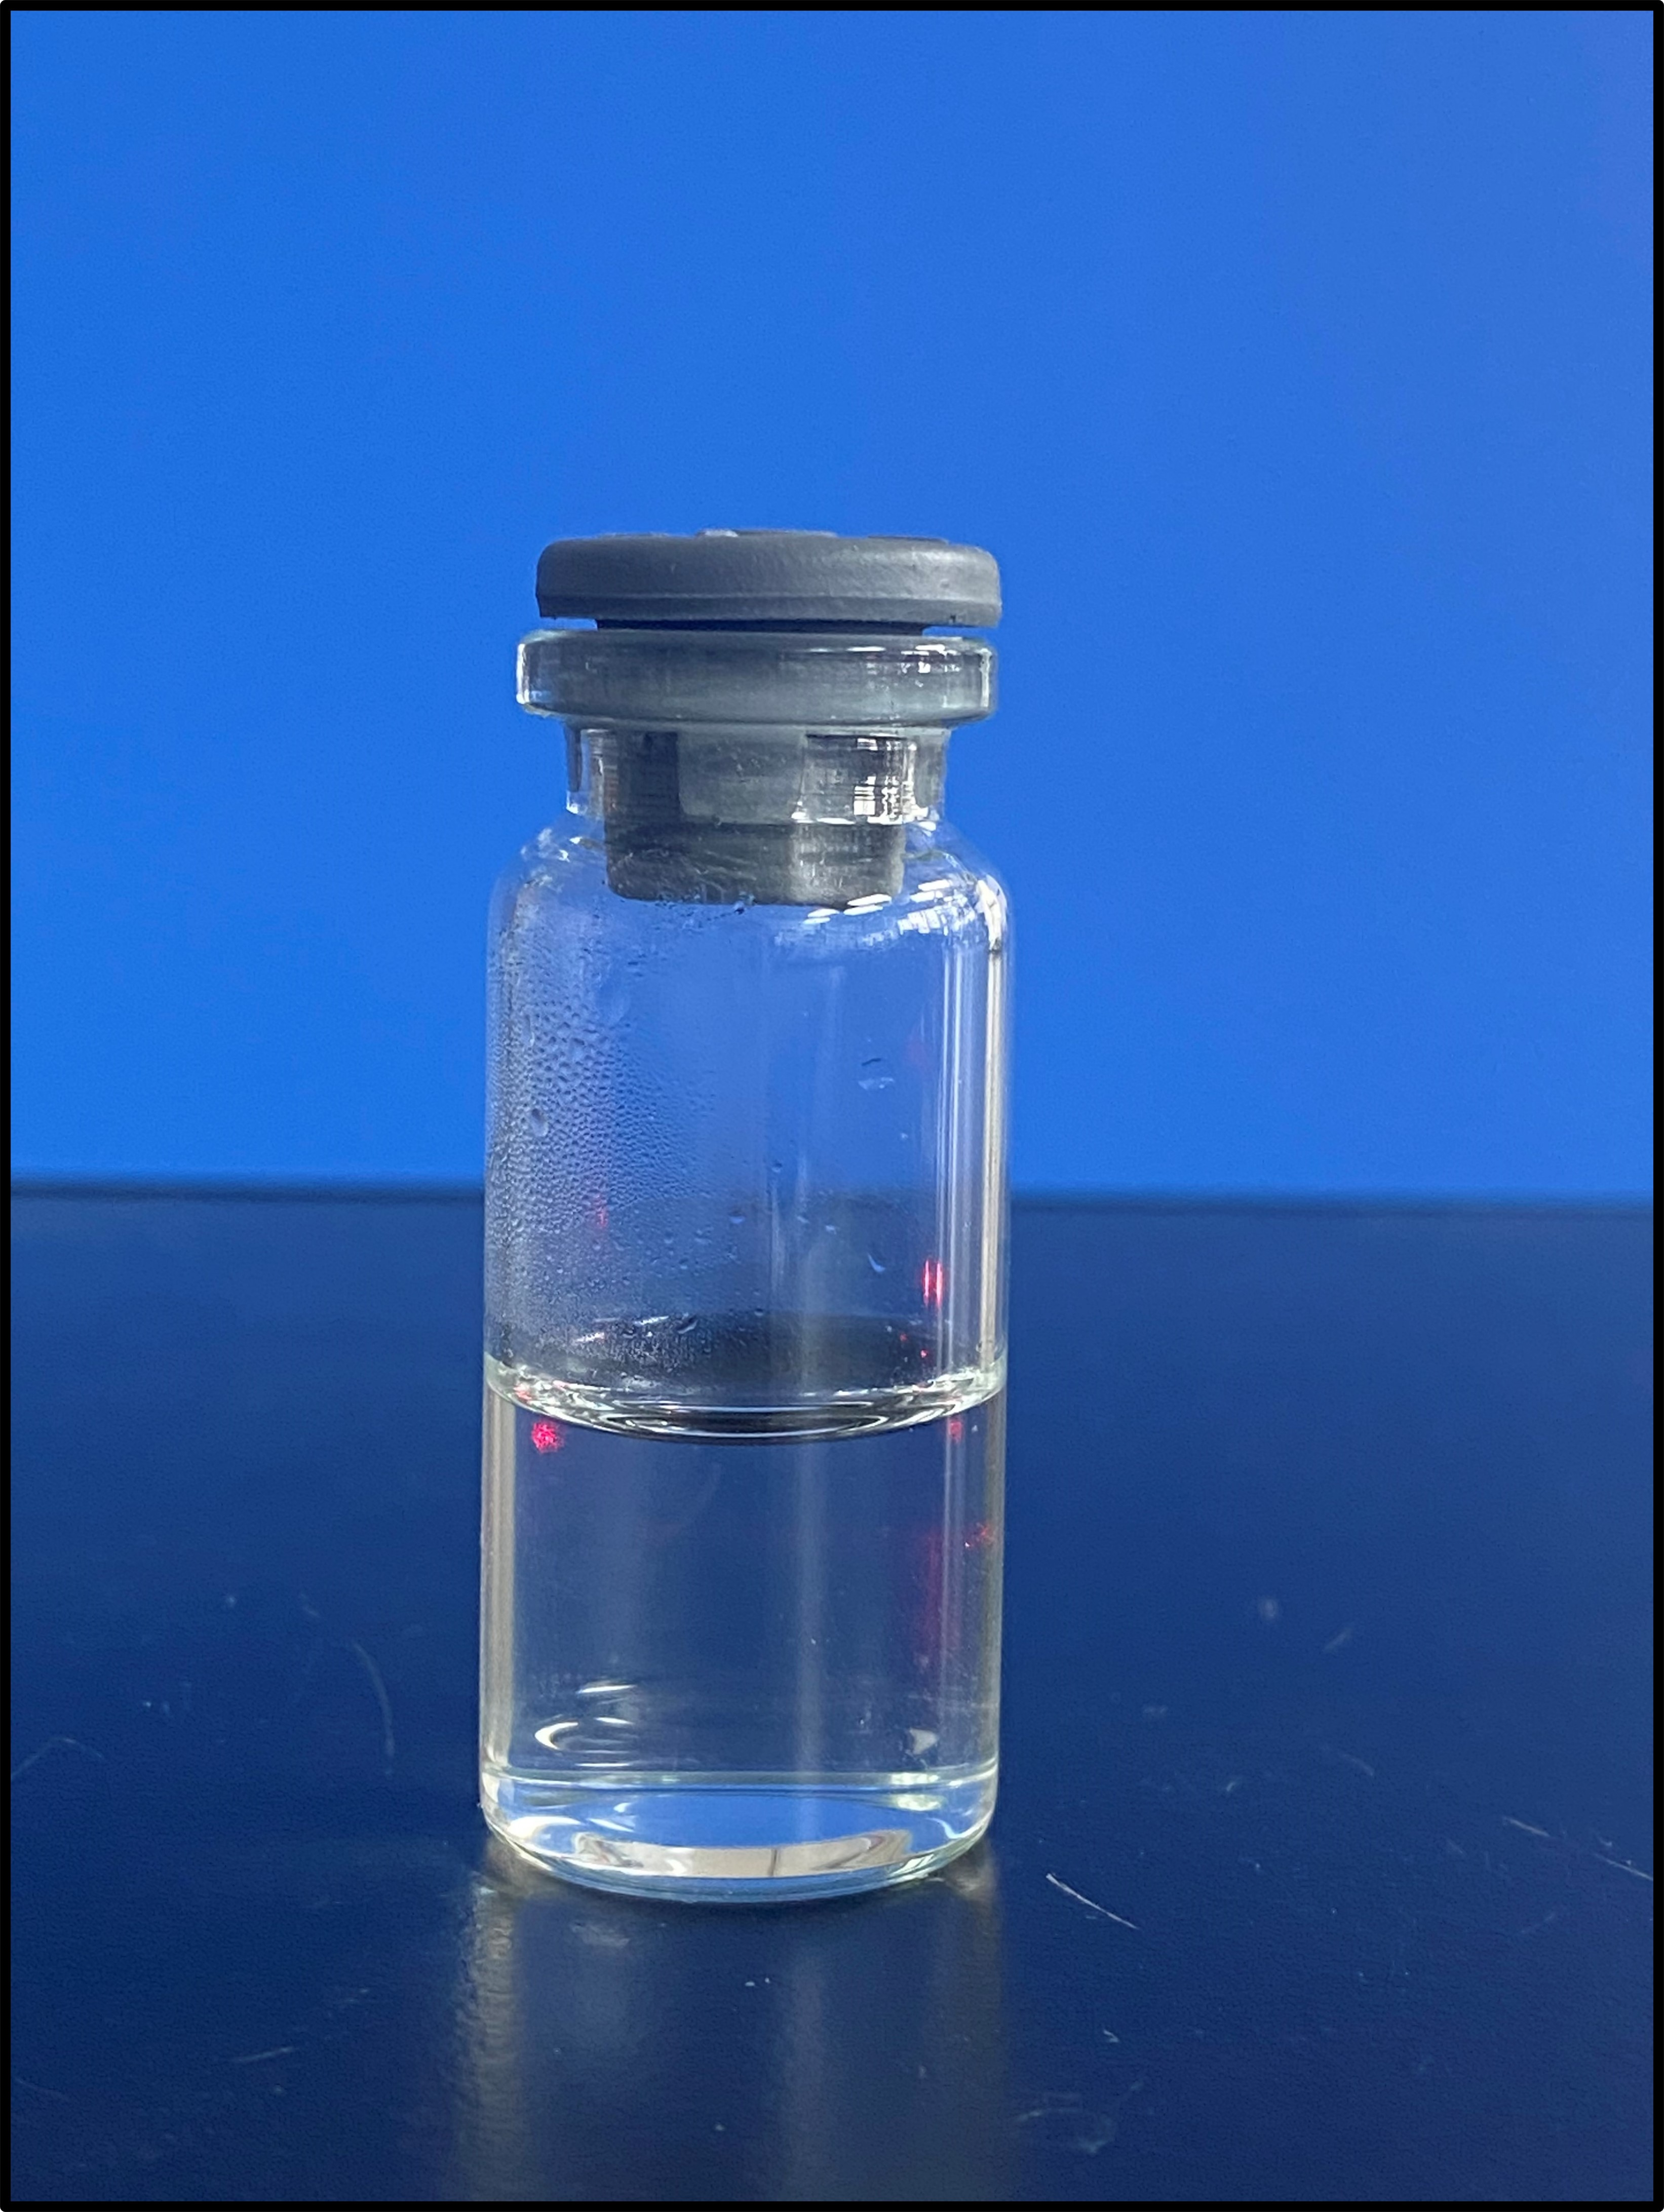
Figure S4. The photograph of TPSA in PBS solution.

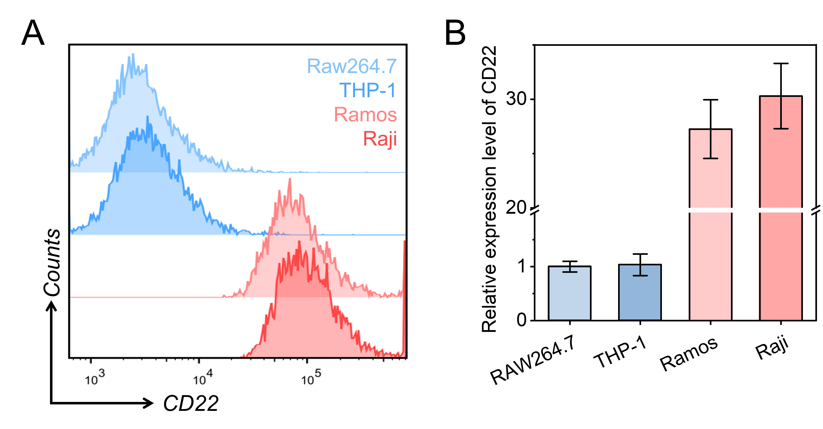
Figure S5. Flow cytometry (A) and data analysis (B) of CD22 expression in RAW264.7, THP-1, Ramos, and Raji cell lines. All data are presented the mean ± SD (n = 6).

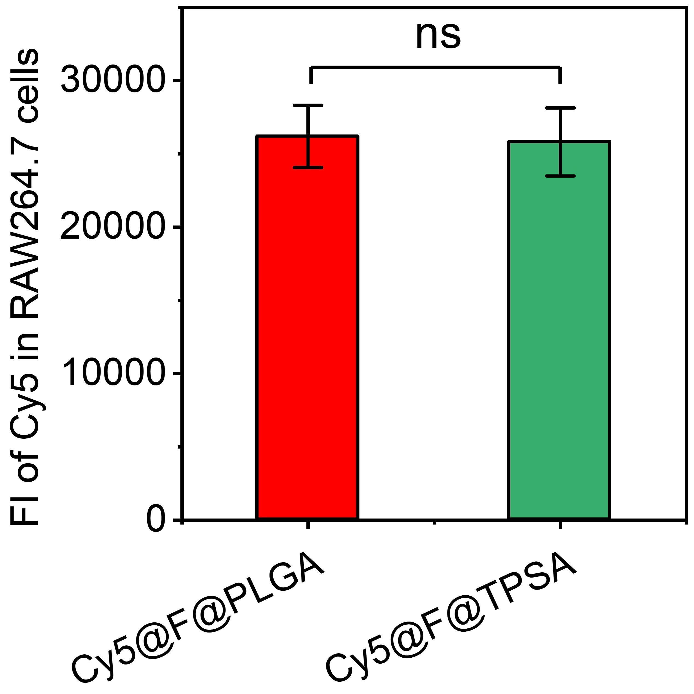
Figure S6. Flow cytometry was used to detect and analyze the fluorescence intensity (FI) of Cy5-labeled F@PLGA or F@TPSA incubated with RAW264.7 cells. All data are presented the mean ± SD (n = 6).

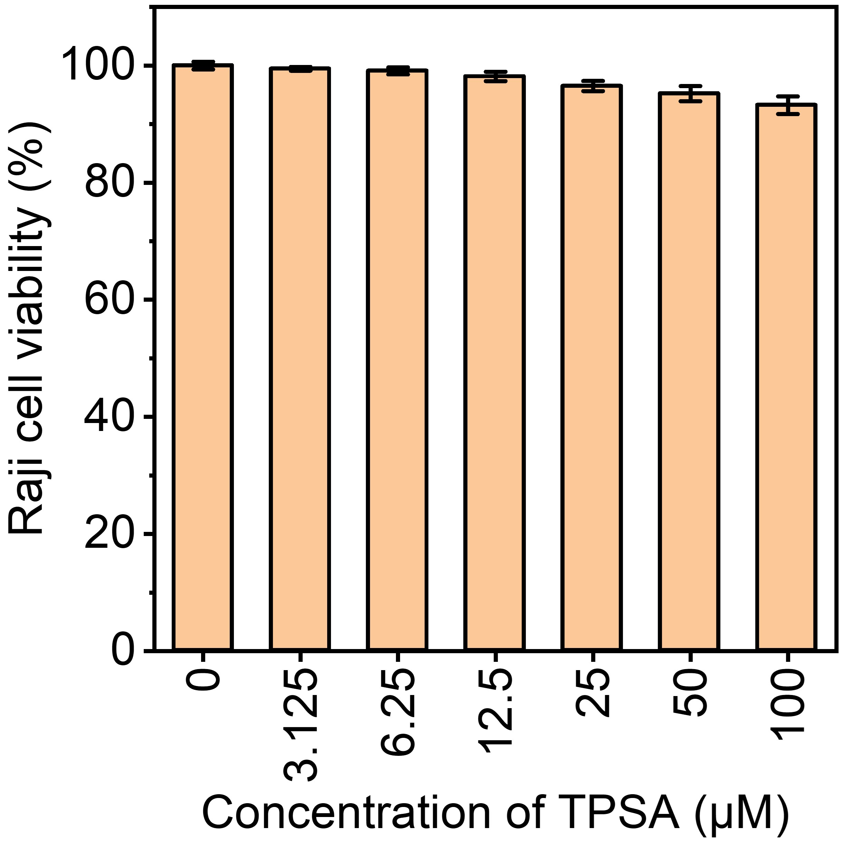
Figure S7. The cell viability of Raji cells after incubation with different dose of TPSA for 24 h. All data are presented the mean ± SD (n = 6).

