Supplementary Figure

Fig. S1 CD3 Nbs and CD105 Nbs possess high purity. A-B. The Nbs were purified by Ni-NTA chromatography column at 4 ºC, and the purified CD3 Nbs (A) and CD105 Nbs (B) were analyzed via 12% SDS-PAGE. C-D. Purified CD3 Nbs(C) and CD105 Nbs (D) were confirmed by western blot using anti-his-tag antibody conjugated by IgG Dylight 800.

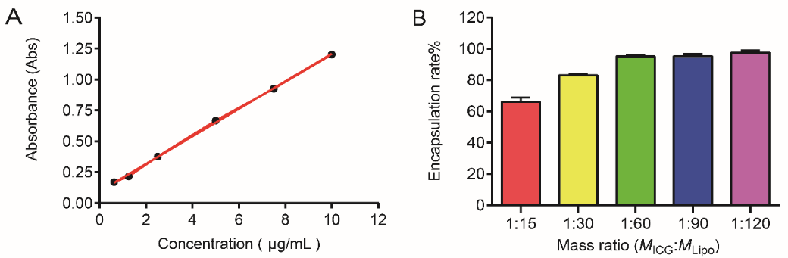

Fig. S2 The ICG encapsulation of CD105/CD3 Nb-LipoICG. A. The standard curve of UV absorption at 820 nm with gradient concentrations (0.625 µg/mL~10 µg/mL). B. The ICG encapsulation rate of CD105/CD3 Nb-LipoICG was calculated according to the serial dilutions (as indicated) before (M_{Total}) and after (M_{ICG}) the ultrasonication based on the obtained ICG standard curve, using the following formula: encapsulation rate (EE) % = M_{ICG}/M_{Total} × 100%.

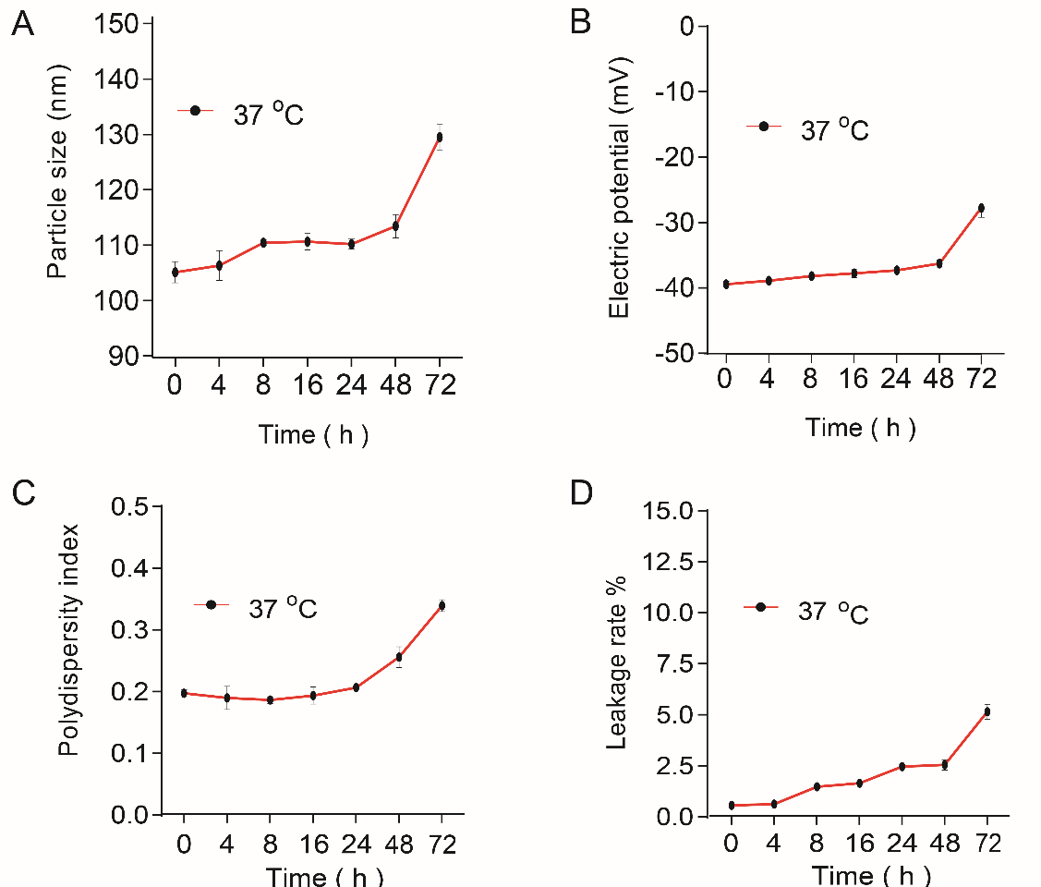

Fig. S3 The stability of CD105/CD3 Nb-LipoICG in cell culture medium containing 10% serum at 37 ºC were detected by Zetasizer Nano ZS. Variation of particle size (A), Zeta potential (B), PDI value (C) and leakage rate (D) were detected and analyzed.

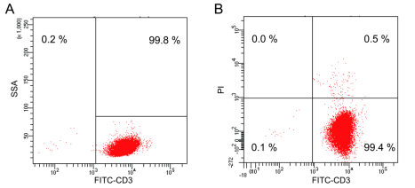

Fig. S4 The sorted CD3⁺ T cells have high purity and viability . A. Naïve CD3⁺ T cells were sorted from human PBMCs with a FITC-conjugated anti-CD3 mAb by FACSAria Cell Sorter. B. The sorted CD3⁺ T cells were stained with propidium iodide (PI) and analyzed by flow cytometry.
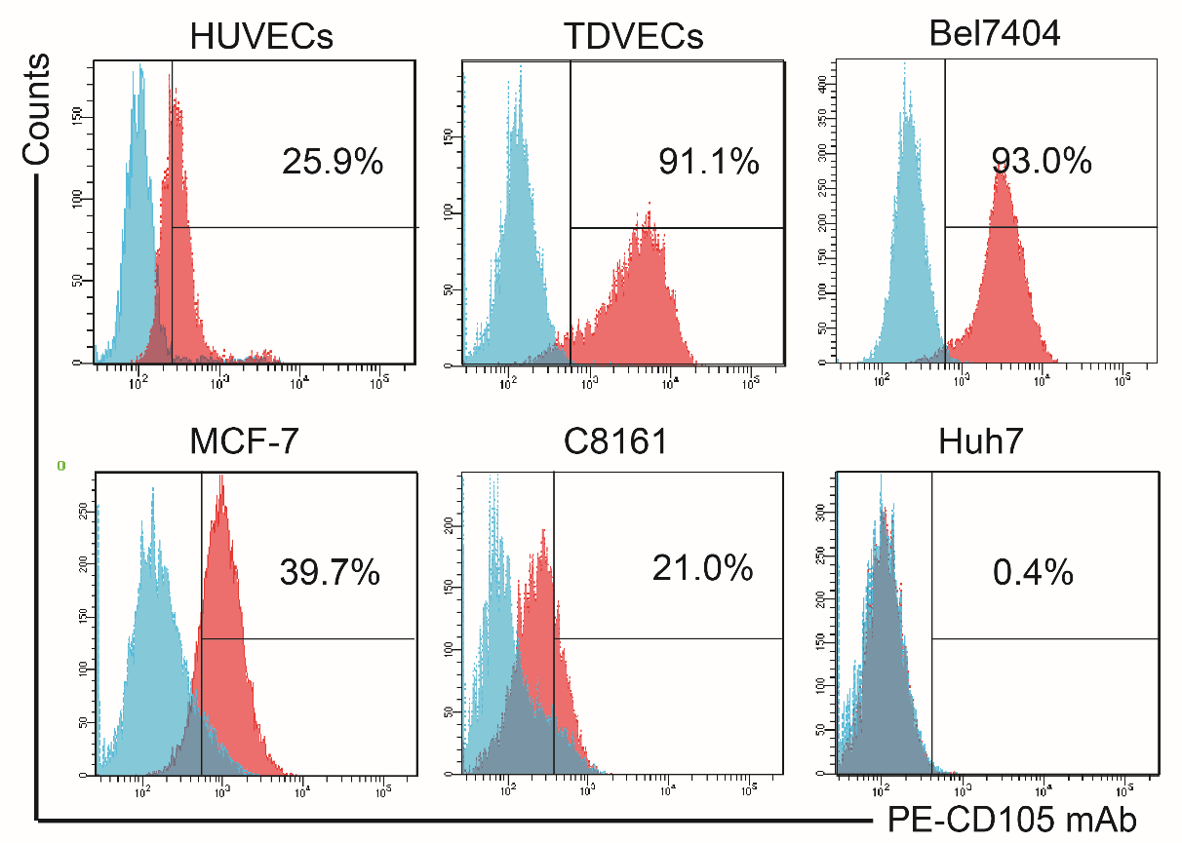

Fig. S5 Flow cytometry analysis of CD105 antigen expression on the cells surface. Endothelial cells (HUVECs and TDVECs) and tumor cells (Bel7404, MCF-7, C8161, Huh7) were labeled with anti-CD105 mAb-PE, then analyzed by flow cytometry, respectively.

Fig. S6 Antitumor effect of CD105/CD3 Nb-LipoICG and T cells combined with photothermal therapy to the NOD/SCID mice bearing with MCF-7 and C8161 tumor cells. A-B. The tumor growth data are expressed as the mean ± SD of the MCF-7(A) and C8161(B) tumor volumes of each group of mice (n = 5 per group). C-D. The survival curves of the MCF-7(C) and C8161(D) tumor-bearing mice were estimated using the Kaplan-Meier method. Data are expressed as the mean percentage of each group of mice (n = 5 per group) that survived throughout the period.

Fig. S7 CD105/CD3 Nb-LipoICG has good biological safety. A. CD105/CD3 Nb-LipoICG at different dilutions were incubated with HUVECs for 24 or 48 h. The cytotoxicity was detected by a CCK-8 assay kit. B. BALB/c mice were randomized (5 mice per group) and injected with CD105/CD3 Nb-LipoICG (ICG, 5 mg/kg) via the caudal veins once every 7 days. The tissues of the heart, liver, spleen, lung and kidney were sampled.Representative HE-stained sections are shown for histology. Scale bars are shown. C. Serum was separated from the coagulated blood of the same batch of mice for the measurement of major biochemical indices. Data are presented as mean ± SD of five replicates of corresponding independent samples.

Supplementary Table

Table 1 Amounts of Nbs coupling to each liposome
